**EY GCP Data Engineer Interview Guide – Experienced 3+**

**Technical Round 1: SQL, Python, Data Warehousing, and Data Modeling**

**1. Introduction**

• Self-introduction including current role, projects, and key responsibilities.

• Focus on SQL expertise, Python skills, and experience in data warehousing and modeling.

**2. SQL: Difference Between SELECT, COUNT(*), and COUNT(1)**

• **SELECT:** Retrieves data from the database.

• **COUNT(*):** Counts all rows in the table, including NULL values.

• **COUNT(1):** Similar to COUNT(*), but often optimized internally by databases.

• **Best Approach:** COUNT(*) is preferred for clarity and consistent optimization across platforms.

**3. Write a Merge Statement for SCD Type 2**

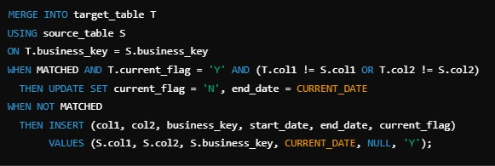

**4. UNNEST and Query Example**

• **Definition:** UNNEST is used to flatten arrays in BigQuery into rows.

• **Query Example:**



**5. Window Functions**

• Examples include ROW_NUMBER(), RANK(), DENSE_RANK(), and NTILE().

• Use cases: Generating row numbers, finding rankings, calculating moving averages.

**6. Data Modeling: SCD Types**

• **Type 1:** Overwrite data.

• **Type 2:** Maintain history with additional columns (start_date, end_date).

• **Type 3:** Maintain limited history using additional columns for old and new data.

**7. Python: Remove Duplicates from a String**

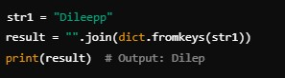

**8. Reverse a String with Special Characters Preserved**

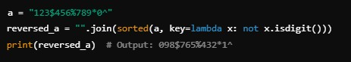

**9. Data Warehousing: OLTP vs. OLAP**

• **OLTP:** Transactional systems, real-time operations, normalized schema.

• **OLAP:** Analytical systems, historical data analysis, denormalized schema.

**10. Joins: How Many Records?**

• **Input Table:**

Table A: (7, 7), (7, 7), (1, 6), (1, 1), (NULL, NULL) Table B: Similar.

• **Results:**

Inner Join: Records where A and B match; excludes NULLs.Left Join: All records from Table A; unmatched records in B as NULL.

Right Join: All records from Table B; unmatched records in A as NULL.

**Round 2: GCP, BigQuery, and Data Engineering Concepts**

**1. Partitioning vs. Clustering in BigQuery**

• **Partitioning:** Data is divided into segments (e.g., by date) for faster query performance.

• **Clustering:** Groups rows within partitions based on one or more columns for better query efficiency.

**2. JSON Files in GCS to BigQuery**

• Use LOAD DATA with the schema auto-detected or provide a schema manually.

**3. BigQuery Internal vs. External Tables**

• **Internal Table:** Stores data within BigQuery.

**External Table:** References data in external storage like GCS.

**4. Removing Duplicate Rows in BigQuery**

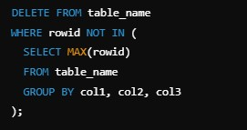

**5. Airflow Operators**

• **Common Operators:**

• PythonOperator

• BashOperator

• BigQueryOperator

• DummyOperator

**6. Airflow: Task Dependencies**

• Use set_upstream() and set_downstream() to define dependencies.

• Example for parallel tasks:



**7. BigQuery Slots**

• Compute resources assigned for query execution.

• Slots ensure predictable performance by managing concurrency.

**8. BigQuery Cache**

• Cache stores query results for future use.

• Helps save costs and reduce execution time.

**9. Parquet vs. CSV**

• **Parquet:** Columnar format, smaller size, faster for analytical queries.

• **CSV:** Row-based format, larger size, suitable for sequential data processing.

**10. Benefits of BigQuery Warehouse**

• Fully managed, scalable, and serverless.

• Optimized for analytical workloads.

**11. BigQuery Architecture**

• Consists of:

• **Storage Layer:** Durable, distributed storage.

• **Query Engine:** Dremel-based, efficient for SQL queries.

• **Compute Layer:** Handles parallel processing.