**Incedo Azure Data Engineer Interview Guide – Experienced 3+**

**Technical Round 1**

**1. Create Two Columns for Sum of Positive and Negative Numbers**

**Input**:

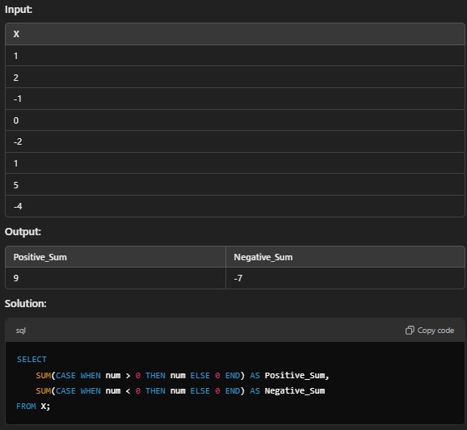

**Explanation**:

• CASE is used to conditionally check each number.

• **Positive numbers** are summed when num > 0.

• **Negative numbers** are summed when num < 0.

• ELSE 0 ensures non-matching conditions do not affect the result.

**2. Identify Consecutive Numbers in a Column**

**Input**:

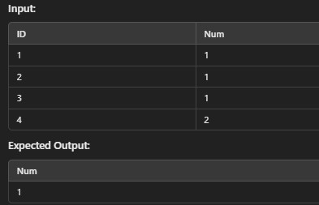

**Solution**: SELECT num FROM (

SELECT num,

ROW_NUMBER() OVER (PARTITION BY num ORDER BY id) AS rn, ROW_NUMBER() OVER (ORDER BY id) - ROW_NUMBER() OVER (PARTITION BY

num ORDER BY id) AS grp

FROM table

) sub

GROUP BY num, grp

HAVING COUNT(*) >= 3;

**Explanation**:

• ROW_NUMBER() is used to assign row numbers to each entry.

• A calculated grp column groups consecutive numbers.

• HAVING COUNT(*) >= 3 filters sequences of at least 3.

**3. Replace Words and Perform String Operations in Python**

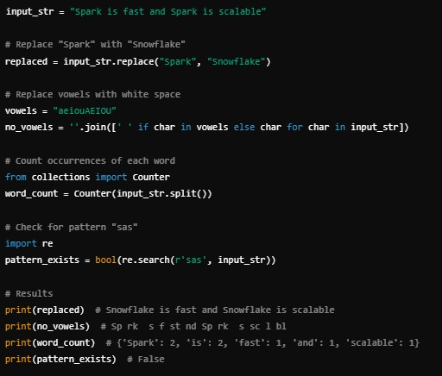

**Explanation**:

• **String Replacement**: .replace() is used for direct word substitution.

• **Vowel Removal**: A list comprehension with join() creates a modified string.

• **Word Count**: Counter splits the string and counts word occurrences.

• **Pattern Check**: re.search() finds the pattern 'sas'.

**4. SQL Where Employee Earns More Than Manager**

**Problem**: Identify employees whose salary is higher than their manager's.

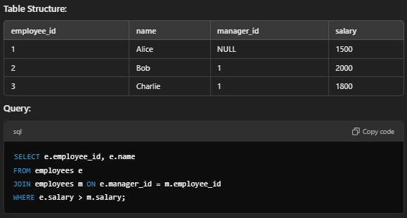

**Explanation**:

• **Self Join**: The table employees is joined to itself (e and m) to compare employee- manager relationships.

• **Condition**: WHERE e.salary > m.salary filters for employees earning more than their manager.

• **Example Output**:

**employee_id name**

2 Bob

**Technical Round 2**

1. **Find the Second-Highest Salary in a Table** SELECT MAX(salary) AS second_highest_salary FROM employees

WHERE salary < (SELECT MAX(salary) FROM employees);

2. **Count the Number of Nulls in Each Column of a Table**

SELECT

SUM(CASE WHEN column1 IS NULL THEN 1 ELSE 0 END) AS column1_nulls, SUM(CASE WHEN column2 IS NULL THEN 1 ELSE 0 END) AS column2_nulls

FROM table_name;

3. **SQL Query to Remove Duplicates from a Table**

DELETE FROM table_name

WHERE id NOT IN ( SELECT MIN(id) FROM table_name

GROUP BY column1, column2, column3

);

4. **Write a Query to Find Employees in the Same Department as 'John'**

SELECT e.name

FROM employees e

JOIN employees john ON e.department_id = john.department_id

WHERE john.name = 'John' AND e.name != 'John';

5. **Python Program to Reverse Words in a String**

input_str = "Hello World from Python" reversed_words = ' '.join(input_str.split()[::-1]) print(reversed_words) # Output: "Python from World Hello"

6. **How to Optimize a Spark Job**

• Use proper partitioning and bucketing.

• Avoid shuffles by optimizing join keys.

• Use broadcast joins for small datasets.

• Cache intermediate results when reused multiple times.

• Enable Dynamic Resource Allocation in Databricks.

7. **Scenario-Based Question: Query Optimization for a Large Dataset**

• Check for proper indexing on queried columns.

• Use EXPLAIN PLAN to identify bottlenecks.

• Partition the dataset by frequently queried columns.

• Use parallel processing for large transformations.

8. **Find Employees Who Earn the Third-Highest Salary**

SELECT employee_id, salary

FROM (

SELECT employee_id, salary, DENSE_RANK() OVER (ORDER BY salary DESC) AS

rank

FROM employees

) WHERE rank = 3;

9. **Difference Between Lazy Evaluation and Eager Execution in PySpark**

• Lazy Evaluation: Transformations are not executed immediately; they are recorded in a DAG.

• Eager Execution: Actions like collect() or show() trigger execution.

10. **Python Program to Check if a String is a Palindrome**

def is_palindrome(s):

s = s.lower().replace(" ", "")

return s == s[::-1]

print(is_palindrome("A man a plan a canal Panama")) # Output: True

11. **SQL Query to Find Departments with More Than 10 Employees**

SELECT department_id, COUNT(*) AS employee_count

FROM employees

GROUP BY department_id

HAVING COUNT(*) > 10;

12. **Explain PySpark’s Catalyst Optimizer**

• Catalyst is PySpark’s query optimization engine.

• Performs logical optimization (predicate pushdown, projection pruning).

• Converts logical plans to physical plans for efficient execution.

**Technical Round 3**

13. **Python Program to Find Consecutive Numbers in a List**

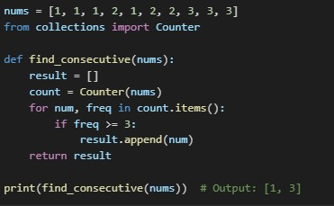

14. **SQL Query to Replace Specific Patterns in a String Column**

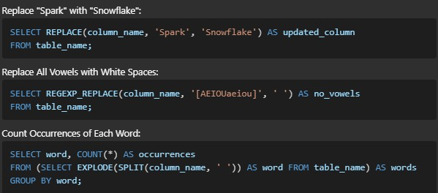

15. **Difference Between Partition Count and Query Performance in Spark**

• Partition count affects parallelism.

• Too few partitions lead to underutilization.

• Too many partitions create task scheduling overhead.

• Use repartition() to increase partitions and coalesce() to reduce partitions.

16. **Incremental Load in ADF and Databricks**

• **In ADF**: Use copy activity with a filter on the last_modified_date column.

• **In Databricks**:

• incremental_data = full_data.filter(full_data.updated_at > last_load_timestamp)

incremental_data.write.format("delta").mode("append").save(target_path)

17. **SQL Query to Find Top 3 Earners in Each Department**

SELECT department_id, employee_id, salary

FROM (

SELECT department_id, employee_id, salary, RANK() OVER (PARTITION BY

department_id ORDER BY salary DESC) AS rank

FROM employees

) WHERE rank <= 3;

18. **Explain the Purpose of SparkSession vs SparkContext**

• SparkSession: Unified entry point for DataFrame and SQL APIs.

• SparkContext: Low-level entry point to interact with Spark's core APIs (RDDs).

19. **How to Remove Duplicate Rows in PySpark**

df = df.dropDuplicates(["column1", "column2"])

20. **Caching Techniques in Databricks**

df.cache()

df.show() # This triggers caching

21. **Python Code to Generate Prime Numbers**

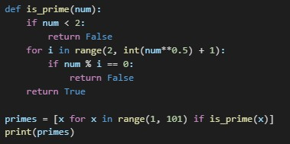

22. **Broadcast Join in PySpark**

from pyspark.sql.functions import broadcast

result_df = large_df.join(broadcast(small_df), "common_key")

23. **Explain Fact and Dimension Tables**

• Fact Table: Contains quantitative data (e.g., sales, revenue).

• Dimension Table: Contains descriptive attributes (e.g., product, customer).

24. **Difference Between Managed and External Tables in Databricks**

• Managed Table: Databricks manages the data storage location.

• External Table: Data resides outside Databricks but is referenced in the metastore.

25. **SQL Query to Fetch Employees Earning More Than Their Manager**

SELECT e.employee_id, e.salary

FROM employees e

JOIN employees m ON e.manager_id = m.employee_id

WHERE e.salary > m.salary;

26. **Explain Z-Ordering in Databricks**

• Z-ordering optimizes file layout by co-locating similar data.

• Improves query performance for frequently filtered columns.