**JIO Data Engineer Interview Guide – Experienced 3+**

**Overview**

The interview process for Jio’s Data Engineer position was structured into two distinct rounds: a technical round that tested coding skills, SQL, PySpark, and optimization strategies, followed by a managerial round focused on personality, project management experience, and career aspirations. Each round presented unique challenges, emphasizing both technical expertise and problem-solving abilities, as well as communication skills and project insights.

**Round 1: Technical (60–90 minutes)**

This round primarily tested coding proficiency in Python, PySpark, and SQL. It also assessed the ability to optimize data processing and solve algorithmic challenges.

**1. Tell me about yourself**

This is often the first question in technical rounds. It’s an opportunity to set the stage with a succinct summary of your technical skills, recent projects, and key accomplishments.

Tip: Tailor your response to highlight relevant experience, such as data processing frameworks, cloud platforms, and optimization techniques used in past roles.

Example:

*"I am a Data Engineer with X years of experience in big data technologies, specializing in Spark, PySpark, and SQL-based data processing. I’ve worked on building scalable data pipelines for processing terabytes of data, optimizing performance using advanced partitioning and caching strategies. In my last project, I integrated Azure Databricks and Data Lake for a real-time data ingestion solution, achieving a 25% reduction in processing latency."*

**2. Find the three numbers from a list whose multiplication equals 180**

**Question**:

Given a list lst = [12, 3, 27, 5, 4, 9, 4], identify three numbers that multiply to 180.

**Approach**:

Loop through the list using a nested loop approach to check combinations of three elements whose product equals 180.

**Python Code**:

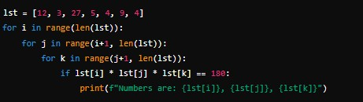

**Insight**:

This problem evaluates algorithmic thinking, iteration techniques, and handling nested loops efficiently. You can improve efficiency with more advanced combinations, but the core approach here works well for small lists.

**3. Python Script to Insert and Delete an Element Without Using insert() or pop()**

This tests basic list manipulations using slicing techniques.

**Solution**:

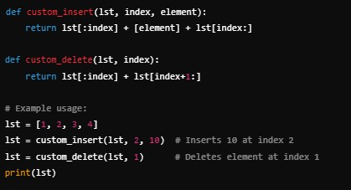

**4. Check if Two Strings Are Anagrams**

Given str1 = "abcd" and str2 = "dabc", determine if they are anagrams.

**Solution**:

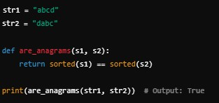

**5. Lead and Lag in SQL Using PySpark DataFrame API**

**Example**:

The interviewer might ask for **lag** and **lead** functions using PySpark.

**Solution**:

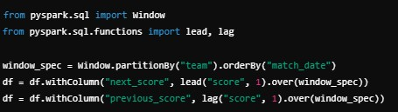

**6. Optimization Techniques Beyond Repartitioning and Caching**

Candidates should discuss additional techniques:

• **Salting**: Used to prevent data skew by adding a random key to partitioned data.

• **Broadcast Joins**: Optimizing small table joins by broadcasting them to all nodes.

• **Predicate Pushdown**: Reducing I/O by filtering data at the source.

**Example**:

*"In one project, we faced a severe data skew issue in a Spark application while joining a small lookup table with a large dataset. By applying salting and using a broadcast join, we significantly improved processing time from 40 minutes to under 10 minutes."*

**7. Query to Print Match List Against Every Team**

This is a SQL-style self-join question to pair teams.

**Example SQL Query**:

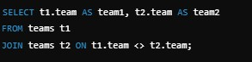

**Round 2: Managerial (30–45 minutes)**

This round evaluates your soft skills, project management capabilities, and career motivations. It is equally critical as the technical round since it highlights how well you fit into the company culture, handle real-world challenges, and collaborate within teams.

**Q1. Tell me about your family.**

**Purpose**: The interviewer is often gauging your background to build rapport and understand your support system or work-life balance.

**Answer**:

*I come from a family of four. My parents have always emphasized education and perseverance. My father works as [occupation], and my mother is a [profession/homemaker]. My younger sibling is pursuing [career/study]. Their support and encouragement have been instrumental in my professional journey. They’ve always inspired me to continuously learn and grow in my career.*

**Tip**: Keep it short and positive, focusing on how your background shapes your motivation

and work ethic.

**Q2. Why are you looking for a change?**

**Purpose**: The interviewer wants to understand your career goals and alignment with the new role. Avoid negative comments about your current employer.

**Answer**:

*I’m looking for a role where I can contribute to more challenging projects, particularly those involving scalable cloud data platforms and advanced big data processing. While I’ve gained substantial experience in my current position, I’m excited about the opportunity at [Company] to work on cutting-edge technologies like [specific tools used by the company] and drive impactful data solutions.*

**Tip**: Focus on growth, learning, and alignment with the company’s vision.

**Q3. Describe a major challenge in your project and how you resolved it. Answer**:

*In a previous project, we faced severe performance issues while processing terabytes of data in Spark due to skewed data in the join keys. After identifying the skewed partitions, I implemented salting by adding random values to the join key to distribute the load evenly. Additionally, I tuned shuffle partitions and caching strategies. This approach improved processing time by 40%, reduced cluster costs, and ensured timely data delivery for reporting.*

**Tip**: Use the STAR method (Situation, Task, Action, Result) to structure your response.

**Q4. How do you handle conflicts within a team?**

**Answer**:

*I believe open communication is key to resolving conflicts. In a situation where two team members had differing opinions on the approach for a data pipeline design, I facilitated a meeting where each could present their perspective with supporting data. We then analyzed both solutions together, considering trade-offs in performance, scalability, and maintenance. Ultimately, we chose a hybrid approach that satisfied both viewpoints. This process not only resolved the conflict but also improved our collaboration.*

**Tip**: Highlight your ability to mediate, communicate, and reach consensus.

**Q5. Explain your approach to delivering critical projects on time. Answer**:

*"I prioritize detailed project planning and clear communication. For a recent data migration project, I started with a thorough requirements analysis and created a timeline with milestones. I proactively identified potential bottlenecks in data transformation stages and allocated resources accordingly. Regular check-ins ensured the team stayed on track, and I used tools like JIRA to monitor progress. This structured approach helped us deliver the project one week ahead of schedule."*

**Tip**: Emphasize planning, communication, and risk management.

**Q6. Describe your experience with cloud platforms like AWS, Azure, or GCP. Answer**:

*"I’ve extensively worked on Azure for building scalable data pipelines. In my most recent project, I used Azure Data Factory for orchestrating data workflows and Azure Databricks for real-time data transformations. I leveraged Azure Data Lake Storage for efficient data management and used Azure Synapse for analytics. I also implemented security best practices using Azure Key Vault and role-based access control (RBAC). This cloud-native approach significantly reduced processing costs while improving scalability."*

**Tip**: Tailor your answer to highlight the cloud platform relevant to the job description.

**Q7. How do you prioritize tasks when working on multiple projects?**

**Answer**:

*"I use a combination of impact assessment and deadlines to prioritize tasks. For example, when working on a data ingestion pipeline and a reporting dashboard simultaneously, I assess which deliverable has the most immediate business impact and deadline sensitivity. I break down each task into smaller, manageable steps, use project management tools like Trello or JIRA to track progress, and communicate regularly with stakeholders to align priorities."*

**Tip**: Focus on time management strategies and proactive communication.

**Q8. Explain Slowly Changing Dimensions (SCD) and its types.**

**Answer**:

Slowly Changing Dimensions (SCD) refer to data warehouse dimensions that change slowly over time, rather than on a regular schedule. There are multiple types:

• Type 1: Overwrites old data with new data.

• Type 2: Tracks historical changes by adding a new row for each change with effective date columns.

• Type 3: Adds a new column to store previous values.

For example, in a customer data warehouse, Type 2 is often used to track address changes, allowing historical data analysis based on where customers lived at different times.

**Tip**: Provide real-world examples to make your explanation clear.

**Q9. What are your long-term career goals? Answer**:

*"My long-term goal is to become a Data Architect, designing scalable and efficient data ecosystems that drive business insights. I’m passionate about learning new technologies like real-time streaming with Apache Kafka and cloud-native data warehouses. I aim to lead data engineering teams and contribute to the overall data strategy of an organization."*

**Tip**: Align your goals with the company’s vision and opportunities for growth.

**Q10. How do you stay updated with the latest data engineering technologies? Answer**:

*"I stay current by following industry blogs, participating in webinars, and engaging with the data engineering community on platforms like LinkedIn. I also complete courses on platforms such as Coursera and Udemy. Recently, I completed a course on advanced Spark optimizations, which I’ve applied to improve query performance in a production*

*environment."*

**Tip**: Mention specific resources and continuous learning habits.