Manual “How to create Quicksight Analysis for deployed DMAFv2 Quicksight stack”:

1. Check Quicksight stack region
2. Copy Quicksight Stack Name (= StackId)

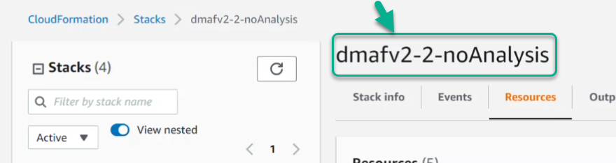

1. Open CloudShell in the same region

C:\Users\abulato\AppData\Local\Temp\SNAGHTML4163796b.PNG

1. Upload create_analysis.py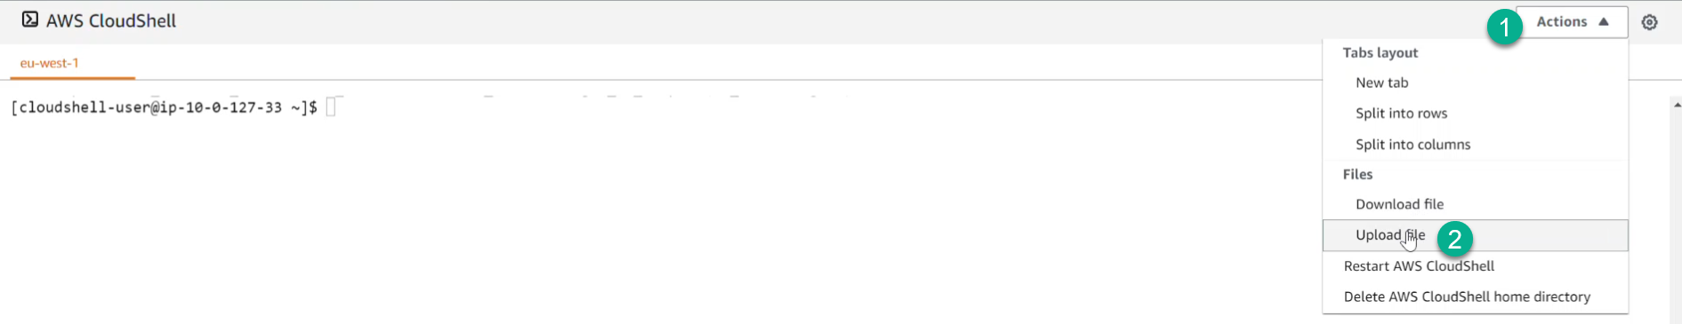
2. Run python3 create_analysis.py -cf=<StackId = StackName>



1. Successful screen should be like this below (please be aware that the user who is granted permissions for Analysis is the same user(group) as in Quicksight Stack):

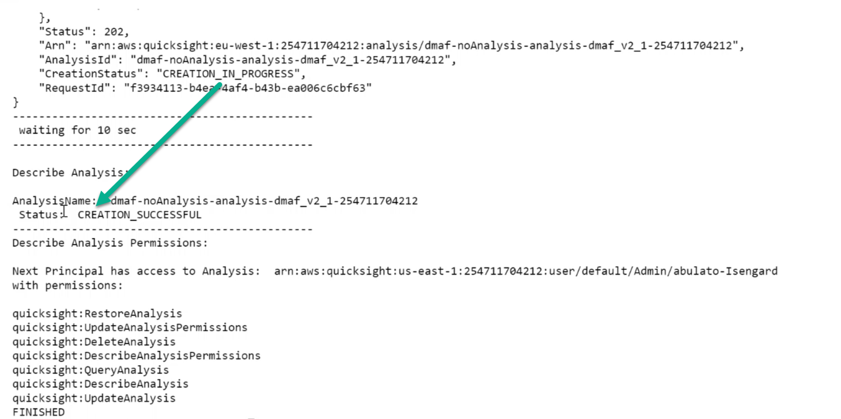

1. If you refresh Quicksight Analysis page – there should be new analysis (only user who is defined in Quicksight Stack will see it via AWS Console)

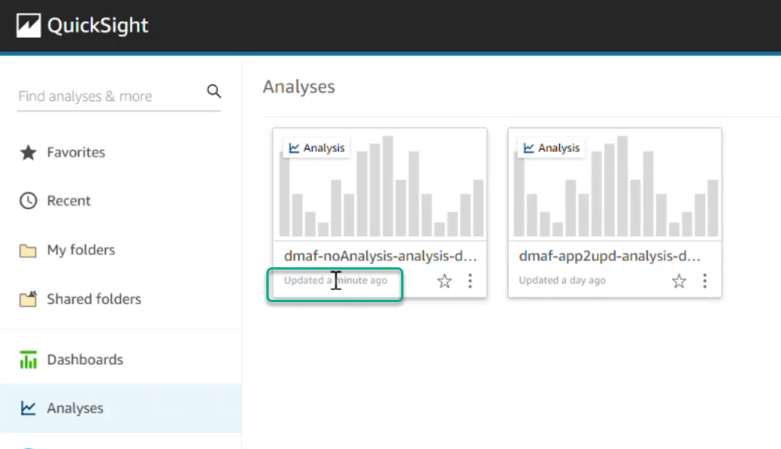

Thank you.