begin;(□)* return;(□)* (abs(calc|pr);) + □ * end;

begin; return; abs( calc + pr); end;

begin; □ return; □ (abs(calc);) end;

begin;□ □ return;□ (abs(calc);) end;

begin;return;abs(pr);abs(calc); end;

begin;return;abs(pr);abs(pr);abs(calc);end;

begin; return;abs(calc);abs(calc);abs(pr);abs(calc);end;

begin;return;abs(pr);abs(pr);abs(calc);abs(pr);abs(calc);end;

|  |  |
| --- | --- |
| a | Begin; |
| b | Return; |
| c | Abs(calc); |
| d | End; |
| f | □ |
| r | Abs(pr); |

|  |  |  |  |  |  |  |
| --- | --- | --- | --- | --- | --- | --- |
|  | a | b | c | r | d | f |
| S0 | S1 |  |  |  |  |  |
| S1 |  | S2 |  |  |  | S1 |
| S2 |  |  | S3 | S3 |  | S2 |
| S3 |  |  | S3 | S3 | Sf | S4 |
| S4 |  |  |  |  | Sf | S4 |
| Sf |  |  |  |  |  |  |  |

begin;(□)* return;(□)* (abs(calc|pr);) + □ * end;

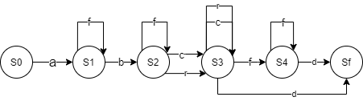

Afbccd

