Question1: Please confirm the correct option

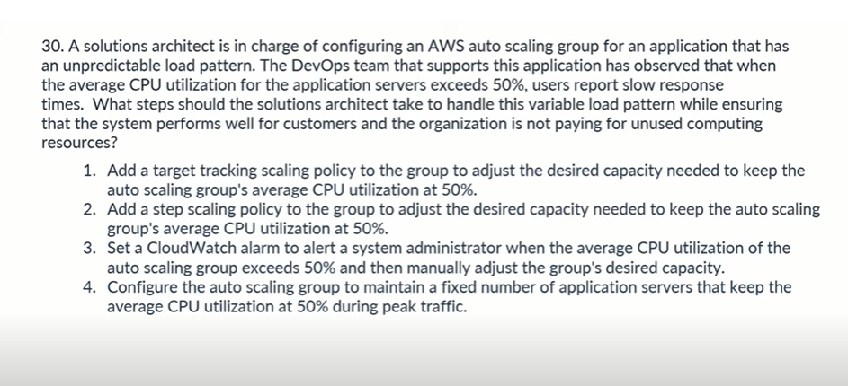

Question 2: Please confirm the correct option

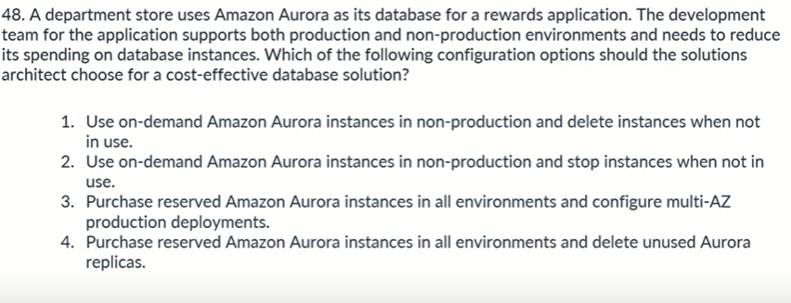

Question3: should be option B rather than C as we can’t expose private subnets to Internet Gateway.. Please confirm

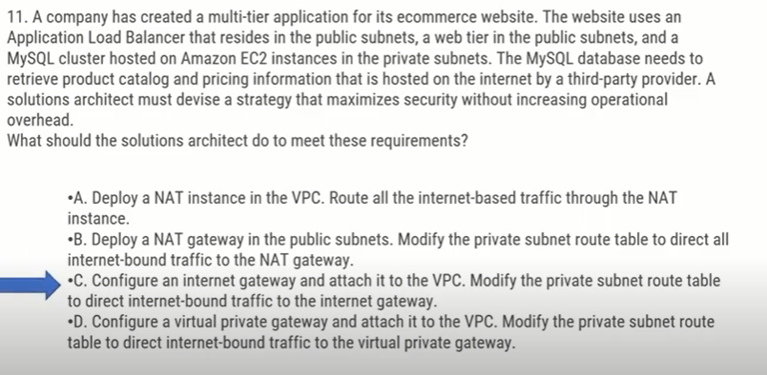

Question 4: Since low network bandwidth is an issue as per question, can’t it be Option D rather than B. Please confirm.

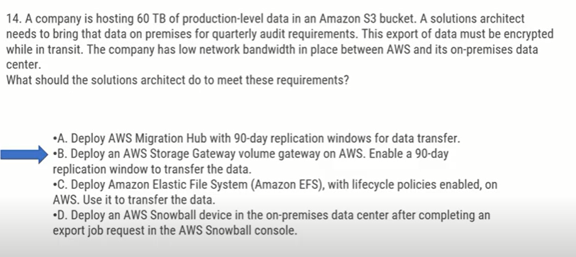

Question 5:

AWS DataSync is a secure, online service that automates and accelerates moving data between on premises and AWS Storage services.

The AWS Schema Conversion Tool (AWS SCT) helps convert your existing database schema from one database engine to another.

As per above explanation, should be either option C or D and NOT B. Please advise the correct option.

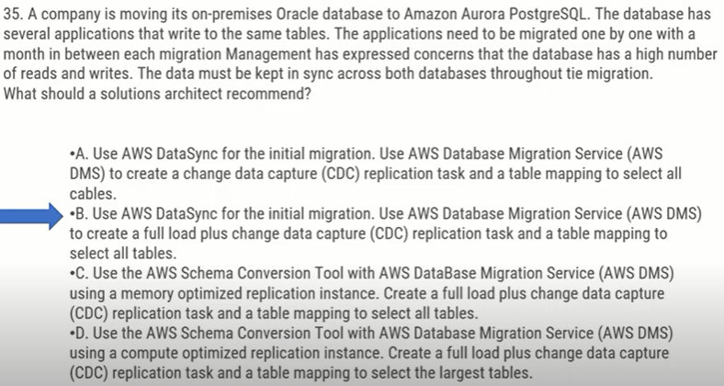

Question 6: Is D the correct answer?? Should be B .. Please confirm

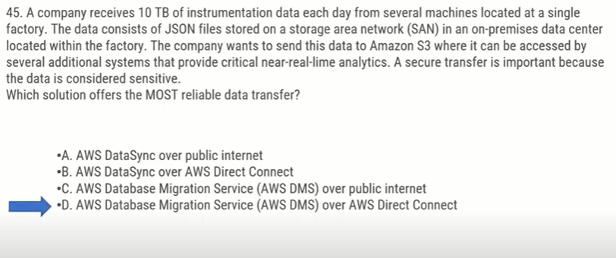

Question 7: Is D the correct option? If yes, why is it so?

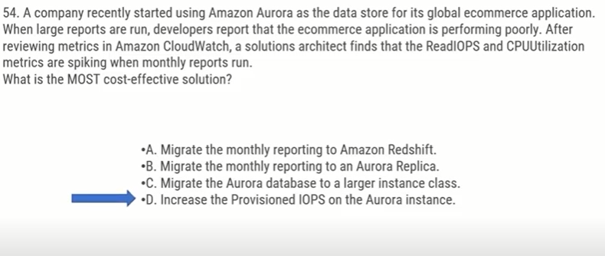

Question 8: For storing shopping cart info, should be DynamoDB rather than Aurora. Please confirm

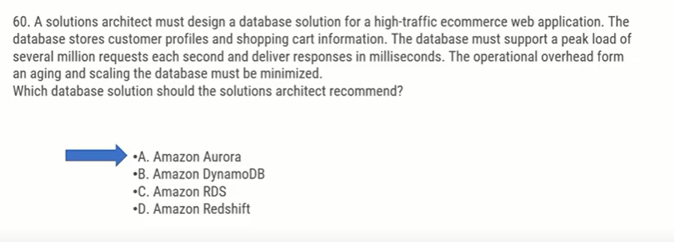

Question 9: As per my understanding, we can use Dynamo stream with Lambda to trigger a notification whenever a new update is made to the DB. Therefore Option C should be the correct one as per my understanding. However, A is the correct one as per website.

Please confirm

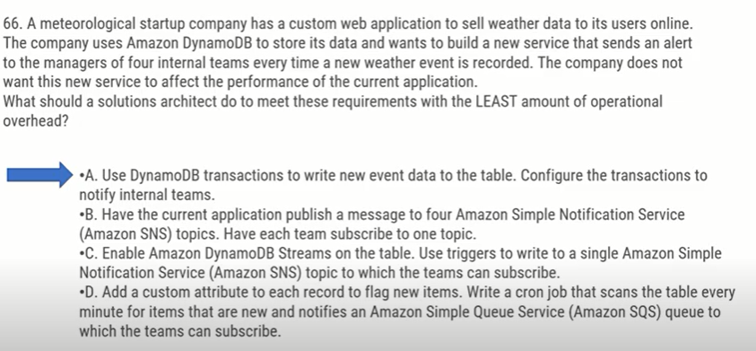

Question 10: As the questions talks about “LEAST” privilege, proving lambda as \* would give all permissions and hence couldn’t be the correct option here. Therefore D should be the correct option as per my understanding. But the correct one is C as per website.

Please confirm.

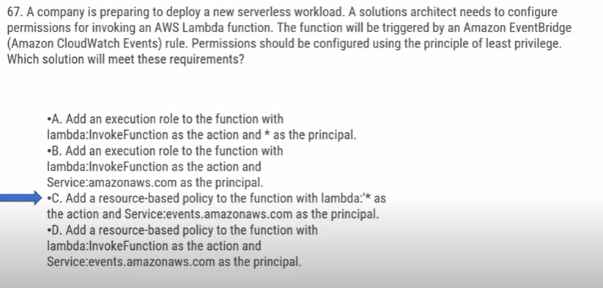

Question 11: Since the messages (writes) should not be dropped, it should be stored somewhere for processing, and I think SQS should be the correct option here. So my understanding is Option D.

However, the marked option is the correct one as per the website from where I picked up the question. Please confirm.

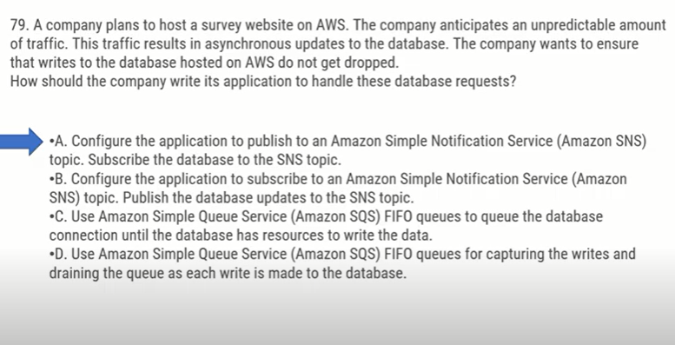

Question 12: As the question asks for improving the application’s infrastructure, I think using AWS Fargate (serverless) to manage application can reduce overhead of maintaining the infrastructure (asked in questions) could be the correct option here. So E is the option.. Not sure about the other option (Option ‘A’ definitely not.. as migrating db increases the overhead and Option ‘B’ talks about hosting on EC2 instances which again is not a good option)

Please confirm the correct Options..s

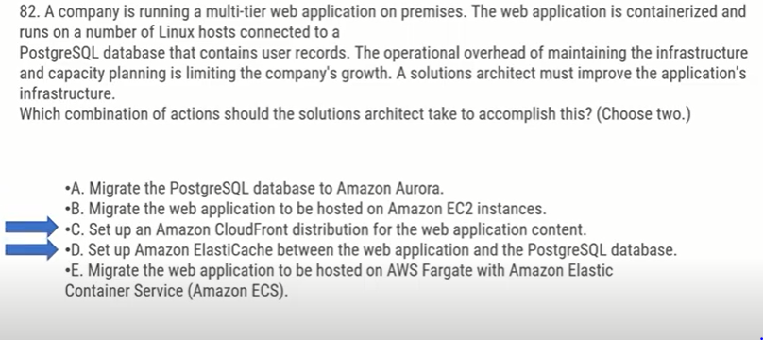

Question 14:

Correct Answer is marked below. How can the versioning disable achieve 99% availability as mentioned in the question? Is Option A the correct one?

