**Coursera**

Algorithms (94.4%),

Introduction to Data Science in Python (95.5%),

Machine Learning (98.4%)

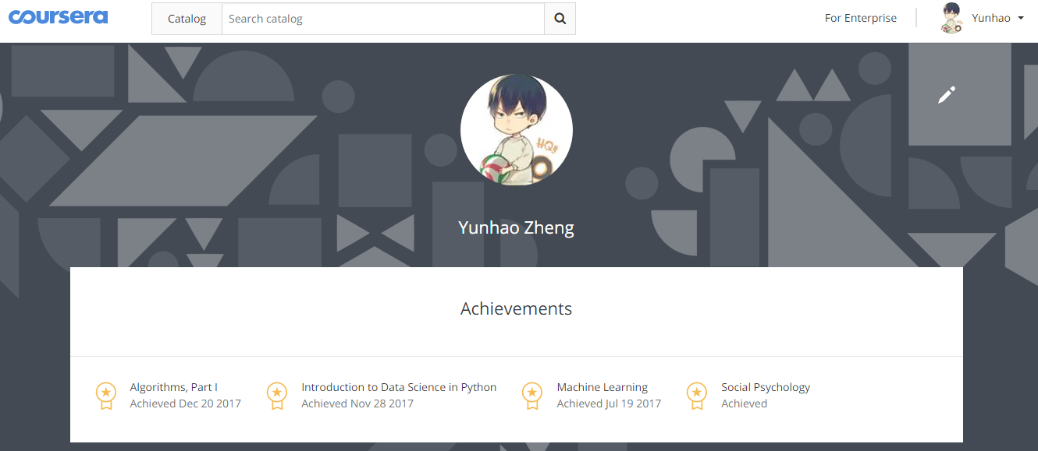

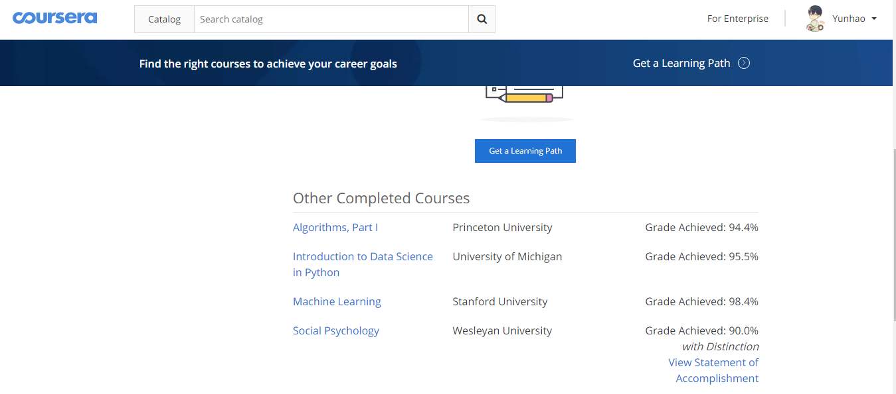

**edX**

Introduction to Apache Hadoop (87%)

