**TABLE OF CONTENTS**

TITLE PAGE

Approval Sheet

Acknowledgment

Abstract

Table of Contents

List of Table

List of Figures

**Chapter I**

**INTRODUCTION**

**Background of the Study**

Artificial Intelligence (AI) is a branch of computer science that focuses on developing intelligent machines that can perform tasks that typically require human intelligence, such as visual perception, speech recognition, decision-making, and language translation. The integration of AI is a crucial aspect of this study as it provides the foundation for the Alumni Tracker with Job Matching system. By leveraging AI algorithms, the system can collect and analyze data on the alumni's education, work experience, skills, and preferences to provide personalized job recommendations that match their profile.

There are several job matching systems and studies that exist in the market, but the NONESCOST Alumni Tracker with Job Matching using AI Integration system has some unique features and approaches that distinguish it from other similar systems. The system is specifically designed to match NONESCOST alumni with job opportunities, providing a more targeted approach than other general job matching systems. The system is designed to cater to the job market in the Northern Negros area, providing job recommendations that are tailored to the local job market and the needs of the alumni.

**Objectives of the Study**

**General Objective**

This study aims to develop an Alumni Tracker with Job Matching using AI Integration.

**Specifically, it aims to**

1. Design a system that manage data of NONESCOST Alumni that includes their education, work experience, skills, and job preferences.
2. Design a system that can assist alumni to self-assist their skills.
3. Design a system that can create alumni resume.
4. Design a system with an AI-based job matching algorithm that can analyze alumni data and provide personalized job recommendations that match their profile.
5. Generate the following reports
   1. Employment rate of Alumni
   2. Job Matching
6. Determine the quality of the developed system based on **ISO/IEC 25010:2011** Systems and Software Quality Requirements and Evaluation (SQuaRE) Quality Model

**Scope and Limitation**

**Significance of the Study**

The NONESCOST Alumni Tracker with Job Matching using AI Integration system is designed to benefit several stakeholders, including NONESCOST alumni, employers, and the academic institution itself.

1. NONESCOST Alumni: The primary beneficiaries of the system are the alumni of the institution. The system will provide personalized job recommendations that match the alumni's education level, work experience, skills, and job preferences. The system will help alumni find job opportunities that align with their career goals, increasing their chances of finding employment that matches their interests and skillset.
2. Employers: The system will benefit employers by providing a pool of qualified job applicants who match their job requirements. Employers will benefit from a more efficient recruitment process, reducing the time and resources required to find suitable candidates. The system will help employers find qualified applicants who match their job requirements, increasing the likelihood of successful job placements.
3. Academic Institution: The system will benefit the academic institution by improving its alumni engagement and support services. By providing a job matching service for alumni, the institution can enhance its reputation and improve its relationships with alumni. The system will also provide valuable data on alumni employment trends, which can be used to improve the institution's academic programs and curriculum.

In summary, the NONESCOST Alumni Tracker with Job Matching using AI Integration system will benefit NONESCOST alumni, employers, and the academic institution itself. The system will help alumni find job opportunities that match their education level, work experience, skills, and job preferences, while providing employers with a pool of qualified job applicants. The system will also benefit the academic institution by improving its alumni engagement and support services and providing valuable data on alumni employment trends.

**Definition of Terms**

AI Integration: Conceptually, AI integration refers to the use of artificial intelligence algorithms and techniques to enhance the performance and capabilities of a system. Operationally, AI integration in the NONESCOST Alumni Tracker system refers to the use of machine learning algorithms to analyze alumni data and provide personalized job recommendations.

Job Matching: Conceptually, job matching refers to the process of matching job seekers with suitable job opportunities based on their skills, education, work experience, and job preferences. Operationally, job matching in the NONESCOST Alumni Tracker system refers to the algorithmic process of analyzing alumni data and employer job requirements to identify suitable job opportunities for alumni.

Alumni Tracker: Conceptually, an alumni tracker refers to a system that tracks the academic and employment progress of alumni. Operationally, the Alumni Tracker in the NONESCOST system refers to the database and user interface that enables alumni to input and update their personal and employment information, which is used by the job matching algorithm to provide personalized job recommendations.

Data Analytics: Conceptually, data analytics refers to the process of analyzing and interpreting data to derive insights and make informed decisions. Operationally, data analytics in the NONESCOST Alumni Tracker system refers to the use of machine learning algorithms to analyze alumni data and employer job requirements to provide personalized job recommendations.

Personalized Job Recommendations: Conceptually, personalized job recommendations refer to job opportunities that match the job seeker's skills, education, work experience, and job preferences. Operationally, personalized job recommendations in the NONESCOST Alumni Tracker system refer to the algorithmic process of analyzing alumni data and employer job requirements to identify suitable job opportunities for alumni.

**Conceptual Framework**

**Chapter II**

**RELATED LITERATURE AND PRIOR ARTS SEARCH**

**Related Literatures**

**Prior Arts**

**Synthesis**

**Chapter III**

**METHODOLOGY**

The researcher used the descriptive developmental approach which is the systematic study of putting into design, developing and careful evaluation of instructional programs, processes and products that must meet the standard or criteria.

**System Design**

The **Rapid Application Development (RAD)** is a development model that prioritizes rapid prototyping and quick feedback over long-drawn-out development and testing cycles. With rapid application development, developers can make multiple iterations and updates to software rapidly without needing to start a development schedule from scratch each time. Thru the entire course of the system development, the researcher did the following activities explained in the different phases:

**Software Life Cycle Model**

**Requirements Planning –** in this phase, the users and analysts met to identify objectives of the application or system and to identify information requirements arising from those objectives. This phase required intense involvement from both groups; it was not just signing off on a proposal or document.

**Prototyping** – This phase required building, rebuilding, fixing, and refining the developed system using feedback from the IT experts.

**Testing** - There are a total of four stages of software testing, which include Unit Testing, Integration Testing, System Testing, and Acceptance Testing. With that said, these four stages can be collectively categorized into two types, the first two being verification stages while the last two are a part of the validation stage.

**Cutover –** this phase resembled the final tasks in the SDLC implementation phase, including data conversion, testing, changeover to the new system, and user training. Compared with traditional methods, the entire process is compressed. As a result, the new system was built, delivered, and placed in operation much sooner.

**Context Flow Diagram**

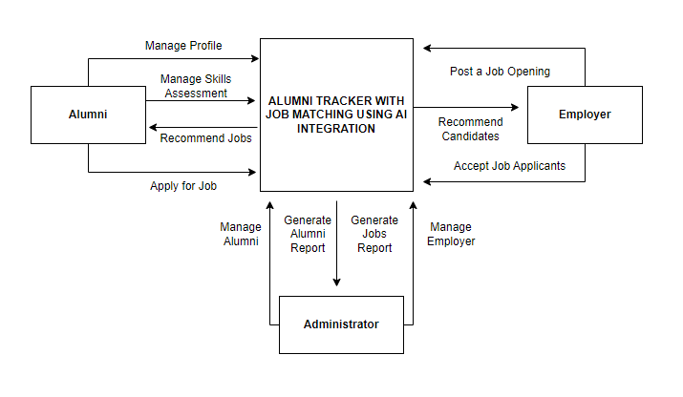

**Figure 3. Context Flow Diagram**

Figure 3 shows how the researcher maps out on how the entire features and components of the system will work together according to its purpose.

**Data Flow Diagram**

Figure 4 shows how information will enter and leave the system, what changes the information and where information is stored. The purpose of a DFD is to show the scope and boundaries of a system as a whole. It may be used as a communications tool between a systems analyst and any person who plays a part in the system that acts as the starting point for redesigning a system.

**Entity-Relationship Diagram**

An entity relationship diagram gives a snapshot of how these entities relate to each other. You could call it the blueprint that underpins your system architecture, offering a visual representation of the relationships between different sets of data (entities).

**Application Architecture**

Figure 6 shows how the web app will work when used by the registered users.

**Use-Case Diagram**

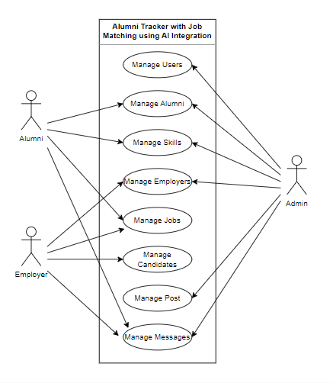

**Figure 9. Use Case Diagram**

A Use Case diagram is a representation of a user's interaction with the system that shows the relationship between the user and the different use cases in which the user is involved as shown in figure 9.

**Software Requirements**

Admin side:

Operating System (Windows 7,8 or 10)

PHP

Web Hosting/Server

MySQL

Python

Client side:

Operating System (Windows 7, 8, or 10)

Web browser

**Hardware and Other Required Devices**

Processor: Intel Core i3 or higher

RAM: 2GB or higher

Hard Disk Drive: 500GB or higher

Printer

Internet Plan at least 5 Mbps

**Cost-Benefit Analysis**

**Chapter IV. PRESENTATION, ANALYSIS, AND INTERPRETATION OF DATA**

**Chapter V. SUMMARY, CONCLUSION, AND RECOMMENDATION**

Summary of Findings

Conclusion

Recommendation

Appendices

References

Curriculum Vitae