Title – Alumni Tracker with Job Matching using AI Integration

**Author -Eduard Rino Q. Carton**

**Abstract - In this study, an Alumni Tracker with Job Matching system was developed, incorporating Artificial Intelligence (AI) integration. The system analyzes data on alumni's education, work experience, skills, and preferences to offer personalized job recommendations. An iterative approach and Agile methodology were employed for system design, development, testing, deployment, and maintenance. AI algorithms, such as Hybrid Filtering, Collaborative Filtering, User Based Content Filtering, and NLP, were utilized to create an effective job matching system. The system's evaluation based on the ISO 25010 Software Quality Model criteria revealed that it fulfilled the requirements for reliability, usability, maintainability, security, compatibility, and functional suitability. Setting itself apart from other alumni tracker systems, the Alumni Tracker with Job Matching using AI Integration system provides personalized job recommendations and real-time information on job openings. The study concludes that integrating AI into the Alumni Tracker system is highly effective and beneficial for managing alumni data, offering personalized job recommendations through AI job matching and NLP algorithms, and generating comprehensive reports for alumni, employers, employment rates, and job postings**

**Keywords: Alumni Tracker, Artificial Intelligence (AI), Job Matching, NLP Algorithm**

**Introduction**

Artificial intelligence (AI) has had a profound impact on various domains, including the job market (Makridakis, 2017). According to Jaiswal et al. (2021, an Alumni Tracker system provides a centralized platform for managing alumni data and facilitates communication between alumni and the institution. By integrating AI algorithms, the Alumni Tracker with Job Matching system provides personalized job recommendations based on alumni's skills and qualifications. This system keeps alumni informed about current job market trends, offers real-time information on job openings, and effectively matches alumni with suitable job opportunities, benefiting both alumni and employers.

* Embed the statement of the problem in your introduction

Design Plan & Software Development

The researcher used the iterative approach, which is a methodology that involves breaking a project into smaller parts and completing those parts in an iterative process, constantly reviewing and refining the work as needed. This approach allows for greater flexibility and adaptability and can help catch errors early on, ultimately leading to a higher-quality final product.

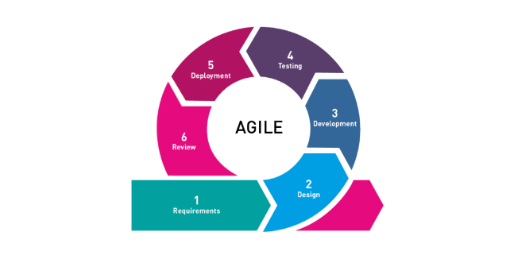

Figure 2. Agile Software Development

The Agile methodology focuses on providing value to end-users and prioritizes collaboration, flexibility, and continuous improvement. The model has five phases: Requirements, Design, Development, Testing, Deployment, and Review. The project utilizes AI algorithms to develop an effective job-matching system, including Hybrid Filtering, Collaborative Filtering, User-Based Content Filtering, and NLP algorithms.

Software Life Cycle Model

Requirements Gathering. In this phase, the researcher needs to identify the specific requirements for the software development project. One crucial requirement is the need for a large amount of data related to job postings, job requirements, job preferences, and alumni data. This data will be used to train and improve the AI algorithms used in the system, particularly Hybrid Filtering, Collaborative Filtering, User-Based Content Filtering, and NLP algorithms.

Design. In this phase, the overall design of the software is created, including the architecture, user interface, and database schema. The design should be capable of incorporating the AI algorithms identified in the previous phase, with appropriate data sources and integration of the algorithms to ensure good job matching.

Development. In the development phase, the project team will work with the datasets to develop and test the AI algorithms. The data will be used to train the algorithms to identify patterns and relationships between job postings and alumni data. The team will use techniques such as supervised and unsupervised learning to ensure that the algorithms can accurately match alumni with relevant job opportunities.

Testing. In this phase, the software is tested to ensure that it meets the requirements and is error-free. The AI Expert should test AI algorithms to ensure they function effectively and provide accurate job-matching results.

Deployment. The software is deployed to the production environment in this phase. The AI algorithms should be integrated and fully operational within the system, ready to provide job-matching services to alumni.

Maintenance. The software is maintained and updated as needed in this phase. The researcher should continuously monitor the AI algorithms to ensure they provide accurate job-matching results and update them as necessary to improve their performance.

Results

**Table 12.0**

**In terms of the characteristics set in ISO 25010 Software Quality Model**

|  |  |  |
| --- | --- | --- |
| Criteria | Mean | Verbal Interpretation |
| Functional Suitability | 5 | Very Good |
| Performance Efficiency | 5 | Very Good |
| Compatibility | 4.66 | Very Good |
| Usability | 4.33 | Good |
| Reliability | 5 | Very Good |
| Security | 4.66 | Very Good |
| Maintainability | 5 | Very Good |
| Portability | 4.66 | Very Good |
| Total | 4.79 | Very Good |

Conflicts of interest. The authors declare that for this article they have no actual, potential or perceived conflict of interests.

References

Makridakis, S. (2017). The forthcoming Artificial Intelligence (AI) revolution: Its impact on society and firms. Futures, 90, 46-60

Jaiswal, S., Gaud, S., Ansari, S., & Gaikwad, R. (2021). Alumni Tracking System. International Research Journal of Engineering and Technology (IRJET, 8(4), 1185-1188. doi: 10.31764/IRJET.8.4.1185