**I. INTRODUCTION**

Artificial Intelligence (AI) has brought about significant changes to various aspects of our lives, including the job market (Makridakis, 2017). An alumni tracker system is a software application that allows educational institutions to monitor the career development of alumni, provide career resources, and gather data to enhance the efficacy of programs and services while maintaining alumni engagement. The integration of AI algorithms in the development of the Alumni Tracker with Job Matching system has enabled job seekers to find personalized job recommendations based on their skills and qualifications.

The Alumni Tracker with Job Matching using AI Integration system will collect and analyze data on alumni's education, work experience, skills, and preferences to provide personalized job recommendations. This system will help alumni stay informed about the latest trends in the job market by providing up-to-date information on job openings and the skills and qualifications required to succeed in those roles. Using AI algorithms, the system will match alumni with job openings that are a good fit, enabling employers to find qualified candidates for their job openings.

The development of the Alumni Tracker with Job Matching system using Hybrid filtering a combination of content based filtering and collaborative filtering algorithm, highlights the commitment of NONESCOST to support its alumni in achieving success in their chosen careers. This system's innovative approach sets it apart from other alumni tracker systems that may rely on manual processes or limited data analysis. The personalized job recommendations and up-to-date information on job openings provided by the system are crucial features that will help alumni navigate the competitive job market and find opportunities that match their profile.

**METHODOLOGY**

**System Design**

The researcher used the iterative approach which is a methodology that involves breaking a project into smaller parts and completing those parts in an iterative process, constantly reviewing and refining the work as needed. This approach allows for greater flexibility and adaptability, and can help catch errors early on, ultimately leading to a higher-quality final product.

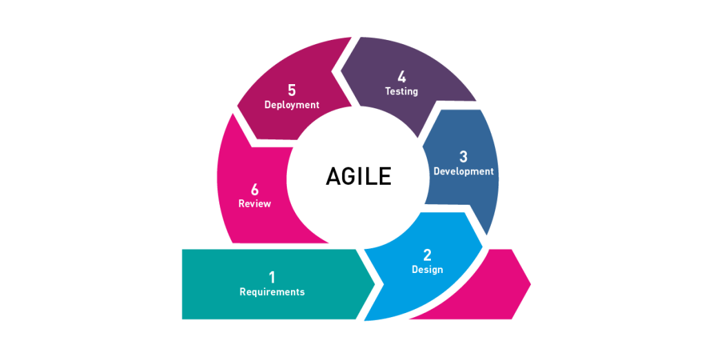**Figure 2. Agile Software Development**

The **Agile** methodology focuses on providing value to end-users and prioritizes collaboration, flexibility, and continuous improvement. The model has five phases which are: Requirements, Design, Development, Testing, Deployment and Review. The project utilizes AI algorithms, including Hybrid Filtering, Collaborative Filtering, User Based Content Filtering, and NLP algorithm, to develop an effective job matching system.

**Requirements Gathering**: In this phase, the researcher needs to identify the specific requirements for the software development project. One crucial requirement is the need for a large amount of data related to job postings, job requirements, job preferences, and alumni data. This data will be used to train and improve the AI algorithms used in the system, particularly the Hybrid Filtering, Collaborative Filtering, User-Based Content Filtering, and NLP algorithms.

**Design**: In this phase, the overall design of the software is created, including the architecture, user interface, and database schema. The design should be capable of incorporating the AI algorithms identified in the previous phase, with appropriate data sources and integration of the algorithms to ensure effective job matching.

**Development**: In the development phase, the project team will work with the datasets to develop and test the AI algorithms. The data will be used to train the algorithms to identify patterns and relationships between job postings and alumni data. The team will use different techniques, such as supervised and unsupervised learning, to ensure that the algorithms can accurately match alumni with relevant job opportunities.

**Testing**: In this phase, the software is tested to ensure that it meets the requirements and is free of errors. AI algorithms should be tested to ensure they are functioning effectively and providing accurate job matching results.

**Deployment**: In this phase, the software is deployed to the production environment. The AI algorithms should be integrated and fully operational within the system, ready to provide job matching services to alumni.

**Maintenance**: In this phase, the software is maintained and updated as needed. The AI algorithms should be continuously monitored to ensure they are providing accurate job matching results, and updated as necessary to improve their performance.

**III. RESULTS AND DISCUSSION**

Table 11.0

In terms of the characteristics set in ISO 25010 Software Quality Model

|  |  |  |
| --- | --- | --- |
| Criteria | Mean | Verbal Interpretation |
| Functional Suitability | 4.69 | Very Good |
| Performance Efficiency | 4.44 | Good |
| Compatibility | 4.81 | Very Good |
| Usability | 4.69 | Very Good |
| Reliability | 4.81 | Very Good |
| Security | 4.81 | Very Good |
| Maintainability | 4.81 | Very Good |
| Portability | 4.44 | Good |
| Total | 4.69 | Very Good |

Table 13.0 shows the result of the IT Experts' feedback in determining the quality of the NONESCOST Alumni Tracker with Job Matching using AI Integration based on the characteristics set in the ISO 25010 Software Quality Model.

In terms of Functional Suitability and Usability, it was rated with a mean value of 4.69, which is interpreted as Very Good. With regards to Security, Compatibility, Reliability and Maintainability, it was rated with a mean value of 4.81, which is interpreted as Good. Concerning Performance Efficiency and Portability, it was rated with a mean value of 4.44, which is interpreted as Good.

**Conclusion**

In the light of the findings of the study, the researcher concludes that, based on the thorough evaluation of the experts and respondents, it can be concluded that the integration of AI in the Alumni Tracker system for NONESCOST is highly effective and beneficial. The system's ability to manage alumni data, provide personalized job recommendations through AI job matching and NLP algorithms, and generate detailed reports for alumni, employers, employment rate, and job postings has been rated as very good. Additionally, the system meets the ISO 25010 software quality model's criteria for reliability, usability, maintainability, portability, and compatibility. These results suggest that the Alumni Tracker with Job Matching using AI Integration has the potential to strengthen the connection between NONESCOST and their alumni, provide a streamlined process for employers to find qualified candidates, and increase the likelihood of successful job placements for alumni.