Machine Learning-Based Mobile Money Fraud Detection: An Experimental Study Using the PaySim Dataset
Artificial Intelligence / Machine Learning Project


Group Members:
Name: BAFFOUR ABRAHAM AWUAH | Index Number: UEB3512623 |
GitHub: https://github.com/awuah-baffour
Name: ABDUL WAKIL MAGIWABA DI-ELUMA | Index Number: UEB3502723|
GitHub: https://github.com/mawdieluma-design
Name: SARBAH DANIEL| Index Number: UEB3512723 |
GitHub: https://github.com/Sarbah08
Date: 10th August, 2026.
Abstract
Mobile-money services process large volumes of transactions, making manual identification of suspicious activity difficult. This project developed and evaluated machine-learning models for detecting fraudulent mobile-money transactions using a reduced 100,000-record experimental subset of the synthetic PaySim dataset. The dataset contained 95,000 legitimate transactions and 5,000 fraudulent transactions, giving a 5% experimental fraud representation. The methodology involved data cleaning, exploratory data analysis, leakage-aware feature engineering, preprocessing with a scikit-learn pipeline, baseline model training, cross-validation, hyperparameter tuning, and threshold analysis. Three supervised classification models were evaluated: Logistic Regression, Random Forest, and XGBoost. The final selected model was XGBoost with an operating threshold of 0.55. On the untouched test set, the final model achieved accuracy of 0.99945, precision of 0.99499, recall of 0.99400, F1-score of 0.99450, ROC-AUC of 0.99904, and PR-AUC of 0.99630. Although these results demonstrate strong fraud classification performance within the reduced PaySim experimental environment, external validation using real transaction data would be required before practical deployment claims could be made.

Table of Contents
1. Introduction
2. Literature Review

2.1 Mobile Money Fraud in Ghana
Tagbo et al. (2026) provide important Ghana-specific evidence on the nature of mobile-money fraud. Their study used a mixed-method, longitudinal survey conducted in three phases between June/July 2023, January/February 2024, and June/July 2024. The respondents included mobile-money customers, agents, and employees of service providers. The authors used questionnaires, interviews, descriptive statistics, reliability testing, and Chi-square hypothesis testing to investigate the causes, targets, and communication channels associated with mobile-money fraud in Ghana.
The study reported fraud prevalence of 41.0%, 46.8%, and 51.5% across its three survey phases. Its hypothesis tests supported the conclusion that social engineering was the main cause of mobile-money fraud in the sampled population, that customers were the prime target among the groups considered, and that telephone calls were the most used communication channel. The authors also reported that more than 60% of victims were contacted through telephone calls. These findings highlight the human and social dimensions of mobile-money fraud and demonstrate the continuing need for effective prevention and detection mechanisms.
The study is relevant to this project because Tagbo et al. (2026) recommend the development of advanced machine-learning fraud prediction and prevention systems capable of studying hidden patterns in fraudulent transactions. This project investigates this recommendation from a transaction-level machine-learning perspective. However, the two studies address different questions and use different data: the Ghanaian study analyzes survey responses about fraud experiences and mechanisms, while this project uses synthetic transaction records from PaySim. Consequently, the present results should be interpreted as an experimental demonstration rather than as evidence about the actual prevalence or mechanisms of fraud in Ghana.

2.2 Research Gap and Positioning of the Present Study
The Ghanaian survey provides evidence about who is affected by mobile-money fraud, how fraudsters contact victims, and the prevalence of reported fraud. It does not, however, develop and evaluate a transaction-level supervised-learning classifier. This project addresses that complementary technical problem by constructing transaction-time features, comparing Logistic Regression, Random Forest, and XGBoost, and evaluating their ability to distinguish fraudulent from legitimate transactions. The use of PaySim also introduces an important limitation: the project evaluates the feasibility of the machine-learning workflow in a controlled synthetic environment rather than validating a model on real Ghanaian mobile-money records.
3. Dataset and Methodology
4. Exploratory Data Analysis
5. Feature Engineering and Preprocessing
6. Model Development
7. Results
8. Discussion
9. Limitations
10. Conclusion and Recommendations
Tagbo, S. K., Adekoya, A. F., Mensah, P. K., Nimbe, P., Akoto-Adjepong, V., & Ayidzoe, M. A. (2026). Survey on mobile money fraud prevalence in Ghana. International Journal of Accounting, Auditing and Performance Evaluation, 22(2), 249–267.
References
Appendices

1. Introduction
Mobile money has become an important channel for digital payments, transfers, and financial inclusion. As transaction volumes increase, fraud detection becomes more challenging because suspicious activity may be hidden among large numbers of legitimate transactions. The Ghanaian context is particularly relevant to this project. Tagbo et al. (2026) investigated mobile-money fraud prevalence in Ghana and found evidence that social engineering is a major cause of reported mobile-money fraud, that customers are the most vulnerable group among the groups examined, and that telephone calls are the most frequently reported communication channel used by fraudsters. These findings establish a practical context for investigating complementary technological approaches to fraud detection.
This project investigates whether machine-learning algorithms can classify fraudulent transactions using transaction-level and behavioral features. It is positioned as a technical complement to the Ghanaian survey research of Tagbo et al. (2026): their study examined fraud prevalence, vulnerable groups, and communication channels through a mixed-method survey, whereas this project investigates automated transaction-level classification using machine-learning algorithms on the PaySim dataset. The project therefore does not claim to detect the social-engineering mechanisms measured by the survey; rather, it evaluates whether transaction-level patterns can support automated fraud classification.
The main research question is: How effectively can machine-learning algorithms detect fraudulent mobile-money transactions based on transactional and behavioral features?

2. Literature Review
Artificial intelligence refers to computational systems designed to perform tasks that normally require human intelligence. Machine learning is a branch of artificial intelligence in which models learn patterns from data rather than being explicitly programmed with fixed rules.
This project uses supervised learning because the dataset contains labeled examples of legitimate and fraudulent transactions. Fraud detection is a classification problem because each transaction must be assigned to one of two classes.
Mobile-money fraud can include social engineering, account takeover, false payment claims, and suspicious transfer or cash-out behavior. Survey-based research helps explain victim experiences and fraud mechanisms, while machine-learning research can explore automated detection from transaction records.
The PaySim dataset is widely used in fraud-detection experiments because real financial transaction data is sensitive and difficult to access. However, because PaySim is synthetic, results must be interpreted as experimental rather than direct evidence of real-world deployment performance.

3. Dataset and Methodology
The project used a reduced 100,000-record experimental subset constructed from the original Kaggle PaySim dataset. The subset contains 95,000 legitimate transactions and 5,000 fraudulent transactions. This 5% fraud representation was intentionally constructed for machine-learning experimentation and should not be interpreted as the natural prevalence of mobile-money fraud. The dataset was selected for experimental machine-learning purposes and is not the survey dataset used by Tagbo et al. (2026). In particular, the PaySim records do not contain variables representing social-engineering communication channels, victim categories, or telephone contact, so the present model cannot directly test the hypotheses investigated in that Ghanaian study.
The original columns were step, type, amount, nameOrig, oldbalanceOrg, newbalanceOrig, nameDest, oldbalanceDest, newbalanceDest, isFraud, and isFlaggedFraud. The target variable was isFraud, where 0 indicates a legitimate transaction and 1 indicates fraud.
The dataset was split into 80,000 training records and 20,000 test records using stratification and random_state=42. The test set was kept untouched during cross-validation and tuning.

4. Exploratory Data Analysis
The dataset contained no missing values, no duplicate rows, no negative transaction amounts, and no negative balances. Fraud was observed only in TRANSFER and CASH_OUT transaction types within this reduced PaySim sample.
Fraud by Transaction Type
type | legitimate_count | fraud_count | total_count | fraud_rate_percent
CASH_IN | 20745 | 0 | 20745 | 0.0000
CASH_OUT | 33310 | 2548 | 35858 | 7.1058
DEBIT | 622 | 0 | 622 | 0.0000
PAYMENT | 32379 | 0 | 32379 | 0.0000
TRANSFER | 7944 | 2452 | 10396 | 23.5860
Amount Summary by Class
transaction_class | count | mean | median | Std | min | max
Legitimate | 95000 | 180352.0319 | 74356.2450 | 642935.3713 | 0.5800 | 69886731.3000
Fraudulent | 5000 | 1515679.1804 | 450944.4650 | 2449810.4994 | 0.0000 | 10000000.0000
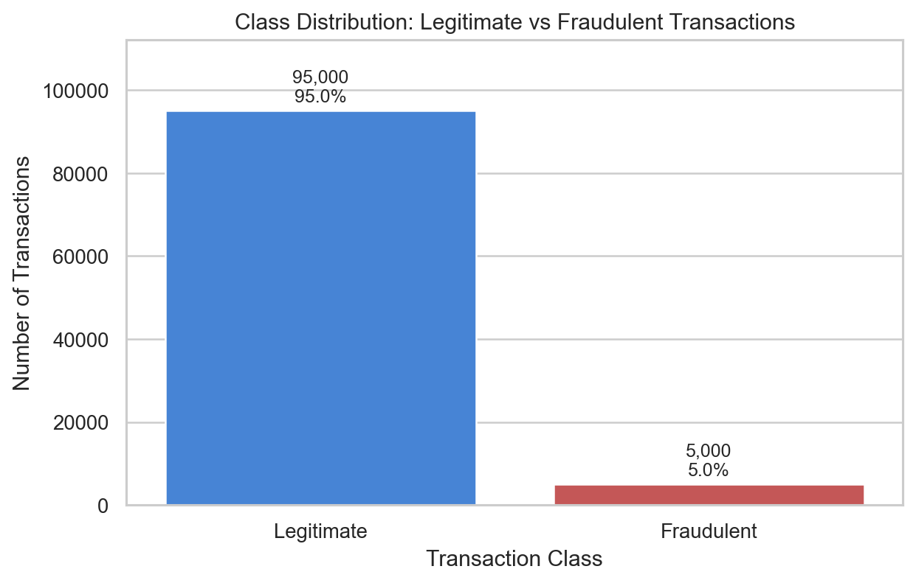
Figure 1: Class Distribution
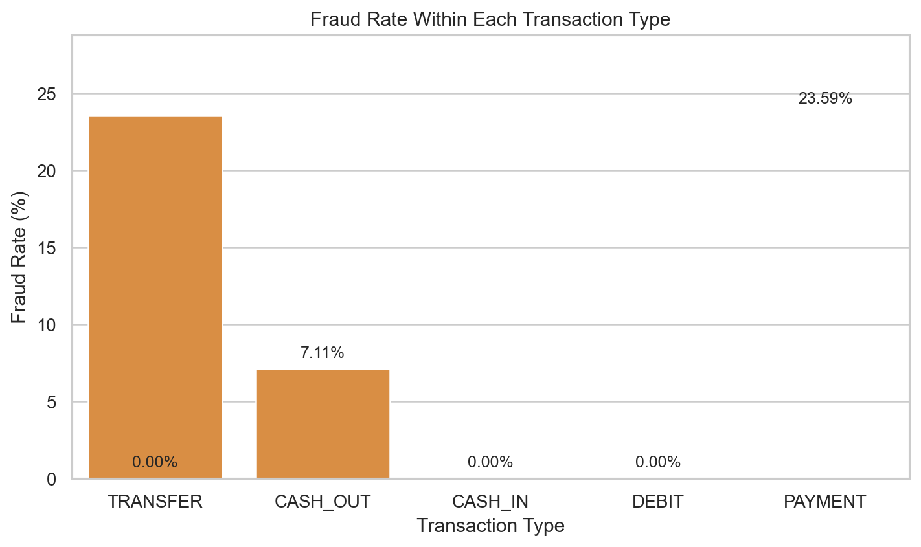
Figure 2: Fraud Rate By Transaction Type
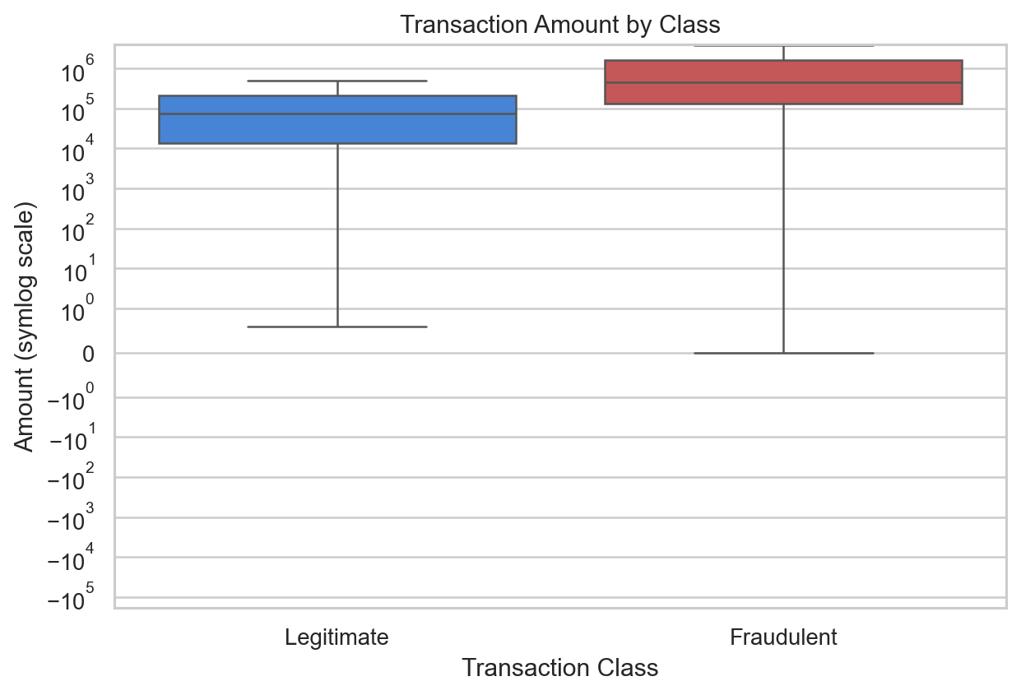
Figure 3: Amount Boxplot
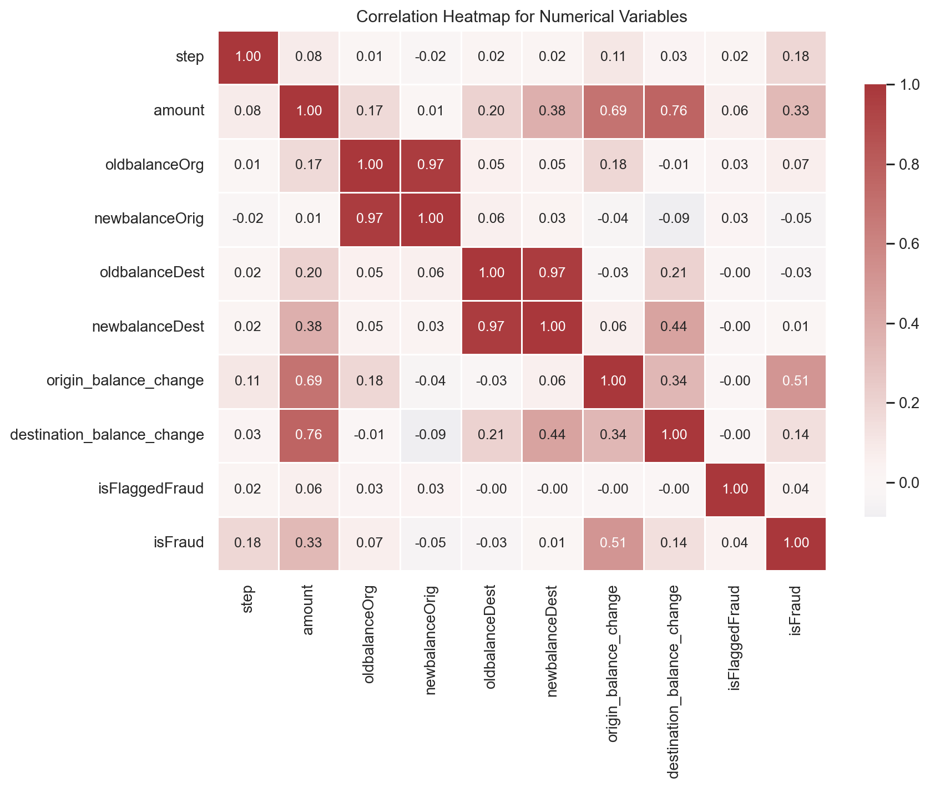
Figure 4: Correlation Heatmap

5. Feature Engineering and Preprocessing
The primary model used transaction-time features only. Raw identifiers, isFlaggedFraud, and post-transaction balance features were excluded from the primary feature set to reduce leakage risk.
Excluded Features
column | Reason
nameOrig | High-cardinality sender identifier; raw encoding would create arbitrary numeric relationships and poor generalization.
nameDest | High-cardinality recipient identifier; raw encoding would create arbitrary numeric relationships and poor generalization.
isFlaggedFraud | Existing PaySim rule-based fraud flag; Stage 2 precision was 1.0000 but recall was only 0.0020, so it is treated separately.
newbalanceOrig | Post-transaction sender balance; may not be available during real-time transaction evaluation.
newbalanceDest | Post-transaction recipient balance; may not be available during real-time transaction evaluation.
origin_balance_change | Requires newbalanceOrig, so it is a post-transaction feature excluded from the primary model.
destination_balance_change | Requires newbalanceDest, so it is a post-transaction feature excluded from the primary model.
Engineered features included log_amount, amount_to_origin_balance_ratio, amount_to_destination_balance_ratio, origin_balance_zero, destination_balance_zero, origin_balance_sufficient, and step_day. Numerical features were median-imputed and scaled. The type feature was one-hot encoded.
Feature Engineering Table
feature | type | available_at_transaction_time | primary_model | reason
step | Numerical raw | Yes | Yes | Captures broad temporal patterns observed in Stage 2.
step_day | Engineered numerical | Yes | Yes | Provides a simple, interpretable day-level simulation period.
type | Categorical raw | Yes | Yes | Stage 2 showed fraud count and fraud rate differ strongly by type.
amount | Numerical raw | Yes | Yes | Fraudulent transactions tended to have higher amounts in Stage 2.
log_amount | Engineered numerical | Yes | Yes | Reduces the effect of extreme right-skewed transaction amounts.
oldbalanceOrg | Numerical raw | Yes | Yes | Represents sender financial state before authorization.
oldbalanceDest | Numerical raw | Yes, where recorded | Yes | Represents destination account state before authorization.
amount_to_origin_balance_ratio | Engineered numerical | Yes | Yes | Shows transaction size relative to sender balance while avoiding division by zero.
amount_to_destination_balance_ratio | Engineered numerical | Yes, where recorded | Yes | Shows transaction size relative to destination balance while avoiding division by zero.
origin_balance_zero | Engineered binary | Yes | Yes | Captures whether the sender has no recorded starting balance.
destination_balance_zero | Engineered binary | Yes, where recorded | Yes | Captures destinations with no recorded starting balance.
origin_balance_sufficient | Engineered binary | Yes | Yes | Indicates whether the sender balance appears sufficient for the transaction amount.
newbalanceOrig | Numerical raw | Potentially no | No | Reserved only for a labeled post-transaction comparison experiment.
newbalanceDest | Numerical raw | Potentially no | No | Reserved only for a labeled post-transaction comparison experiment.
origin_balance_change | Engineered post-transaction | No for real-time authorization | No | Useful for EDA and post-transaction comparison, not primary model.
destination_balance_change | Engineered post-transaction | No for real-time authorization | No | Useful for EDA and post-transaction comparison, not primary model.
nameOrig | Identifier | Identifier is known, but not directly meaningful as a numeric feature | No | Do not arbitrary-label-encode raw identifiers.
nameDest | Identifier | Identifier is known, but not directly meaningful as a numeric feature | No | Do not arbitrary-label-encode raw identifiers.

6. Model Development
Three models were trained: Logistic Regression, Random Forest, and XGBoost. Logistic Regression served as an interpretable baseline, Random Forest captured nonlinear ensemble behavior, and XGBoost provided gradient-boosted tree modeling. Evaluation emphasized precision, recall, F1-score, ROC-AUC, and PR-AUC rather than accuracy alone.
Baseline Results
Model | Accuracy | Precision | Recall | F1 | ROC-AUC | PR-AUC
Logistic Regression | 0.9583 | 0.5457 | 0.9920 | 0.7040 | 0.9937 | 0.9349
Random Forest | 0.9956 | 0.9247 | 0.9940 | 0.9581 | 0.9976 | 0.9935
XGBoost | 0.9996 | 0.9980 | 0.9940 | 0.9960 | 0.9988 | 0.9959
Cross-Validation Results
Model | CV ROC-AUC mean | CV ROC-AUC std | CV PR-AUC mean | CV PR-AUC std | CV F1 mean | CV Precision mean | CV Recall mean
Logistic Regression | 0.9962 | 0.0005 | 0.9507 | 0.0022 | 0.8706 | 0.9110 | 0.8338
Random Forest | 0.9995 | 0.0004 | 0.9969 | 0.0008 | 0.9704 | 0.9455 | 0.9968
XGBoost | 0.9998 | 0.0002 | 0.9990 | 0.0008 | 0.9950 | 0.9926 | 0.9975
Tuned Model Results
Model | Tuned? | Accuracy | Precision | Recall | F1 | ROC-AUC | PR-AUC
Logistic Regression | Yes | 0.9871 | 0.8972 | 0.8380 | 0.8666 | 0.9938 | 0.9422
Random Forest | Yes | 0.9967 | 0.9431 | 0.9940 | 0.9679 | 0.9975 | 0.9935
XGBoost | Yes | 0.9994 | 0.9950 | 0.9940 | 0.9945 | 0.9990 | 0.9963

7. Results
XGBoost was selected as the final model for this experiment because it provided the strongest overall balance of precision, recall, F1-score, ROC-AUC, and PR-AUC among the evaluated models.
Final Test Results
Model | Threshold | Accuracy | Precision | Recall | F1 | ROC-AUC | PR-AUC | TN | FP | FN | TP
XGBoost | 0.5500 | 0.9994 | 0.9950 | 0.9940 | 0.9945 | 0.9990 | 0.9963 | 18995 | 5 | 6 | 994
Final confusion matrix: TN = 18,995, FP = 5, FN = 6, TP = 994. This means 994 of 1,000 fraud cases were correctly detected, 6 fraud cases were missed, 5 legitimate transactions were incorrectly flagged, and 18,995 legitimate transactions were correctly classified.
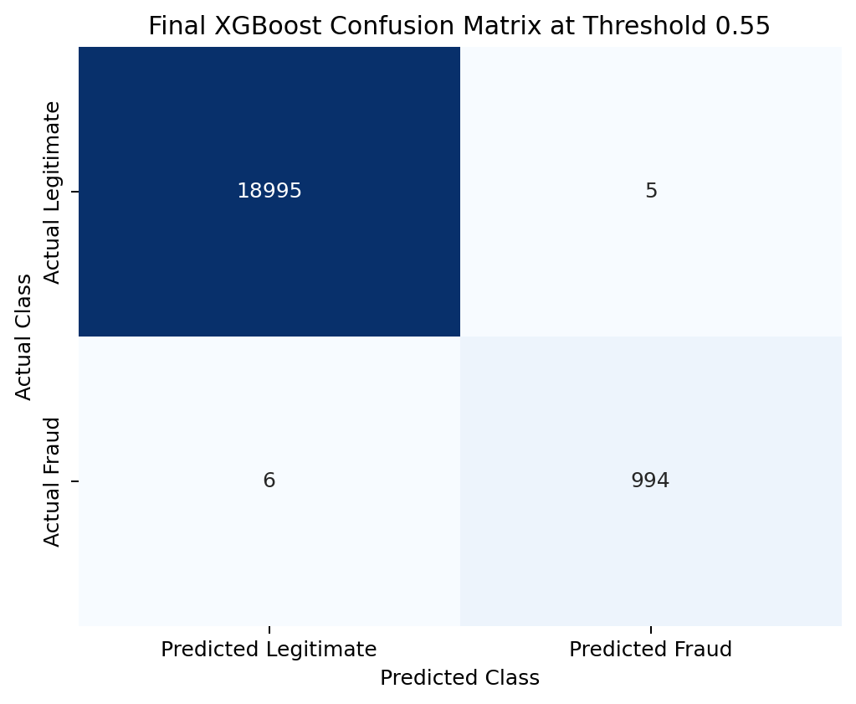
Figure: Final Confusion Matrix
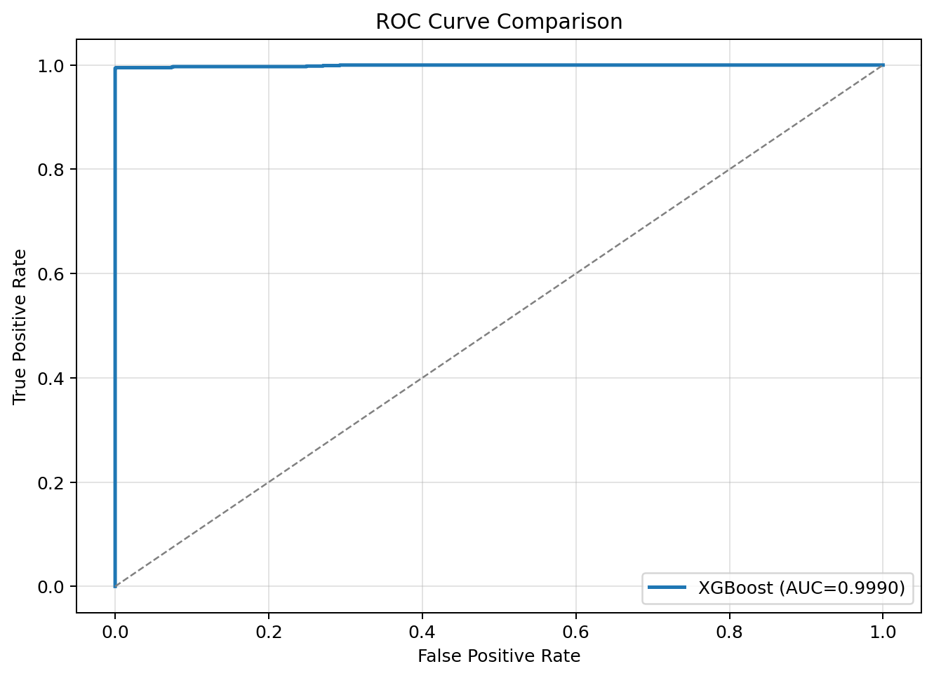
Figure: Final Roc Curve
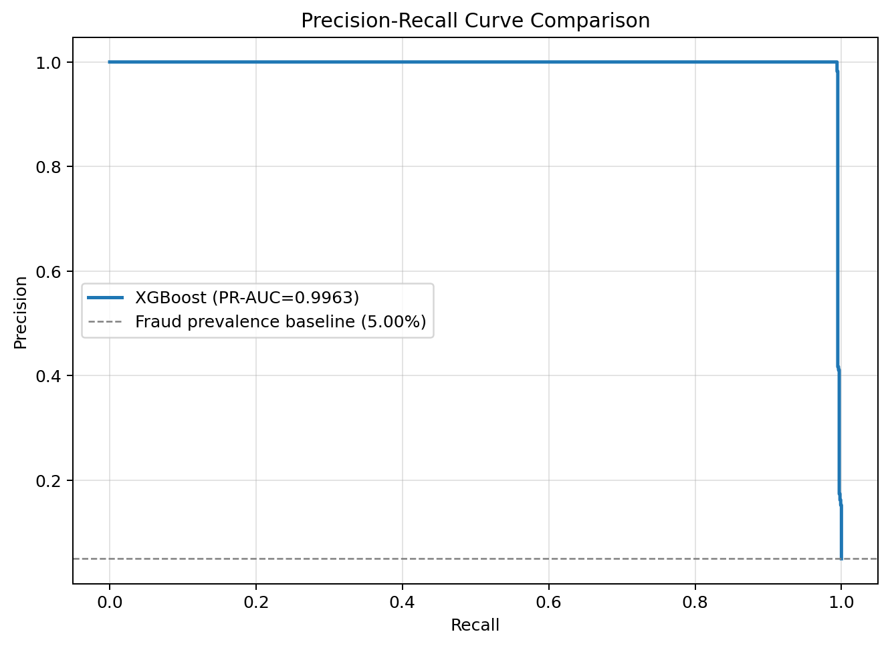
Figure: Final Precision Recall Curve
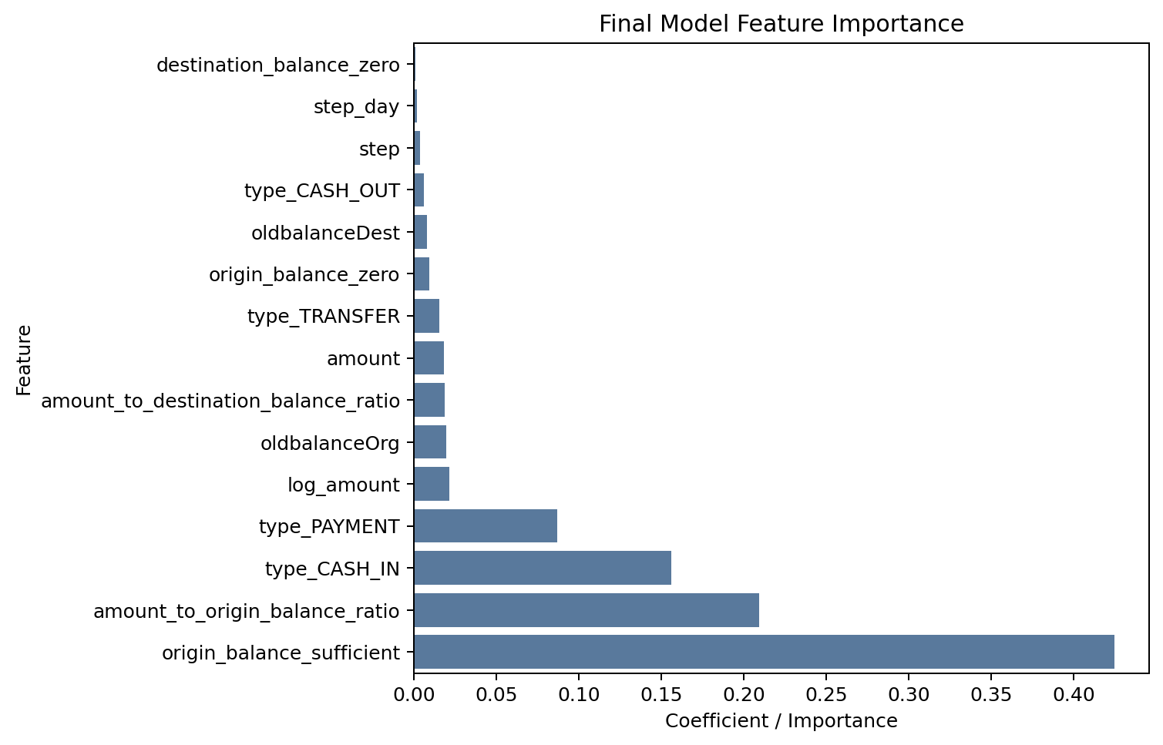
Figure: Final Feature Importance
Top Final Feature Importance
feature | Importance | absolute_importance
origin_balance_sufficient | 0.4245 | 0.4245
amount_to_origin_balance_ratio | 0.2091 | 0.2091
type_CASH_IN | 0.1559 | 0.1559
type_PAYMENT | 0.0870 | 0.0870
log_amount | 0.0214 | 0.0214
oldbalanceOrg | 0.0196 | 0.0196
amount_to_destination_balance_ratio | 0.0188 | 0.0188
amount | 0.0183 | 0.0183
type_TRANSFER | 0.0152 | 0.0152
origin_balance_zero | 0.0094 | 0.0094

8. Discussion
The tuned XGBoost model achieved very high performance on the reduced PaySim experimental dataset. However, the unusually high performance requires cautious interpretation. PaySim is synthetic, and the model may be learning simulation-specific relationships involving transaction type, balance sufficiency, amount ratios, and timing. This result should be viewed alongside the Ghanaian evidence reported by Tagbo et al. (2026). Their findings establish that mobile-money fraud in Ghana has important human and social-engineering dimensions, while the present experiment shows that transaction-level features can be highly predictive in a synthetic environment. The two findings are complementary rather than directly comparable: high classification performance on PaySim does not establish that the same features would identify social-engineering-driven fraud in Ghanaian transactions.
A simple diagnostic rule that predicted fraud for TRANSFER or CASH_OUT transactions achieved recall of 1.0000 but precision of only 0.1082. This indicates that transaction type explains substantial dataset structure but is not sufficiently precise as a standalone fraud detector.
The final threshold of 0.55 was selected using an illustrative cost framework where false negatives cost 10 units and false positives cost 1 unit. These values are hypothetical teaching assumptions and are not actual financial costs.

9. Limitations
- The dataset is synthetic.
- The dataset is a reduced 100,000-record subset.
- The 5% fraud representation is artificial and experimental.
- The project does not use real Ghanaian mobile-money transaction data.
- PaySim may contain simulation-specific patterns.
- There is no external validation on real financial institution data.
- The threshold cost assumptions are hypothetical.

10. Conclusion and Recommendations
The experiment demonstrates that machine-learning models can classify fraudulent transactions with very high performance within the reduced PaySim environment. XGBoost was the strongest final candidate, and transaction/balance-related features were highly informative. In relation to the Ghanaian context, the findings of Tagbo et al. (2026) provide evidence of the prevalence and social-engineering dimensions of mobile-money fraud and explicitly motivate further development of machine-learning fraud prediction and prevention systems. This project provides an experimental transaction-level implementation of that broader direction, while recognizing that PaySim results cannot substitute for validation using real Ghanaian mobile-money data.
Future work should evaluate the approach on real-world Ghanaian transaction data, investigate fairness and false-positive impacts, explore operational threshold setting with domain experts, and validate whether PaySim-derived patterns generalize beyond the synthetic dataset. A particularly useful extension would combine transaction-level signals with information about social-engineering events, communication channels, and user vulnerability so that the technical detection approach can be studied alongside the human factors identified by Tagbo et al. (2026).

References
Tagbo, S. K., Mensah, P. K., Nimbe, P., Akoto-Adjepong, V., Ayidzoe, M. A., & Adekoya, A. F. (2026). Survey on mobile money fraud prevalence in Ghana. International Journal of Accounting, Auditing and Performance Evaluation, 22(2), 249–267.
Lopez-Rojas, E. A., Elmir, A., & Axelsson, S. (2016). PaySim: A financial mobile money simulator for fraud detection. 28th European Modeling and Simulation Symposium (EMSS), Larnaca, Cyprus.
Kaggle. Synthetic Financial Datasets For Fraud Detection: PaySim dataset. https://www.kaggle.com/datasets/ealaxi/paysim1
Chen, T., & Guestrin, C. (2016). XGBoost: A scalable tree boosting system. Proceedings of the 22nd ACM SIGKDD International Conference on Knowledge Discovery and Data Mining.
Pedregosa, F., et al. (2011). Scikit-learn: Machine Learning in Python. Journal of Machine Learning Research, 12, 2825-2830.

Appendices
Appendix A: Project source code is stored in the src/ directory.
Appendix B: Additional tables and figures are stored in the results/ and figures/ directories.
Appendix C: Group member names, index numbers, and GitHub repository links are provided in the first page of this paper.

