電通二乙微處理器實驗 實驗結報

實驗名稱 | ４ｘ４鍵盤
組別 | 26 | 組員 | 韓皓文/張騏纓

- 實驗目的
1. Arduino 接喇叭如何接線?
2. 如何使用 tone library?
3. 如何演奏一段音樂?
4. 如何使用 4x4 鍵盤演奏音樂?
5. 如何發報摩斯電碼?
- 實驗步驟
(1)Arduino 演奏一段特定的音樂, 旋律不得是小蜜蜂(2)顯示在 PC 上 * 4x4 鍵盤之按鍵值顯示在七段顯示器上
(2)使用 4x4 鍵盤演奏音樂
(3) 如何發報摩斯電碼
- 程式碼

(1)
#define NOTE_ 0
#define NOTE_B0 31
#define NOTE_C1 33
#define NOTE_CS1 35
#define NOTE_D1 37
#define NOTE_DS1 39
#define NOTE_E1 41
#define NOTE_F1 44
#define NOTE_FS1 46
#define NOTE_G1 49
#define NOTE_GS1 52
#define NOTE_A1 55
#define NOTE_AS1 58
#define NOTE_B1 62
#define NOTE_C2 65
#define NOTE_CS2 69
#define NOTE_D2 73
#define NOTE_DS2 78
#define NOTE_E2 82
#define NOTE_F2 87
#define NOTE_FS2 93
#define NOTE_G2 98
#define NOTE_GS2 104
#define NOTE_A2 110
#define NOTE_AS2 117
#define NOTE_B2 123
#define NOTE_C3 131
#define NOTE_CS3 139
#define NOTE_D3 147
#define NOTE_DS3 156
#define NOTE_E3 165
#define NOTE_F3 175
#define NOTE_FS3 185
#define NOTE_G3 196
#define NOTE_GS3 208
#define NOTE_A3 220
#define NOTE_AS3 233
#define NOTE_B3 247
#define NOTE_C4 262
#define NOTE_CS4 277
#define NOTE_D4 294
#define NOTE_DS4 311
#define NOTE_E4 330
#define NOTE_F4 349
#define NOTE_FS4 370
#define NOTE_G4 392
#define NOTE_GS4 415
#define NOTE_A4 440
#define NOTE_AS4 466
#define NOTE_B4 494
#define NOTE_C5 523
#define NOTE_CS5 554
#define NOTE_D5 587
#define NOTE_DS5 622
#define NOTE_E5 659
#define NOTE_F5 698
#define NOTE_FS5 740
#define NOTE_G5 784
#define NOTE_GS5 831
#define NOTE_A5 880
#define NOTE_AS5 932
#define NOTE_B5 988
#define NOTE_C6 1047
#define NOTE_CS6 1109
#define NOTE_D6 1175
#define NOTE_DS6 1245
#define NOTE_E6 1319
#define NOTE_F6 1397
#define NOTE_FS6 1480
#define NOTE_G6 1568
#define NOTE_GS6 1661
#define NOTE_A6 1760
#define NOTE_AS6 1865
#define NOTE_B6 1976
#define NOTE_C7 2093
#define NOTE_CS7 2217
#define NOTE_D7 2349
#define NOTE_DS7 2489
#define NOTE_E7 2637
#define NOTE_F7 2794
#define NOTE_FS7 2960
#define NOTE_G7 3136
#define NOTE_GS7 3322
#define NOTE_A7 3520
#define NOTE_AS7 3729
#define NOTE_B7 3951
#define NOTE_C8 4186
#define NOTE_CS8 4435
#define NOTE_D8 4699
#define NOTE_DS8 4978
int melody[] = {
NOTE_E3, NOTE_G4, NOTE_C5, NOTE_E5, NOTE_B2, NOTE_G4, NOTE_B4, NOTE_D5,
NOTE_C3, NOTE_E4, NOTE_A4, NOTE_C5, NOTE_G2, NOTE_E4, NOTE_G4, NOTE_B4,
NOTE_A2, NOTE_C4, NOTE_F4, NOTE_A4, NOTE_E1, NOTE_C4, NOTE_E4, NOTE_G4,
NOTE_A2, NOTE_D4, NOTE_F4, NOTE_A4, NOTE_B2, NOTE_D4, NOTE_G4, NOTE_B4,
NOTE_E3, NOTE_E5, NOTE_F5, NOTE_G5, NOTE_E5, NOTE_F5, NOTE_G5, NOTE_G4, NOTE_A4, NOTE_B4, NOTE_C5, NOTE_D5, NOTE_E5, NOTE_F5,
NOTE_E5, NOTE_C5, NOTE_D5, NOTE_E5, NOTE_E4, NOTE_F4, NOTE_G4, NOTE_A4, NOTE_G4, NOTE_F4, NOTE_G4, NOTE_F4, NOTE_F4, NOTE_G4,
NOTE_F4, NOTE_A4, NOTE_G4, NOTE_F4, NOTE_E4, NOTE_D4, NOTE_E4, NOTE_D4, NOTE_C4, NOTE_D4, NOTE_E4, NOTE_F4, NOTE_G4, NOTE_A4,
NOTE_F4, NOTE_A4, NOTE_G4, NOTE_A4, NOTE_B4, NOTE_C5, NOTE_G4, NOTE_A4, NOTE_B4, NOTE_C5, NOTE_D5, NOTE_E5, NOTE_F5, NOTE_G5,
NOTE_E5, NOTE_C5, NOTE_D5, NOTE_E5, NOTE_D5, NOTE_C5, NOTE_D5, NOTE_B4, NOTE_C5, NOTE_D5, NOTE_E5, NOTE_D5, NOTE_C5, NOTE_B4,
NOTE_C5, NOTE_A4, NOTE_B4, NOTE_C5, NOTE_C4, NOTE_D4, NOTE_E4, NOTE_F4, NOTE_E4, NOTE_D4, NOTE_E4, NOTE_C5, NOTE_B4, NOTE_C5,
NOTE_A4, NOTE_C5, NOTE_B4, NOTE_A4, NOTE_G4, NOTE_F4, NOTE_G4, NOTE_F4, NOTE_E4, NOTE_F4, NOTE_G4, NOTE_A4, NOTE_B4, NOTE_C5,
NOTE_A4, NOTE_C5, NOTE_B4, NOTE_C5, NOTE_B4, NOTE_A4, NOTE_B4, NOTE_C5, NOTE_D5, NOTE_C5, NOTE_B4, NOTE_C5, NOTE_A4, NOTE_B4,
NOTE_C5,0
};
int noteDurations[] = {
8, 8, 8, 8, 8, 8, 8, 8,
8, 8, 8, 8, 8, 8, 8, 8,
8, 8, 8, 8, 8, 8, 8, 8,
8, 8, 8, 8, 8, 8, 8, 8,
8,16,16,8,16,16,16,16,16,16,16,16,16, 16,
8,16,16,8,16,16,16,16,16,16,16,16,16, 16,
8,16,16,8,16,16,16,16,16,16,16,16,16, 16,
8,16,16,8,16,16,16,16,16,16,16,16,16, 16,
8,16,16,8,16,16,16,16,16,16,16,16,16, 16,
8,16,16,8,16,16,16,16,16,16,16,16,16, 16,
8,16,16,8,16,16,16,16,16,16,16,16,16, 16,
8,16,16,8,16,16,16,16,16,16,16,16,16, 16,
1 };
void play(int *melody, int *noteDurations, int num){
for(int note = 0; note < num; note++){
int noteDuration = 3000 / noteDurations[note];
tone(8, melody[note], noteDuration);

delay(noteDuration * 1.30);
}
}
void setup(){
}

void loop(){
play(melody, noteDurations, sizeof(melody) / sizeof(int));

delay(2000);
} (2)

#define do1 261
#define re1 294
#define me1 329
#define fa1 349
#define so1 392
#define la1 440
#define si1 493

#define do2 523
#define re2 587
#define me2 659
#define fa2 698
#define so2 784
#define la2 880
#define si2 988

#define do3 1046
#define re3 1175
int tune[] = {do1,re1,me1,fa1,so1,la1,si1,do2,re2,me2,fa2,so2,la2,si2,do3,re3};
#include<Keypad.h>
const byte ROWS = 4; // 4 Rows
const byte COLS = 4; // 4 Columns // 定義 Keypad 的按鍵

char keys[ROWS][COLS] = {
{'F', 'B', '7', '3'},
{'E','A','6','2'},
{'D', '9', '5', '1'},
{'C', '8', '4', '0'} }; // 定義 Keypad 連到 Arduino 的接腳
byte rowPins[ROWS] = {13, 12, 11, 10}; // 連到 Keypad 的 4 個 Rows
byte colPins[COLS] = {9, 8, 7, 6}; // 連到 Keypad 的 4 個 Columns
// 建立 Keypad 物件
Keypad keypad = Keypad(makeKeymap(keys), rowPins,colPins,ROWS, COLS );
void setup(){
Serial.begin(9600);
}
void loop(){
char key = keypad.getKey(); // 讀取 Keypad
if(key != NO_KEY){
if(key>='A'&&key<='F')
{
Serial.println(key);
tone(5, tune[key-'A'+10]);
delay(100);
noTone(5);
}
else
{
Serial.println(key);
tone(5, tune[key-'0']);
delay(100);
noTone(5);
}
}
}
(3)
char *morse[]={
"01","1000","1010","100", //A~D
"0","0010","110","0000", //E~H
"00","0111","101","0100", //I~L
"11","10","111","0110", //M~P
"1101","010","000","1", //Q~T
"001","0001","11","1001", //U~X
"1011","1100" //Y~Z
};

const byte Buzzer=5;
char chr,index;
char *ptr;

void setup() {
pinMode(Buzzer,OUTPUT);
Serial.begin(9600);
}

void loop() {
if( Serial.available() ){
chr=Serial.read();
Serial.println(chr);
if( (chr-'A')>=0 && (chr-'Z')<=0 ){
index=chr-'A';
ptr=morse[index];
while(*ptr!='\0'){
if(*ptr=='0'){
tone(Buzzer,440,100);
delay(100);
}
else{
tone(Buzzer,440,300);
delay(300);
}
ptr++;
delay(100);
}
delay(300);
}
else
delay(700);
}
}
- 實驗結果及分析
使用 tone()函數,設定音調,和持續時間,就可以輕鬆的使喇叭發出聲音。
使用序ｓｅｒｉａｌ，得入就可以將４ｘ４鍵盤的質設定為ｄｏ，ｒｅ，ｍｅ….等等的音調。
加上電組可以使得音量變小。
- 心得討論
這次前半部在音階跟程式碼那邊遇到了困難～不過問題還是迎刃而解了～～～開心ＯＵＯｂ
修正電路圖

(1)
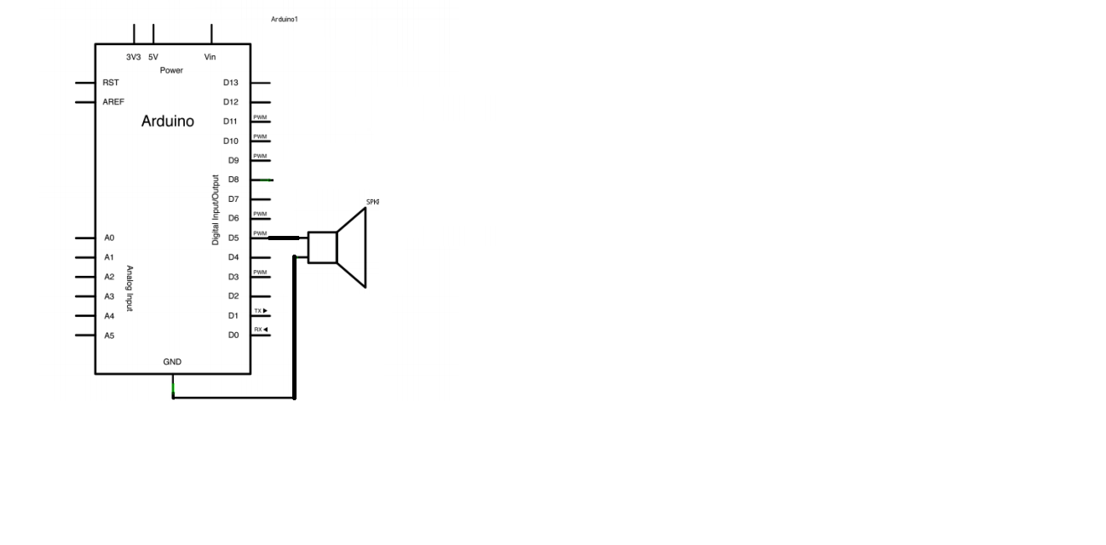
（２）
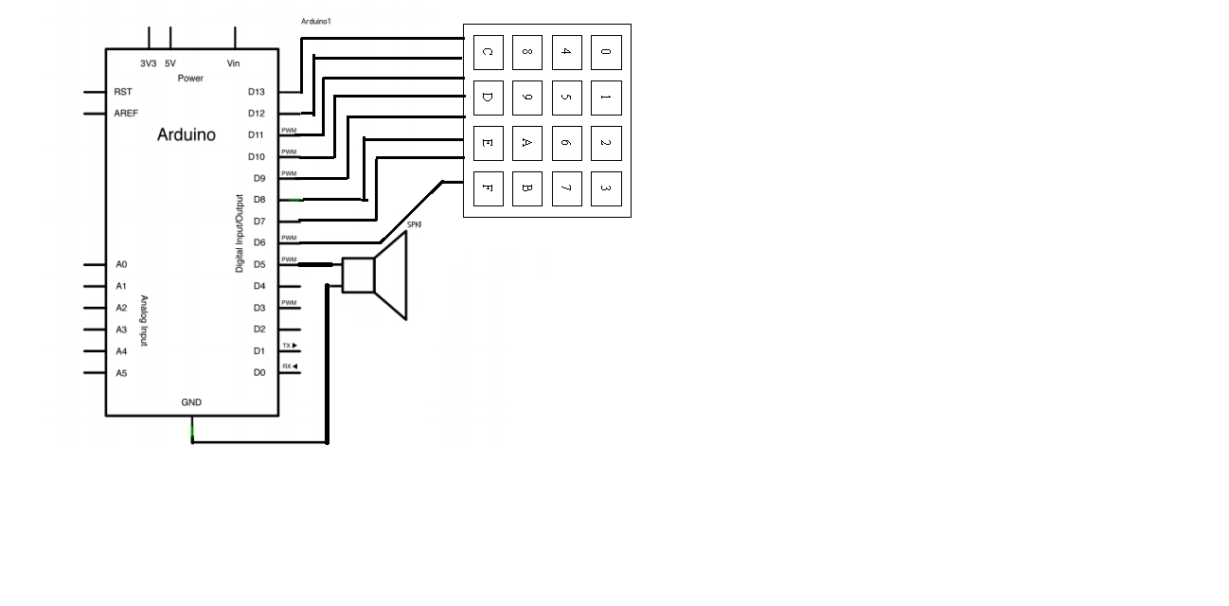
（３）

