**電通二甲微處理器實驗 實驗結報**

|  |  |  |  |
| --- | --- | --- | --- |
| **實驗名稱** | Lab07-–LCD 顯示器 | | |
| **組別** | **26** | **組員** | 04052643-張騏纓//04050423-韓皓文 |

1. **實驗目的**

使用 Arduino LCD 程式庫, 於16x2 LCD 顯示器上顯示特定文字?

1. Arduino 與 LCD 如何接線?

2. 如何使用 LCD library?

3. 如何清除螢幕?

4. 如何顯示文字?

1. **實驗步驟**

1.Arduino 顯示自己的學號及英文姓名

2.使用 PC 串列輸入, 所有 PC 輸入之文字皆顯示在 LCD 螢幕上

1. **程式碼**

LCD Library 範例

**#include<LiguidCrystal.h> // include the library code**

LiquidCrystal lcd(12, 11, 5, 4, 3, 2); // initialize interface pins

void setup() {

lcd.begin(16, 2); // set up the LCD's number of columns and rows

lcd.print("hello, world!"); // Print a message to the LCD

}

void loop() {

lcd.setCursor(0, 1); // set the cursor to column 0, line 1

lcd.print(millis()/1000); // print the number of seconds since reset

}

1. **實驗結果及分析**

LCD的5V接腳負責供電，LCD亮度可調整

如果訊息沒有顯示在螢幕上，或是模糊不清，可以轉動可變電阻以調整對比

程式中若設定line 1，是指第2行的意思，因為是從0數起

1. **心得討論**

此次實驗在程式上沒有遇到甚麼大問題，比較複雜的部份是在接線。在接5v、GND和可變電阻的腳位之間容易出錯。

1. **修正電路圖**

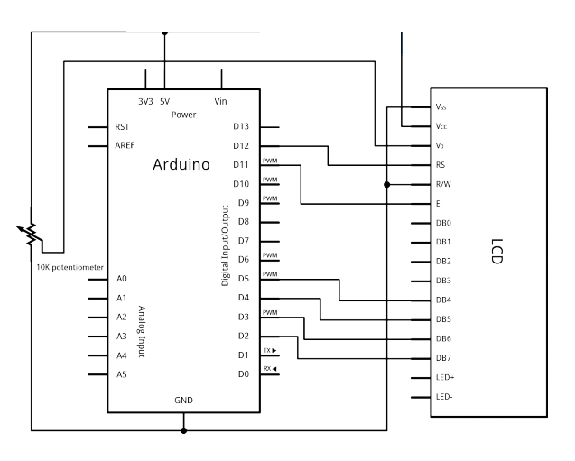

1. **修正程式碼**

[Arduino 顯示自己的學號及英文姓名](https://github.com/Ivy000000/Lab07/commit/f216c66d0d6648a25b9cf29ae25e50886b55fd96)

|  |
| --- |
| #include <LiquidCrystal.h> // include the library code |
|  |  |
|  | LiquidCrystal lcd(12, 11, 5, 4, 3, 2); // initialize interface pins |
|  | void setup() { |
|  |  |
|  | lcd.begin(20,2); |
|  |  |
|  | lcd.print("04050423Andy "); // Print a message to the LCD. |
|  |  |
|  | lcd.print("04052643Ramy "); |
|  | lcd.setCursor(1,0); |
|  |  |
|  | } |
|  | void loop() { |
|  | // set the cursor to column 0, line 1 |
|  | // (note: line 1 is the second row, since countingbegins with 0): |
|  | lcd.setCursor(0, 1); |
|  | //lcd.print(millis()/1000); // print the number of secondssince reset: |
|  | } |

[使用 PC 串列輸入, 所有 PC 輸入之文字皆顯示在 LCD 螢幕上](https://github.com/Ivy000000/Lab07/commit/ab170611d2d07a736d573dd782018ffd8744f2d2)

|  |
| --- |
| #include <LiquidCrystal.h> // include the library code |
|  |  |
|  | LiquidCrystal lcd(12, 11, 5, 4, 3, 2); // initialize interface pins |
|  | void setup() { |
|  | Serial.begin(9600); |
|  |  |
|  | lcd.begin(20,2); |
|  |  |
|  | lcd.setCursor(1,0); |
|  |  |
|  | } |
|  | void loop() { |
|  |  |
|  | char val; |
|  | if(Serial.available()) |
|  | { |
|  | lcd.clear(); |
|  | while(Serial.available()>0) |
|  | { |
|  | val= Serial.read(); |
|  | lcd.write(val); |
|  | } |
|  | } |
|  |  |
|  | // set the cursor to column 0, line 1 |
|  | // (note: line 1 is the second row, since countingbegins with 0): |
|  | //lcd.print(millis()/1000); // print the number of secondssince reset: |
|  | } |