PROGRAM CODE:
import os
import heapq
import math
# Node class for Huffman Tree
class Node:
def __init__(self, char, freq):
self.char = char # character stored in the node
self.freq = freq # frequency of the character
self.left = None # left child
self.right = None # right child

# comparison operator (needed for priority queue / heapq)
def __lt__(self, other):
return self.freq < other.freq

# Build Huffman Tree
def build_huffman_tree(symbols_freq):
# Create a min-heap of nodes (priority = frequency)
heap = [Node(char, freq) for char, freq in symbols_freq]
heapq.heapify(heap)

# Keep combining two lowest-frequency nodes until one root remains
while len(heap) > 1:
left = heapq.heappop(heap) # lowest frequency
right = heapq.heappop(heap) # second lowest frequency

# Merge nodes into a new parent node
merged = Node(None, left.freq + right.freq)
merged.left = left
merged.right = right
heapq.heappush(heap, merged) # push merged node back
return heap[0] # root of Huffman Tree

# Generate Huffman Codes
def generate_codes(node, code='', codes=None):
if codes is None:
codes = {}
if node:
# If this is a leaf node → store its code
if node.char is not None:
codes[node.char] = code

# Recurse left → add "0"
generate_codes(node.left, code + '0', codes)
# Recurse right → add "1"
generate_codes(node.right, code + '1', codes)

return codes

# Encode the input message
def encode_message(message, codes):
return ''.join(codes[char] for char in message)

# Decode the encoded bitstring
def decode_message(encoded, root):
decoded, node = '', root
for bit in encoded:
node = node.left if bit == '0' else node.right

# If leaf node reached → append character
if node.char:
decoded += node.char
node = root # restart for next symbol
return decoded
# Calculate entropy, avg length, and efficiency
def calculate_efficiency(message, codes):
total_chars = len(message)
freq_dict = {ch: message.count(ch) for ch in set(message)}

# Probability of each symbol
probabilities = {ch: freq / total_chars for ch, freq in freq_dict.items()}

# Entropy (theoretical lower bound of average code length)
entropy = -sum(p * math.log2(p) for p in probabilities.values())

# Average Code Length (weighted sum of code lengths)
avg_length = sum(probabilities[ch] * len(codes[ch]) for ch in probabilities)

# Efficiency = Entropy / Avg Code Length
efficiency = (entropy / avg_length) if avg_length > 0 else 0
redundancy = 1 - efficiency if efficiency > 0 else 0
return entropy, avg_length, efficiency, redundancy

# Main function
def main():
input_file = input("Enter the text file name: ")
with open(input_file, 'r') as f:
message = f.read().strip()
print("Original message successfully loaded.")

freq = sorted({ch: message.count(ch) for ch in set(message)}.items(),
key=lambda x: x[1], reverse=True)
root = build_huffman_tree(freq)

# Generate Huffman Codes
codes = generate_codes(root)

# Create output folder
os.makedirs("output_files", exist_ok=True)

# Step 6: Encode and save
encoded = encode_message(message, codes)
with open("output_files/encoded_message.huff", 'w') as f:
f.write(encoded)
print("Encoded message saved to output_files/encoded_message.huff")

# Step 7: Decode and save
decoded = decode_message(encoded, root)
with open("output_files/decoded_message.txt", 'w') as f:
f.write(decoded)
print("Decoded message saved to output_files/decoded_message.txt")

# Step 8: File sizes and Compression Ratio
original_size_bytes = len(message) # 1 char = 1 byte (ASCII assumption)
encoded_size_bits = len(encoded) # encoded size in bits
encoded_size_bytes = encoded_size_bits / 8
decoded_size_bytes = len(decoded)

print("\n--- Compression Statistics ---")
print(f"Original File Size : {original_size_bytes} bytes")
print(f"Encoded File Size : {encoded_size_bits} bits ({encoded_size_bytes:.2f} bytes approx.)")
print(f"Decoded File Size : {decoded_size_bytes} bytes")
if original_size_bytes > 0:
compression_ratio = encoded_size_bytes / original_size_bytes
print(f"Compression Ratio : {compression_ratio:.2f}")
else:
print("Compression Ratio : Not applicable (empty file)")

# Step 9: Efficiency Calculation
if original_size_bytes > 0:
entropy, avg_length, efficiency, redundancy = calculate_efficiency(message, codes)
print("\n--- Coding Efficiency ---")
print(f"Entropy : {entropy:.4f} bits/symbol")
print(f"Average Code Length : {avg_length:.4f} bits/symbol")
print(f"Efficiency : {efficiency * 100:.2f}%")
print(f"Redundancy : {redundancy * 100:.2f}%")

if message == decoded:
print("\nSUCCESS!!! The original and decoded messages are *EQUAL*.")
else:
print("\nERROR!!! The original and decoded messages are NOT equal.")

if __name__ == "__main__":
main()

F1: (Best case)
Input file:
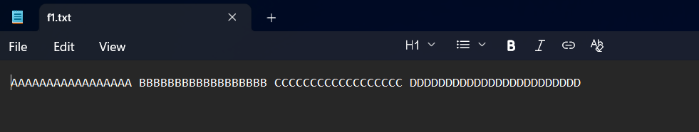
Encoded file:
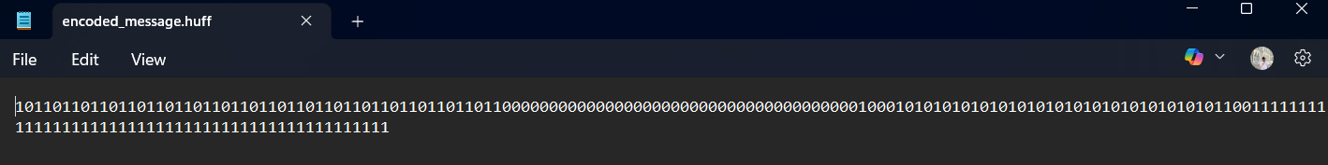
Decoded file:
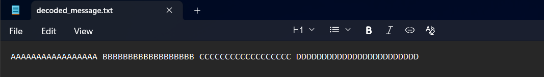
OUTPUT:
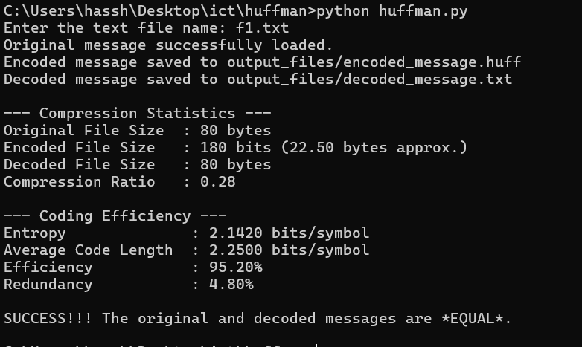
F2: (Worst case)
Input file:
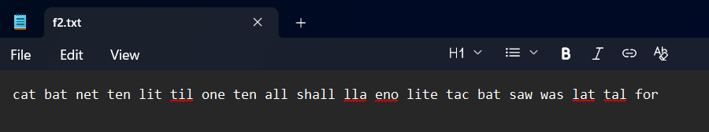
Encoded file:
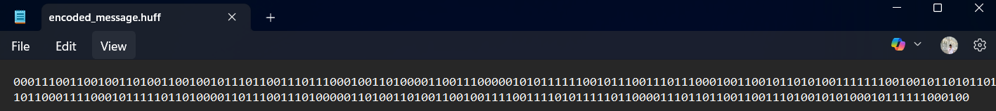
Decoded message:
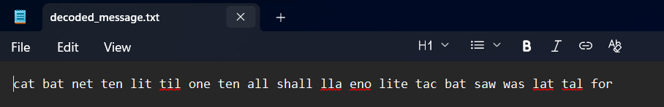
OUTPUT:
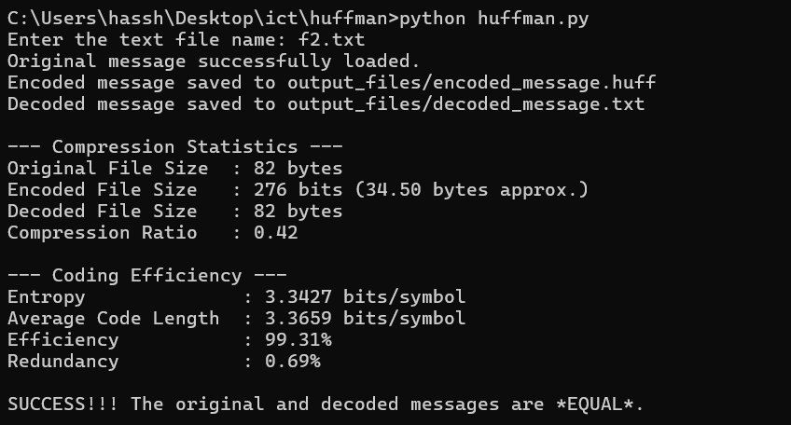

F3:(Average case)
Input file:
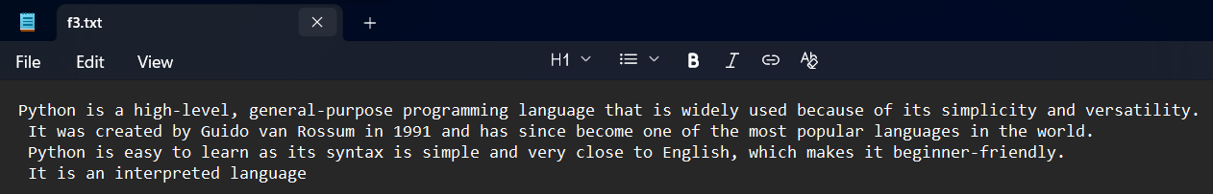
Encoded message: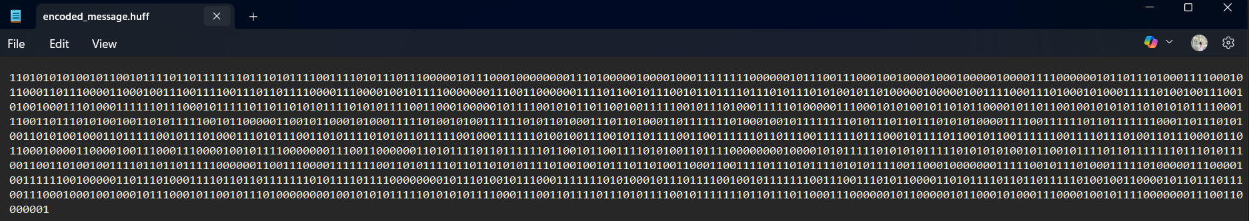
Decoded message:
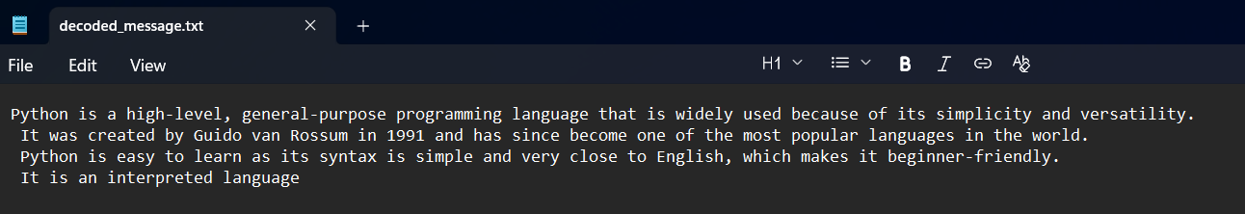
OUTPUT:
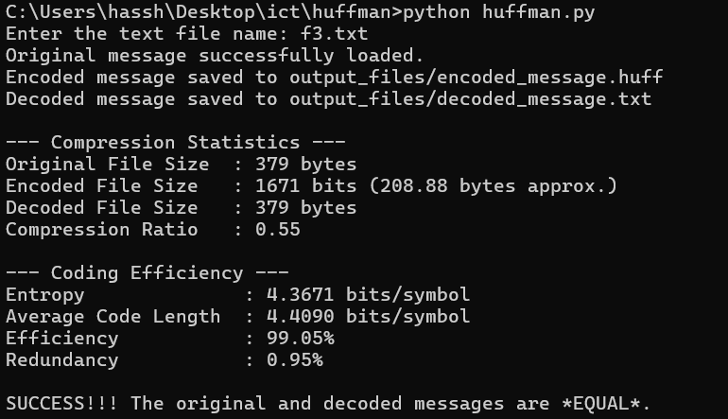
PROGRAM CODE:
import os
import math

# Shannon–Fano Recursive Algorithm
def shannon_fano(symbols, code=''):

if len(symbols) == 1:
return {symbols[0][0]: code}

# Find split point where cumulative frequency is about half
total = sum(freq for _, freq in symbols)
split = next(i+1 for i in range(len(symbols))
if sum(freq for _, freq in symbols[:i+1]) >= total/2)

# Recursively assign '0' to left half and '1' to right half
left = shannon_fano(symbols[:split], code + '0')
right = shannon_fano(symbols[split:], code + '1')
return {**left, **right}

# Encode message into binary using Shannon–Fano codes
def encode(msg, codes):
return ''.join(codes[c] for c in msg)

# Decode binary string back into original message
def decode(encoded, codes):
rev = {v: k for k, v in codes.items()} # Reverse map: code → symbol
cur, decoded = '', ''
for bit in encoded:
cur += bit
if cur in rev: # When a complete symbol code is found
decoded += rev[cur]
cur = ''
return decoded

# Information Theory Metrics
def entropy(probabilities):
return -sum(p * math.log2(p) for p in probabilities if p > 0)

def average_code_length(codes, freq, total_chars):
return sum(len(codes[symbol]) * (freq[symbol]/total_chars) for symbol in freq)

# Main Driver Function
def main():
fname = input("Enter text file name: ")
with open(fname, 'r') as f:
msg = f.read().strip()
print("Loaded message.")

# --- Frequency count of characters ---
freq = {c: msg.count(c) for c in set(msg)}
sorted_freq = sorted(freq.items(), key=lambda x: -x[1]) # sort by frequency (descending)

# --- Build Shannon–Fano codes ---
codes = shannon_fano(sorted_freq)

# --- Encode ---
os.makedirs("output_files", exist_ok=True)
encoded = encode(msg, codes)
with open("output_files/encoded_message.fano", 'w') as f:
f.write(encoded)
print("Encoded message saved.")

# --- Decode ---
decoded = decode(encoded, codes)
with open("output_files/decoded_message.txt", 'w') as f:
f.write(decoded)
print("Decoded message saved.")

# --- Verify correctness ---
if msg == decoded:
print(" SUCCESS: Original and decoded messages match.")
else:
print(" ERROR: Original and decoded messages do NOT match.")

# Compression & Efficiency Metrics
original_bits = len(msg) * 8 # Assume ASCII → 8 bits per char
compressed_bits = len(encoded) # Encoded length in bits
compression_ratio = original_bits / compressed_bits if compressed_bits > 0 else 0

total_chars = len(msg)
probabilities = [freq[c]/total_chars for c in freq] # Probabilities of symbols
H = entropy(probabilities) # Entropy
L_avg = average_code_length(codes, freq, total_chars) # Average code length
efficiency = H / L_avg if L_avg > 0 else 0
redundancy = 1 - efficiency

# --- Print results ---
print("\n Shannon-Fano Coding Results:")
print(f"Original Size (bits): {original_bits}")
print(f"Compressed Size (bits): {compressed_bits}")
print(f"Compression Ratio: {compression_ratio:.2f}")
print()
print(“-----------Coding Efficiency----------“)
print(f"Entropy (H): {H:.4f} bits/symbol")
print(f"Average Code Length (L): {L_avg:.4f} bits/symbol")
print(f"Coding Efficiency: {efficiency*100:.2f}%")
print(f"Redundancy: {redundancy*100:.2f}%")

if __name__ == "__main__":
main()

F1:(Best case)

Input file:

Encoded message:
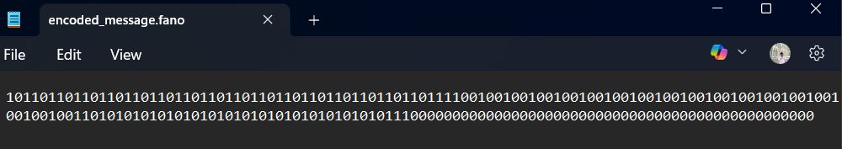

Decoded message:

OUTPUT:
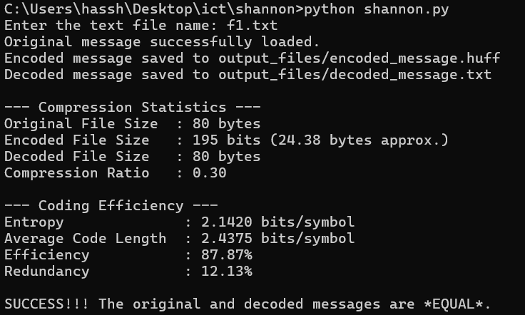
F2(Worst case)
Input File:

Encoded message:
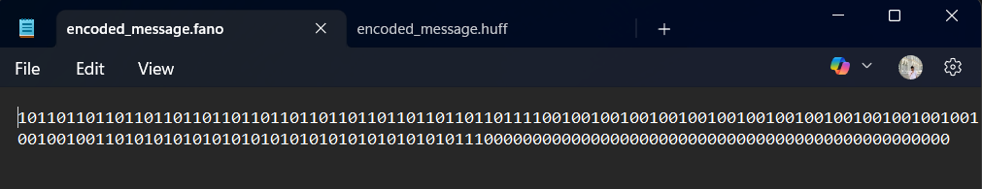

Decoded message:
OUTPUT:
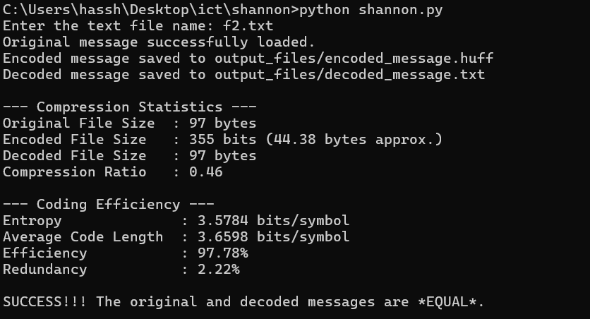
F3(Average case)
Input File:
Encoded message:
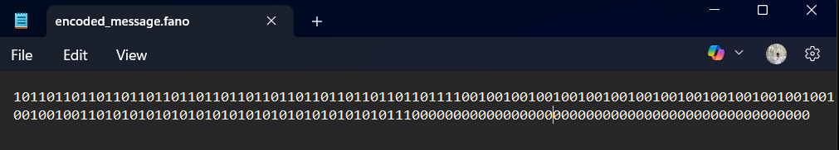

Decoded message:
OUTPUT:

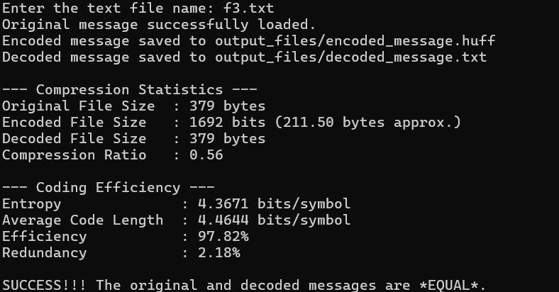

PROGRAM CODE:
from collections import defaultdict
from decimal import Decimal, getcontext
import math
import os

# Setup high precision decimals
getcontext().prec = 500 # ensures accurate probability interval calculation

# Step 1: Calculate probability ranges for each symbol
def calculate_ranges(message):
freq = defaultdict(int)
for char in message:
freq[char] += 1
total = len(message)

ranges = {}
lower = Decimal(0)

# Assign each symbol a unique interval proportional to its probability
for char, count in freq.items():
ranges[char] = (
lower / total,
(lower + count) / total
)
lower += count
return ranges

# Step 2: Arithmetic Encoding
def arithmetic_encode(message):
ranges = calculate_ranges(message)
low = Decimal(0)
high = Decimal(1)

# Narrow down [low, high) interval for each symbol
for char in message:
width = high - low
high = low + width * Decimal(ranges[char][1])
low = low + width * Decimal(ranges[char][0])

# Return both low and high to calculate interval width later
return (low, high), ranges

# Step 3: Arithmetic Decoding
def arithmetic_decode(encoded_val, length, ranges):
low = Decimal(0)
high = Decimal(1)
decoded = ''

# Iteratively map the encoded number back into symbols
for _ in range(length):
width = high - low
value = (encoded_val - low) / width

# Find which interval the value falls into
for char, (l, h) in ranges.items():
if Decimal(l) <= value < Decimal(h):
decoded += char
high = low + width * Decimal(h)
low = low + width * Decimal(l)
break
return decoded

# Step 4: Efficiency & Redundancy
def calculate_efficiency(message, low, high):
total_chars = len(message)

# --- Entropy from probabilities ---
freq_dict = {ch: message.count(ch) for ch in set(message)}
probabilities = {ch: freq / total_chars for ch, freq in freq_dict.items()}
entropy = -sum(p * math.log2(p) for p in probabilities.values())

# --- Actual average code length from arithmetic interval width ---
width = float(high - low) if high > low else 0.0
if width > 0.0:
total_bits = -math.log2(width)
avg_length = total_bits / total_chars
else:
avg_length = float("inf")

# Efficiency and redundancy
efficiency = entropy / avg_length if avg_length > 0 else 0
redundancy = 1 - efficiency
return entropy, avg_length, efficiency, redundancy

# Step 5: Main Function
def main():
# Load input text
input_file = input("Enter the text file name: ").strip()
if not os.path.isfile(input_file):
print("Error: File not found.")
return

with open(input_file, 'r') as f:
message = f.read().strip()
print("Original message successfully loaded.")

# Encode
(low, high), ranges = arithmetic_encode(message)

os.makedirs("output_files", exist_ok=True)
encoded_path = "output_files/encoded_value.arith"
with open(encoded_path, 'w') as f:
f.write(str((low + high) / 2)) # store midpoint for reference
print(f"Encoded value saved to {encoded_path}")

# Decode
decoded = arithmetic_decode((low + high) / 2, len(message), ranges)
decoded_path = "output_files/decoded_message.txt"
with open(decoded_path, 'w') as f:
f.write(decoded)
print(f"Decoded message saved to {decoded_path}")

# File sizes
input_size = len(message.encode('utf-8')) # original in bytes
encoded_size = len(str((low + high) / 2)) # approx encoded size
decoded_size = len(decoded.encode('utf-8')) # decoded size in bytes

print("\n--- Compression Statistics ---")
print(f"Input File Size : {input_size} bytes")
print(f"Encoded Value Size : {encoded_size} bytes (approx)")
print(f"Decoded File Size : {decoded_size} bytes")

if input_size > 0:
compression_ratio = encoded_size / input_size
print(f"Compression Ratio : {compression_ratio:.2f}")
else:
print("Compression Ratio : Not applicable (empty file)")

# Efficiency and Redundancy
if input_size > 0:
entropy, avg_length, efficiency, redundancy = calculate_efficiency(message, low, high)
print("\n--- Coding Efficiency ---")
print(f"Entropy : {entropy:.4f} bits/symbol")
print(f"Average Code Length : {avg_length:.4f} bits/symbol")
print(f"Efficiency : {efficiency * 100:.2f}%")
print(f"Redundancy : {redundancy * 100:.2f}%")

# Success check
if message == decoded:
print("\nSUCCESS!!! The original and decoded messages are *EQUAL*.")
else:
print("\nERROR!!! The original and decoded messages are NOT equal.")

# Entry Point
if __name__ == "__main__":
main()

F1:(Best case)
Input file:

Encoded file:
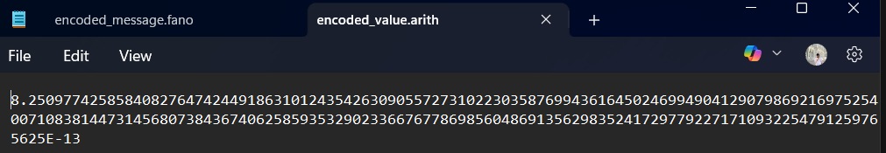
Decoded file:

OUTPUT:

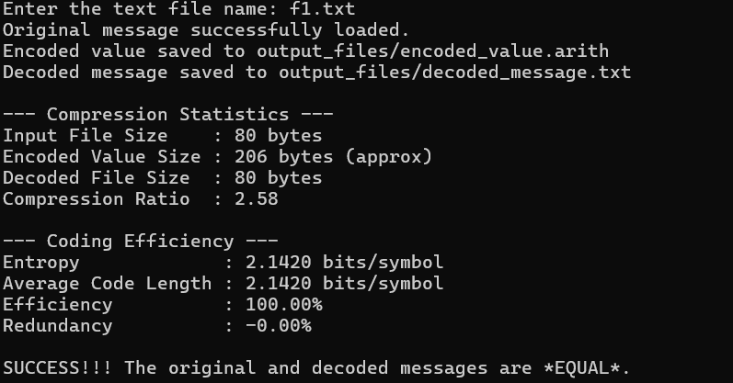

F2:(Worst case)

Input file:

Encoded file:
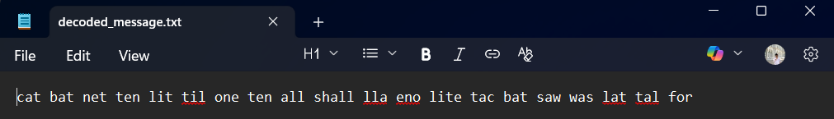

Decoded file:
OUTPUT:
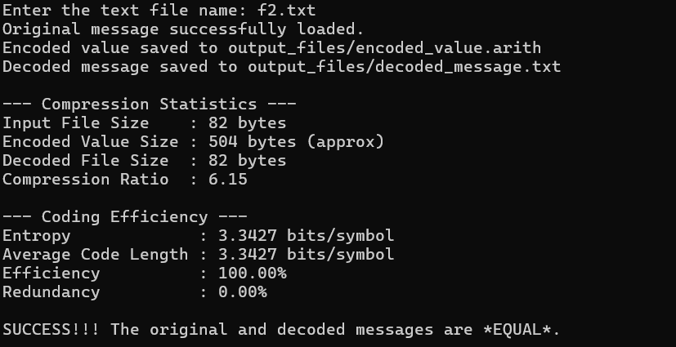

F3:(Average case)
Input file:

Encoded file:
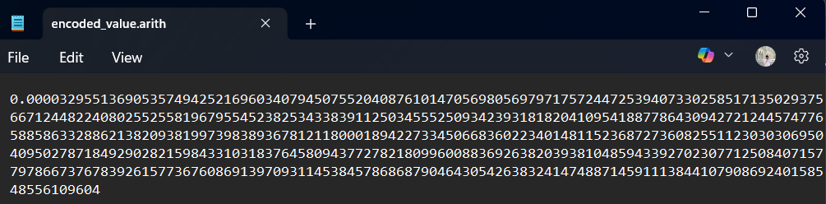

Decoded file:
OUTPUT: 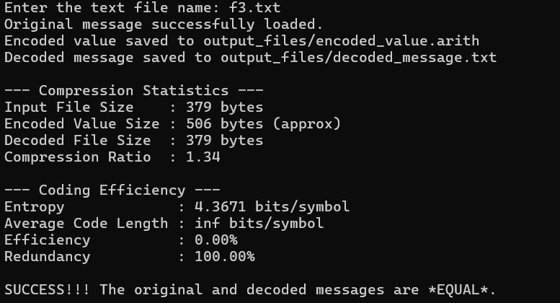

PROGRAM CODE:
import os
import math

# Run-Length Encoding (RLE)
def run_length_encoding(data):
encoding = []
i = 0
while i < len(data):
count = 1
# Count consecutive repeats of the same character
while i + 1 < len(data) and data[i] == data[i + 1]:
count += 1
i += 1
encoding.append((data[i], count))
i += 1
return encoding

def save_to_file(filepath, content):
with open(filepath, 'w', encoding='utf-8') as f:
f.write(content)

# Calculate efficiency & redundancy
def calculate_efficiency(data, encoded_data):
total_chars = len(data)
freq_dict = {ch: data.count(ch) for ch in set(data)}

# Probability of each character
probabilities = {ch: freq / total_chars for ch, freq in freq_dict.items()}

# Entropy = Σ p(x) * log2(1/p(x))
entropy = -sum(p * math.log2(p) for p in probabilities.values())

# Approximate average code length (symbols per char in RLE string)
encoded_str = ','.join(f"{ch}:{cnt}" for ch, cnt in encoded_data)
avg_length = len(encoded_str.encode('utf-8')) / total_chars

efficiency = entropy / avg_length if avg_length > 0 else 0
redundancy = 1 - efficiency
return entropy, avg_length, efficiency, redundancy

def main():
file_path = input("Enter input file path: ").strip()

if not os.path.isfile(file_path):
print(f"Error: File '{file_path}' not found.")
return

# Step 1: Load original message
with open(file_path, 'r', encoding='utf-8') as f:
data = f.read().strip()
print("Original message loaded.")

# Step 2: Encode using RLE
encoded_data = run_length_encoding(data)
encoded_str = ', '.join(f"{ch}:{cnt}" for ch, cnt in encoded_data)

# Step 3: Save encoded file
output_folder = "output_files"
os.makedirs(output_folder, exist_ok=True)
encoded_file = os.path.join(output_folder, 'encoded_message.rle')
save_to_file(encoded_file, encoded_str)
print(f"Encoded message saved to {encoded_file}")

# Step 4: Compression statistics
input_size = len(data.encode('utf-8')) # original size in bytes
encoded_size = len(encoded_str.encode('utf-8')) # compressed size in bytes
compression_ratio = input_size / encoded_size if encoded_size else 0

print("\n--- Compression Info ---")
print(f"Input File Size : {input_size} bytes")
print(f"Encoded File Size : {encoded_size} bytes")
print(f"Compression Ratio : {compression_ratio:.2f}")

# Step 5: Efficiency and Redundancy
if input_size > 0:
entropy, avg_length, efficiency, redundancy = calculate_efficiency(data, encoded_data)
print("\n--- Coding Efficiency ---")
print(f"Entropy : {entropy:.4f} bits/symbol")
print(f"Average Code Length : {avg_length:.4f} bits/symbol (approx.)")
print(f"Efficiency : {efficiency * 100:.2f}%")
print(f"Redundancy : {redundancy * 100:.2f}%")

# Step 6: Decode & validate
decoded_message = ''.join(ch * cnt for ch, cnt in encoded_data)
decoded_file = os.path.join(output_folder, 'decoded_message.txt')
save_to_file(decoded_file, decoded_message)
print(f"\nDecoded message saved to {decoded_file}")

if data == decoded_message:
print(f"SUCCESS: Original and decoded messages are equal.")
else:
print(f"ERROR: Original and decoded messages differ.")

# Entry Point
if __name__ == "__main__":
main()

F1:(Best case)

Input file:
Encoded file:

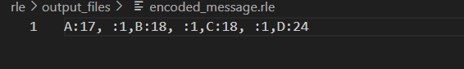

Decoded file:
OUTPUT:

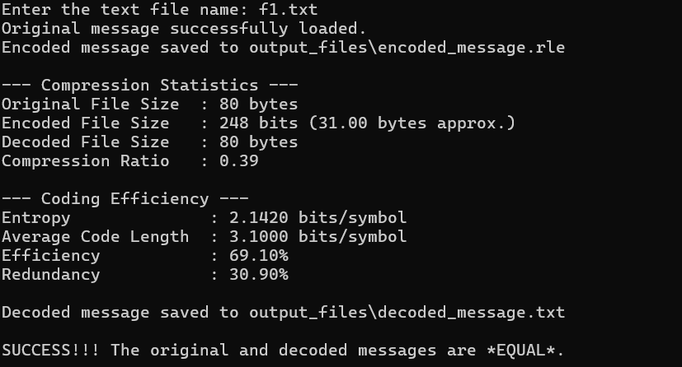

F2:(Worst case)

Input file:
Encoded file:

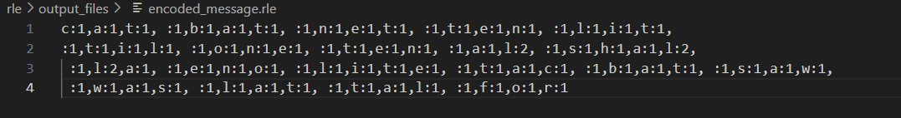
Decoded file:

OUTPUT:
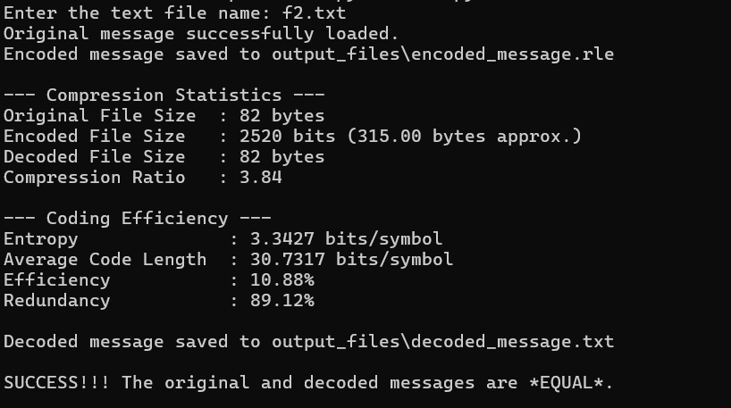

F3:(Average case)

Input file:

Encoded file:

Decoded file:

OUTPUT:

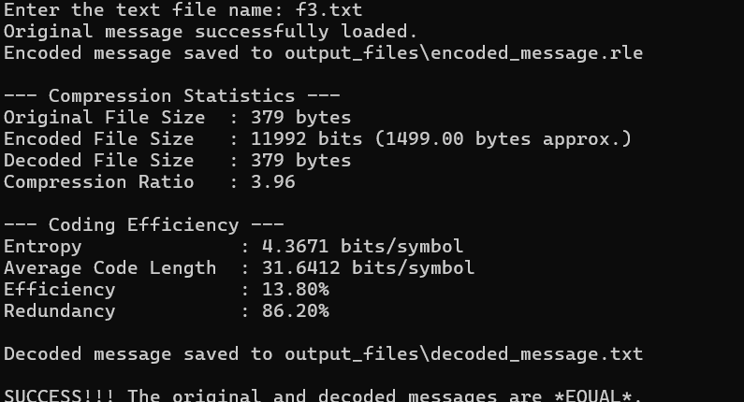

PROGRAM CODE:
import os
import math

# Compress a string to a list of output symbols using the LZW algorithm.
def lzw_encode(data):
dictionary = {chr(i): i for i in range(256)}
dict_size = 256
result = []
w = ""
for c in data:
wc = w + c
if wc in dictionary:
w = wc
else:
result.append(dictionary[w]) # output the code for w
dictionary[wc] = dict_size # add new sequence to dictionary
dict_size += 1
w = c
if w:
result.append(dictionary[w])
return result

# Decompress a list of output symbols back to string using LZW algorithm.
def lzw_decode(compressed)
dictionary = {i: chr(i) for i in range(256)}
dict_size = 256
w = chr(compressed.pop(0))
result = w
for k in compressed:
if k in dictionary:
entry = dictionary[k]
elif k == dict_size: # special case: construct entry
entry = w + w[0]
else:
raise ValueError("Bad compressed k: %s" % k)
result += entry
# Add new entry to dictionary
dictionary[dict_size] = w + entry[0]
dict_size += 1
w = entry
return result

#Calculate coding efficiency and redundancy
def calculate_efficiency_and_redundancy(data, encoded_size, input_size):

# Symbol probabilities
freq = {}
for ch in data:
freq[ch] = freq.get(ch, 0) + 1
total = len(data)
probabilities = [count / total for count in freq.values()]

# Entropy calculation
entropy = -sum(p * math.log2(p) for p in probabilities)

# To approximate, use encoded_size/input_size ratio (bytes).
avg_code_length = (encoded_size * 8) / total if total > 0 else 0

efficiency = entropy / avg_code_length if avg_code_length > 0 else 0
redundancy = 1 - efficiency if efficiency <= 1 else 0

return entropy, efficiency, redundancy

def main():
input_file = input("Enter the text file name: ")
with open(input_file, 'r') as file:
message = file.read().strip()
print("Original message successfully loaded.")

# Encode
compressed = lzw_encode(message)
folder_name = "output_files"
if not os.path.exists(folder_name):
os.makedirs(folder_name)
encoded_file = os.path.join(folder_name, 'encoded_message.lzw')
with open(encoded_file, 'w') as file:
file.write(' '.join(map(str, compressed)))
print(f"Encoded message saved to {encoded_file}")

# Decode
decoded_message = lzw_decode(compressed.copy())
decoded_file = os.path.join(folder_name, 'decoded_message.txt')
with open(decoded_file, 'w') as file:
file.write(decoded_message)
print(f"Decoded message saved to {decoded_file}")

# File sizes
input_size = os.path.getsize(input_file)
encoded_size = os.path.getsize(encoded_file)
decoded_size = os.path.getsize(decoded_file)

# Compression ratio
if input_size > 0:
compression_ratio = (encoded_size / input_size) * 100
else:
compression_ratio = 0

print("\n=== Compression Statistics ===")
print(f"Input file size : {input_size} bytes")
print(f"Encoded file size : {encoded_size} bytes")
print(f"Decoded file size : {decoded_size} bytes")
print(f"Compression ratio : {compression_ratio:.2f}% of original")

# Coding efficiency & redundancy
entropy, efficiency, redundancy = calculate_efficiency_and_redundancy(
message, encoded_size, input_size
)
print("\n=== Coding Theory Metrics ===")
print(f"Entropy (H) : {entropy:.4f} bits/symbol")
print(f"Efficiency : {efficiency * 100:.2f}%")
print(f"Redundancy : {redundancy * 100:.2f}%")

# Verify correctness
if message == decoded_message:
print("\nSUCCESS!!! The original and decoded messages are IDENTICAL.")
else:
print("\nERROR! The original and decoded messages are NOT identical.")

if __name__ == "__main__":
main()

F1:(Best case)
Input file:

Encoded file:
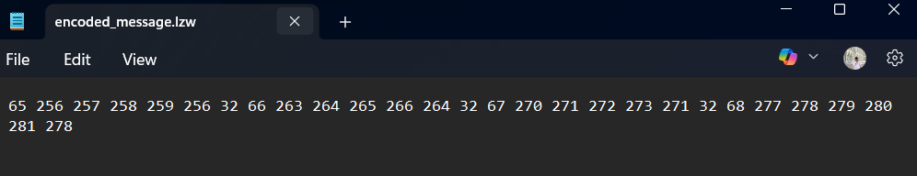

Decoded file:

OUTPUT:

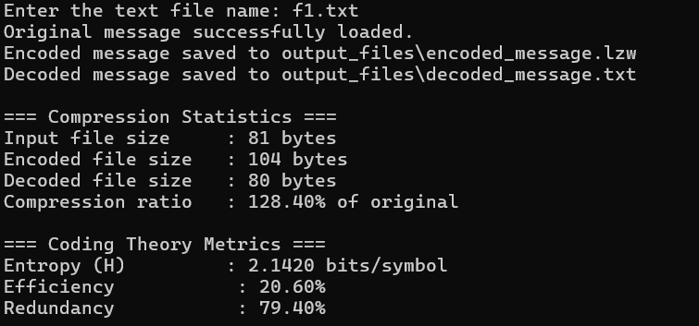
F2:(Worst case)

Input file:

Encoded file:
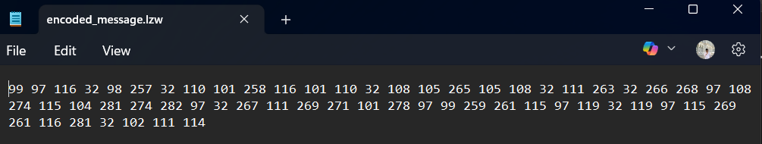
Decoded file:

OUTPUT:
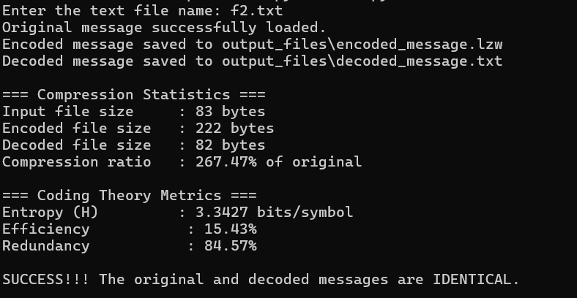

F3:(Average case)

Input file:
Encoded file:
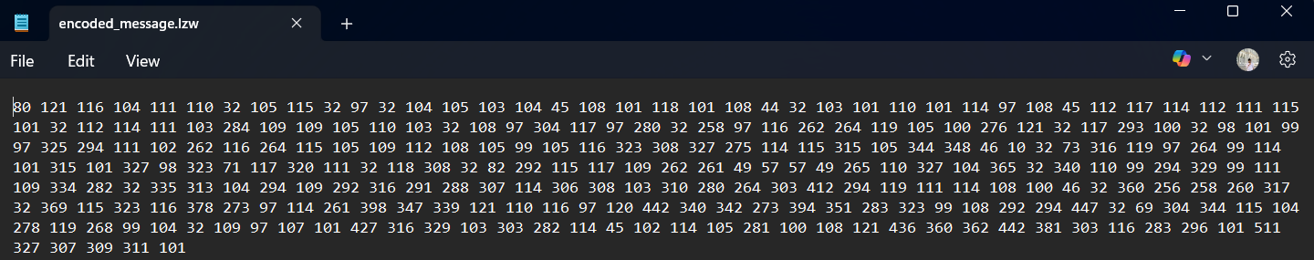
Decoded file:
OUTPUT:
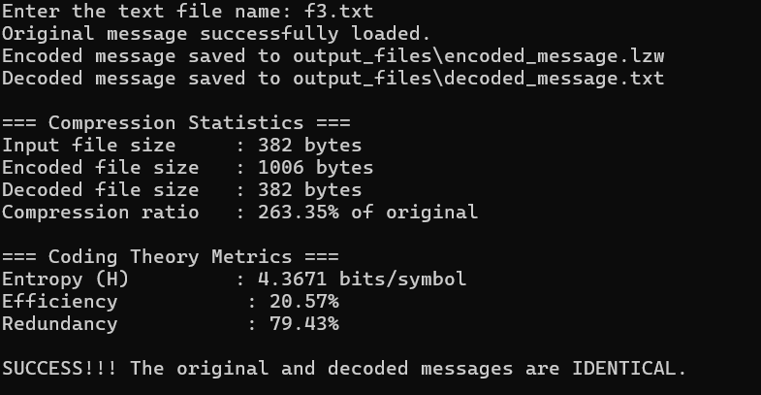

PROGRAM CODE:

F1:(Best case):

Input file:

Encoded file:

OUTPUT:

F2:(Worst case):
Input file:

Encoded file:

OUTPUT:

F3:(Best case):

Input file:

Encoded file:

OUTPUT:

