Harvester main components

Harvester hardware:
- Energy harvesting module or battery: The energy source.
- MCU: containing the logic for adapting time-slots and sending signals.
- radio unit: currently the inexpensive 433 modules are used but other modules and technologies can be attached.

Harvester software
- 433 serial comm: check id[4..n] where a+b+c+d=KEY. Id can be variable length (typically 4 digits( but any value could be used).
- Energy prediction algorithm: based on battery/storage value, adjust the time-slots to emit alive signal.
- Energy level measurement: adapted depending on the storage system. Battery discharge and supercapacitor discharge has very different curves
- Sleep modules: either by using a built-in 8 seconds watchdog timer or by using a wake-up pin.

Testing the energy level measurement

Code at `read_battery.ino`

For battery, see LiPo discharge graphs https://oscarliang.com/ctt/uploads/2017/02/Lipo-battery-guide-Voltage-vs-capacity-used-percentage.jpg

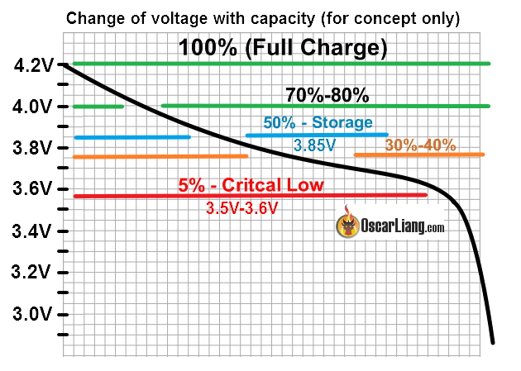

max batt= 4.2-4.3
if batt>3.9→OK
if batt<3.9→LOW BATT
if batt<3.6→ CRITICAL, do not send data until charging

Testing the energy prediction algorithm

Earlier test were done by using supercapacitors, and they are expected to be reviewed and installed as storage solution in the last stage of the project. For this stage and for testing we will use LiPo batteries as storage system, so the energy/time slot formula to be run in the harvester will be adapted for that case

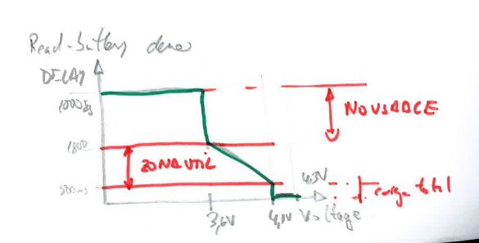

The prediction algorithm is a C99 compliant code (so it can run on a wide range of MCUs) and some adapters for different microprocessors, in this case, an adapter for using it as an arduino library.

Code test at EnergyPredictor.c EnergyPredictor.h and at test/EnergypredictorTest.c

Configuration:
- set the period multiplier.
- [OPTIONAL] set energy health barriers (default are `<30%-low energy` and `>60%-charged`).
- [OPTIONAL] set max daily iterations

The library is time-slot configurable, the default values are 1/10/100, so a normal operation would translate period by multiplying the time-slot returned by the algorithm.

Example: if multiplier is 6 minutes, the min period is 6 min, the median period is 60 min = 1 hour and the max period (the most energy saving) is to emit data every 600 minutes = 10 hours.

La gráfica de E/T copiarla del sharelatex o del word anterior del BB.2.5

The health barriers are also configurable sliders. Depending on real use cases, the healthy battery range can be from 10%-100%. For other cases where the energy intake is unpredictable, a safe range could be 50-10%. The default barriers, in conjunction with the period multiplier are 0%-100% (even if the sliders are at 30% 60% , but values below 30% still emits once every 100 times). As an example, if a 20-100% is required to operate, just change the `E_LOW` to 20 and T_MAX to 100 or 1000. For other cases where energy intake is more predictable, a 10-90 can be set and adjust the T_MAX to 20 (instead of 100) because we can ensure that the device will harvest enough energy to recharge 20 slots after last execution time.

Installation as arduino library

See README.md in the /dist/arduino folder. The lib can be provided as zip file so the arduino library manager wizard will take care of the library.

execution
See /examples/predictor.ino for a ATTINY85 standalone example from the arduino platform.

There is an arduino project to test the energy algorithm, so it is as easy as burn the code with the default configuration. See the `/dist` folder for implementations on other MCUs. Pleas note that this implementations are only wrappers for MCUs, the library itself is MCU agnostic, so the only requirement for using the algorithm is to have a C99 compliant compiler.

Note that there is a `PRODUCTION` flag in the arduino project. This flag is only useful when testing code when plugged to the laptop USB or to a power source. Default value is `PRODUCTION=true`, this value is valid for the 90% of the cases where the code is being tested so do not change it.

Note also that `VCC_MAX` is also useful to make the different power sources to have a canonical value. The ATTYNY85 can operate from 2,7 (or 1.8V in L models) to 5.5V in general, while the internal Vref is set to 1.1V. Therefore LiPo 100% batt are adjusted to VCC_MAX=4300 mVolts while 5V supercaps will be adjusted to 5000 (and 2,5V supercaps to 2500 and so on).

Testing the sleep and watchdog features

This part is useful to set the MCU into sleep mode as much as possible to save energy. The harvester must be dedicated only to gather energy, while keeping all secondary devices stopped. The energy prediction algorithm is executed periodically and the communications module is only started when energy conditions are good.
Code at SLEEP_NO_WATCHDOG_ATTINY85.ino and at sleep_watchdog_ATTINY85.ino
There are several options to wake the device from sleep:
- by adding a wake-up pin. The startup is on-demand from another element. If conditions are met, a change a preset pin in the MCU is enough to start it up. This mode would be the best for energy savings but it requires external circuitry.
- by adding a watchdog timer: The MCU is started from time to time, in the current MCU every 8 seconds. Then the code takes decision on execute actions or not and then go to sleep again. In this mode there is only a controller for all the harvesting device (1 MCU and no comparator or external logic chips)

At this stage of the project the current configuration is using a watchdog because the energy wasted compared to the other option is still acceptable on low energy harvesting environments and the cost and complexity of the harvesting device is lower. Remember that cost is a variable as important as energy efficiency ratio for these devices because they are intended to be disposable.

Testing the battery level

The batt level can be measured using external voltage comparators, but this approach has two main drawbacks:
- a secondary battery is needed to act as fixed voltage, and therefore, required.
- the system must be also set to sleep periodically to save energy consumption.

For these reasons, we have opted to use internal voltage references after waking up the MCU. This solution is not very precise in terms on measuring the real voltage (and battery/supercapacitor charge status) but it uses the internal circuitry, so no added cost of components or complexity, and the energy spent on that extra operation is very small compared to the general operation.

Code at read_battery.ino

Testing the radio communication via 433 radio

The 433MHz inexpensive radios are chosen at this stage because the real range is acceptable (hundreds of meters) and the cost of the radio solution is very cheap compared to other technologies. The main disadvantages are the ratio of failures (to be compensated by software noise reduction) and the security (it must be set for software).

For preliminary tests on arduino devices, the results were promising, but when adapting the code to the ATTINY85, the chosen library (Radiohead) was not compatible, and the the “Manchester” library was evaluated but the field range in real experiments (indoor and outdor) with the same radio devices was much worse. Therefore another library was selected (RCSwitch) and while not as useful as “Radiohead” because of sending numbers only (instead of custom variable-length alphanumeric) and a little lower range.

Regarding the hardware for experiments, the most inexepensive commercial radios were bought and some of then adapted (while being still compliant with UE regulations) to allow better default range at lower voltages.

Code at /433 folder containing several .ino files depending on device (arduino or attiny) and on library.

Main higlights:
- Radiohead for receiver does not work on attiny. Anyway this solution could also be chosen because the receiver (in the scope of the project) can be a non-power-efficient device (and it could be an arduino nano instead of the tiny).
- Manchester library was very problematic on the effective range when using the attiny85.
- RCSwitch library has enough compatibility (devices), features (at least, sending IDs) and range (less than Radiohead but still acceptable) to be chose. This library allows the receiver to be installed into the same MCU selected for the harvester and the total size of the receiver will be small compared to the receiver antenna.

Integrated emmiter
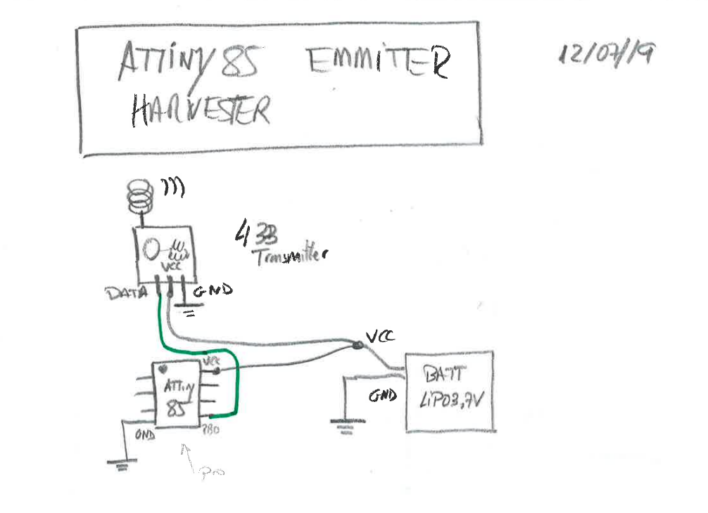

Integrated receiver
