Automated Segmentation of Colorectal Cancer on Routine Computed Tomography Using Deep Learning

YUXIN, LIN

Abstract
Begin the abstract two lines below author names and addresses. The abstract summarizes key findings in the paper. It is a paragraph of 250 words or less. For the keywords, select up to 8 key terms for a search on your manuscript's subject.

Keywords: AI, deep learning, colon cancer, segmentation

INTRODUCTION
Colorectal cancer (CRC) is the third most common cancer worldwide and results in significant morbidity and mortality.[1]
Colonoscopy is the most commonly used and efficient diagnostic method for CRC. Combining colonoscopy with polypectomy can lower the incidence and mortality rates of CRC.[2, 3]
An alternative for patients who are unable to tolerate colonoscopy is computed tomographic (CT) virtual colonoscopy, which is comparable with colonoscopy in detecting CRC and polyps larger than 10mm.[4]
Nevertheless, CT virtual colonography necessitates bowel preparation and insufflation of gas, which might be difficult for certain patient groups, such as the elderly or frail.[5] Previous studies have investigated the value of routine, unprepared abdominopelvic CT for the detection of CRC and shown various performances depending on different study designs.[5-8]
Although the accuracy of routine CT is not as good as that of colonoscopy and CT virtual colonography, it is still able to detect a considerable number of CRC, and has better availability and patient compliance. However, the miss rate of routine CT was significant. A study reported that 41% of the routine abdominopelvic CTs before the diagnosis of CRC had the findings undetected by radiologists.[9]
Suppose the CT scans are performed for reasons other than the detection of colorectal lesions, such as routine follow-up of abdominal aortic aneurysm or hepatocellular carcinoma. In that case, radiologists may fail to detect the incidental CRC because of perceptual errors. A delay in the diagnosis of CRC on a CT scan may worsen the patient's survival.[9]
Artificial intelligence may have the potential to reduce perceptual and interpretive errors in diagnostic radiology.[10] Numerous deep-learning models have been proposed to detect colorectal polyps or cancer. Most of them were based on colonoscopy or CT virtual colonography.[11-14]

Furthermore, training radiologists to be able to identify colorectal cancer tumors in traditional computed tomography scans is far more difficult than looking at other organs and requires years of specialized training. In addition, because tumors do not have clear borders on traditional CT scans, the results marked by different doctors can vary significantly.

Therefore, this study aims to develop such a model. It can reduce the missed diagnosis rate, reduce the workload of doctors, reduce the training costs of doctors and improve consistency.

Methodology

Data Source
The training and testing data are sourced from the Medical Segmentation Decathlon (MSD) dataset [X] and the National Taiwan University Hospital (NTUH) internal dataset , containing 126 and 70 samples, respectively. The MSD dataset is a generalizable 3D Semantic Segmentation dataset that contains 10 tasks. In our research, we used Task 10 Colon Cancer subset.

Preprocessing
File format: Common medical image formats include DICOM (suffix .dcm), MHD (suffix .mhd and .raw), NIFTI (suffix .nii or .nii.gz), and MRB (suffix .mrb). Among them, NIFTI files are the most common in deep learning, but hospitals are usually accustomed to using DICOM or MRB. We need to convert to NIFTI files before subsequent operations.
In the nnU-Net framework, additional programs must convert the training data into numpy arrays (.npz) and corresponding pickle files (.pkl). The numpy files store each image's voxel intensity, and the pickle files store the image spacing, direction, and origin information. However, the data used for testing does not need to undergo this step and only needs to maintain NIFTI.

Adjust Intensity:
In CT images, the intensity of the image is represented by Hounsfield unit (HU) instead of the general grayscale 8-bit intensity. HU is the linear attenuation coefficient of the measurement medium and is linearly mapped to the space of HU_{water} 0 and HU_{air} -1000. Usually the range may be from -1024 to 2048 etc. When observing abdominal CT, it is usually customary to set window 400 and level 40 to facilitate observation of the organs in the abdomen.

GPT指令:
根據nnU-Net的論文 我以下的描述正確嗎? 幫我改進這段描述
翻譯成英文

Crop:
三維醫學影像當中通常包含大量背景區域，並且影像尺寸及模型尺寸通常相當龐大，這些不必要的資訊可能導致硬體設備無法負擔訓練工作。因此我們需要先將影像的前景部分裁切出來，提高計算效率。

Resample:
CT影像拍攝時，由於病人身材與機器設置不同，每筆CT影像的間距、原點等資訊都會不同。因此需要先重採樣，將每筆影像的間距統一。nnU-Net框架採用的策略是統計資料集當中所有影像的間距，一般時候將所有資料重採樣為中位數；在各向異性(最大間距/最小間距>3)的資料集中，取10百分位的值作為重採樣後的目標。過程當中使用雙線性插值來填補體素。

Normalization:
Z scoring: 減平均值後 除標準差

5 fold cross validation

https://www.ebaina.com/articles/140000012588
https://www.cnblogs.com/xyf9474/p/16305556.html
https://blog.csdn.net/weixin_46141646/article/details/129133449

Traditional Segment Models
nnU-Net

Swin-UMamba

Prompt Driven Segment Model
Promise

Prism

Hardware Environment
For this study, we used a server with an Intel(R) Xeon(R) Silver 4110 CPU @ 2.10GHz, running CentOS Linux release 7.9.2009 (Core), and equipped with 2 NVIDIA RTX 3090 graphics cards (24GB).

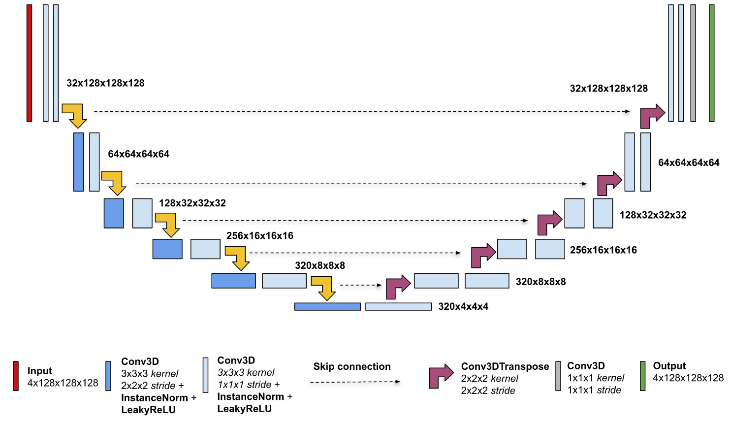
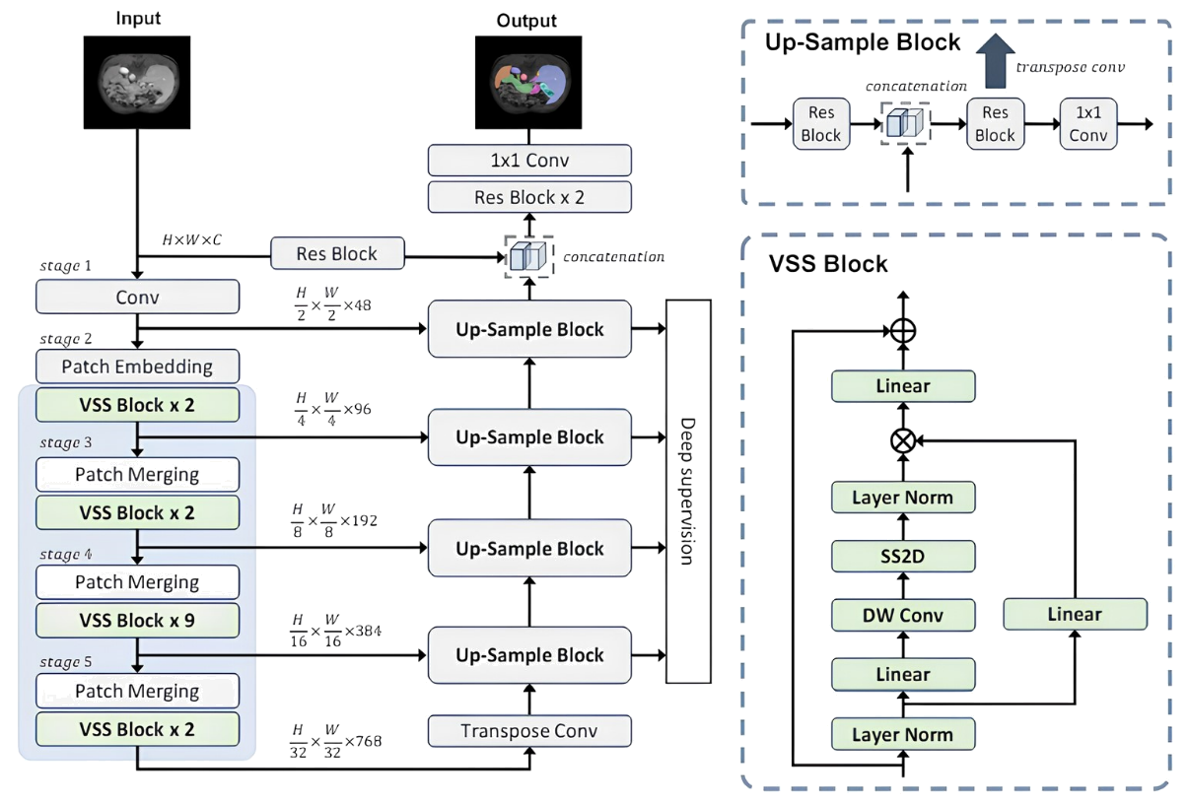

muti-modality
Model | Detection / Segmentation | 2D / 3D | Prompt | Metrics | Notes
Promise | Segmentation | 3D | Point | DSC: 0.49345  NSD: 0.31174  HD95: 24.20799 | Test on 31 NTUH positive data (001~040)  Auxiliary annotation, Not direct prediction
PRISM | Segmentation | 3D | Point  Box  Mask  Scribble | DSC: 0.5525 (iter1)  DSC: 0.6362 (iter2)  DSC: 0.6644 (iter9) | Test on 34 NTUH positive data (001~043)  Only validate.  Cannot infer.  Auxiliary annotation, Not direct prediction
MedSAM | Segmentation | 2D | Box

Model | Detection / Segmentation | 2D / 3D | Metrics | Notes
Swin-UMamba | Segmentation | 2D | DSC: 0.32465  NSD: 0.283745  HD95: 92.66501  Recall: 0.29756  FN rate: 7/20
nnU-Net vanilla | Segmentation | 3D | DSC: 0.536395  NSD: 0.44307  HD95: 124.4473  Recall: 0.62459  FN rate: 2/20

Results

Traditional Segment Models

Prompt Driven Segment Model

Table X. temp
 | Dice | NSD (誤差=) | HD95 | Recall
nnU-Net
Swin-UMamba
Promise

Conclusions.

REFERENCE
- Isensee, Fabian, Jens Petersen, André Klein, David Zimmerer, Paul F. Jaeger, Simon A. A. Kohl, Jakob Wasserthal, Gregor Koehler, Tobias Norajitra, Sebastian J. Wirkert and Klaus Maier-Hein. “nnU-Net: Self-adapting Framework for U-Net-Based Medical Image Segmentation.” ArXiv abs/1809.10486 (2018): n. pag.
- Liu, Jiarun, Hao Yang, Hong-Yu Zhou, Yan Xi, Lequan Yu, Yizhou Yu, Yong Liang, Guangming Shi, Shaoting Zhang, Hairong Zheng and Shanshan Wang. “Swin-UMamba: Mamba-based UNet with ImageNet-based pretraining.” International Conference on Medical Image Computing and Computer-Assisted Intervention (2024).
- Li, Hao, Han Liu, Dewei Hu, Jiacheng Wang and Ipek Oguz. “Promise: Prompt-Driven 3D Medical Image Segmentation Using Pretrained Image Foundation Models.” 2024 IEEE International Symposium on Biomedical Imaging (ISBI) (2023): 1-5.

Margins
If the paper does not have the margins shown in Table 1, it will not upload properly.

Table 1. Margins and print area specifications.
PAPER MARGINS
A4 Letter
Top margin 2.54 cm (1in.) Top margin 1.0 in. (2.54 cm)
Bottom margin 4.94 cm (1.95 in.) Bottom margin 1.25 in. (3.17 cm)
Left, right margin 1.925 cm (.76 in.) Left, right margin .875 in. (2.22 cm)
Printable area--all text, figures and footnotes:
A4: 17.15×22.23 cm Letter : 6.75×8.75 in.

Fonts
Table 2 shows the font sizes and highlighting in a typical manuscript. These font "styles" are contained with this sample manuscript and Section 4 below explains how to use them. Use Times Roman or another standard font to avoid font errors.

*s.greg.jones@narelab.com; phone 1 222 555-1234; fax 1 222 555-876; narelab.com
Table 2. Manuscript font sizes and formatting. This Microsoft Word template includes these formats as automated "styles", which can be selected in the Format menu -- Styles and Formatting. (9pt)

Preformatted SPIE Template Styles

Manuscript component Description

SPIE paper title 16 pt. bold, center

SPIE authors/affiliations 12 pt., center
Keywords: *Keywords* 10 pt., left justify

SPIE ABSTRACT TITLE 11 pt. BOLD, center
SPIE abstract body text 10 pt., justify

SPIE SECTION HEADING 11 pt. BOLD, center, whole numbers
1.1 Heading 2, SPIE subsection heading 10 pt. bold, left justify, subsection numbers
SPIE body text 10 pt., justify
SPIE figure caption 9 pt., justify below figure
SPIE table caption 9 pt., justify above figure
SPIE footnote text 9 pt., justify, numbered
REFERENCE HEADING 11 pt. BOLD, center
1. SPIE reference listing 10 pt., justify, numbered in brackets

Formatting of manuscript components

Title
Center the paper title at the top of the page in 16-pt. bold. Only the first word, proper nouns, and acronyms are capitalized. Keep titles brief and descriptive. Spell out acronyms unless they are widely known. Avoid starting with articles or prepositions, e.g., “The study of … ,” or, “On the ….”

Author affiliations
The author list is in 12-pt. regular, centered. Omit titles and degrees such as Dr., Prof., Ph.D., etc. The list of affiliations follows. Each author's affiliation should be clearly noted.

Section headings
Section headings are 11-pt. bold capitals, centered. Sections numbers have whole numbers, e.g., 1, 2, 3… Don't number the "Acknowledgements" and "References." Headings often used are: 1. Introduction, 2. Methodology, 3. Data, 4. Results, and 5. Conclusions.

Subsection heading
Subsection headings are left-justified, 10-pt. bold. Capitalize the first word, acronyms, and proper nouns.

Paragraphs
Add a blank line above and below section headings and between paragraphs. Avoid headings or one-line paragraphs at the top or bottom of a page by using page breaks or extra blank lines. One method to preserve page breaks is to make the bottom margin a little larger than the specifications. Indentation is optional. This spacing is automatic if you are using the SPIE "section" styles in Word.

Text
Text is 10 point and justified. Each sentence ends with a period and a single space before the next sentence.

Figures and captions
Figures are centered. Use or insert .jpg, .tiff, or .gif illustrations instead of PowerPoint or graphic constructions. Captions go below figures. Indent 5 spaces from left margin and justify.

Figure 1. Figure captions are indented 5 spaces and justified. If you are familiar with Word styles, you can insert a field code called Seq figure which automatically numbers your figures.

Tables and captions
Tables are centered. The caption goes above the table. The caption text should indent 5 spaces from left margin and justify. Table examples are on page 1 and 2 and below.

Multimedia figures – video and audio files
Video and audio files can be included for publication. Table 3 lists the specifications for the mulitimedia files. Use a screenshot or another .jpg illustration for placement in the text. Use the file name to begin the caption. The text of the caption must end with the text "http://dx.doi.org/doi.number.goes.here" which tells the SPIE editor where to insert the hyperlink in the digital version of the manuscript.
Here is a sample illustration and caption for a multimedia file:
Video 2. A label of “Video/Audio 1, 2, …” should appear at the beginning of the caption to indicate to which multimedia file it is linked . Include this text at the end of the caption: http://dx.doi.org/doi.number.goes.here

Table 3. Information on video and audio files that can accompany a manuscript submission.
Item | Video | Audio
File name | Video1, video2, … | Audio1, audio2, …
Number of files | 0-10 | 0-10
Size of each file | max. 5 mb | max. 5mb
File types accepted | .mpeg, .mov (Quicktime), .wmv (Windows Media Player) | .wav, .mp3

Mathematical Equations
Use common fonts like Times Roman in your math equations. A math reference in a paragraph sentence such as 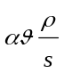 is not numbered. The steps of a mathematical argument can be numbered using a right-aligned tab for clarity, for example
α = 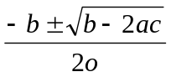 (1)
and
ρ=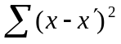. (2)

using THIS TEMPLATE AND ITS Automatic formatting
This document template and more information is available on SPIE.org:
http://spie.org/x14101.xml or by emailing authorhelp@spie.org

View the pre-formatted styles
To see the formats available with this manuscript, go to the Format menu and choose "Styles and Formatting". To view which style is being used in any part of this document, place your cursor on the line and look in the Styles and Formatting display.

Using SPIE styles
To use this template in Microsoft Word: open this file and save it to a new file name. Type over the existing text with your paper. Alternately, you can delete all text, and select the SPIE style for each paragraph from the Styles and Formatting menu.

Notes on SPIE styles
The styles listed in Table 2 automatically add extra spacing before and/or after paragraphs: SPIE title, SPIE authors-affiliations, SPIE section heading, SPIE subsection heading, and SPIE body text. The 1.1 Heading 2 style automatically goes into the body text style after one paragraph return.

reference linking
SPIE is able to display the references section of your paper in the SPIE Digital Library, complete with links to referenced journal articles, proceedings papers, and books, when available. This added feature will bring more readers to your paper and improve the usefulness of the SPIE Digital Library for all researchers.
Denote reference citations within the text of your paper by means of a superscript number. List references at the end of the paper in numerical order, and enclose the reference number in square brackets. Include the following information (as applicable).
If you use this formatting, your references will link your manuscript to other research papers that are in the CrossRef system. Exact punctuation is required for the automated linking to be successful.
book: [1] Booth, N. and Smith, A. S., [Infrared Detectors], Goodwin House Publishers, New York & Boston, 241-248 (1997).
journal paper: [2] Davis, A. R., Bush, C., Harvey, J. C. and Foley, M. F., "Fresnel lenses in rear projection displays," SID Int. Symp. Digest Tech. Papers 32(1), 934-937 (2001).
proceedings paper: [3] Van Derlofske, J. F., "Computer modeling of LED light pipe systems for uniform display illumination," Proc. SPIE 4445, 119-129 (2001).
website: [4] Myhrvold, N., “Confessions of a cybershaman,” Slate, 12 June 1997, <http://www.slate.com/CriticalMass/97-06-12/CriticalMass.asp> (19 October 1997).
-OR-
[4] Myhrvold, N., “Confessions of a cybershaman,” Slate, 12 June 1997, http://www.slate.com/CriticalMass/97-06-12/CriticalMass.asp (19 October 1997).

References
- Booth, N. and Smith, A. S., [Infrared Detectors], Goodwin House Publishers, New York & Boston, 241-248 (1997).
- Davis, A. R., Bush, C., Harvey, J. C. and Foley, M. F., "Fresnel lenses in rear projection displays," SID Int. Symp. Digest Tech. Papers 32(1), 934-937 (2001).
- Van Derlofske, J. F., "Computer modeling of LED light pipe systems for uniform display illumination," Proc. SPIE 4445, 119-129 (2001).
- Myhrvold, N., “Confessions of a cybershaman,” Slate, 12 June 1997, <http://www.slate.com/CriticalMass/97-06-12/CriticalMass.asp> (19 October 1997). www.optics4yurresearch.com/7752.html
- Jones, C. J., Director, Miscellaneous Optics Corporation, interview, Sept. 23 2011
- FamilyName, GivenName Initial., "Title," Source, pg# (year).

