The Experiment Report of Machine Learning



December 15, 2017

Grade: 2015

Undergraduate or Graduate

Student ID：201530612033

Supervisor:

Mingkui Tan or Qingyao Wu

Author:

Ruiyong Li

**SUBJECT:**SOFTWARE ENGINEERING

**SCHOOL:** SCHOOL OF SOFTWARE ENGINEERING

[1]Logistic Regression, Linear Classification and Stochastic Gradient Descent

Abstract—

* Compare and understand the difference between gradient descent and stochastic gradient descent.
* Compare and understand the differences and relationships between Logistic regression and linear classification.
* Further understand the principles of SVM and practice on larger data.

# INTRODUCTION

Experiment uses a9a of LIBSVM Data, including 32561/16281(testing) samples and each sample has 123/123 (testing) features.

# METHODS AND THEORY

Logistic Regression and Stochastic Gradient Descent

Linear Classification and Stochastic Gradient Descent

NAG，RMSProp，AdaDelta and Adam

# Experiment

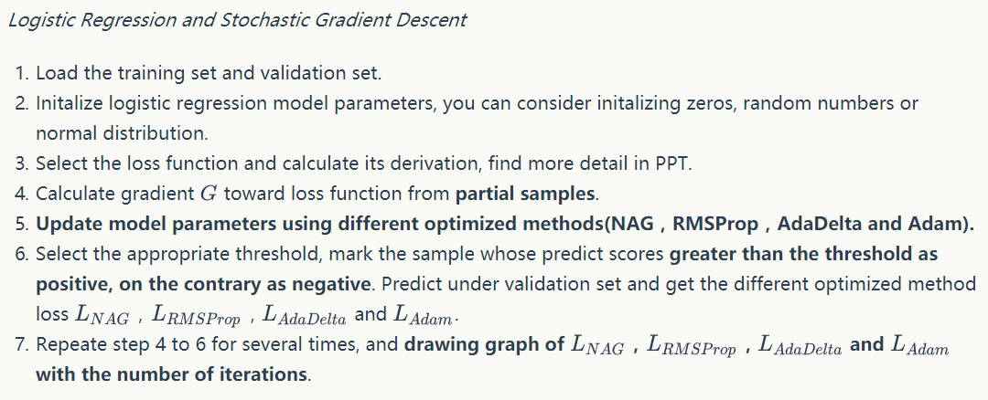

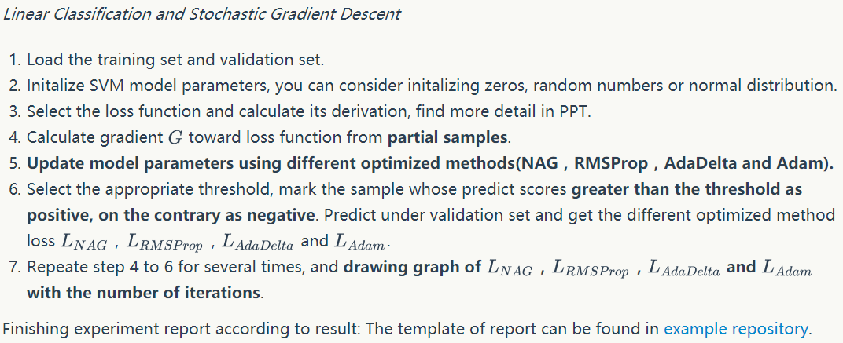

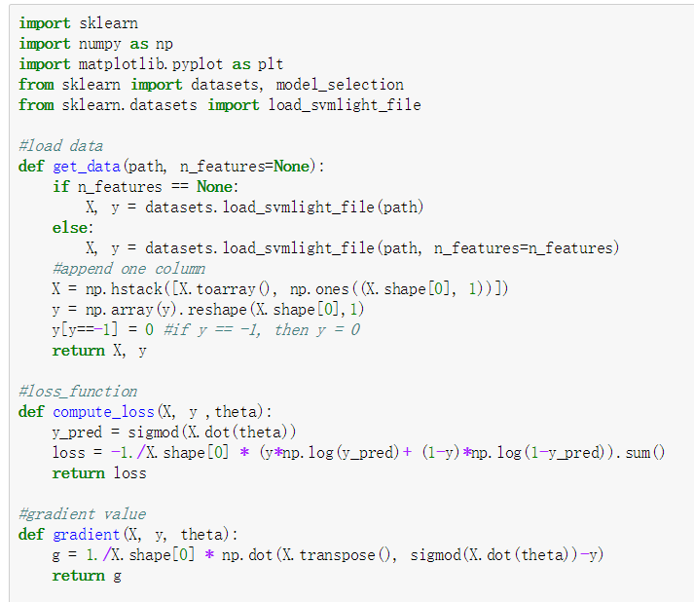

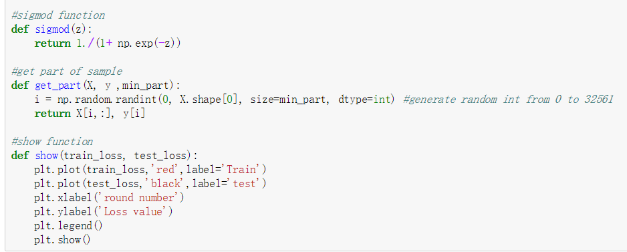

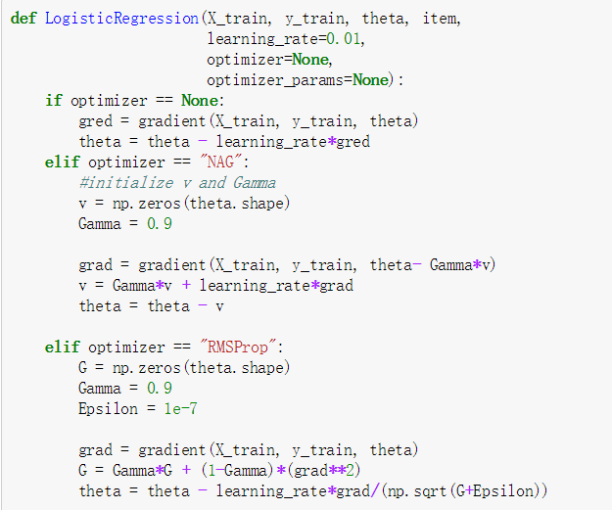

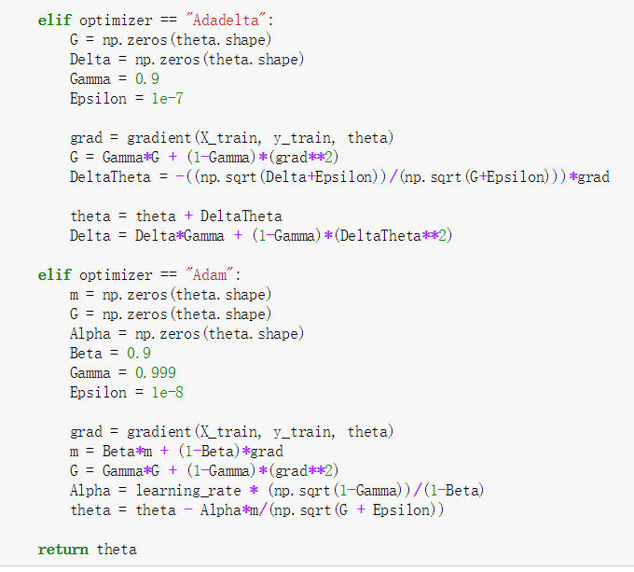

# conclusion

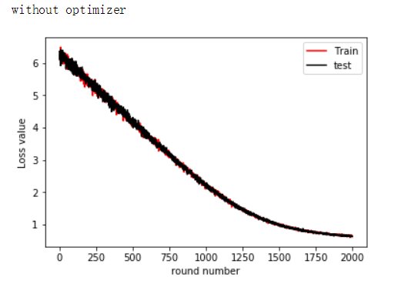

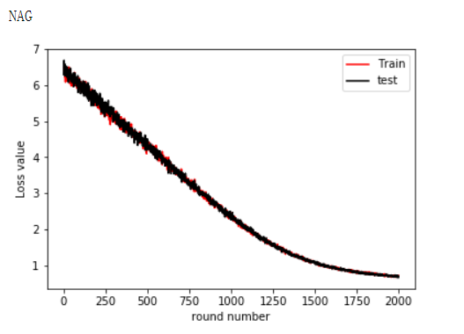

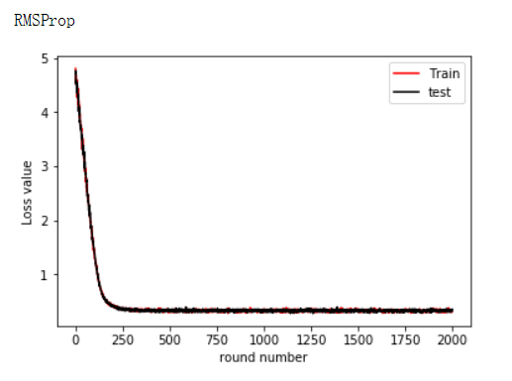

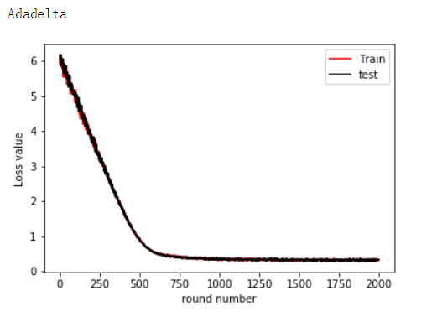

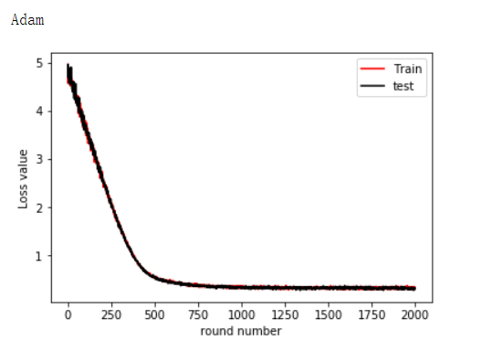

1.