The Experiment Report of Machine Learning



December 9, 2017

Student ID：

201530612033

201530612705

201530611074

Author:

Ruiyong Li

Xin Shu

Xingyang Cai

Grade:

Undergraduate or Graduate

Supervisor:

Qingyao Wu

**SUBJECT:**SOFTWARE ENGINEERING

**SCHOOL:** SCHOOL OF SOFTWARE ENGINEERING

[1]Linear Regression, Linear Classiﬁcation and Gradient Descent

Abstract—

# INTRODUCTION

Motivation

1. Explore the construction of recommended system.
2. Understand the principle of matrix decomposition.
3. Be familiar to the use of gradient descent.
4. Construct a recommendation system under small-scale dataset, cultivate engineering ability.

Dataset

1. Utilizing MovieLens-100k dataset.
2. u.data -- Consisting 10,000 comments from 943 users out of 1682 movies. At least, each user comment 20 videos. Users and movies are numbered consecutively from number 1 respectively. The data is sorted randomly
3. u1.base / u1.test are train set and validation set respectively, seperated from dataset u.data with proportion of 80% and 20%. It also make sense to train set and validation set from u1.base / u1.test to u5.base / u5.test.

# METHODS AND THEORY

Matrix Decomposition; Recommender System; stochastic gradient descent(SGD)

# Experiment

Using stochastic gradient descent method(SGD):

1. Read the data set and divide it (or use u1.base / u1.test to u5.base / u5.test directly). Populate the original scoring matrix  against the raw data, and fill 0 for null values.

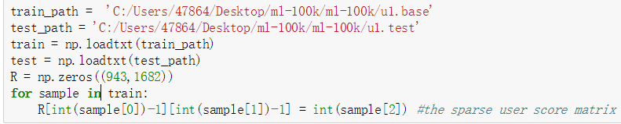

1. Initialize the user factor matrix  and the item (movie) factor matrix , where K is the number of potential features.

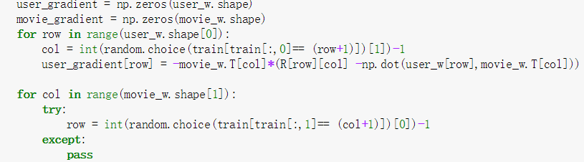

1. Determine the loss function and hyperparameter learning rate  and the penalty factor .

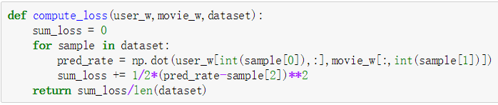

1. Use the stochastic gradient descent method to decompose the sparse user score matrix, get the user factor matrix and item (movie) factor matrix:
   1. Select a sample from scoring matrix randomly;
   2. Calculate this sample's loss gradient of specific row(column) of user factor matrix and item factor matrix;

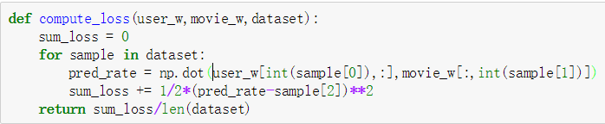

* 1. Use SGD to update the specific row(column) of  and ;

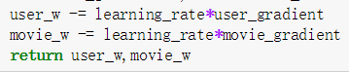

* 1. Calculate the  on the validation set, comparing with the  of the previous iteration to determine if it has converged.

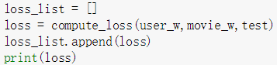

1. Repeat step 4. several times, get a satisfactory user factor matrix P and an item factor matrix Q, Draw a  curve with varying iterations.

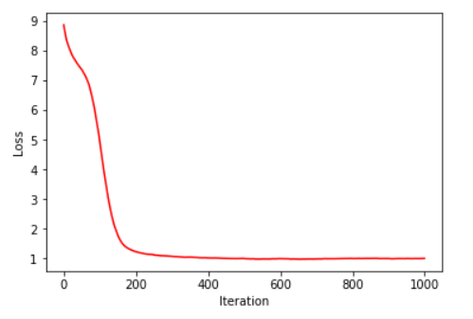

1. The final score prediction matrix  is obtained by multiplying the user factor matrix  and the transpose of the item factor matrix .

# conclusion

From the  curve with varying iterations, we can find that the minimum loss is appeared(0.98002206146) when the iteration is about 543.

1.