Name: Aman Singh
Email ID: Aman.14.Singh@coforge.com / lcsinghaman259@gmail.com
Emp ID: 85010870

GUI TESTING CHECKLIST – INDEED.COM (COMPLETED)

Sr.No. | GUI Description | Steps to Check on Website | Actual Value | Expected Value | Status | Screenshots
1 | Testing the size, position, width, and height of elements on the homepage (search box, Search button, navigation menu) | 1. Go to www.indeed.com  2. Observe the search boxes, Search button, and nav menu  3. Check spacing and alignment | Search boxes and Search button are aligned in one row, evenly sized, no overlap | Elements should be properly sized and positioned without overlap | Pass | 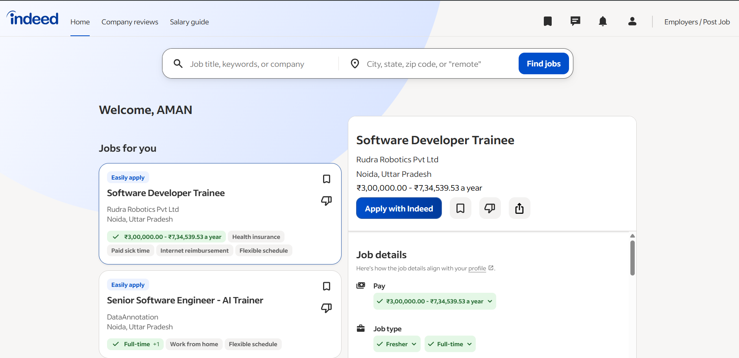
2 | Testing the error messages displayed on Sign in / Registration forms | 1. Click "Sign in"  2. Enter a valid email, click Continue  3. Enter a wrong code  4. Click Sign in | Error message "Invalid email or code" shown in red below the password field | Error messages should be clear, visible, and displayed close to the relevant field | Pass | 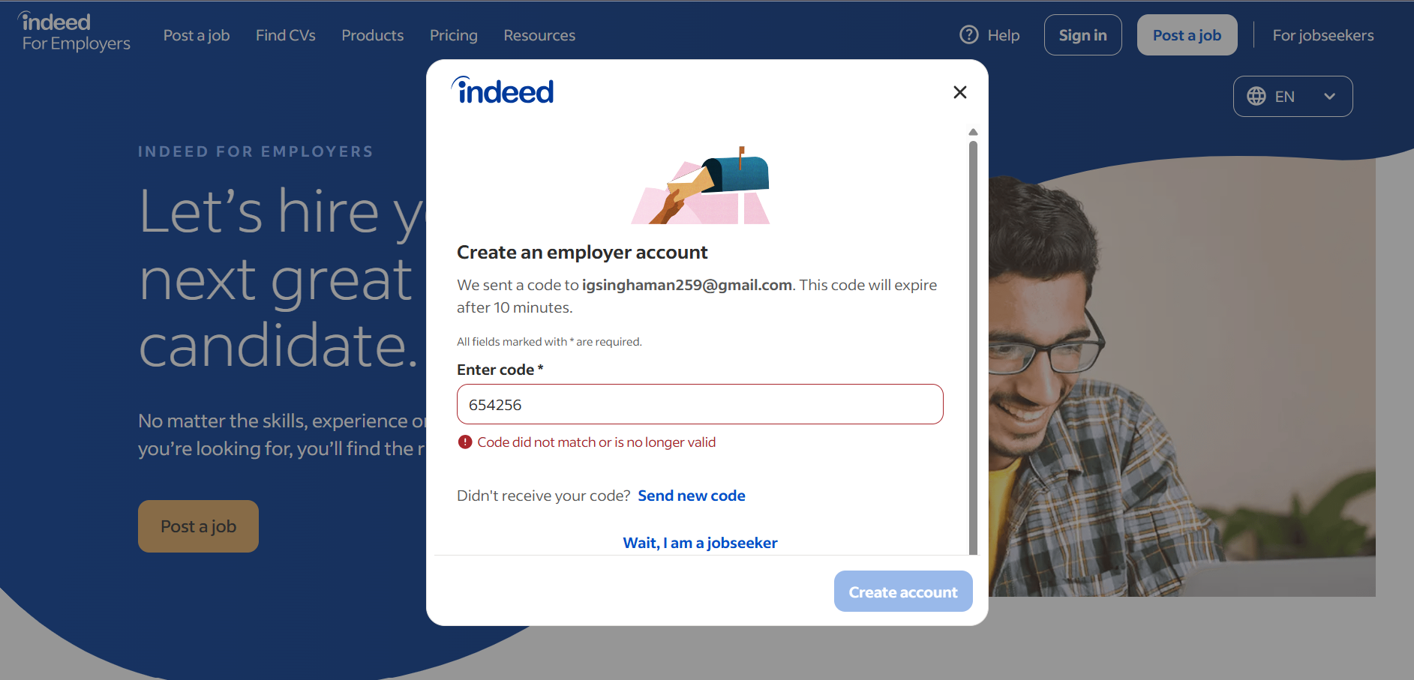
3 | Testing the different sections of the screen (Header, Search bar, Job listings, Footer) | 1. Go to www.indeed.com  2. Scroll from top to bottom  3. Note each section's boundaries | Header, search bar, job listings, and footer are clearly separated with visible spacing | All sections should be clearly separated and properly aligned | Pass | 
4 | Testing whether the font used across pages is readable or not | 1. Open homepage and a Job Details page  2. Read the heading and body text | Font is sans-serif, approx. 14-16px, dark grey/black text on white background | Font should be legible, with adequate size and good contrast | Pass | 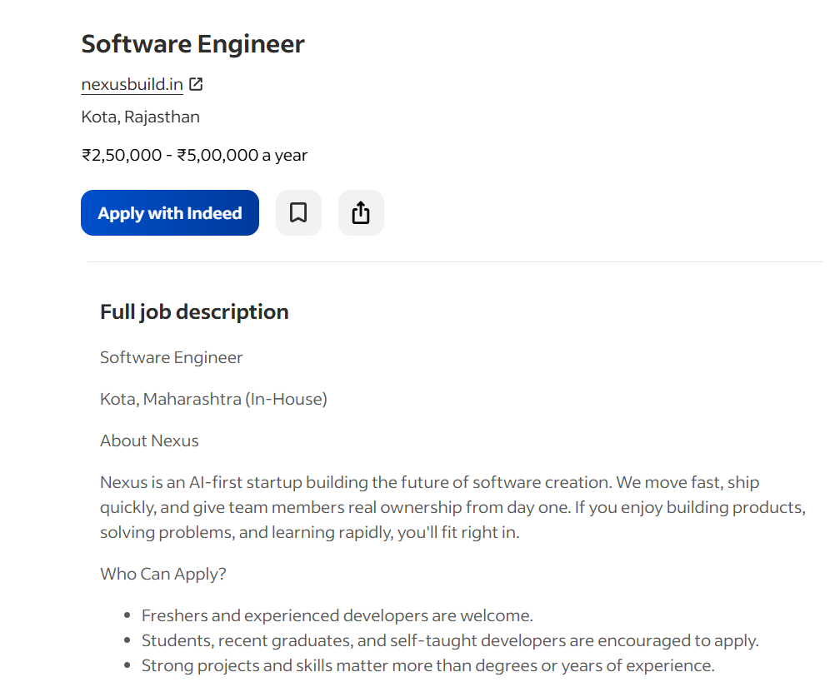
5 | Testing the screen in different resolutions using zoom in and zoom out | 1. Open homepage  2. Press Ctrl + "+" to zoom to 125%, 150%  3. Press Ctrl + "-" to zoom to 80% | At 150% zoom, filter panel does not overlaps job listing text | Layout remain usable and not break at different zoom levels | Pass | 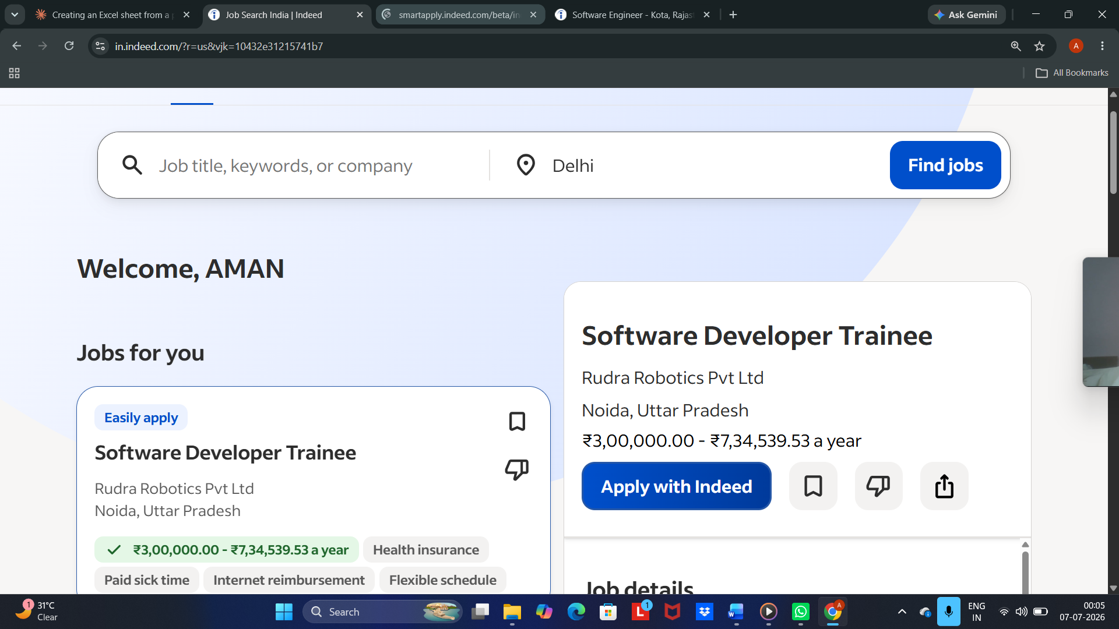
6 | Testing the alignment of texts and elements like icons/buttons on Job Search and Job Details pages | 1. Perform a job search  2. Observe alignment of job title, company, icons and Apply button | Job title, company name, and Apply button are left/right aligned consistently across all cards | All text, icons, and buttons should be properly aligned | Pass | 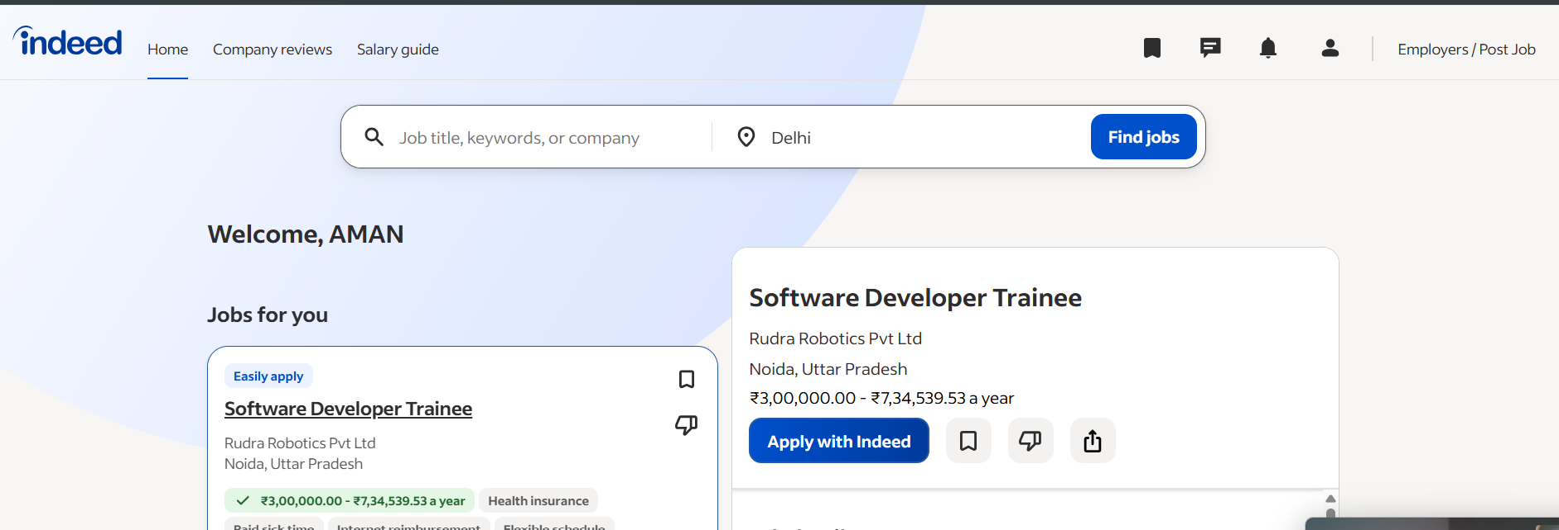
7 | Testing the color of fonts used on headings, body text, and links | 1. Open homepage and Job Details page  2. Compare heading, body text, and link colors | Headings are dark grey/black bold, body text is grey, links are blue | Font colors should be consistent and provide sufficient contrast | Pass | 
8 | Testing whether company logos and job-related images have good clarity | 1. Perform a job search  2. Zoom into company logos on job cards | Logos appear sharp with no pixelation at normal zoom level | Images should load clearly without pixelation or distortion | Pass | 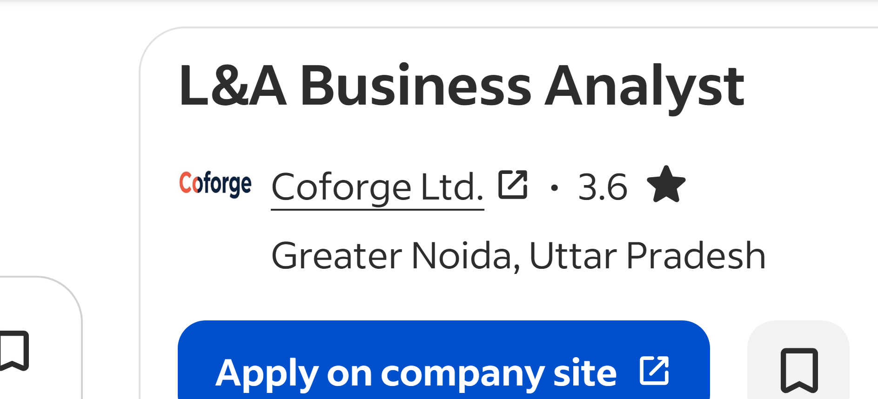
9 | Testing the alignment of images (company logos, profile icon) on Job cards and Profile page | 1. Open search results and Profile page  2. Check logo/icon position relative to text | Logos and profile icon are vertically centered and consistently placed | Images should be aligned consistently within their containers | Pass | 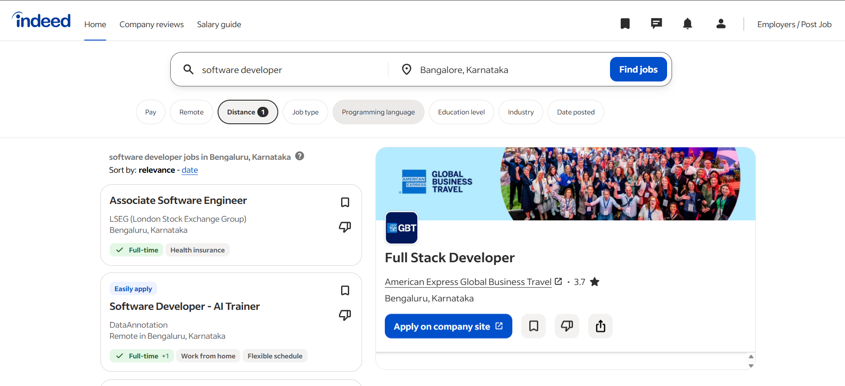
10 | Testing the spelling of text content on homepage, search results, and profile pages | 1. Read all visible text on homepage, results page, and profile page carefully | No spelling or grammatical errors found | There should be no spelling or grammatical errors | Pass | 
11 | Testing that the user does not get frustrated while using the interface (search, filters, apply flow) | 1. Perform a full flow: search job -> apply filter -> open job -> click Apply  2. Count number of steps/clicks | Flow takes 4-5 clicks with no confusing steps or dead ends | Interface should be intuitive with minimal steps | Pass | 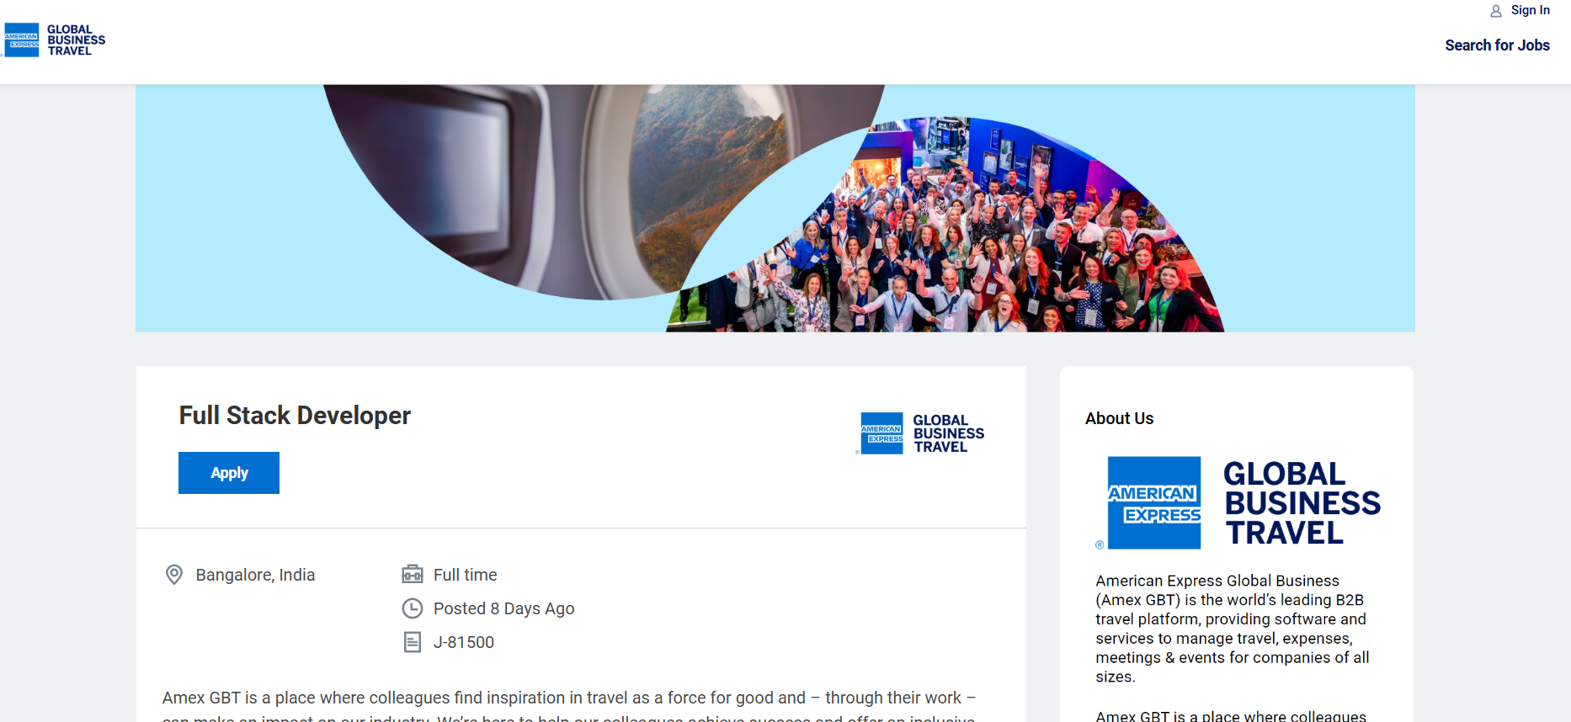
12 | Testing whether the overall interface is attractive and professional looking | 1. Observe overall color scheme, spacing, and typography across pages | Clean blue/white theme, consistent spacing, modern look | Interface should have a clean, modern, visually appealing design | Pass | 
13 | Testing scrollbars on Job Search results page and Job Details panel | 1. Perform a job search with many results  2. Scroll the results list and the details panel separately | Both panels scroll independently and smoothly without lag | Scrollbars should appear only when content overflows and scroll smoothly | Pass | 
14 | Testing disabled fields/buttons, if any | 1. Go to homepage, click Search without entering location  2. Observe Save button before making profile changes | Search button remains clickable even with blank fields (no disabled state used) | Disabled fields/buttons should be visually greyed out and non-clickable | N/A  Indeed does not disable Search button | 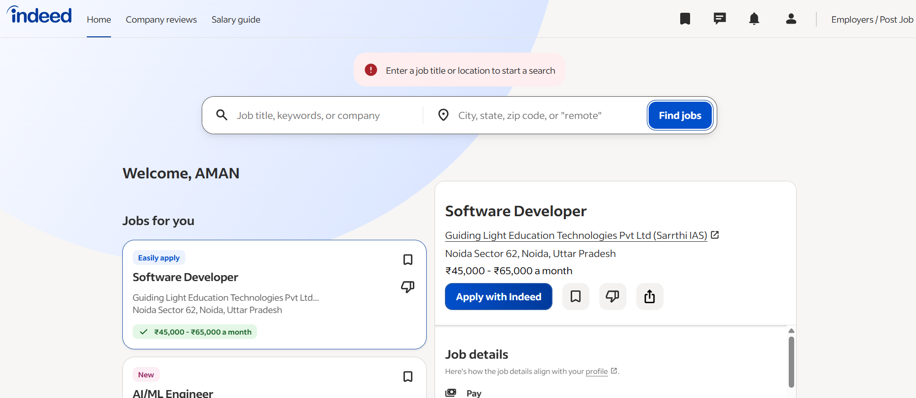
15 | Testing the size of images/icons used (search icon, save/bookmark icon, filter icon) | 1. Observe icon sizes on homepage and search results page | Icons are small (~16-20px), consistent in size across the page | Icons should be appropriately sized, not too small or too large | Pass | 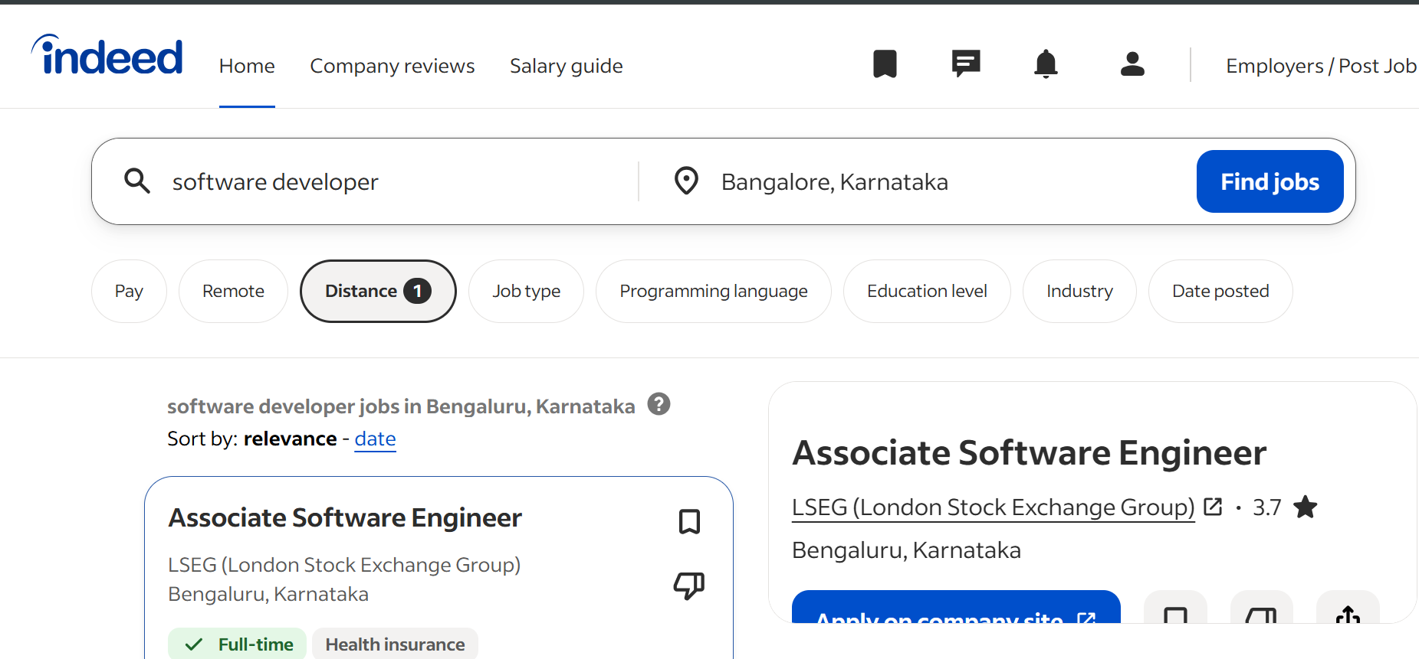
16 | Testing whether headings ("Job Search", "Company reviews", "Find salaries") are properly aligned | 1. Open homepage  2. Check alignment of top navigation headings | All navigation headings are aligned horizontally in a single row | Headings should be consistently aligned as per page design | Pass | 
17 | Testing the color of hyperlinks ("Sign in", "Create an account", footer links) | 1. Observe link color on homepage and footer  2. Hover over a link to check hover effect | Links appear in blue; underline/highlight shows on hover | Hyperlinks should be visually distinct and show a hover effect | Pass | 
18 | Testing UI elements like buttons, text boxes, checkboxes, radio buttons, dropdowns, and links | 1. Interact with Search button, Keyword/Location boxes, Job Type filter, Save icon, Apply button one by one | All elements respond correctly on click/hover with no broken functionality | All UI elements should be functional and behave as expected | Pass | 

