How To Run My Project

Steps

Step1:

Open the following link.

<https://colab.research.google.com/drive/116dT6ek81GOQiESxrTYAMdrLgZtPVqS9?usp=sharing>

Step2:

Because we are using CNNs you will need to set the runtime to GPU instead of CPU. How to do that?

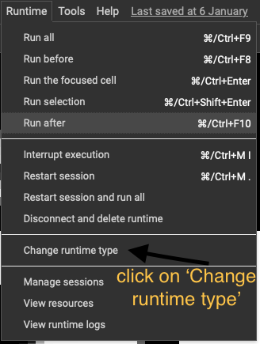

Step 3:

Run the first cell (the cell with all the imports)

Step 4:

Drag into colab the **dataset.zip** folder and unzip it using the cell shown below

Note: the cells that you can see above the ‘!unzip dataset.zip’ were used to preprocess the original images.

Step5:

You may proceed to execute all the cells below the command '!unzip dataset.zip,' with the exception of the last two cells in the application, specifically designed for conducting tests administered to both humans and the CNN.

Step6:  
To run the last cell you will need to drag the testSetProcessed.zip into colab and unzip it using the cell below



After running the unzip cell you will be able to run the last cell that will predict the unlabeled images from that folder.