**Comparing the cost-effectiveness of 2 medical treatments for Chronic Diseases using Markov Analysis**

**Akshay Danthi (0606752)**

**Final Project Report for MSBA – 329**

**Prescriptive Analytics and Optimization**

**MS in Business Analytics**

**Golden Gate University**

**Index**

Executive Summary 3

Introduction 4

Modeling the problem with a Decision Tree 5

Limitations of using Decision Tree 6

Markov Chains – Description 8

Markov Model Structure – Representation of Disease States 9

Construction of a Markov Chain model 10

Markov Matrix and Initial Transitional Probabilities 11

Markov Model Matrix – Setting up the initial parameters: Initial Transitional Probabilities 12

Markov Model Matrix – Setting up the initial parameters - Costs (in USD) and Utility Values (in QALY’s) 13

Running the Markov simulation – Finding Intermediate Transitional Probabilities 14

Running the Markov simulation – Finding the Intermediate Total Expected Costs at each cycle 15

Running the Markov simulation – Finding the Intermediate Total Expected QALY’s (Utility) at each cycle 16

Model output: Comparison of transitional probabilities at   
each cycle 17

Incremental Cost-Effectiveness Ratio (ICER) 18

Conclusion 19

References 20

**Executive Summary**

Chronic diseases are characterized by their long duration and persistent effects on health. The management and assessment of treatments for chronic diseases often hinge on understanding and applying key health economic concepts, such as Cost-Effectiveness and Quality Adjusted Life Years (QALY).

This project, focusing on comparing two treatments for a chronic disease using the Incremental Cost-Effectiveness Ratio (ICER) through Markov Chain simulations, aims to elucidate which treatment offers the best value in terms of cost and patient outcome. This project also aims to provide an overview of how to construct such a comparison, detail the methods involved, and discusses the implications of the findings.

(A Markov chain showing different Transitional Probabilities between the 3 States: Well, Illness, and Dead).

**Introduction**

Chronic diseases are long-lasting conditions with persistent effects on individuals' health, posing continuous demands on healthcare systems. Effective management strategies are crucial not only for improving patient outcomes but also for ensuring economic efficiency. Costs and QALY are fundamental metrics in health economics, offering a way to quantify the balance between the financial inputs into healthcare and the quality and quantity of life outputs.

**Cost-Effectiveness Analysis (CEA)**:

CEA is a method used to compare the costs and health outcomes of two or more interventions. It is particularly useful in determining which treatment provides the best value for money in the management of chronic diseases. The result is often expressed as an ICER, which represents the ratio of the difference in costs to the difference in benefits between two competing options.

**Quality Adjusted Life Years (QALY)**:

QALY is a measure that combines life expectancy with a Quality of Life assessment on a scale from 0 (worst possible health state) to 1 (perfect health). It allows health economists and decision-makers to evaluate the extent to which a treatment can increase the length and quality of life.

**Incremental Cost-Effectiveness Ratio (ICER)**:

ICER is a crucial calculation in health economics for comparing the cost-effectiveness of different treatments. It is calculated by dividing the difference in costs by the difference in effectiveness (measured in QALYs) between two interventions. A lower ICER indicates a more cost-effective treatment option, assuming quality of life and additional years of life are sufficiently valued.

**Markov Chain Simulations in Health Economics**:

Markov Chain models are particularly suited for the study of chronic diseases, where patients transition between various states of health over time. Each state in a Markov model has a set cost, quality of life score, and transition probabilities. By simulating these transitions over time, Markov models can project the long-term costs and health outcomes associated with different treatments.

**Modeling the problem with a Decision Tree**:

The use of a Decision Tree to model the progression and treatment outcomes of a chronic disease offers a structured and intuitive approach to understanding the complexities involved in patient care decisions. By breaking down the disease timeline into distinct decision points and potential outcomes, healthcare providers and researchers can visually and analytically assess the impacts of different interventions.

This problem can be naively modeled using a Decision Tree, as shown in the previous slide, where each branch symbolizes potential events or decision points, leading to further complexities as more outcomes are considered.

Starting with the onset of the disease, the model progresses through critical stages, culminating in the ultimate outcomes: either 'Live' or 'Die’.

The intermediate states, 'Illness' or 'No Illness', reflect the patient's response to treatment, indicating either an ongoing struggle with the disease or a successful mitigation of symptoms.

Each branch and node within the Decision Tree represents key decisions and potential outcomes.

(A decision tree representing the 3 states: Life, illness, death)

**Limitations of using Decision Trees**:

1. **Repetition**:

The highlighted part in Red of the decision tree is a repeat of the Illness node.

When a subject has an illness, they can live or die. If they live and have another illness, they can live or die once again.

This cycle repeats itself over and over in a decision tree.

1. **Inability to reuse**:

With decision trees, there is no return state, i.e. there is no way to represent a patient’s return to illness or no-illness state and to consider the conditional probabilities involved in these successive intermediate states.

Well 🡪 Well

Well 🡪 Illness

Well 🡪 Death

Illness 🡪 Illness

Illness 🡪 Well

Illness 🡪 Death

Death 🡪 Death

**Increasing Complexity**: The inherent complexity of Decision Trees increases significantly as they attempt to model the recursive nature of events in chronic diseases. Each potential event or decision point can lead to multiple outcomes, which then become new decision points themselves, thus creating a web of possibilities that can be daunting to navigate. As the number of stages or cycles of illness and recovery increases, the tree expands dramatically, making it cumbersome to visualize and analyze. This exponential growth in complexity can obscure key insights and make it difficult for healthcare providers to discern the most effective treatment pathways without advanced analytical tools.

**Limited Suitability for Long-Term Projections**: Decision Trees typically illustrate a progression of decisions and outcomes in a linear and unidirectional manner. This structure is not well-suited to accurately representing the often cyclical and fluctuating nature of chronic diseases, where a patient's condition might improve, worsen, and stabilize over time in a non-linear fashion. Chronic diseases often require the ability to revert to previous states or jump between different states unexpectedly, which linear models like Decision Trees fail to capture. This limitation restricts their usefulness in long-term disease management planning, where flexibility and adaptability in modeling are crucial.

**Computational Demands and Rigidity**: The static structure of Decision Trees necessitates considerable computational effort to build, especially as the complexity of the tree increases. They require a large amount of data to define the various pathways and outcomes accurately. Moreover, once a Decision Tree is constructed, incorporating new data or insights into the model is not straightforward. This rigidity means that the tree may not reflect the latest treatment advancements or changes in a patient's condition, limiting its practical application in dynamic clinical environments where conditions and treatments can change rapidly.

**Reduced Predictive Capability**: One of the key limitations of using Decision Trees in the context of chronic diseases is their lack of feedback loops. In real-world clinical scenarios, the condition of a patient often influences and alters the course of treatment, requiring a model that can adapt and learn from each outcome. Without the ability to incorporate feedback from previous outcomes, Decision Trees struggle to accurately predict future states in diseases that exhibit high variability and require frequent reassessment. This diminished predictive capability makes them less effective for diseases that are not well-understood or highly individualistic in how they progress and respond to treatments.

Each of these points highlights critical limitations and considerations that need to be addressed when employing Decision Trees in the modeling of chronic disease pathways. Understanding these challenges is essential for healthcare professionals and researchers as they strive to create more accurate and effective tools for disease management and treatment decision-making.

**Markov Chains - Description**

A Markov model is a mathematical model used to describe systems that transition from one state to another. It is characterized by the property that the future state depends only on the current state, not on the sequence of events that preceded it. This memoryless property is known as the Markov property, making these models particularly useful for modeling random processes where history does not directly inform the future.

**Key Components of Markov Models**:

**States**: In Markov models, states represent the various conditions or statuses that the subject, such as a patient, might occupy at any given time. In healthcare applications, typical states within a Markov model include "Well", indicating good health; "Ill", indicating a state of disease or decline; and "Dead". These states are exhaustive and mutually exclusive, meaning every possible condition of the subject is covered and no subject can be in more than one state at a time.

**Transitions**: Transitions are the movements between states, governed by set probabilities. These probabilities are often derived from clinical data or expert opinions, providing a quantitative basis for predicting future states based on current conditions. The model evolves over time by moving between these states at discrete time intervals, typically reflecting the periodic assessment of a patient’s condition.

**Transition Probabilities**: The probabilities of transitioning from one state to another within a given cycle or time period are central to the functionality of Markov models. These probabilities are non-negative and sum to 1 for all possible transitions from any given state, ensuring that some kind of transition occurs in each cycle. For instance, if a patient is currently "Well", the next state could be either remaining "Well", transitioning to "Ill", or in dire circumstances, becoming "Dead". The sum of probabilities for these transitions must equal 1.

**Utility of Markov Models in Healthcare**:

Markov models are particularly valuable in healthcare for several reasons:

1. Chronic Disease Management: They are ideal for modeling chronic diseases, where patients frequently move between disease states (like remission and relapse) over time.

2. Treatment Evaluation: They help in evaluating the effectiveness and cost-effectiveness of new drugs and treatments, by simulating long-term outcomes based on short-term clinical trial data.

3. Policy Making: Healthcare policymakers utilize Markov models to understand the potential impacts of healthcare decisions and to allocate resources effectively.

**Advantages of Using Markov Models**:

**Simplicity and Flexibility**: Markov models are relatively simple to understand and can be easily adapted as new data becomes available or as treatment protocols change.

**Predictive Power**: They provide a powerful way to predict future health states based on current data, which is invaluable for planning patient care and managing healthcare systems.

**Markov Model Structure – Representation of Disease States**:

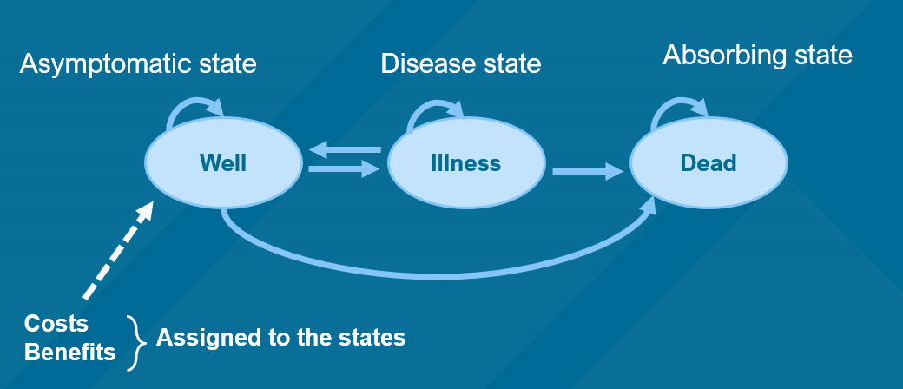

The diagram presents a simplified structure of a Markov model as applied to a healthcare context, mapping out the progression of a disease through various states. These states are represented as "Well," "Illness," and "Dead," and the model allows for transitions between these states over discrete time intervals, typically corresponding to the cycles of treatment or progression of the disease.  
  
**Asymptomatic State - "Well"**:

The "Well" state signifies a phase where the patient is asymptomatic; they do not exhibit symptoms of the disease. This could either be due to the successful management of the disease, where the patient is in remission, or it could represent the initial state before the disease's onset. The transition from this state to "Illness" represents the occurrence of symptoms or the exacerbation of the disease.

**Disease State - "Illness"**:

The "Illness" state reflects periods when the patient is symptomatic or the disease is active. The transitions to and from this state denote the fluctuating nature of many chronic conditions where patients may experience periods of relapse and remission. Importantly, transitions can occur back to the "Well" state, representing recovery or effective control of symptoms, as well as forward to the "Dead" state, reflecting a deterioration in the patient's condition.

**Absorbing State - "Dead"**:

The "Dead" state is known as an absorbing state, indicating that once entered, there are no further transitions to other states; it is the final state within the model. In healthcare models, this state reflects the end of the patient journey and is a critical component for evaluating the severity and progression of a disease as well as the effectiveness of treatment over time.

**Construction of a Markov Chain model to represent this problem and to perform the Cost-Benefit analysis of 2 Treatments for a Chronic Disease**

Let’s say the state tp1 is a patient being well and remaining well. tp2 represents a patient becoming ill after being well and tp3 represents a patient dying from an illness.

Since these are mutually exclusive states, tp1 would be equal to (1-tp2-tp3), as all the probabilities add up to 1. The same applies to tp4, tp5, tp6 and tp7 states.

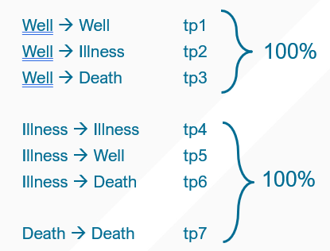

As mentioned earlier, tp1 = 1-tp2-tp3, and vice-versa for tp2 and tp3.  
Similarly, tp4 = 1-tp5-tp6, and vice-versa for tp5 and tp6.

**Markov Matrix and Initial Transitional Probabilities**:

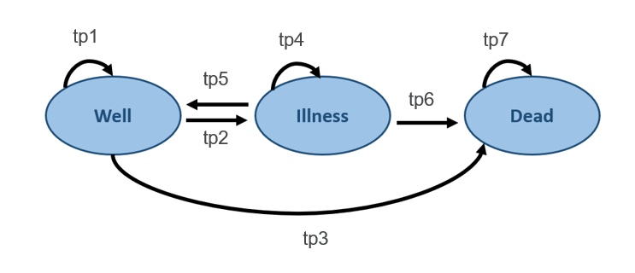

|  |  |  |  |
| --- | --- | --- | --- |
| **From / To** | **Well** | **Illness** | **Dead** |
| **Well** | tp1  (1 – tp2 – tp3) | tp2 | tp3 |
| **Illness** | tp5 | tp4  (1 – tp5 – tp6) | tp6 |
| **Dead** | 0 | 0 | tp7 |

Here, the probabilities for dead->well and dead->illness are defined as 0.

Similarly, the probability of a patient remaining in dead state after death is defined as 1.

The dead state is the Absorbing State in our Markov Model.

This definition reflects the fundamental concept of an Absorbing State in a Markov model, where once entered, no other transitions are possible. The absorbing nature of the "Dead" state means that it is terminal and conclusive in the model's context, ensuring that the simulation of the patient's journey through various health states realistically terminates at this point.

Thus, the model accurately mirrors the irreversible nature of death, providing a realistic framework for predicting and understanding patient trajectories in a healthcare setting.

**Markov Model Matrix – Setting up the initial parameters: Initial Transitional Probabilities**

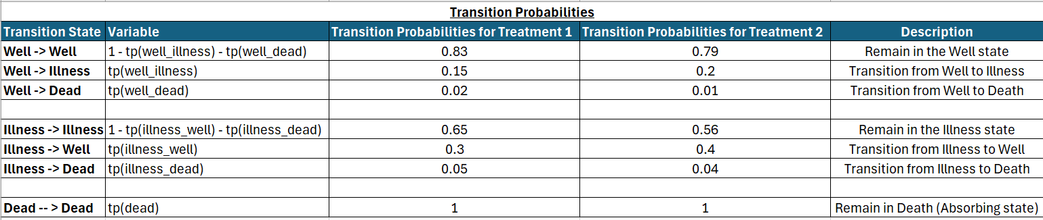

**The probabilities in the red box are the Initial Transitional Probabilities for Treatment 1.**

**Similarly, the probabilities in the green box are the Initial Transitional Probabilities for Treatment 2.**

In the given Markov Model Matrix, the transition probabilities between states under two different treatments are presented. These probabilities are essential in understanding the dynamics of patient health status progression under each treatment scenario. For instance, under Treatment 1, the probability of a patient remaining well is 0.83, whereas, for Treatment 2, this probability is slightly lower at 0.79, suggesting a slight difference in the effectiveness or stability of the patient's health in the "Well" state between the two treatments.

The transition from "Illness" to "Well" reflects the recovery rate, which is higher in Treatment 2 (0.4) as compared to Treatment 1 (0.3). This indicates that patients have a better chance of recovering from illness under Treatment 2 within the given time cycle. Conversely, the transition from "Illness" to "Death" is lower in Treatment 2 (0.04) than in Treatment 1 (0.05), which may suggest that Treatment 2 is slightly more effective in reducing mortality.

The "Dead" state, highlighted as an Absorbing State, confirms that once patients transition to this state, they cannot transition back to any other state. The transition probability for "Dead" -> "Dead" is 1 for both treatments, which is a standard convention in Markov models as it reflects the permanence of the death state.

**Markov Model Matrix – Setting up the initial parameters - Costs (in USD) and Utility Values (in QALY’s)**In the assessment of the cost-effectiveness of different treatments for a given condition, assigning monetary values to each health state under the different treatment options is a fundamental step.

The 'Well' state incurs a cost of $500 under Treatment 1 and a slightly higher cost of $600 under Treatment 2. For the 'Illness' state, the cost difference is more pronounced, with Treatment 1 associated with a cost of $2,000, while Treatment 2 is considerably less at $900. No costs are assigned to the 'Dead' state, reflecting the end of treatment expenses.

Utility values, expressed in Quality Adjusted Life Years (QALYs), are entered in the fourth and fifth columns, representing the quality of life experienced by a patient in each state under the respective treatments. For the 'Well' state, the utility is the same for both treatments, valued at 1 QALY, indicating full health. For the 'Illness' state, the utility is 0.5 under Treatment 1, which suggests that the quality of life is half of what would be experienced in full health. Under Treatment 2, the utility for 'Illness' is slightly lower at 0.45 QALYs, implying a marginally reduced quality of life compared to Treatment 1. In the 'Dead' state, the utility is 0 for both treatments, as expected.

These inputs are crucial for conducting a Markov analysis, as they allow for the calculation of expected costs and QALYs over the course of the disease. They feed into the model's simulations to project long-term outcomes, such as the cost per QALY gained, which is a standard measure used to assess the value for money of a treatment in health economics. By comparing these projections, decision-makers can prioritize treatments based on the maximization of patient welfare subject to budget constraints.

When interpreting this data in the context of a Markov decision analysis, it's essential to note that while Treatment 2 appears to be more cost-effective for the 'Illness' state, the slightly lower utility value indicates a trade-off between cost and quality of life. These trade-offs are at the heart of health economic evaluations and inform critical healthcare decisions, such as which treatment to fund or recommend in clinical guidelines.

**Running the Markov simulation – Finding Intermediate Transitional Probabilities**

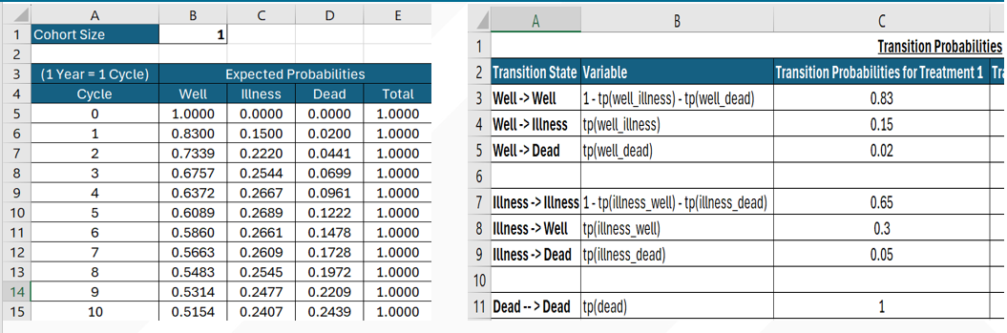

**The intermediate values for Transitional Probabilities for Well, Illness and Dead are calculated by the following formulae**:  
  
**Intermediate Well TP** = [(Previous Well Cycle TP) * (Initial Well -> Well TP)] + [(Previous Illness Cycle TP) * (Initial Illness -> Well TP)].  
 **Intermediate Illness TP** = [(Previous Well Cycle TP) * (Initial Well -> Illness TP)] + [(Previous Illness Cycle TP) * (Initial Illness -> Illness TP)].  
 **Intermediate Dead TP** = [(Previous Well Cycle TP) * (Initial Well -> Dead TP)] + [(Previous Illness Cycle TP) * (Initial Illness -> Dead TP)] + [Previous Dead Cycle TP]

The intermediate transition probabilities (TPs) are dynamic and pivotal in a Markov model, as they represent the likelihood of transitioning between health states in subsequent cycles, influenced by the probabilities in the initial cycle and the transitions that occurred in previous cycles.

By utilizing the aforementioned formulae, the Markov model can iteratively update the transition probabilities for each health state:

Intermediate Well TP accounts for the proportion of the cohort that remains well due to the stability of their current state and the proportion that returns to well from illness.

Intermediate Illness TP calculates the new cases of illness arising from the well population, along with the ongoing cases from the previously ill population.

Intermediate Dead TP sums the probabilities of death from both well and illness states, as well as accounting for those already in the dead state from the previous cycle.

**Running the Markov simulation – Finding the Intermediate Total Expected Costs at each cycle**

**The intermediate Total Expected Cost at each cycle is calculated by**:  
  
In a Markov model, calculating the Total Expected Costs involves a systematic process that integrates both the transitional probabilities and the costs associated with each health state for a given treatment. To elucidate this calculation, consider the following steps performed at each cycle of the simulation:

**Determine State-Specific Costs**: For each health state (Well, Illness, Dead), multiply the state's transitional probability for that cycle by the initial cost assigned to the state for the chosen treatment. This reflects the cost incurred by the cohort members who are in each state during that cycle. For example, if the transitional probability for being in the 'Well' state in a certain cycle is 0.7, and the cost for being 'Well' is $500, the expected cost for that state in that cycle is 0.7 * $500.

**Aggregate State Costs**: Sum the expected costs across all health states to find the Total Expected Cost for that cycle. Continuing with the previous example, if the expected costs for 'Illness' and 'Dead' are $1,400 and $0 respectively, then the Total Expected Cost for the cycle would be $500 (from 'Well') + $1,400 (from 'Illness') + $0 (from 'Dead').

**Repeat for Each Cycle**: This calculation is repeated for each cycle (year) of the simulation. The results will yield the Total Expected Cost for each cycle, providing insight into how the costs may evolve as the cohort transitions between states over time.

**Sum Over All Cycles**: To find the cumulative cost over the entire simulation period, sum all the Total Expected Costs from each cycle. This sum represents the lifecycle cost of the treatment for the cohort size set in the model.

The output of this calculation is a crucial input for cost-effectiveness analysis in health economics. It provides an estimate of the financial burden of a treatment across a projected timespan, which, when combined with the quality of life adjustments (QALYs), can be used to determine the cost per QALY gained—a common measure to assess whether a treatment provides good value for money in the context of healthcare decision-making.

**Running the Markov simulation – Finding the Intermediate Total Expected QALY’s (Utility) at each cycle**

To evaluate the effectiveness of medical interventions within a Markov model, not only costs but also the quality-of-life gains, typically measured in Quality Adjusted Life Years (QALYs), must be quantified over time. The process for calculating the total expected QALYs (or utility) at each cycle in a Markov simulation involves several key steps:

State-Specific Utility Calculation: For each health state, calculate the expected utility for that cycle by multiplying the state's transitional probability by the initial utility value assigned to that state for the treatment. The utility values represent the quality of life experienced by a patient in each state. For example, if the probability of being 'Well' is 0.7 and the utility value for 'Well' is 1 QALY, the expected utility for the 'Well' state in that cycle would be 0.7 * 1 QALY.

Summation of Cycle-Specific Utilities: After calculating the expected utilities for all health states within a cycle, sum these values to obtain the total expected QALYs for that cycle. This step is analogous to the calculation of total expected costs, but instead of financial figures, we are now summing the utility values, which are indicators of the patients' quality of life during that cycle.

Repeating the Process Across Cycles: Perform the above calculations for each cycle to reflect changes in health states and transition probabilities over time. This series of calculations gives a cycle-by-cycle account of the QALYs accrued, painting a dynamic picture of the intervention’s impact on patients' quality of life.

Calculating Cumulative QALYs: To determine the overall effectiveness of a treatment, sum the total expected QALYs across all cycles of the simulation. This cumulative figure represents the aggregate quality of life benefit provided by the treatment across the entire simulated time horizon.

The resultant metric, total expected QALYs, is a cornerstone of health economic evaluation. When combined with total expected costs, it allows analysts to compute cost-effectiveness ratios, such as the incremental cost per QALY gained, which are essential for comparing the value of different healthcare interventions.

**Model output: comparison of transitional probabilities at each cycle**

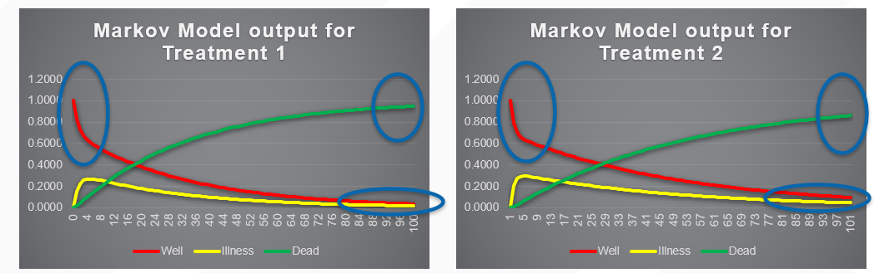

The visual output from the Markov models for Treatment 1 and Treatment 2 over 100 cycles, representing the transitional probabilities for 'Well', 'Illness', and 'Dead' states, offers insightful contrasts between the two treatment strategies. These differences are critical in understanding the long-term implications of each treatment option.

In the blue circled areas on the graphs, we notice a stark divergence in the trends for the 'Well' state. Under Treatment 2, there's a pronounced steep decline in the probability of patients remaining 'Well', indicating that this treatment may be less effective at maintaining patient wellness over time compared to Treatment 1, which shows a more gradual decline. This could be due to several factors including the efficacy of the treatment, patient adherence, or the nature of the disease progression under each treatment modality.

The transition to the 'Dead' state, as indicated by the red line, also shows a notable difference between treatments. Treatment 1's graph suggests that the likelihood of death approaches 1 more rapidly than with Treatment 2. This could imply that Treatment 1, while perhaps better at maintaining a state of wellness for longer, does not ultimately extend life expectancy as effectively as Treatment 2. In contrast, the lower terminal probability for the 'Dead' state under Treatment 2 suggests that this option may offer a survival advantage, although it may result in more prolonged periods of illness, as indicated by the 'Illness' probability curve (yellow line).

These observations could reflect the quality and nature of each treatment—whether one is more aggressive in early stages but with more severe long-term consequences, or if the other offers a more conservative approach that results in a slower disease progression and possibly an extended life span. It's also important to consider the quality of life associated with each state; a treatment that better maintains the 'Well' state is likely to result in higher QALYs, even if it doesn't substantially extend lifespan.

In summary, these graphs provide a visual and quantitative foundation for comparing the two treatments in terms of both short-term outcomes and long-term prognosis. When making decisions based on these models, it is essential to consider not only the probability of being in each state but also the impact on patients' quality of life and the associated healthcare costs.

**Incremental Cost-Effectiveness Ratio (ICER)**

The Incremental Cost-Effectiveness Ratio (ICER) is a fundamental metric in health economics, representing the ratio of the difference in costs to the difference in effectiveness of two comparative health interventions. It is a decision-making tool used to prioritize healthcare spending effectively, especially when resources are limited. The ICER provides a quantitative framework to guide decisions regarding whether the additional investment required for a new treatment is justified by the health benefits it delivers over an alternative.

**The ICER is particularly helpful for various stakeholders**:

* Policymakers can use it to allocate healthcare budgets efficiently, ensuring that the population derives maximum benefit from the available funds.
* Insurers employ ICER calculations to determine which treatments to include in their coverage plans.
* Healthcare providers use it to decide on the best treatment protocols to recommend to their patients, considering both the costs and potential health benefits.

**How ICER Is Calculated**:

To compute the ICER, one needs to know the cost and utility values of two treatment options. The standard option, often the incumbent or most widely used treatment, serves as a baseline against which the new treatment is evaluated. Here:

Treatment 1 is considered the standard treatment.

Treatment 2 is the new treatment being evaluated.

The formula for ICER is:

Where,

ΔC (Delta C) is the change in cost between the new treatment (Treatment 2) and the standard treatment (Treatment 1). This figure is obtained by subtracting the total expected cost of Treatment 1 from the total expected cost of Treatment 2 over the simulation period.

ΔE (Delta E) is the change in effectiveness, typically measured in terms of utility, between the new treatment and the standard treatment. This is calculated by subtracting the total expected utility (QALYs) of Treatment 1 from the total expected utility of Treatment 2.

By dividing the incremental costs (ΔC) by the incremental effectiveness (ΔE), we get a ratio that tells us about the additional cost per additional unit of effectiveness (usually per QALY gained). The lower the ICER, the more cost-effective the new treatment is considered to be relative to the standard treatment.

**Conclusion**

**Thus, we conclude that Treatment 2 is better based on our simulation parameters and calculation of Transitional Probabilities, Costs (in USD) and QALYs involved.**



In summarizing the findings of this Markov model simulation and subsequent analysis, we reach the conclusion regarding the comparison between two treatment options for a chronic condition. Treatment 2 emerges as the superior choice when evaluated against the simulation parameters, which encompass Transitional Probabilities, associated Costs (in USD), and Quality Adjusted Life Years (QALYs).

**Cost and Utility Calculations:**

The simulation aggregates costs and utilities across all health states and cycles to determine the overall impact of each treatment. The Total Cost for a treatment is the sum of costs incurred in each state—'Well', 'Illness', and 'Dead'—throughout the treatment cycles. Similarly, the Total Utility is the sum of all QALYs accumulated across these states for the duration of the simulation.

**Incremental Analysis**:

The incremental analysis, a cornerstone of cost-effectiveness evaluation, involves the comparison of Treatment 2 against Treatment 1. The Incremental Costs, calculated as the difference in total costs between the treatments, amount to an additional $158.66 for Treatment 2. In contrast, the Incremental Utility, representing the difference in total QALYs, is a decrease of 9.12 QALYs when moving from Treatment 1 to Treatment 2.

**ICER Determination**:

The Incremental Cost-Effectiveness Ratio (ICER) is derived by dividing the Incremental Costs by the Incremental QALYs, which results in an ICER of -$17.39/QALY. Under typical circumstances, ICER values are positive, reflecting the cost incurred for each additional unit of health benefit gained. However, in this analysis, the negative ICER signifies that Treatment 2 is both less expensive and more effective—termed as 'dominant' in health economic evaluations—over Treatment 1.

This dominance indicates that Treatment 2 not only reduces costs but also improves patient outcomes in terms of QALYs, making it the unequivocally preferable option within the simulation's parameters. Treatment 2, as per the simulation data, stands out as the more cost-effective strategy, presenting a compelling case for its adoption in clinical practice. Yet, the adoption of any healthcare intervention must be grounded in a multifaceted assessment that includes, beyond economic analysis, considerations of patient preferences, societal values, and ethical dimensions of healthcare provision.

**References**

1. **Sonnenberg, F. A., & Beck, J. R. (1993). Markov models in medical decision making. *Medical Decision Making*, *13*(4), 322–338. https://doi.org/10.1177/0272989x9301300409**
2. **Green, N., Lamrock, F., Naylor, N., Williams, J., & Briggs, A. (2022). Health economic evaluation using Markov models in R for Microsoft Excel Users: A tutorial. *PharmacoEconomics*, *41*(1), 5–19. https://doi.org/10.1007/s40273-022-01199-7**
3. **Edlin, R., McCabe, C., Hulme, C., Hall, P., & Wright, J. (2015). Building a markov cost effectiveness model in Excel. *Cost Effectiveness Modelling for Health Technology Assessment*, 133–143. https://doi.org/10.1007/978-3-319-15744-3_9**
4. **Komorowski, M., & Raffa, J. (2016). Markov models and Cost Effectiveness Analysis: Applications in Medical Research. *Secondary Analysis of Electronic Health Records*, 351–367. https://doi.org/10.1007/978-3-319-43742-2_24**