1----------------

esto es en myApp.js

var express = require('express');

var app = express();

console.log("Hello world");

-----------------

2----------------

sigue siendo en myApp.js

var express = require('express');

var app = express();

app.get("/", (req, res) => {

res.send("Hello Express");

});

-----------------

3----------------

sigue siendo en myApp.js

var express = require('express');

var app = express();

app.get("/", function(req, res) {

res.sendFile(__dirname + "/views/index.html");

});

----------------

4---------------

sigue siendo en myApp.js

var express = require('express');

var app = express();

app.use("/public", express.static(__dirname + "/public"));

----------------

5---------------

sigue siendo en myApp.js

var express = require('express');

var app = express();

app.get("/json", (req, res) => {

res.json({

message: "Hello json"

});

});

----------------

6---------------

sigue siendo en myApp.js

----------------

7---------------

sigue siendo en myApp.js

var express = require('express');

var app = express();

app.use((request, response, next) => {

console.log(request.method + " " + request.path + " - " + request.ip);

next();

});

module.exports = app;

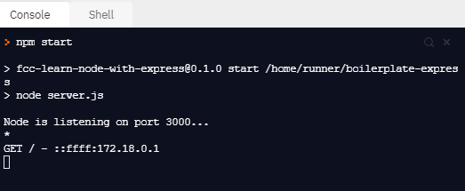

----------------

8---------------

sigue siendo en myApp.js

var express = require("express");

var app = express();

app.get(

"/now",

(request, response, next) => {

request.time = new Date().toString();

next();

},

(request, response) => {

response.json({ time: request.time });

}

);

module.exports = app;

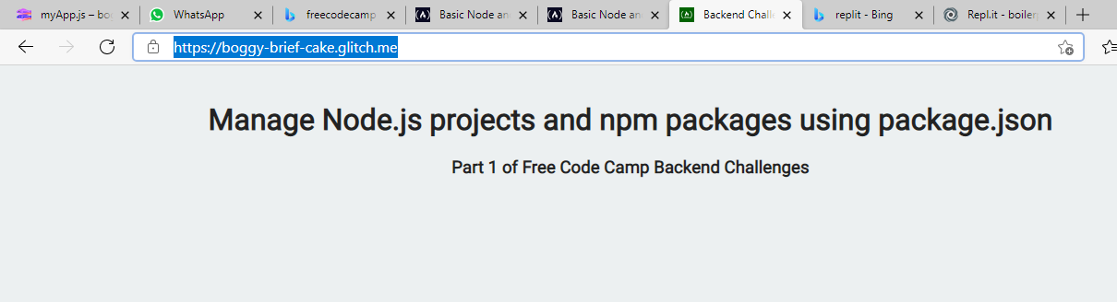

---------------

9---------------

sigue siendo en myApp.js

var express = require('express');

var app = express();

app.get("/:word/echo", (req, res) => {

const { word } = req.params;

res.json({

echo: word

});

});

----------------

10---------------

sigue siendo en myApp.js

app.get("/name", function(req, res) {

var firstName = req.query.first;

var lastName = req.query.last;

var { first: firstName, last: lastName } = req.query;

res.json({

name: `${firstName} ${lastName}`

});

});

----------------

11---------------

sigue siendo en myApp.js

var express = require('express');

var app = express();

var bodyParser = require("body-parser");

app.use(bodyParser.urlencoded({ extended: false }));

console.log("body-Parser");

----------------

12--------------

var express = require('express');

var app = express();

let bodyParser =require('body-parser')

app.post(

"/name",

bodyParser.urlencoded({ extended: false }),

(request, response) => {

let string = request.body.first + " " + request.body.last;

response.json({ name: string });

}

)

module.exports = app;

----------------