Political Ideology and Attitudinal Ambivalence: Investigating the Role of Ideological Extremity

Axel M. Burger  
GESIS – Leibniz Institute for the Social Sciences, Mannheim, Germany

**Author Note**

Please direct correspondence concerning this article to Dr. Axel M. Burger, GESIS – Leibniz Institute for the Social Sciences, P.O Box 12 21 55, 68072 Mannheim, Germany, E-Mail: axel.burger@gesis.org, FAX: +49 621-1246 100.

Parts of this work have been presented at the Annual Meeting of the International Society of Political Psychology (ISPP) 2022 in Athens, Greece, and at the 2022 online meeting of the German Political Psychology Network.

Abstract

[…]

**Ideological Extremity and Attitudinal Ambivalence**

One of the most prominent definitions of attitudes conceptualizes them as “a psychological tendency that is expressed by evaluating a particular entity with some degree of favor or disfavor” (Eagly & Chaiken, 1993, p. 1). However, attitudes are often more complex than this definition makes it seem at first sight. For example, attitudes involve affective, cognitive, and behavioral components and types of attitudes can vary in the extent to which they are based on these different components. Furthermore, individuals can have positive and negative evaluative reactions toward the same attitude object at the same time (e.g., Cacioppo et al., 1997). That is, attitudes can be ambivalent (e.g., Thompson et al., 1995). It seems reasonable to expect that this is particularly likely in the case of political attitudes, where individuals are continuously exposed to a multitude of conflicting pieces of information and opinions about the same attitude object such as a particular politician, a political party, or a policy proposal. However, the tools used in surveys to measure political attitudes do very often not allow to capture the complexity of these attitudes.

The present research investigates whether and how political-ideological orientations of individuals are associated with the extent to which they tend to hold ambivalent political attitudes. The prediction that such a link exists follows from a long history of theorizing and empirical findings on the associations of ideological orientations with thinking styles and from the assumption that individual differences in thinking styles have implications for the structure and complexity of the attitudes that these individuals hold. Interestingly, extant empirical findings of research on this question are inconsistent: While findings by Krochik, Jost, and Nosek (2007; reported in Jost & Krochik, 2014) suggest a stable tendency for more conservative (vs. more liberal) individuals to hold less ambivalent attitudes, findings by Newman and Sargent (2020; Sargent & Newman, 2020) indicate an association in the opposite direction.

In the following, after briefly introducing the concept of attitudinal ambivalence, I describe the theoretical explanations for the opposite predictions/findings of previous research and propose a third perspective. In the empirical part, I use data from large electoral surveys that allow for quantifying the ambivalence of political attitudes to test the predictions that follow from the three theoretical perspectives.

**Attitudinal Ambivalence**

Attitudinal ambivalence refers to the simultaneous existence of strong positive *and* strong negative evaluative reactions toward the same attitude object (e.g., Conner & Sparks, 2002; Haddock & Maio, 2019; Jonas et al., 2000; Thompson et al., 1995; van Harreveld et al., 2015). This definition makes clear that attitudinal ambivalence is conceptually distinct from indifference where an attitude object elicits weak evaluative reactions overall. Attitudinal ambivalence can emerge *within* affective, cognitive, and behavioral attitude components as well as *between* attitude components. The present research focuses on ambivalence within the affective and the cognitive attitude component. Furthermore, it is possible to distinguish between *subjective* ambivalence, which refers to the self-reported experience of ambivalence, and *objective* (or *potential*) ambivalence, which refers to the simultaneous presence of opposite evaluative reactions. Research shows that the extent to which objective ambivalence leads to a subjective experience of ambivalence depends on several boundary conditions (see van Harreveld et al., 2015). The present research focuses on objective ambivalence.

**The Rigidity of the Right Hypothesis**

As mentioned above, the prediction that ideological orientations are linked to a tendency to hold more or less ambivalent attitudes follows from considerations concerning the association of ideological orientations with thinking styles. One of the most prominent theoretical perspectives in this respect is the rigidity-of-the-right hypothesis (Tetlock, 1983), which can be traced back to early work on the psychological bases of authoritarianism (Adorno et al., 1950). According to this view and the closely related ideology-as-motivated-social-cognition theory (Jost, 2017; Jost et al., 2003, 2009), strong needs for security (existential needs) and certainty (epistemic needs) facilitate the endorsement of conservative political views that can be characterized by two core elements: (a) resistance to change and (b) acceptance of inequality. Strong epistemic needs, on the other hand, are associated with a rigid cognitive style. In line with this reasoning, numerous studies have documented associations between conservatism and measures that reflect a motivation to obtain clear answers and stick to them, low tolerance of ambiguity, avoidance of attitude-inconsistent information and cognitive dissonance, low openness for new experiences, and a tendency to rely on intuitive rather than reflective judgments (for overviews, see Hibbing et al., 2014; Jost et al., 2009; Van Hiel et al., 2010).

One straightforward prediction regarding the association of ideological orientations with attitudinal ambivalence that can be derived from the rigidity-of-the-right perspective holds that the low tolerance of ambiguity that characterizes the rigid cognitive style of conservative individuals, decreases the likelihood of holding ambivalent attitudes. In line with this reasoning, Krochick and colleagues (2007) conducted an online study using a large convenience sample of US residents and involving 95 political and non-political attitude objects, and found support for their hypotheses that individuals with a more conservative (vs. liberal) orientation tend to endorse attitudes with greater certainty, expect less variability of their attitudes, and experience less ambivalent affective reactions toward attitudinal objects.

**The Conservatism-Ambiguity Hypothesis**

Newman and Sargent (2020) investigated the association of political orientations with (subjective and objective) attitudinal ambivalence among convenience samples US residents in a set of five online-studies where they failed to find support for a negative association of conservatism with attitudinal ambivalence (across attitude objects as well as at the level of individual attitude objects). Instead, their results indicate associations of subjective and objective ambivalence in the opposite direction: conservatism was associated with more rather than less attitudinal ambivalence (across attitude objects as well as at the level of most individual attitude objects). A follow-up study (Sargent & Newman, 2020) replicated this pattern for objective (but not subjective) ambivalence using attitude objects similar to the ones used by Krochik and colleagues (2007) as well as systematically varying the procedure of presenting these objects (paired vs. separate). As a post-hoc explanation for their findings Newman and Sargent (2020) speculate that increased attitudinal ambivalence among conservatives (vs. liberals) might result from conservatism being associated with a tendency to avoid conscious reflection on ambivalent attitude objects which could be a necessary condition for resolving these ambiguities and constructing more consistent attitudes.

**The Ideological Extremity Hypothesis**

According to the ideological extremity hypothesis extreme political orientations on both sides of the political spectrum rather than conservatism specifically are associated with simplistic, dogmatic, and inflexible belief systems and thinking styles (Brandt et al., 2015; Conway et al., 2018; Fernbach et al., 2013; Greenberg & Jonas, 2003; Lammers et al., 2017; Toner et al., 2013; van Prooijen & Krouwel, 2019; Zmigrod et al., 2020). In line with this view, ideological extremity on both sides of the ideological spectrum has been demonstrated to be associated with higher scores on behavioral measures of cognitive inflexibility (Zmigrod et al., 2020), more simplistic perceptions of the political domain (Lammers et al., 2017), a tendency to ignore external information in judgments (Brandt et al., 2015), illusions of understanding (Fernbach et al., 2013), the perception of own beliefs as superior (Toner et al., 2013), as well as intolerance (Brandt et al., 2014) and authoritarianism (Conway et al., 2018; for an overview, see van Prooijen & Krouwel, 2019). If Jost and Krochik (2014) are right that a rigid cognitive style as well a biased information processing and intolerance decrease the likelihood of holding ambivalent attitudes, it follows from the ideological extremity hypothesis that attitudinal ambivalence should be low at the extremes of both sides of the political spectrum rather than on the right side in particular.

**The Present Study**

[…]

**Study 1**

Study 1 investigates the association of political ideology with the ambivalence of political attitudes using data on attitudes toward the two main candidates for the chancellorship in the 2017 German Federal Elections, Angela Merkel of the Christian conservative party (CDU) and Martin Schulz of the social democratic party (SPD).

**Method**

**Sample.** Study 1 uses data of the Short-term Campaign Panel of the GLES collected during the campaign period of the German Federal Elections in 2017 (GLES, 2019). This study was conducted as an online survey and respondents eligible to vote at the elections were recruited trough quota sampling (age, gender, education) from the frame population of a large online access panel run by a commercial service provider (for details, see official study documentation). All respondents with answers on the relevant variables (see below) were included in the analyses which resulted in a maximal sample of 13,808 respondents (50.60% women, *M*age = 48.84, *SD*age = 14.69).

**Attitudinal ambivalence.** Respondents indicated the strengths of their negative feelings as well as the strength of their positive feelings toward each of the two candidates on five-point scales ranging from 1 (*no negative/positive feelings at all*) to 5 (*very strong*). On the basis of the reported positive and negative feelings, ambivalence scores regarding the two candidates were calculated using a formula proposed by Thompson and colleagues (1995): [[P + N] / 2] – |P – N|, where P and N represent the scores for positive and negative evaluative reactions. As these measures of negative and positive feelings were included in waves 4 and 6 of the campaign panel, average ambivalence scores across waves were calculated (*r* = .55 for Merkel and *r* = .49 for Schulz).

**General attitudes.** Respondents indicated their general attitudes toward the two candidates on scales ranging from -5 (*I do not think much of the politician at all*) to +5 (*I think a great deal of the politician*). This scale was recoded from 1 to 11 and average scores across the waves 4 and 6 of the panel survey were calculated (*r* = .90 for Merkel and *r* = .81 for Schulz).

**Political ideology.** As in the previous studies on ideology and attitudinal ambivalence, a measure of symbolic ideology was used as a measure of the ideological orientation of respondents. Respondents positioned themselves on a scale ranging from 1 (*left*) to 11 (*right*). Average scores across the waves 4 and 6 of the panel survey were calculated (*r* = .84).

**Control variables.** Some analyses reported below include the following control variables: gender (0 = *male*, 1 = *female*), age, education (highest school degree coded as *low*, *medium*, or *high*), and region of residence (0 = *Eastern Germany*, 1 = *Western Germany*), as well as political interest – measured on a recoded scale originally ranging from 1 (*very interested*) to 2 (*somewhat interested*), to 3 (*in between*), to 4 (*not very interested*) to 5 (*not at all interested*) and averaged across waves 4 and 6 (*r* = .87).

**Results**

In the data of Study 1, political interest is negatively correlated with political ideology, *r* = -.07, *p* < .001, 95% CI [-.05, -.08], as well as with affective ambivalence toward Merkel, *r* = .09, *p* <.001, 95% CI [-.07, -.10], and Schulz, *r* = -.12, *p* < .001, 95% CI [-.11, -.14].

Political ideology is negatively correlated with affective ambivalence toward Merkel, *r* = -.09, *p* < .001, 95% CI [-.07, -.11], as well as toward Schulz, *r* = -.09, *p* >.001, 95% CI [-.07, -.10]. In linear regression terms, these associations indicate that moving from the leftmost ideological position to the rightmost position is predicted to result in a 10% decrease in affective ambivalence toward Merkel, b = -0.10, SE = 0.01, p < .001, and a 9% decrease in affective ambivalence toward Schulz, b = -.09, SE = 0.01, p < .001. These associations remain stable when the control variables listed above are included in the regression models (see Online Appendix).

As recommended by Simonsohn (2018), the prediction of an inversely u-shaped association between political ideology and attitudinal ambivalence was tested using a two-lines test and using the algorithm proposed by the same author to identify the point where the sign of the linear association of ideology with ambivalence changes. As shown in panel A of *Figure 1* and *Figure 2*, the results of the two-lines tests provide evidence for an inversely u-shaped association between ideology and affective ambivalence toward the two political candidates.

As a next step, analyses aimed at accounting for an expected association of attitudinal ambivalence with the general attitudes toward the two candidates. As *Figure 1* and *Figure 2* show, the association of ideology with the general attitudes toward the candidates (panel B in both figures) as well as the association of the general attitudes with attitudinal ambivalence (panel C in both figures) are clearly inversely u-shaped. To account for the association of affective ambivalence with general attitudes, the two-lines tests were performed with respect to the variance in affective ambivalence not accounted for by general attitudes (regression model including a linear and a quadratic term). As shown in panel D of *Figure 1* and *Figure 2*, the results of these two-lines tests do not provide evidence for an inversely u-shaped association between political ideology and the variance in affective ambivalence not accounted for by general attitudes. Correlations of political ideology with the residual affective ambivalence toward Merkel, *r* = .00, *p* = .82, and Schulz, *r* = .01, *p* = .22, are also non-significant.

*Figure 1.*  
Associations of affective ambivalence and the general attitude toward Angela Merkel with crucial predictors

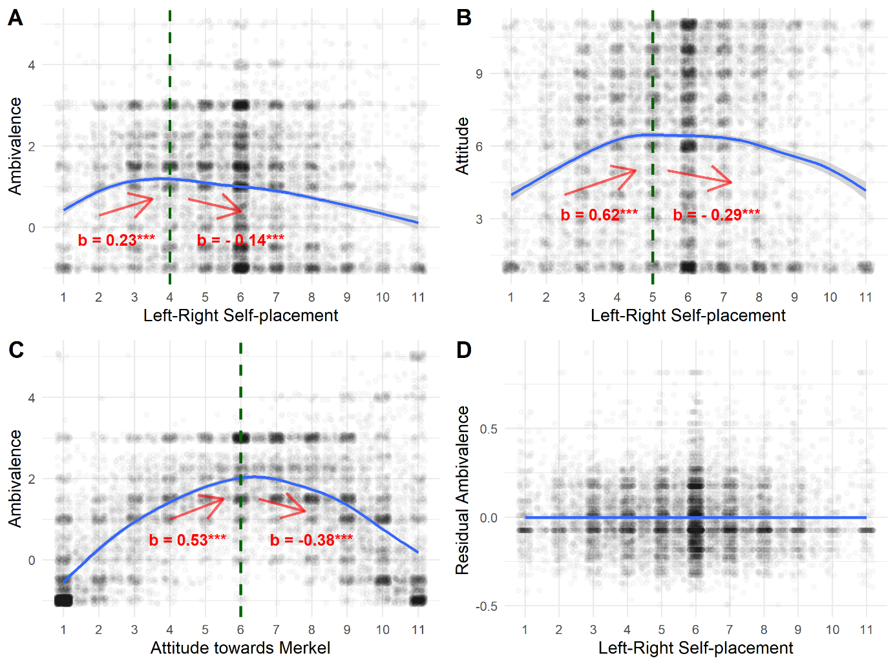

Note.

*Figure 2.*  
Associations of affective ambivalence and the general attitude toward Martin Schulz with crucial predictors

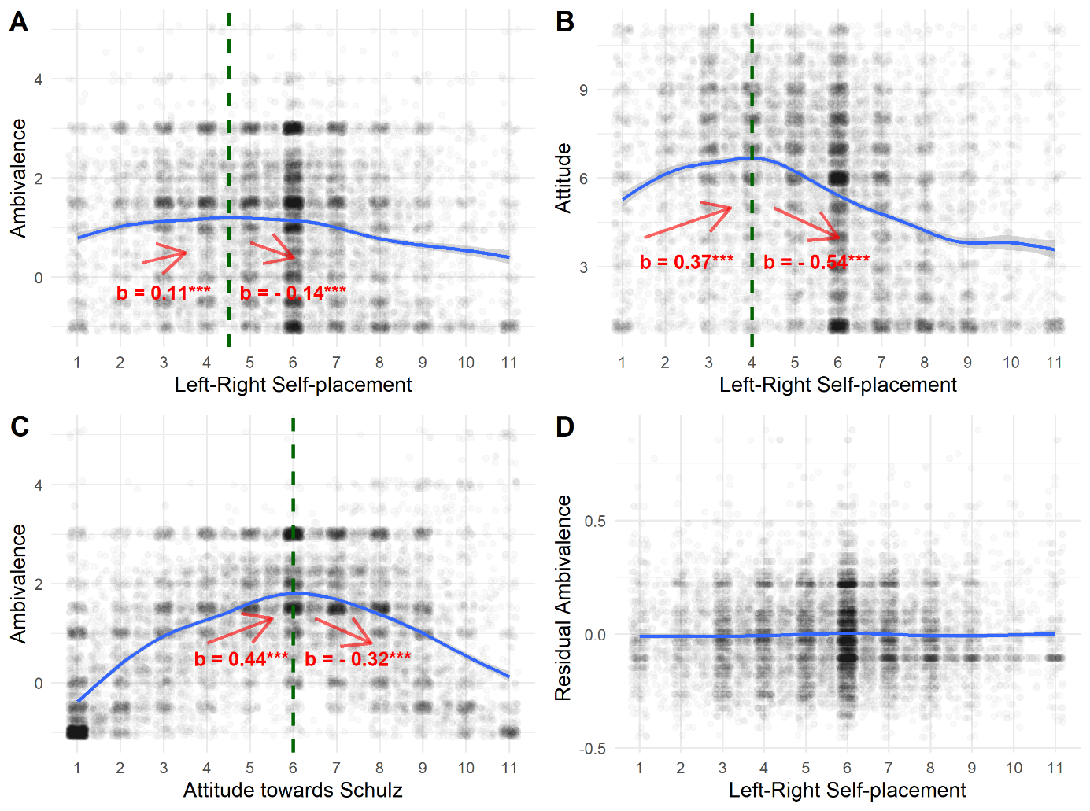

Note.

**Study 2**

Like Study 1, Study 2 investigates the association of political ideology with the ambivalence of attitudes toward political candidates. In addition to using data on a different election with different political candidates that has been collected using a different interview mode and sampling design and using a different question format to assess positive and negative reactions toward the candidates, Study 2 differs from Study 1 by allowing to distinguish between affective and cognitive ambivalence. Study 2 uses data collected in the context of the German Federal Election in 2021, in which Olaf Scholz of the social democratic party (SPD), Armin Laschet of the Christian conservative party (CDU), and Annalena Baerbock of the green party competed for the chancellorship.

**Method**

**Sample.** Study 2 uses data of the GLES Rolling Cross-Section 2021 (GLES, 2022), which was conducted using computer-assisted telephone interviews. The sample of this study is a probability sample of individuals eligible to vote at the elections that results from landline (60%) and mobile (40%) telephone numbers that are drawn from sampling frames that include all registered as well as generated telephone numbers (for details, see official study documentation). All respondents with answers on the relevant variables (see below) were included in the analyses

**Attitudinal Ambivalence.** The GLES Rolling Cross-Section 2021 included not only measures feelings toward the candidates but also measures of their perceived strengths and weaknesses, which allows to differential between affective and cognitive ambivalence. With respect to feelings, respondents indicated their (dis-)agreement with the statements “[Candidate] triggers negative feelings in me.” and “[Candidate] triggers positive feelings in me.” using a scale ranging from 1 (*strongly agree*) to 2 (*agree*) to 3 (*neither agree nor disagree*), to 4 (*disagree*) to 5 (*strongly disagree*). With respect to strengths and weaknesses, respondents indicated their (dis-)agreement with the statements “[Candidate] has great weaknesses as a politician.” and “[Candidate] has great strengths as a politician.” using the same scale. The order of asking about feelings or strengths and weaknesses first versus second as well as the order of asking about the positive or the negative reaction first versus second was randomly determined for each respondent. Ambivalence scores were calculated using the same formula as in Study 1.

**Further variables.** General attitudes toward the candidates, political ideology, political interest, and the other control variables were measured as in Study 1.

**Results**

As in Study 1, political interest is negatively correlated with political ideology as well as with attitudinal ambivalence (see *Table 1*). The correlations between the scores for affective and cognitive ambivalence range between *r* = .43 and *r* = .49. The mean scores for cognitive ambivalence (see *Table 1*) are significantly higher than the scores for affective ambivalence for Scholz, *t*(6567) = -27.47, *p* < .001, Laschet, *t*(6444) = -35.30, *p* < .001, and Baerbock, *t*(6519) = -34.82, *p* < .001.

In contrast to Study 1, the direction of the linear association of political ideology with affective ambivalence is inconsistent in Study 2: Political ideology is positively correlated with affective ambivalence toward Scholz and Laschet and negative correlated with affective and ambivalence toward Baerbock. Regarding cognitive ambivalence, political ideology is unrelated to cognitive ambivalence toward Scholz, positively correlated with ambivalence toward Laschet, and negatively correlated with cognitive ambivalence toward Baerbock (see Table 1; see also Tables OA2 to OA4 in the Online Appendix, for the results of regression analyses including control variables).

Two-lines tests provide evidence for an inversely u-shaped association between ideology and affective/cognitive ambivalence in the case of Laschet only (for details, see Figures OA1 to OA6 in the Online Appendix). However, when looking at the variance in ambivalence not explained by the general attitude, there is no evidence for an inversely u-shaped association between political ideology and the residual ambivalence (affective or cognitive) for any of the candidates (see Online Appendix). Correlations of political ideology with the residual affective ambivalence toward Scholz, *r* = -.00, *p* = .75, Laschet, *r* = .02, p = .06, and Baerbock, *r* = .00, *p* = .75, are not statistically significant. However, the correlations of political ideology with the residual cognitive ambivalence toward Scholz, *r* = -.03, *p* =.01, and Baerbock, *r* = -.04, *p* < .01, are statistically significant while the correlation for Laschet is not, *r* = .02, p = .23.

**Study 3**

Study 3 investigates the association of political ideology with attitudinal ambivalence with respect to political parties rather than political candidates as attitude targets. It uses data collected in the context of the German Federal Elections 2013 on attitudes toward the five parties represented in the German Bundestag at that time.

**Method**

**Sample.** Study 3 uses data of the Short-term Campaign Panel of the GLES collected during the campaign period of the German Federal Elections in 2013 (GLES, 2016). This study was conducted as an online survey and respondents eligible to vote at the elections were recruited trough quota sampling (age, gender, education) from the frame population of a large online access panel run by a commercial service provider (for details, see official study documentation). All respondents with answers on the relevant variables (see below) were included in the analyses which resulted in a maximal sample of 4,789 respondents (49.05% women, *M*age = 46.03, *SD*age = 14.76).

**Affective ambivalence.** Positive and negative feelings were measured as in Study 1, however, with political parties instead of political candidates as the attitude targets. An affective ambivalence score for each political party was calculated as described in Study 1. As the measures of negative and positive feelings were included in waves 1, 3, and 6 of the campaign panel, average ambivalence scores across waves were calculated (.86 ≤ *α* ≤ .91).

**Further variables.** General attitudes toward the parties, political ideology, political interest, and the other control variables were measured as in Study 1.

**Results**

As in the previous studies, political interest is negatively correlated with political ideology as well as with attitudinal ambivalence toward the different parties (see *Table 2*).

The direction of the linear association of political ideology with affective ambivalence is inconsistent for the different political parties, ranging from a positive correlation of r = .33 to a negative correlation of r = -.14 (see Table 2, see also Tables OA5 and OA6 in the Online Appendix, for the results of regression analyses including control variables).

Two-lines tests provide evidence for an inversely u-shaped association between ideology and affective ambivalence in the case of all political parties except for the FDP (for details, see Figures OA7 to OA11 in the Online Appendix). However, when looking at the variance in ambivalence not explained by the general attitude toward the respective party, there is no evidence for an inversely u-shaped association between political ideology and the residual ambivalence for any of the parties (see Online Appendix). Correlations of political ideology with the residual affective ambivalence are positive in the case of four of the five parties, ranging from *r* = .03 to *r* = .10 (see Table OA7 in the Online Appendix).

**References**

Adorno, T., Frenkel-Brenswik, Levinson, D. J., & Sanford, R. N. (1950). *The authoritarian personality*. Verso Books.

Baron, J., & Jost, J. T. (2019). False Equivalence: Are Liberals and Conservatives in the United States Equally Biased? *Perspectives on Psychological Science*, *14*(2), 292–303. https://doi.org/10.1177/1745691618788876

Brandt, M. J., Evans, A. M., & Crawford, J. T. (2015). The Unthinking or Confident Extremist? Political Extremists Are More Likely Than Moderates to Reject Experimenter-Generated Anchors. *Psychological Science*, *26*(2), 189–202. https://doi.org/10.1177/0956797614559730

Brandt, M. J., Reyna, C., Chambers, J. R., Crawford, J. T., & Wetherell, G. (2014). The Ideological-Conflict Hypothesis: Intolerance Among Both Liberals and Conservatives. *Current Directions in Psychological Science*, *23*(1), 27–34. https://doi.org/10.1177/0963721413510932

Cacioppo, J. T., Gardner, W. L., & Berntson, G. G. (1997). Beyond Bipolar Conceptualizations and Measures: The Case of Attitudes and Evaluative Space. *Personality and Social Psychology Review*, *1*(1), 3–25. https://doi.org/10.1207/s15327957pspr0101_2

Conner, M., & Sparks, P. (2002). Ambivalence and Attitudes. *European Review of Social Psychology*, *12*(1), 37–70. https://doi.org/10.1080/14792772143000012

Conway, L. G., Houck, S. C., Gornick, L. J., & Repke, M. A. (2018). Finding the Loch Ness Monster: Left-Wing Authoritarianism in the United States: Left-Wing Authoritarianism in the United States. *Political Psychology*, *39*(5), 1049–1067. https://doi.org/10.1111/pops.12470

Ditto, P. H., Liu, B. S., Clark, C. J., Wojcik, S. P., Chen, E. E., Grady, R. H., Celniker, J. B., & Zinger, J. F. (2019). At Least Bias Is Bipartisan: A Meta-Analytic Comparison of Partisan Bias in Liberals and Conservatives. *Perspectives on Psychological Science*, *14*(2), 273–291. https://doi.org/10.1177/1745691617746796

Eagly, A. H., & Chaiken, S. (1993). *The psychology of attitudes*. Hartcourt Brace Janovich College Publishers.

Fernbach, P. M., Rogers, T., Fox, C. R., & Sloman, S. A. (2013). Political Extremism Is Supported by an Illusion of Understanding. *Psychological Science*, *24*(6), 939–946. https://doi.org/10.1177/0956797612464058

Frimer, J. A., Skitka, L. J., & Motyl, M. (2017). Liberals and conservatives are similarly motivated to avoid exposure to one another’s opinions. *Journal of Experimental Social Psychology*, *72*, 1–12. https://doi.org/10.1016/j.jesp.2017.04.003

GLES. (2016). *Short-term Campaign Panel 2013 (GLES)* (3.2.0) [Data set]. GESIS Data Archive. https://doi.org/10.4232/1.12561

GLES. (2019). *Short-term Campaign Panel (GLES 2017)* (7.0.0) [Data set]. GESIS Data Archive. https://doi.org/10.4232/1.13323

GLES. (2022). *GLES Rolling Cross-Section 2021GLES Rolling Cross-Section 2021* (2.0.0) [Data set]. GESIS. https://doi.org/10.4232/1.13876

Greenberg, J., & Jonas, E. (2003). Psychological motives and political orientation--The left, the right, and the rigid: Comment on Jost et al. (2003). *Psychological Bulletin*, *129*(3), 376–382. https://doi.org/10.1037/0033-2909.129.3.376

Haddock, G., & Maio, G. R. (2019). Inter-individual differences in attitude content: Cognition, affect, and attitudes. In *Advances in Experimental Social Psychology* (Vol. 59, pp. 53–102). Elsevier. https://doi.org/10.1016/bs.aesp.2018.10.002

Hibbing, J. R., Smith, K. B., & Alford, J. R. (2014). Differences in negativity bias underlie variations in political ideology. *Behavioral and Brain Sciences*, *37*(3), 297–307. https://doi.org/10.1017/S0140525X13001192

Jonas, K., Broemer, P., & Diehl, M. (2000). Attitudinal Ambivalence. *European Review of Social Psychology*, *11*(1), 35–74. https://doi.org/10.1080/14792779943000125

Jost, J. T. (2017). Ideological Asymmetries and the Essence of Political Psychology: Presidential Address. *Political Psychology*, *38*(2), 167–208. https://doi.org/10.1111/pops.12407

Jost, J. T., Federico, C. M., & Napier, J. L. (2009). Political Ideology: Its Structure, Functions, and Elective Affinities. *Annual Review of Psychology*, *60*(1), 307–337. https://doi.org/10.1146/annurev.psych.60.110707.163600

Jost, J. T., Glaser, J., Kruglanski, A. W., & Sulloway, F. J. (2003). Political conservatism as motivated social cognition. *Psychological Bulletin*, *129*(3), 339–375. https://doi.org/10.1037/0033-2909.129.3.339

Jost, J. T., & Krochik, M. (2014). Ideological Differences in Epistemic Motivation: Implications for Attitude Structure, Depth of Information Processing, Susceptibility to Persuasion, and Stereotyping. In *Advances in Motivation Science* (Vol. 1, pp. 181–231). Elsevier. https://doi.org/10.1016/bs.adms.2014.08.005

Krochik, M., Jost, J. T., & Nosek, B. A. (2007). *Ideology informs structure: Social and moti- vational inﬂuences on the attitudinal strength of liberals and conservatives.*

Lammers, J., Koch, A., Conway, P., & Brandt, M. J. (2017). The Political Domain Appears Simpler to the Politically Extreme Than to Political Moderates. *Social Psychological and Personality Science*, *8*(6), 612–622. https://doi.org/10.1177/1948550616678456

Newman, L. S., & Sargent, R. H. (2020). Liberals Report Lower Levels of Attitudinal Ambivalence Than Conservatives. *Social Psychological and Personality Science*, 194855062093979. https://doi.org/10.1177/1948550620939798

Sargent, R. H., & Newman, L. S. (2020). Conservatism and attitudinal ambivalence: Investigating conflicting findings. *Personality and Individual Differences*, 109996. https://doi.org/10.1016/j.paid.2020.109996

Simonsohn, U. (2018). Two Lines: A Valid Alternative to the Invalid Testing of U-Shaped Relationships With Quadratic Regressions. *Advances in Methods and Practices in Psychological Science*, *1*(4), 538–555. https://doi.org/10.1177/2515245918805755

Tetlock, P. E. (1983). Cognitive style and political ideology. *Journal of Personality and Social Psychology*, *45*(1), 118–126. https://doi.org/10.1037/0022-3514.45.1.118

Thompson, M. M., Zanna, M. P., & Griffin, D. W. (1995). Let’s not be indifferent about (attitudinal) ambivalence. In R. E. Petty & J. A. Krosnick (Eds.), *Attitude strength: Antecedents and consequences* (pp. 361–386). Lawrence Erlbaum Associates, Inc.

Toner, K., Leary, M. R., Asher, M. W., & Jongman-Sereno, K. P. (2013). Feeling Superior Is a Bipartisan Issue: Extremity (Not Direction) of Political Views Predicts Perceived Belief Superiority. *Psychological Science*, *24*(12), 2454–2462. https://doi.org/10.1177/0956797613494848

van Harreveld, F., Nohlen, H. U., & Schneider, I. K. (2015). The ABC of Ambivalence. In *Advances in Experimental Social Psychology* (Vol. 52, pp. 285–324). Elsevier. https://doi.org/10.1016/bs.aesp.2015.01.002

Van Hiel, A., Onraet, E., & De Pauw, S. (2010). The Relationship Between Social-Cultural Attitudes and Behavioral Measures of Cognitive Style: A Meta-Analytic Integration of Studies: Social-Cultural Attitudes and Cognitive Style. *Journal of Personality*, *78*(6), 1765–1800. https://doi.org/10.1111/j.1467-6494.2010.00669.x

van Prooijen, J.-W., & Krouwel, A. P. M. (2019). Psychological Features of Extreme Political Ideologies. *Current Directions in Psychological Science*, *28*(2), 159–163. https://doi.org/10.1177/0963721418817755

Zmigrod, L., Rentfrow, P. J., & Robbins, T. W. (2020). The partisan mind: Is extreme political partisanship related to cognitive inflexibility? *Journal of Experimental Psychology: General*, *149*(3), 407–418. https://doi.org/10.1037/xge0000661