Project Title: LLM-Guided Discovery of Patient- and Variant-Adaptive Algorithms for Reliable Prostate Cancer Genetic Risk Prediction

1. Background

1.1 Genomic risk prediction for early detection is limited by ancestry drift
Prostate cancer is unusually well suited to prevention and early-detection approaches informed by inherited genetic risk. Twin studies estimate that inherited factors account for approximately 57% of prostate cancer risk [Mucci et al., 2016]. Genomic risk tools are also moving toward clinical use. In the BARCODE1 study, polygenic-risk-directed screening identified clinically significant prostate cancers that would have been missed by conventional PSA- and MRI-based pathways; however, eligibility was restricted to men of self-reported European ancestry and the score was derived from European-ancestry genome-wide association studies [McHugh et al., 2025]. This limitation matters because the population with the greatest prostate cancer burden is not the population in which current genomic risk tools have been most extensively developed: prostate cancer incidence in Black men is approximately 67% higher than in White men, and mortality is approximately twice as high [Kratzer et al., 2025]. Thus, the promise of genotype-informed risk stratification for earlier screening is inseparable from the problem of whether a model remains reliable when the ancestry-related genomic architecture of the patient being scored differs from that represented in the data used to develop the risk determining model.
We use the term ancestry drift to describe this mismatch between the ancestry-related genomic architecture represented in a model-development dataset and the architecture present in the patient to whom the model is applied. The mismatch is not captured by one variable. Allele frequencies, linkage disequilibrium, local ancestry, training-sample density, and variant effect estimates can all change across ancestry space [Kachuri et al., 2024; Harlemon et al., 2020; Rebbeck, 2017]. These shifts alter both the distribution of the genotypes presented to a model and the relationship between those genotypes and disease risk. In prostate cancer, the latter problem is directly observable: across 269 established risk variants, European-ancestry odds-ratio effect sizes correlated only moderately with effect sizes in African-ancestry, East Asian-ancestry, and Hispanic participants (r = 0.45, 0.37, and 0.51, respectively) [Conti et al., 2021]. Individual variants can differ substantially in magnitude and, in some cases, direction across ancestry backgrounds. Therefore, a training sample that is highly informative for estimating the predictive contribution of one variant for one patient may be much less informative for another variant or another patient.
This project focuses on that data-borrowing decision. Consider a patient being scored who has germline genotype data and a labeled reference cohort containing prostate cancer cases and controls with the same genotype features. For each genetic variant, the model must decide which reference subjects should inform the local effect-size estimate used for that patient. Borrowing too broadly may mix subjects whose genomic context is poorly matched to the patient; borrowing too narrowly may discard valuable information and leave too few samples for stable estimation. The optimal balance can change from variant to variant because some associations are comparatively stable across ancestry space whereas others are non-stationary. A reliable genomic risk model therefore needs a principled data-borrowing scheme that determines how far to borrow information through ancestry space for each patient-variant pair.

1.2 Existing multi-population learning relies on human-designed data-borrowing schemes
Existing approaches address limited sample size and distribution shift with investigator-specified data-borrowing schemes. In mixture learning, all available ancestry groups are pooled and one model is fit to the combined data. In independent learning, a separate model is fit using only subjects assigned to the same discrete ancestry group as the patient being scored. In transfer learning, a model is first learned from a larger source population and then adapted using the smaller focal population. Our laboratory formalized and compared these multi-population learning schemes, showing that transfer learning can improve prediction for groups with limited training data when mixture and independent learning are constrained by distribution mismatch or sample size [Gao and Cui, 2020]. Critically, no single human-designed scheme dominates.
Which scheme performs best depends on the focal group, the reference-sample size, and the degree of effect-size heterogeneity: mixture learning wins where effects are stable and focal samples are scarce, independent learning wins where effects are strongly ancestry-specific and focal samples are adequate, and transfer learning wins in the intermediate regime [Gao and Cui, 2020; Gao and Cui, 2024; Wu et al., 2026]. Because the degree of heterogeneity differs from variant to variant [Conti et al., 2021] and from patient to patient along the ancestry continuum [Ding et al., 2023], the best available human heuristics are, by construction, applying one global compromise to a decision that is intrinsically local. The correct object to specify is therefore not a scheme but a master scheme that chooses a scheme per patient-variant pair, that master scheme has never been searched for. That unresolved patient- and variant-specific data-borrowing choice is the methodological gap addressed here.
A second limitation of discrete group-based schemes is that genetic ancestry is continuous. Ding and colleagues showed that polygenic-score accuracy decreases individual by individual with genetic distance from the training data across a genetic ancestry continuum, including substantial variation within conventionally defined ancestry clusters [Ding et al., 2023]. This motivates representing each patient by continuous ancestry coordinates derived from genome-wide principal components rather than treating ancestry labels as the complete description of genetic similarity. In our framework, each subject is represented by a 16-dimensional ancestry coordinate. A candidate data-borrowing scheme can therefore adapt continuously to where the patient lies in ancestry space instead of selecting among a small number of discrete ancestry bins.

1.3 Evaluator-grounded LLM-guided scientific discovery provides a new way to search for better schemes
The central innovation of this proposal is to replace manual design of the data-borrowing scheme with evaluator-grounded LLM-guided scientific discovery of a scheme. The concept is straightforward (Figure 1). An LLM writes an executable candidate scheme. A fixed evaluator tests that scheme on real data and returns an objective score. The program database stores the candidate scheme, its score. The historical candidates later returned to the LLM are not human-designed starting schemes: they are candidate schemes generated by the LLM itself in earlier iterations and already scored by the evaluator. Repeating this generate-evaluate-refine loop converts the LLM from a text generator into a search component operating inside a controlled experimental system. Importantly, an attractive explanation from the LLM does not make a candidate successful: only executable candidate schemes that perform well under the prespecified evaluator are retained.
LLM-guided scientific discovery has recently scored many successes, leading to breakthroughs for established problems. These successes share three structural features rather than a common scientific domain: (i) the unknown can be framed as a short, executable algorithm/object; (ii) a fixed, objective evaluator can score any proposed algorithm/object automatically and preferably cheaply; and (iii) the space of plausible algorithms is far larger than the handful humans have written down. Where these three conditions hold, AI-guided scientific discovery has repeatedly found algorithms/objects better than the best human-designed ones. The data-borrowing decision under ancestry drift satisfies all three. The same structure is now appearing in experimental biomedicine. Two 2026 papers published in Nature described Co-Scientist, which continuously generates, critiques, and refines hypotheses that were experimentally validated in biomedical applications, and Robin, which integrates literature search, hypothesis generation, experimental-data analysis, and hypothesis revision in a multi-agent discovery loop [Gottweis et al., 2026; Ghareeb et al., 2026]. The pattern is also established in mathematical and algorithmic problems. FunSearch paired an LLM with a systematic evaluator and discovered improved constructions for the cap-set problem as well as new online bin-packing heuristics [Romera-Paredes et al., 2024]. Google DeepMind subsequently demonstrated olympiad-level formal mathematical reasoning with reinforcement learning in work published in Nature [Hubert et al., 2026]. AI research laboratories have also contributed directly to open research problems: a related formal-proof effort reported autonomously resolving 9 of 353 open Erdős problems and proving 44 of 492 open OEIS conjectures [Tsoukalas et al., 2026], while OpenAI reported an AI-generated construction that disproved a long-standing conjecture in the 80-year-old planar unit-distance problem [Howlett, 2026]. We apply this same evaluator-grounded structure to a concrete barrier in prostate cancer early detection: discovering a better data-borrowing scheme under ancestry drift.
Our prostate cancer problem has exactly this structure. A candidate data-borrowing scheme is represented as a short Python priority function. Given (i) a labeled reference cohort, (ii) the continuous ancestry coordinate of a patient being scored, and (iii) a genetic variant, as inputs, the function returns how broadly the algorithm should borrow reference subjects around that patient in ancestry space. A fixed downstream evaluator then estimates the local marginal effect of the variant, builds patient-level genomic features, calibrates a prostate cancer risk model, and scores the candidate scheme on held-out subjects. LLM-guided scientific discovery can therefore search directly over interpretable data-borrowing schemes while every candidate is judged by the prostate-cancer-specific objective.

1.4 Relevance to the FY26 PCRP Overarching Challenge and ability of the team to execute the project
The project directly addresses the FY26 PCRP Overarching Challenge to "Enhance clinical care for all patients with prostate cancer," with special emphasis on high-risk groups. The selected aspect of the challenge is the reduction of factors that impair a person or family's ability to prevent and detect prostate cancer. Ancestry drift is such a factor because it can reduce the reliability of inherited-risk estimates used to decide who should receive earlier or more intensive screening. A patient- and variant-adaptive data-borrowing scheme that remains accurate when the target patient is poorly represented in the available reference cohort would strengthen the use of genomic risk prediction for prevention and early detection. This is also relevant to Service Members, Veterans, and their Families because a portable method should remain reliable as the ancestry composition of the population receiving care differs from, or changes relative to, the population represented in the model-development data.
The research team combines the two areas of expertise required for this work. Anirban Das has a PhD in Mathematics and research experience spanning AI, large-language-model reasoning, programmatic LLM search, and machine learning for genomic tabular data. He is first author of a NeurIPS 2025 paper on systematic neural reasoning, first author of a 2024 Nature Communications paper developing computational methods for biological data, and first author with Yan Cui of a 2026 Bioinformatics study on bridging ancestry gaps in genomic risk prediction with tabular foundation models [Das et al., 2024; Das et al., 2025; Das and Cui, 2026]. Yan Cui is Professor of Genetics, Genomics and Informatics and Director of Bioinformatics and Artificial Intelligence at UTHSC. His research program centers on precision oncology, machine learning, and algorithmic solutions to prediction problems created by ancestry-dependent distribution shift and uneven training-sample availability. He is PI of NIH R01 CA262296, Algorithm-based Prevention and Reduction of Cancer Health Disparity Arising from Data Inequality, and our laboratory has published both the foundational multi-population transfer-learning framework and its later extension to ancestry-aware clinico-genomic prediction that included prostate cancer [Gao and Cui, 2020; Gao and Cui, 2024]. Together with our recent joint work on genomic prediction across the ancestry continuum [Das and Cui, 2026], this provides direct in-house expertise in LLM/AI methods, precision oncology, genomic prediction, and algorithmic approaches to ancestry-dependent model degradation.

2. Hypothesis
Our central hypothesis is that evaluator-grounded LLM-guided scientific discovery can discover an interpretable, patient- and variant-adaptive data-borrowing scheme that improves prostate cancer genomic risk prediction when the ancestry of the patient being scored is sparsely represented in the labeled reference cohort. In each discovery run, the disease endpoint is fixed as prostate cancer and one focal ancestry group is specified; by focal ancestry group, we mean the ancestry group for which that discovery run is explicitly optimized. The discovered data-borrowing scheme will use the patient's continuous ancestry coordinate and the identity of each genetic variant to determine which reference subjects should contribute to that variant's local predictive effect estimate. We further hypothesize that, once the discovered scheme is selected and its priority function is locked, the resulting genomic risk pipeline will outperform established human-designed data-borrowing schemes - including mixture learning, independent learning, and transfer-learning baselines - on independent validation data that were never accessed by the discovery evaluator or exposed directly or indirectly to the LLM. Our preliminary results provide encouraging support for the feasibility of this hypothesis; those results will be presented in the Research Strategy and Feasibility section.

3. Specific Aims
The overall objective is to discover, independently validate, and openly release data-borrowing schemes for reliable prostate cancer genomic risk prediction across ancestry space. The disease endpoint is fixed throughout the project as prostate cancer. We will repeat the discovery process for multiple focal ancestry groups, where the focal ancestry group is the ancestry group for which a given discovery run is designed to improve prediction despite sparse representation in the labeled reference cohort. Throughout the project we distinguish two strictly separated data roles. The Discovery Cohort is a real prostate cancer dataset used inside the LLM-guided scientific discovery to score candidate schemes. The Independent Validation Cohorts are never touched by the LLM-guided scientific discovery: they are not passed to the discovery evaluator, summarized for the LLM, used to construct prompts, used to score or rank any candidate scheme, used to select the final scheme, or used for discovery-phase tuning. They enter the analysis only after the selected priority function has been locked. This separation is central to the project because it allows the final evaluation to test whether the discovered data-borrowing scheme generalizes beyond all data that shaped the search. Throughout, improved discrimination is the intermediate outcome; the target application is risk-stratified selection of men for earlier or more intensive prostate cancer screening.
Specific Aim 1. Use evaluator-grounded LLM-guided scientific discovery to discover patient- and variant-adaptive data-borrowing schemes for prostate cancer genomic risk prediction. For every discovery run, the disease endpoint will remain fixed as prostate cancer and we will specify one focal ancestry group - the ancestry group whose prediction performance the run is intended to improve. We will repeat this process across multiple focal ancestry groups. The LLM will propose candidate data-borrowing schemes as executable Python priority functions, and a fixed evaluator will score each candidate using only the Discovery Cohort. For a patient being scored and a genetic variant, the priority function receives the labeled reference data, the patient's 16-dimensional ancestry coordinate, and the variant identity, and returns a neighborhood size in ancestry space. Reference subjects within the resulting neighborhood are used to estimate a local marginal effect size for that variant. Repeating this calculation across variants produces patient-specific genomic features that are calibrated into a prostate cancer risk score. The Discovery Cohort will be deliberately structured so that its reference/training portion is dominated by ancestry groups other than the focal ancestry group, while the in-loop evaluation portion is enriched for the focal ancestry group. This creates the intended selection pressure: a candidate scheme earns a high score only if it can use abundant non-focal data without losing predictive performance for patients from the focal ancestry group that is sparsely represented in the reference set. Within the repeated calibration/scoring folds, ROC-AUC will be calculated only on subjects in the in-loop evaluation portion and used to score candidate schemes. Candidate schemes and scores are stored in the program database; selected candidate schemes generated by the LLM in earlier iterations are sampled and returned to the LLM as historical context, allowing later proposals to build on prior successes and failures. After prespecified discovery cycles, or earlier stopping for lack of improvement, the highest-performing data-borrowing scheme will be selected and its priority function will be locked for validation. The overall discovery loop is summarized in Figure 1. The expected outcome of Aim 1 is an interpretable locked priority function and a fully auditable discovery history for each focal ancestry group. This is the algorithmic component required before a genomic risk tool can be used to select men for earlier screening for the focal groups stated. The exact priority-function contract, evaluator score, and discovery procedure are specified in Methods (Section 4.2.1).

Specific Aim 2. Rigorously benchmark each locked data-borrowing scheme on independent prostate cancer validation cohorts that were never used during scientific discovery. We will implement a separate held-out evaluation workflow that loads the locked priority function and applies the same patient- and variant-specific data-borrowing scheme to validation data outside the discovery loop. These Independent Validation Cohorts are never accessed by the discovery evaluator and are never shown, directly or through summaries, to the LLM; the first time they enter the analysis is after the priority function for that focal ancestry group has been locked. Any prostate cancer cohort may be used for this purpose if it is independent of discovery and can be reduced to the common evaluator-ready input contract defined in Methods (Section 4.2). The Independent Validation Cohorts are not required to contain the same variants used in the Discovery Cohort; each validation analysis may use its own harmonized variant set because the locked priority function operates on the current variant identity and the current labeled reference data, rather than on a fixed discovery variant panel. For each focal ancestry group, the validation reference/training data will remain dominated by a larger non-focal ancestry group, while the final evaluation set will contain only subjects from the focal ancestry group. The locked data-borrowing scheme will be evaluated without any further modification. We will compare its held-out prostate cancer prediction performance with established human-designed data-borrowing schemes implemented in our evaluation framework: mixture learning, independent learning, and transfer-learning schemes, including TL-GDES and TL-PR [Wu et al., 2026]. The same validation partitions and scoring procedure will be used for all schemes so that differences reflect the data-borrowing scheme rather than differences in test data. The primary expected outcome of Aim 2 is an unbiased estimate of whether the LLM-discovered data-borrowing scheme improves genomic risk discrimination for patients whose focal ancestry group is sparsely represented in the labeled reference cohort, together with evidence of whether that advantage reproduces across independent datasets. The post-lock evaluation workflow and cohort harmonization contract are specified in Methods (Section 4.2.2).
Specific Aim 3. Generalize and openly release validated ancestry-adaptive prostate cancer risk-prediction workflows for East Asian, African, and Latino focal ancestry groups. Using the discovery and validation framework established in Aims 1 and 2, we will derive and validate a locked data-borrowing scheme separately for multiple focal ancestry groups corresponding to East Asian, African, and Latino populations represented in the available cohorts. We will then release the discovered priority functions, the evaluator and validation code, and a documented end-to-end software workflow that accepts a labeled reference cohort, genotype data and continuous ancestry coordinates for a new patient and returns a prostate cancer genomic risk score. The genotype data may contain target variants that were never present in the Discovery Cohort or in any Independent Validation Cohort; such variants can be scored when the labeled reference cohort and the new patient provide harmonized effect-allele dosages for them. The released implementation will preserve the patient- and variant-adaptive data-borrowing scheme that was independently validated in Aim 2 and will be designed so additional prostate cancer genomic datasets can be incorporated without redesigning the discovery framework. The expected product is a transparent and reproducible community resource that can be evaluated, extended, and integrated into future prostate cancer risk-modeling studies. By making the discovered schemes and computational process openly available, Aim 3 advances the selected FY26 PCRP Overarching Challenge by strengthening the reliability of genomic risk assessment across the ancestry continuum. The common input contract, cohort adapters, and released scoring workflow are specified in Methods (Section 4.2.3).
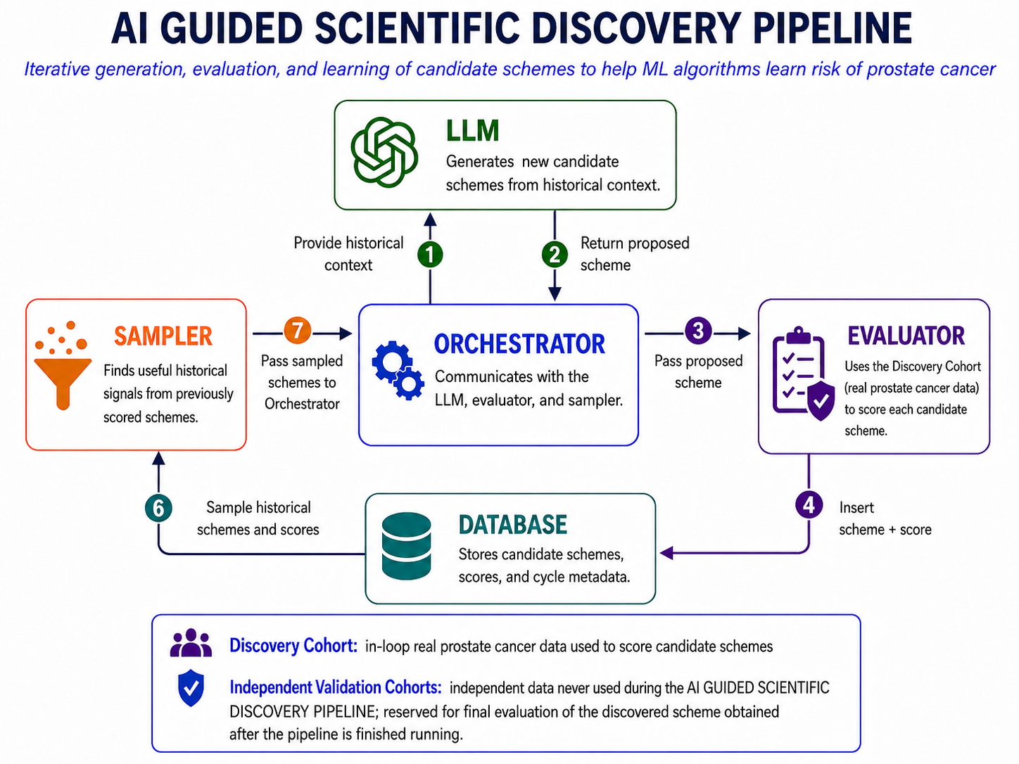
Figure 1. LLM-guided scientific discovery. The LLM proposes executable candidate data-borrowing schemes; the evaluator scores them using only the in-loop Discovery Cohort; the program database stores candidate schemes, scores, and cycle information; and the sampler returns selected candidate schemes that were generated by the LLM in earlier iterations to guide subsequent proposals. Independent Validation Cohorts are not accessed by the evaluator or exposed to the LLM during discovery.

4. Research Strategy and Feasibility

4.1 Preliminary Studies
We selected East Asian as the focal ancestry group for this proof-of-concept. It was an especially informative starting point because it was severely underrepresented in the available reference data, while independent data were available from three prostate cancer studies, allowing us to test both discovery under severe data imbalance and cross-study validation. The focal ancestry is represented by study-specific labels: JA (Japanese American) in the Multiethnic Cohort (MEC), ASIAN in OncoArray, and EAS (East Asian) in All of Us. MEC source publications use the terms Japanese American, Latino, and African American for the groups represented in our accessed data [Kolonel et al., 2000; Haiman et al., 2007]. For clarity, after establishing these study-specific mappings, we refer below only to the focal ancestry group and non-focal ancestry groups. The preliminary study was designed to test two central feasibility claims: first, that evaluator-grounded LLM-guided scientific discovery can produce an executable patient- and variant-adaptive data-borrowing scheme using real prostate cancer data; and second, that after selection and locking, the discovered scheme can generalize to subjects whose labels never participated in the discovery process.
Preliminary Results for Specific Aim 1: LLM-guided scientific discovery produced a locked data-borrowing scheme using MEC prostate cancer data. The Discovery Cohort was derived from the MEC prostate cancer study. Its reference portion contained 51 subjects from the focal ancestry group and 1,871 subjects from non-focal ancestry groups, whereas its in-loop evaluation portion contained 76 subjects from the focal ancestry group and 279 subjects from non-focal ancestry groups. The focal-ancestry subjects constituted 2.7% of the reference portion but 21.4% of the in-loop evaluation portion. This enrichment was deliberate: the reference portion reproduced the severe data-scarcity problem faced by patients of the focal ancestry group, while the in-loop evaluation portion provided enough focal-ancestry subjects for the evaluator to distinguish candidate schemes that did or did not improve prediction for that group. The search ran for four cycles on four parallel islands, with each island maintaining its own stream of previously scored candidate schemes (see methods for details). In every cycle, each island requested seven new proposals from GPT-5.5 (July 2026 version), and every executable proposal was scored by the same fixed evaluator (see Methods, Section 4.2.1). No improvement in evaluator score was obtained in the final two cycles. The LLM received only information from the Discovery Cohort and previously scored candidate schemes; The run yielded a selected priority function that was locked before the independent evaluations described below. These results establish the technical feasibility of the core Aim 1 generate-evaluate-refine loop while using real prostate cancer genotype and phenotype data to power the evalautor.

Preliminary Results for Specific Aim 2: the locked scheme generalized to three Independent Validation Cohorts that were not used for LLM-guided scientific discovery. We evaluated the same locked priority function in one held-out MEC set and two study-independent resources. The comparison set in every validation used the same five approaches: the Scheme Discovered by LLM, Independent Learning Scheme, Mixture Learning Scheme, TL-GDES Scheme, and TL-PR Scheme [Wu et al., 2026]. All five approaches used the same fixed downstream logistic regression model; only the data-borrowing scheme differed, ensuring a controlled comparison. No new discovery or scheme adaptation was permitted after the priority function was locked.
Independent Validation Cohort 1 - held-out MEC subjects. For post-lock evaluation, the MEC reference data contained 127 subjects from the focal ancestry group and 2,150 subjects from non-focal ancestry groups, while 19 additional subjects from the focal ancestry group had been held out i.e. altogether excluded from the discovery process and were used only for final ROC-AUC calculation. The locked LLM-discovered scheme achieved the highest ROC-AUC among the five evaluated schemes on these 19 held-out subjects (Figure 3A). Because these subjects came from the same parent study, but their labels were never used in the LLM-guided scientific discovery (Specific Aim 1), this analysis tests discovery-label holdout while holding study-specific measurement conditions constant.
Independent Validation Cohort 2 - OncoArray. We next evaluated the locked scheme in the independent OncoArray prostate cancer resource [Conti et al., 2021]. The validation reference data contained 566 subjects from the focal ancestry group and 28,220 subjects from non-focal ancestry groups; the final evaluation set contained 63 held-out subjects from the focal ancestry group. The LLM-discovered scheme achieved the highest ROC-AUC of the evaluated schemes (Figure 2), demonstrating that the selected data-borrowing behavior transferred beyond the MEC dataset in which discovery was performed.
Independent Validation Cohort 3 - All of Us. We then evaluated the same locked scheme in All of Us, a large, independently generated U.S. genomic resource [All of Us Research Program Genomics Investigators, 2024]. The validation reference data contained 46 subjects from the focal ancestry group and 6,560 subjects from non-focal ancestry groups. The final evaluation set contained 30 subjects from the focal ancestry group, balanced at 15 cases and 15 controls. The locked LLM-discovered scheme tied Mixture Learning for the highest ROC-AUC and exceeded Independent Learning, TL-GDES, and TL-PR [Wu et al., 2026] (Figure 3B). Together with the MEC result in Figure 3A, this demonstrates that the locked scheme remained effective across markedly different focal-to-non-focal sample ratios and independent data resources.

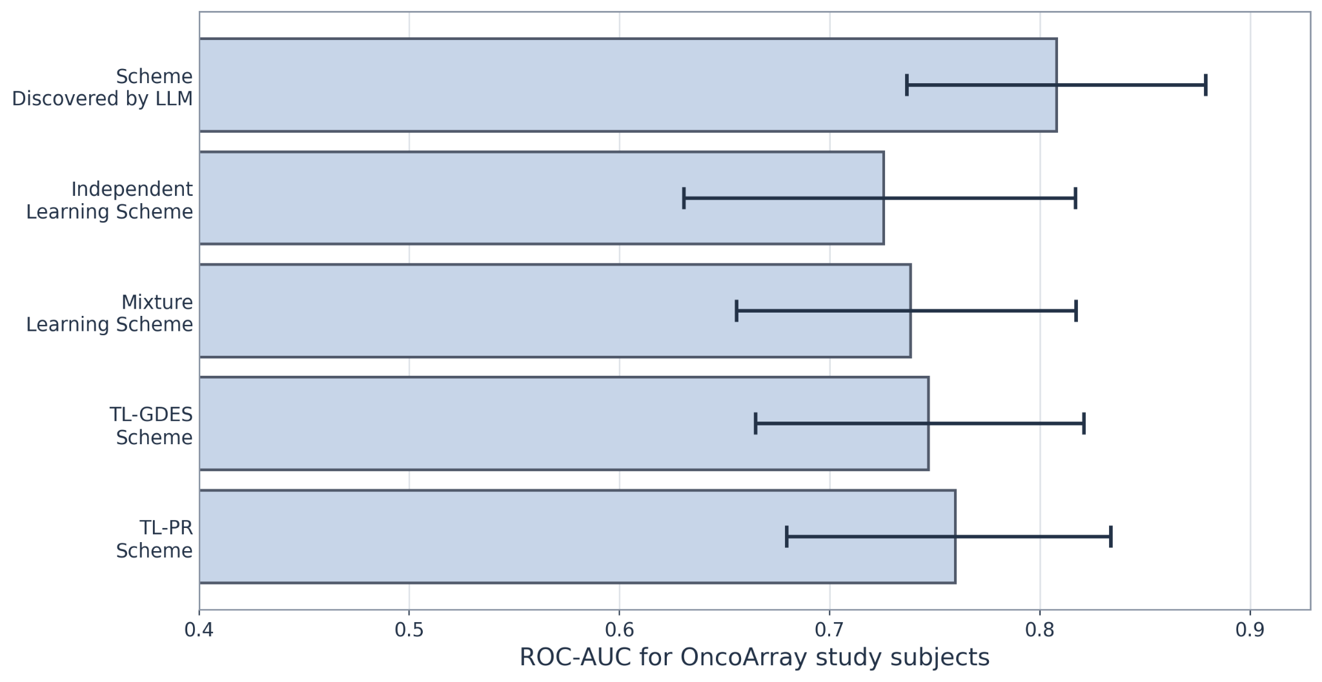
Figure 2. Independent validation in OncoArray. ROC-AUC of regression models fitted using the locked LLM-discovered scheme and four established human-designed comparison schemes. The ROC-AUC (with 80% ci) was calculated only on 63 held-out subjects from the focal ancestry group whose labels were not used during LLM-guided scientific discovery. The locked discovered scheme produced the highest ROC-AUC.
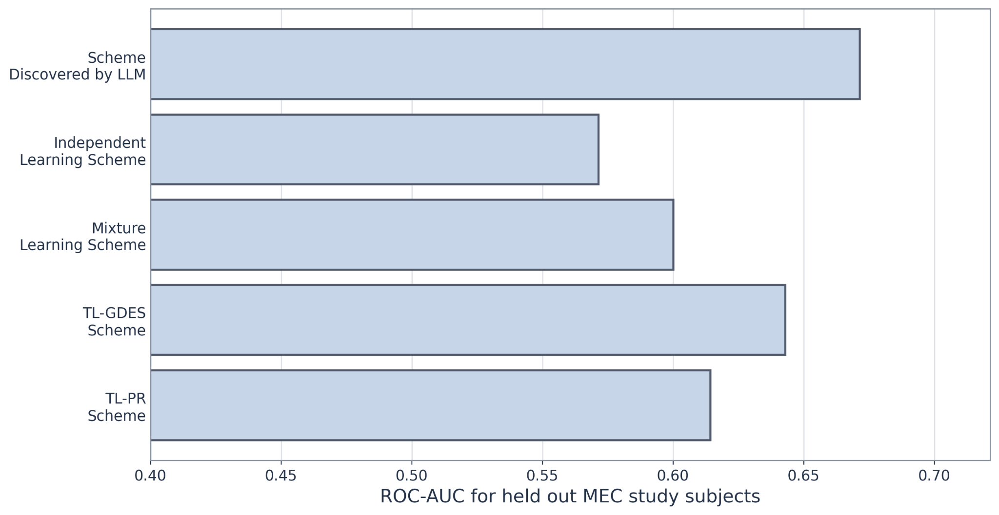
Figure 3A. Independent validation in held-out MEC subjects. ROC-AUC was calculated on 19 held-out subjects from the focal ancestry group; These sampes were excluded from LLM-guided scientific discovery, and the priority function was locked before evaluation. Too few samples to compute confidence intervals.

We complemented cohort-level ROC-AUC with a subject-paired analysis across all three Independent Validation Cohorts. Each held-out subject was evaluated by the locked LLM-discovered scheme and by each comparator, allowing the comparison to be made within the same subject. For held-out subject $i$, scheme $m$, and comparator $b$ (schemes besides the LLM discovered one), we use the following definitions:
$C_{i}^{\left(m\right)}$ = correct-label probability assigned by scheme $m$ to held-out subject $i$.
For held-out subject $i$ and comparator scheme $b$, define the paired difference $D_{i}^{\left(b\right)}$ by $D_{i}^{\left(b\right)}$ = $C_{i}^{\left(LLM\right)}$ - $C_{i}^{\left(b\right)}$. The population quantity tested is the mean paired difference:
$$μ_{D_{b}}=E​\left[D_{i}^{\left(b\right)}\right]$$

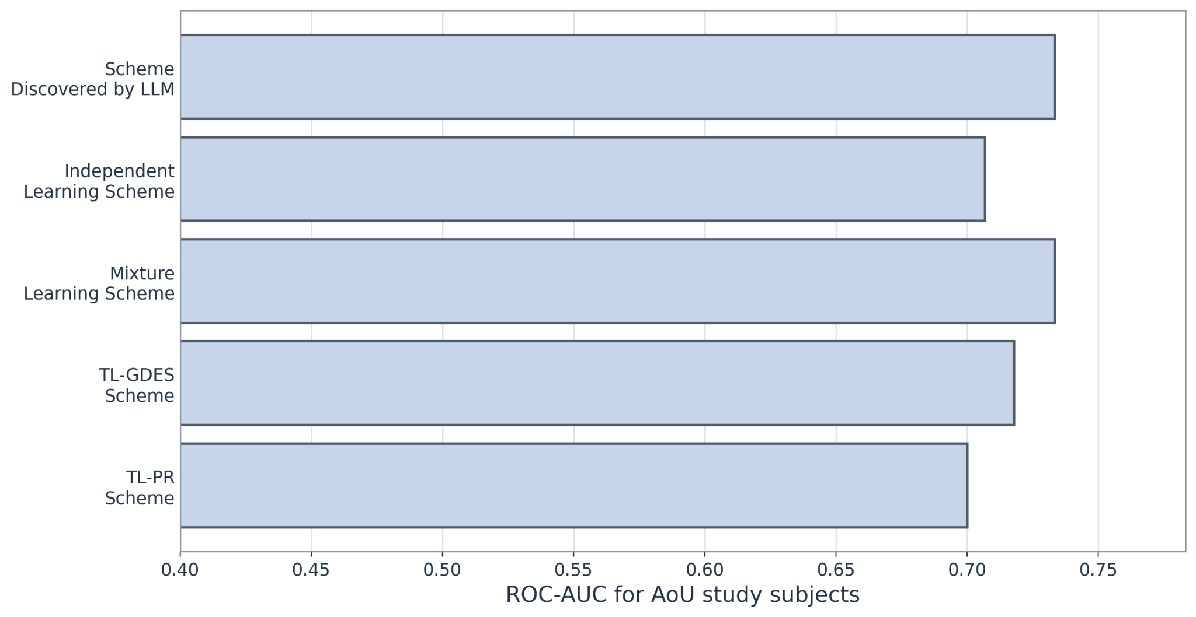
Figure 3B. Independent validation in All of Us. ROC-AUC on 30 held-out focal-ancestry subjects; Validation labels were never included during the discovery process. Too few samples to compute confidence intervals.

We pooled the matched differences across the 19 MEC, 63 OncoArray, and 30 All of Us held-out subjects from the focal ancestry group ($n=112$). For each comparator $b$, the one-sided paired t-test used the hypotheses in Equation (H1).
 | $$H_{0}: μ_{D_{b}}=0$$  $$H_{A}: μ_{D_{b}}>0$$ | (H1)
All four one-sided p-values were below 0.05 (Figure 4). The scientific claim here is that the locked LLM-discovered scheme outperforms prespecified human-designed comparator. We report the exact p-values rather than interpreting them as posterior probabilities or relying only on a binary significance label [Amrhein et al., 2019].
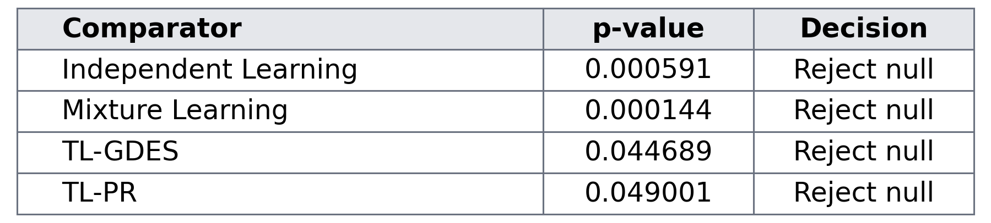
Figure 4. Pooled one-sided paired t-tests across the three Independent Validation Cohorts. All four component p-values are below 0.05.

The MEC variant panel was derived from prostate-cancer PGS Catalog scores after excluding scores whose metadata indicated use of MEC or closely related source data, thereby avoiding study-specific leakage in variant selection. The OncoArray variant panel was independently derived from prostate-cancer PGS Catalog scores, excluding scores whose metadata indicated use of OncoArray data; consequently, the variants evaluated here could differ from those used in MEC. All of Us used a deliberately different variant-selection route: the top prostate-cancer-associated variants from the version 7 All by All analysis, followed by LD pruning, so its evaluated variant panel could again differ from those used in MEC and OncoArray.

Preliminary Results for Specific Aim 3: the locked scheme and validation workflow were portable across independently constructed prostate cancer resources. In these Preliminary Studies, MEC, OncoArray, and All of Us served as three examples of very different source datasets. They differ in cohort composition, focal-sample availability, genotype source, and processing environment, yet the same locked priority function could be evaluated across all three without redesign because each source was reduced to the same evaluator-ready input contract. This portability is the key engineering prerequisite for Aim 3. The funded workflow is therefore defined by the common input contract, not by dependence on these three named studies: another prostate cancer resource can be used if it is independently held out and can be transformed to the same contract. The present preliminary work is limited to a single focal ancestry group; extension to additional focal ancestry groups remains proposed work.

4.2 Methods

4.2.1 Methods supporting Specific Aim 1: Discover patient- and variant-adaptive data-borrowing schemes
4.2.1.1 Broad overview of pipeline. Figure 1 gives the high-level generate-evaluate-refine loop; this subsection expands Figure 1 by specifying how the sampler, evaluator, and program database interact. Our discovery architecture largely follows the FunSearch paradigm [Romera-Paredes et al., 2024]. The LLM proposes an executable priority function. The fixed prostate-cancer evaluator scores that proposal. The program database then stores the proposed function, its evaluator outputs, its island, and its cycle provenance. The database is partitioned into islands, and each island maintains its own population of previously evaluated functions. The sampler draws informative, already scored functions from one island and supplies them to the LLM as historical examples for a subsequent proposal. A cycle is one complete round of proposal and evaluation across all islands. In the prespecified search, four islands operate in parallel; each island requests seven candidates per cycle, and a prompt may contain up to two previously scored functions. At the end of a completed cycle, if the stopping rule has not been met, the weaker half of the islands are retired and reseeded from strong functions selected from the surviving islands. Search continues for at most 12 cycles and may stop after two consecutive cycles without improvement. Independent Validation Cohorts are never exposed to the LLM, sampler, evaluator, or program database during this search. Importantly, the discovered scheme is a general algorithm, not a fitted vector of prostate-cancer coefficients. Once locked, the same priority function can be applied to any correctly formatted combination of a labeled reference dataset, a patient's 16-dimensional ancestry coordinate, and a target-variant identity. The remaining subsections give the exact input contract and evaluator that make this possible.
Common analysis-ready cohort signature. The funded method is defined by its final mathematical input signature rather than by a particular raw study. Let n be the number of labeled reference subjects and p the number of currently available variants. For reference subject k = 1, …, n, y_{k} is the binary prostate-cancer case/control label; a_{k} is the 16-dimensional continuous ancestry vector; g_{k} = (G_{k1}, …, G_{kp})^{T} is the p-variant vector of measured effect-allele dosages; and c_{k} is the optional prespecified covariate vector (with no entries when no additional covariates are used). Equation (1) collects these quantities into the labeled reference cohort R.
 | $$R=\{\left(y_{k},a_{k},g_{k},c_{k}\right)\}_{k=1}^{n},$$  $$y_{k}∈\{0,1\}, a_{k}∈R^{16},$$  $$g_{k}={\left(G_{k1},…,G_{kp}\right)}^{T}.$$ | (1)
For reference subject k and variant j = 1, …, p, G_{kj} is the measured effect-allele dosage supplied by the analysis-ready data. A patient i to be scored supplies the same data types except for the disease label: a_{i} is the patient's 16-dimensional ancestry vector and g_{i} = (G_{i1}, …, G_{ip})^{T} is the patient's effect-allele dosage vector. Thus G_{ij} is formally the jth dosage entry of patient vector g_{i}. Variant metadata identifies the logical variant and its matching dosage field. In the Preliminary Studies, for example, MEC, OncoArray, and All of Us required different upstream wrangling, but each was reduced to this same phenotype/ancestry/dosage structure before evaluation. These studies are examples of the adapter process, not mandatory inputs to the funded method.
Continuous ancestry input. Every reference subject and patient is represented by a 16-dimensional continuous ancestry coordinate of the same type used in the All of Us genomic release. We use this continuous representation rather than treating a discrete ancestry label as the full description of genetic similarity, consistent with the ancestry-continuum analysis of Ding and colleagues [Ding et al., 2023]. Derivation of the coordinates is an upstream data-preparation step and is not part of LLM-guided scientific discovery; the evaluator receives the completed 16-dimensional coordinates.
Priority-function contract and ancestry neighborhood. Let f denote a candidate LLM-generated priority function. For patient i and current variant j, let v_{j} denote the target-variant descriptor supplied to f; it contains the stable variant identifier, chromosome and position when available, effect allele, and key identifying the matching dosage field in the current analysis-ready data. The three scientific inputs to f are therefore R, a_{i}, and v_{j}. Its output r_{ij} is a finite non-negative radius. Equation (2) then defines N_{ij} as the reference-subject indices whose 16-dimensional ancestry vectors lie within Euclidean distance r_{ij} of a_{i}. The priority function never receives the patient's disease label and cannot change the phenotype definition, local effect estimator, calibration model, fold assignment, or evaluation metric.
 | $$r_{ij}=f\left(R,a_{i},v_{j}\right)≥0,$$  $$N_{ij}=\{k∈\{1,…,n\}:∥a_{k}-a_{i}∥_{2}≤r_{ij}\}.$$ | (2)
Equation (2) is the only decision made by the LLM-generated scheme: for each patient-variant pair, it determines how far to borrow through ancestry space. Everything after the radius is fixed by the evaluator.
Local marginal-effect estimation. For a binary label y in {0,1} and a real-valued linear predictor η, let ℓ(y, η) denote the one-observation Bernoulli logistic negative log-likelihood. Equation (3) gives its definition.
 | $$l\left(y,η\right)=log\left(1+exp\left(η\right)\right)-yη.$$ | (3)
For a fixed patient $i$ and target variant $j$, $k$ indexes the labeled reference subjects in the neighborhood $N_{ij}$ from Equation (2). Let $G_{kj}$ denote the effect-allele dosage of reference subject $k$ at variant $j$, and let $c_{k}∈R^{d}$ denote the prespecified covariate vector for that subject; $d=0$ when no additional covariates are used. Equation (4) forms $z_{kj}={\left(1,G_{kj},c_{k}^{T}\right)}^{T}$ and estimates the coefficient vector $θ={\left(β_{0},b,θ_{c}^{T}\right)}^{T}$ using only subjects $k∈N_{ij}$.
 | $$z_{kj}={\left(1,G_{kj},c_{k}^{T}\right)}^{T}, θ={\left(β_{0},b,θ_{c}^{T}\right)}^{T},$$  $${\hat{θ}}_{ij}=\underset{θ}{argmin}$$  k∈Nij​l​yk,zkjTθ+10-62∥θ-0∥22. | (4)
In Equation (4), $β_{0}$ is the neighborhood-specific intercept, $b$ is the coefficient of the current target-variant dosage, and $θ_{c}$ contains the coefficients of the prespecified covariates. The notation $θ_{-0}={\left(b,θ_{c}^{T}\right)}^{T}$ denotes all non-intercept coefficients, so the fixed L2 penalty $\frac{{10}^{-6}}{2}{∥θ_{-0}∥}_{2}^{2}$ does not penalize $β_{0}$. The minimizer is denoted ${\hat{θ}}_{ij}$, and its dosage coordinate ${\hat{b}}_{j}\left(a_{i}\right)$ is the local marginal effect of variant $j$ at the ancestry location $a_{i}$ of patient $i$. A local fit is attempted only when $N_{ij}$ contains at least 25 labeled reference subjects, both phenotype classes, and non-constant dosage for variant $j$. If any of these identifiability conditions fail, ${\hat{b}}_{j}\left(a_{i}\right)=0$. The patient-specific genomic feature is then Equation (5).
 | $$X_{ij}=G_{ij} {\hat{b}}_{j}\left(a_{i}\right).$$ | (5)
In Equation (5), $X_{ij}$ is the genomic feature contributed by variant $j$ for patient $i$, $G_{ij}$ is that patient's effect-allele dosage supplied in the patient input at variant $j$, and ${\hat{b}}_{j}\left(a_{i}\right)$ is the local dosage coefficient estimated by Equation (4) from labeled reference subjects near $a_{i}$. Thus $X_{ij}=G_{ij}{\hat{b}}_{j}\left(a_{i}\right)$. Repeating this construction over the $p$ variants in the current analysis gives $X_{i}={\left(X_{i1},…,X_{ip}\right)}^{T}$, the patient-specific genomic feature vector used by the calibration model. The same observed dosage can therefore receive a different predictive contribution at different positions on the ancestry continuum.
Fixed evaluator, calibration folds, and ROC-AUC fold score. Let Q be the total number of prespecified analysis conditions, and let q = 1, …, Q index one condition. Let H_{q} be the prespecified number of scoring folds for condition q. For that condition, the in-loop evaluation rows are deterministically partitioned into those disjoint scoring folds. For scoring fold h = 1, …, H_{q}, all remaining evaluation rows form the calibration set. To construct genomic features for calibration subjects, Equation (4) uses only the condition-specific Discovery Cohort reference set. To construct genomic features for subjects in scoring fold h, Equation (4) uses the union of that Discovery reference set and the calibration subjects. Thus a scoring subject's phenotype is never used to estimate that subject's local effects and is never used to fit the calibration model.
For analysis condition q and scoring fold h, let S_{qh} denote the subjects in the scoring fold and let C_{qh} denote all remaining in-loop evaluation subjects used for calibration. For each i in C_{qh}, X_{i} is the p-dimensional patient-specific genomic feature vector defined by Equation (5), c_{i} is the prespecified d-dimensional covariate vector, and y_{i} is the observed prostate-cancer label. Let α denote the calibration intercept, γ the covariate-coefficient vector, and ω the genomic-feature-coefficient vector. The ridge penalty λ is fixed at 0.1. Equation (6) defines the linear predictor and fits α, γ, and ω using only subjects in C_{qh}.
 | $$η_{i}\left(α,γ,ω\right)=α+γ^{T}c_{i}+ω^{T}X_{i},$$  $$\left({\hat{α}}_{λ,qh},{\hat{γ}}_{λ,qh},{\hat{ω}}_{λ,qh}\right)=\underset{α,γ,ω}{argmin}$$  i∈Cqh​lyi,ηi+λ2∥ω∥22. | (6)
In Equation (6), only ω is ridge-penalized; α and γ are unpenalized. The ridge penalty is 0.1 for every condition and fold. To retain the notation used in Equation (7), define λ_{sel,qh} = 0.1 for all q and h. The hatted α, γ, and ω quantities in Equation (6) are the corresponding coefficients fitted on C_{qh} at this fixed penalty.
For each subject i in S_{qh}, the evaluator constructs X_{i} without using y_{i}. In Equation (7), the hatted η quantity, with subscripts i and λ_{sel,qh}, denotes Equation (6)'s linear predictor evaluated at the hatted coefficients fitted on C_{qh} with λ_{sel,qh} = 0.1. Equation (7) defines s_{i,qh} as this frozen real-valued predictor value. The scoring-fold label y_{i} is not used in constructing s_{i,qh}.
 | $$s_{i,qh}={\hat{η}}_{i,λ_{sel,qh}}, i∈S_{qh}.$$ | (7)
The sigmoid of Equation (7) is the corresponding risk probability, but ROC-AUC depends only on the ordering of the scores $s_{i,qh}$. Within $S_{qh}$, let $n_{1}$ be the number of prostate-cancer cases and $n_{0}$ the number of controls. Let $u_{r}, r=1,…,n_{1}$, denote the Equation (7) scores for the cases, and let $v_{s}, s=1,…,n_{0}$, denote the scores for the controls. In Equation (8), $I\left(⋅\right)$ is the indicator function, equal to 1 when its condition is true and 0 otherwise. $A_{qh}$ is therefore the empirical ROC-AUC for condition $q$ and fold $h$: the average over all case-control pairs of 1 when the case score exceeds the control score and $1/2$ when the two scores are tied.
 | $$A_{qh}=\frac{1}{n_{1}n_{0}}\sum_{r=1}^{n_{1}}{\sum_{s=1}^{n_{0}}{H_{rs}}},$$  $$H_{rs}=I\left(u_{r}>v_{s}\right)+\frac{1}{2}I\left(u_{r}=v_{s}\right).$$ | (8)
For robustness, the fold score F_{qh} is the median ROC-AUC across B = 200 bootstrap resamples of S_{qh}. Resamples containing only one phenotype class are omitted; if no valid resample remains, F_{qh} is set to the direct ROC-AUC A_{qh} from Equation (8).
Let F̄ denote the candidate's base performance score. After F_{qh} has been obtained for every prespecified condition q = 1, …, Q and fold h = 1, …, H_{q}, Equation (9) defines F̄ as the arithmetic mean of these fold scores.
 | $$\overline{F}={\left(\sum_{q=1}^{Q}{H_{q}}\right)}^{-1}\sum_{q=1}^{Q}{\sum_{h=1}^{H_{q}}{F_{qh}}}.$$ | (9)
In the Preliminary Studies, for example, there were two prespecified conditions (without and with additional covariates) and two folds per condition, so Equation (9) averaged four fold scores.
Program-database ranking and locking. Every evaluated candidate, its fold-level scores, mean performance, island assignment, cycle, prompt context, and LLM completion are stored in the program database. Let s denote the candidate's auxiliary simplicity value, equal to minus the number of abstract-syntax-tree nodes in the candidate priority function. At registration, s is compared with M other functions sampled from the destination island, with M at most 100. When M > 0, let r be the number of comparison functions with simplicity strictly greater than s plus one-half the number tied with s; the simplicity bonus is B_{simp} = 0.008(1 - 2r/M). When M = 0, B_{simp} = 0. Thus B_{simp} is bounded in [-0.008, 0.008]. Let F̄ denote the base performance score from Equation (9); Equation (10) defines S_{rank} as the island-ranking score.
 | $$S_{rank}=\overline{F}+B_{simp},$$  $$B_{simp}∈\left[-0.008,0.008\right].$$ | (10)
Accepted candidates are registered in their island before the next proposal is sampled, allowing later prompts to use earlier improvements. At cycle end, the weaker two of four islands are reset and reseeded from strong functions selected from the surviving islands. The globally best candidate (according to S_{rank}) at the prespecified stopping point is locked. No Independent Validation Cohort is examined to choose the candidate, alter Equation (2), select the stopping time, or otherwise modify the discovered scheme.

4.2.2 Methods supporting Specific Aim 2: Post-lock evaluation on Independent Validation Cohorts
Post-lock validation protocol. Aim 2 is completely separated from discovery: the LLM, sampler, islands, and program database are no longer active, and the locked priority function cannot be changed in response to validation results. Before evaluation, each Independent Validation Cohort is partitioned into three disjoint roles: a labeled reference subset, a calibration subset, and a final held-out subset. Calibration-subject genomic features are constructed using only the labeled reference subset for Equation (4), after which the calibration model is fitted by Equation (6), with the ridge penalty fixed at 0.1 as specified in Section 4.2.1. Final held-out-subject genomic features are then constructed using the union of the labeled reference and calibration subsets for Equation (4), and the already fitted calibration coefficients are applied without refitting. The final reported validation ROC-AUC is Equation (8) computed only on the final held-out subjects. Every final held-out subject is outside the Discovery Cohort and was never available to the discovery evaluator. Its phenotype label is used only to compute the final validation ROC-AUC, never to choose a radius, estimate a local variant effect, select a candidate scheme, or fit the calibration model.
Independence across studies and variant sets. Aim 2 deliberately includes both same-parent-study held-out validation, when appropriate, and Independent Validation Cohorts drawn from studies that are completely independent of the study used for discovery. The study-independent cohorts provide the stronger test against discovery-study artifacts. Independence is also not restricted to subjects: the validation variant panel does not have to equal the discovery variant panel. For every variant present in a validation analysis, the current validation reference, calibration, and held-out data need only supply a harmonized effect-allele dosage and the variant descriptor required by the common contract. The locked priority function is then applied to that current variant using the current labeled reference data and current patient's ancestry coordinate. A variant that was absent from the Discovery Cohort can therefore be evaluated without rediscovering or refitting the priority function.
Human-designed comparison schemes. Within every validation analysis, the locked LLM-discovered scheme and the prespecified comparison schemes - Mixture Learning, Independent Learning, TL-GDES, and TL-PR - receive the same reference subjects, calibration subjects, final held-out subjects, current variant set, and optional covariates. These comparators include established transfer-learning approaches developed in our laboratory and recent transfer-learning work [Gao and Cui, 2020; Gao and Cui, 2024; Wu et al., 2026]. Overall and ancestry-specific final held-out ROC-AUC and subject-level risk scores will be retained for the Statistical Plan. Statistical testing will evaluate the already locked scheme and will never be used to choose or modify it.
Preliminary-study examples: held-out MEC and OncoArray. In the Preliminary Studies, for example, a held-out subset of MEC provided a same-parent-study validation example, whereas OncoArray provided a study-independent validation example [Conti et al., 2021]. The raw genotype sources differed and required different upstream phenotype and variant harmonization, but those differences ended at the adapter boundary: both were represented by the same binary phenotype, 16-dimensional ancestry coordinates, effect-allele dosage fields, and optional covariates before post-lock evaluation. These are examples of compatible validation resources, not hard-coded requirements of the funded method.
Preliminary-study example: All of Us. In the Preliminary Studies, for example, All of Us supplied a second study-independent validation setting [All of Us Research Program Genomics Investigators, 2024]. We did not use the PGS Catalog for this example. Version 7 All by All prostate-cancer association results were used to select the top 50 associated variants, followed by LD pruning, and version 7 participants provided the labeled reference data. The final Independent Validation Cohort consisted of participants entering the program in version 8; those individuals were not part of the version 7 All by All analysis used for feature selection. After conversion to the common phenotype/ancestry/dosage signature, the same locked priority function was evaluated. This example illustrates both protections emphasized in Aim 2: the final held-out subjects came from data that were never part of discovery, and the variant panel was defined by the validation resource rather than being required to reproduce the discovery panel.
Generalization criterion. Aim 2 asks whether a locked patient- and variant-adaptive data-borrowing scheme remains useful when the study, subjects, and potentially the scored variants change while the mathematical input contract remains fixed. A negative result in an Independent Validation Cohort will be retained as a validation result and will not trigger post hoc discovery on that cohort.

4.2.3 Methods supporting Specific Aim 3: Generalize and release the validated workflow
Repeat the discovery-lock-validation sequence across focal ancestry groups. After the East Asian proof-of-concept, the funded work will execute the same prespecified discovery architecture separately for East Asian, African, and Latino focal ancestry groups. Prostate cancer remains the disease endpoint in every run; only the focal ancestry group and prespecified cohort partitions change. Each run ends with one locked priority function before any group-matched Independent Validation Cohort is accessed. Cohorts without an adequate prespecified focal-group validation sample will not be relabeled or pooled post hoc.
User-facing input contract. The released workflow will accept a labeled prostate-cancer reference cohort satisfying Equation (1), the new patient's compatible 16-dimensional ancestry coordinate, and a requested set of target variants with effect-allele dosages. The patient supplies no phenotype. Each target-variant descriptor identifies one variant and its matching dosage field. The 16-dimensional ancestry coordinates are prepared upstream using the same continuous representation described above; the risk-locus panel itself is not used to infer ancestry.
Target variants are not restricted to discovery or validation panels. A future user's requested variants need not be a subset of the variants used in the Discovery Cohort or in any Independent Validation Cohort. The locked priority function acts on one current target variant at a time using the current labeled reference data and the current patient's ancestry coordinate. Therefore a previously unseen variant can be scored without changing the priority function, provided that the user's labeled reference cohort and patient contain a harmonized effect-allele dosage for that variant and the variant satisfies the prespecified quality-control requirements. The released product is consequently a reusable data-borrowing scheme and not tied to one historical SNP panel.
From a labeled reference cohort to a patient-level risk score. A user may provide separate effect-estimation and calibration subsets or allow the workflow to create a deterministic prespecified split of the supplied labeled reference cohort. The effect-estimation subset is used to fit the local effects in Equation (4) for the calibration subjects. Equation (6) fits the calibration model using only the calibration subset. For the new patient, the effect-estimation reference is expanded to include the calibration subset, Equation (4) produces the patient's local effects, and Equation (5) produces the patient's genomic feature vector. The locked priority function itself is never refit. The patient's final genomic risk score is the frozen linear score in Equation (7), with its sigmoid reported when a bounded risk-like probability is desired.
Transforming heterogeneous cohort data to the common contract. Users who already have the canonical phenotype/ancestry/dosage table can supply it directly. Users starting from genotype data and phenotype metadata will use a source-specific adapter that aligns samples to labels, harmonizes variant identifiers and effect alleles, converts genotypes to numeric effect-allele dosages, applies prespecified variant/sample quality control and LD pruning when required, attaches the supplied 16-dimensional ancestry coordinates, and records row and variant provenance. In the Preliminary Studies, for example, MEC, OncoArray, and All of Us represented three different raw-data settings that were reduced to Equation (1)'s common contract. Those implementations illustrate the transformation; the funded workflow is source-agnostic after the canonical table is produced.
Interpretable outputs and community release. For each patient, the workflow will return the final genomic risk score and, when requested, an audit table containing the target variant, the radius from Equation (2), the number of reference subjects inside that radius, the local effect fitted by Equation (4), the patient's input dosage, and the contribution from Equation (5). We will release the locked priority functions that complete validation, the fixed evaluator and post-lock validation workflow, the canonical data-schema specification, cohort-adapter templates, variant and row provenance formats, validation tests, example configurations, and a small synthetic example dataset that can be used without controlled-access data. Patient scoring after discovery requires only the locked priority function and the fixed statistical workflow; it does not require an LLM.

4.3 Address potential problem areas and present alternative methods
Reproducibility of LLM-guided scientific discovery. The Preliminary Studies used OpenAI GPT-5.5, a commercially hosted model. Because the underlying model weights and serving stack are not under our control, another laboratory cannot guarantee reproduction of the exact discovery trajectory or regeneration of the same final priority function from the same starting prompt. The priority function itself, once generated and locked, is ordinary executable code and is reproducible. Under the award, we will address this limitation by running the discovery stage with locally hosted, openly available models whose weights can be archived, such as models from Meta's Llama family. We will archive the exact model weights and checksums, tokenizer, prompts, decoding settings, random seeds, sampler state, and evaluator configuration. No patient-level genotype, phenotype, ancestry-coordinate, or other participant data are sent to the LLM. Candidate priority functions are executed and scored locally; the LLM receives only historical candidate priority functions and aggregate evaluator feedback. In the current evaluator, that feedback is derived from prespecified scoring folds summarized using 200 bootstrap resamples per fold. Thus, the protected patient data remain inside the evaluator regardless of which LLM is used.
Discovery-cohort composition for an African focal ancestry. The MEC data were suitable for the East Asian proof-of-concept but their composition is not suitable for constructing the intended African-focal discovery setting. For the African focal ancestry, we will instead derive the Discovery Cohort from OncoArray and reserve All of Us as an Independent Validation Cohort. The same common input contract, priority-function contract, and fixed evaluator described in Section 4.2 will be used, so changing the cohort changes the source data rather than the scientific question or algorithmic search space.
Rapid evolution of LLM-guided scientific discovery. LLM-guided scientific discovery is advancing rapidly, and several components of the search pipeline are evolving in parallel: how previously evaluated candidate priority functions are sampled and returned to the LLM, which LLM is used to generate new candidates, and how the program database is updated to retain useful discoveries while removing unproductive candidate lineages. Recent work has explored alternative strategies for these components, including more structured round-robin sampling schemes, while reasoning-oriented models and test-time scaling have shown that allocating additional inference-time computation can substantially improve performance on difficult reasoning problems [Snell et al., 2024]. We will therefore treat the sampler, LLM, and database-update policy as modular components while keeping the prostate-cancer data contract, evaluator, and Independent Validation boundary fixed. As more effective approaches emerge, our team will evaluate and incorporate those that can improve the search for algorithms that enable more reliable early detection of prostate cancer, without changing the prespecified scientific objective or protected validation design.

4.4 Resources Needed
The project requires no new data collection, prospective recruitment, or clinical trial. The dbGaP multi-population prostate cancer resource is the Discovery Cohort, within which LLM-guided scientific discovery, evaluator scoring, and scheme selection occur; All of Us is an Independent Validation Cohort, entering only after a priority function is locked. This separation is fixed before discovery and prevents validation labels from influencing scheme selection.
Discovery resource - dbGaP. Individual-level genotypes, prostate cancer case-control status, ancestry information, recruitment site, and principal components are available under phs001391.v1.p1, phs000306.v4.p1, phs001120.v1.p1, phs001221.v1.p1, phs000812.v1.p1, and phs000838.v1.p1 [Conti et al., 2021]. Across these deposits, 149,708 participants have individual-level data: 84,574 cases and 65,134 controls (Table 1). The 82.9% European-ancestry share supplies the abundant non-focal reference data that the discovered borrowing scheme must learn to use. MEC and OncoArray, used in the Preliminary Studies, are contained in this resource, so the required harmonization code and variant adapters are already established.
Independent validation resource - All of Us. All of Us links genomic data to longitudinal electronic health records. A peer-reviewed analytic sample contains 98,185 male-sex participants, including 7,577 prostate cancer cases and 90,608 controls across six genetic ancestry groups [Cheng et al., 2026]. Access is through the Controlled Tier of the Researcher Workbench, with analyses performed inside the secure workspace.
Table 1. Individual-level prostate cancer case-control data available in dbGaP and All of Us.
Population group | dbGaP cases | dbGaP controls | AoU cases | AoU controls
European | 71,570 | 52,531 | 5,757 | 54,751
African | 9,126 | 8,702 | 1,212 | 20,193
Latino / Admixed American | 2,226 | 2,098 | 492 | 12,807
East Asian | 1,652 | 1,803 | 63 | 1,512
South Asian / Middle Eastern | - | - | 53 | 1,345
Total | 84,574 | 65,134 | 7,577 | 90,608
Focal-group availability. African and Latino analyses have thousands of focal-group cases available for discovery and hundreds to thousands for validation while remaining a minority of the Discovery resource. East Asian validation is more constrained because All of Us contains 63 East Asian cases; for this arm, the primary Independent Validation Cohort will therefore be a substudy-independent partition of the dbGaP resource using non-overlapping contributing studies, with All of Us used as secondary confirmation, as demonstrated in the Preliminary Studies. We have active institutional access to the dbGaP and All of Us resources described above.

4.5 How Each Specific Aim Progresses Toward the FY26 PCRP Overarching Challenge
This application addresses the FY26 PCRP Overarching Challenge to "Enhance clinical care for all patients with prostate cancer," with emphasis on high-risk groups. The specific barrier is ancestry drift: risk-stratified early detection depends on inherited-risk estimates, but those estimates can become unreliable when the ancestry-related genomic architecture of the patient differs from the model-development cohort. The response has often been to restrict genomic risk tools to the populations in which they were developed, as in BARCODE1 [McHugh et al., 2025]. Each aim removes a different part of this barrier.
Aim 1 - discover the missing adaptive data-borrowing mechanism. Prostate cancer variant effects differ across ancestry backgrounds [Conti et al., 2021], while existing schemes set borrowing at the population or model level. Aim 1 turns the patient- and variant-specific borrowing decision into an executable function, scores candidate priority functions with a fixed prostate-cancer evaluator, and uses LLM-guided scientific discovery to search for a better scheme. Its deliverable is a locked, interpretable priority function for each focal ancestry group; the detailed discovery loop is defined in Section 4.2.1.
Aim 2 - establish whether the discovered scheme actually generalizes. Performance on the data that selected a scheme is not evidence that it will help patients outside discovery. Aim 2 therefore opens Independent Validation Cohorts only after the priority function is locked, applies identical partitions and variant sets to the LLM-discovered and human-designed schemes, and evaluates final held-out subjects from the focal ancestry group. A negative result is retained and cannot trigger post hoc discovery. This converts an in-loop discovery into an unbiased test of whether ancestry drift has been reduced in new patients (Section 4.2.2).
Aim 3 - extend the result and make it usable by the prostate cancer community. We will repeat the discovery-lock-validation sequence for East Asian, African, and Latino focal ancestry groups, with the African analysis prioritized because Black men have approximately 67% higher incidence and twice the mortality of White men [Kratzer et al., 2025]. We will then release the validated priority functions, evaluator, adapters, and end-to-end scoring workflow. Patient scoring requires only the locked executable function, not an LLM, so other investigators can apply the method to compatible prostate cancer cohorts and inspect the per-variant borrowing decisions (Section 4.2.3).

5. Statistical Plan
Primary estimands and reporting. Statistical testing begins only after a priority function is locked and never feeds back into discovery. For each focal ancestry group, the primary confirmatory comparison is subject-paired performance of the locked LLM-discovered scheme versus the four prespecified human-designed schemes: Independent Learning, Mixture Learning, TL-GDES, and TL-PR. For held-out subject i and comparator b, the paired outcome is the correct-label probability difference defined in the Preliminary Studies. We will estimate the mean paired difference with a confidence interval and use a one-sided paired t-test for improvement; focal-group held-out ROC-AUC with bootstrap confidence intervals will be reported as a complementary discrimination measure. Exact p-values, effect estimates, and uncertainty intervals will be reported rather than reducing results to a binary significant/non-significant label [Amrhein et al., 2019].
Control of false-positive discoveries in multiple comparison settings. The principal statistical risk is Type I error created by flexible LLM-guided scientific discovery. Under the present design, one locked LLM-discovered scheme is carried forward per focal ancestry group. As described in Section 4.3, the rapidly evolving field may justify prespecified experiments with different core LLMs, sampler policies for selecting historical programs, or program-database update policies. If K candidate LLM-discovered schemes are carried to validation for one focal group, multiple comparison issues arise. The main concern is type 1 errors and not power, as we do not want to degrade confidence by releasing schemes that do not generalize. Here familywise error rate (FWER) will be controlled at 0.05 with the Bonferroni correction, using alpha/K for the K candidate locked proposals[Bonferroni, 1936; Dunn, 1961]. The Benjamini-Hochberg false discovery rate (FDR) procedure will be reported as a less conservative exploratory summary [Benjamini and Hochberg, 1995]. Independent Validation data remain sealed and cannot be used to choose K or redesign a candidate.
Sample size. This award uses fixed existing cohorts rather than recruiting subjects; projected availability is given in Table 1.
Statistical expertise. Anirban Das has a PhD in Mathematics specializing in Applied Probability and experience with statistical analysis of biological and genomic data. UTHSC also has the Biostatistics, Epidemiology, and Research Design (BERD) Unit in the Department of Preventive Medicine, which provides consultation on study design and statistical analysis to UTHSC investigators.

