

**PBL Manual   
Design and Analysis of Algorithm [CSL0503]:**

**SUBMITTED TO: SUBMITTED BY:**

**MR. H N VERMA   
Itm university Gwalior**

**Saurabh Lakshkar BETN1CS22188  
Anubhavi Singh**

**BETN1CS22166**

**B.Tech (Cyber Forensics )**

**SEC: E , Vth  SEM**

Step1: RUN the file in the browser

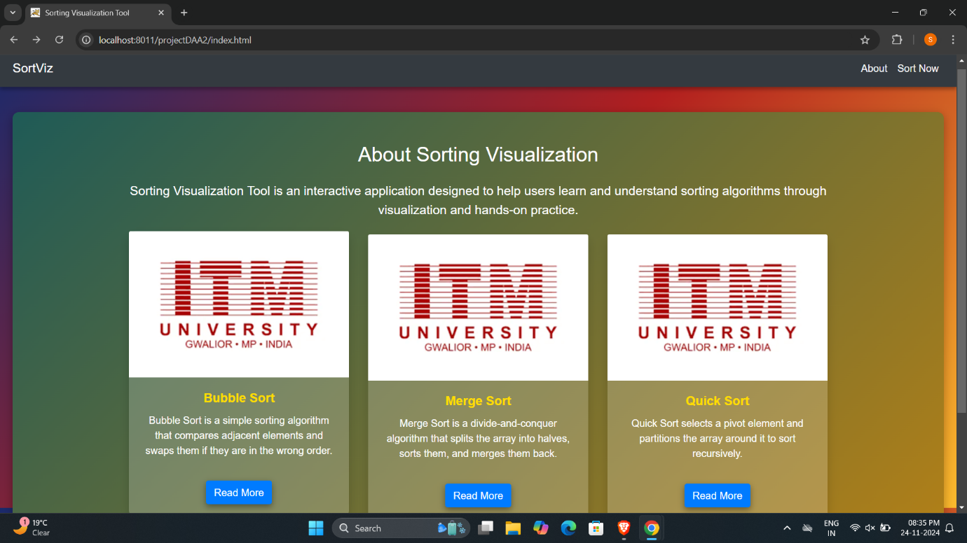 Step2: CLICK THE READ MORE BUTTON TO SEE ABOUT SORTING ALGORITHMS

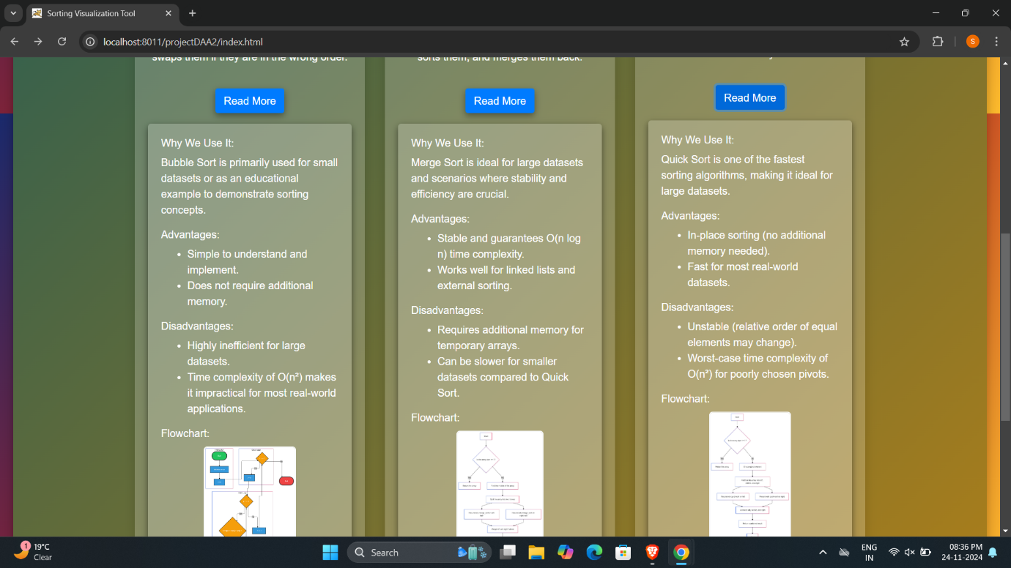

Step3: CLICK THE “**SORT NOW** “ BUTTON TO GO ON SORTING VISULIZATION PAGE

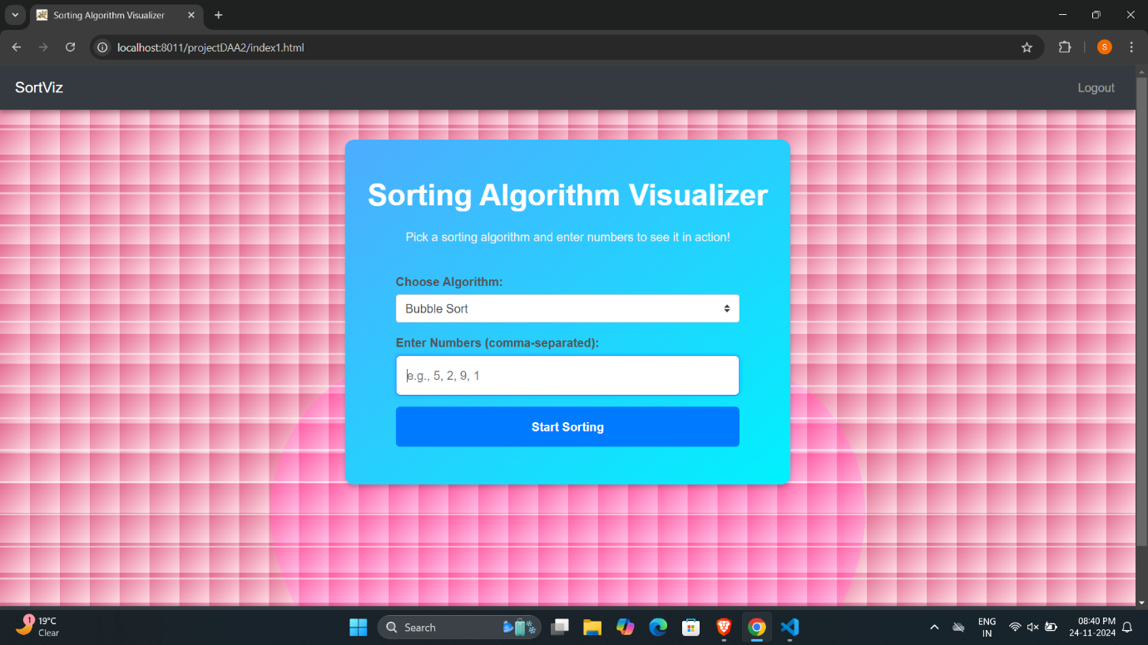  
Step4: ENTER THE SORTING NUMBERS LIST AND CLICK ON START SORTING BUTTON TO VISULIZE AND SORT THE LIST .

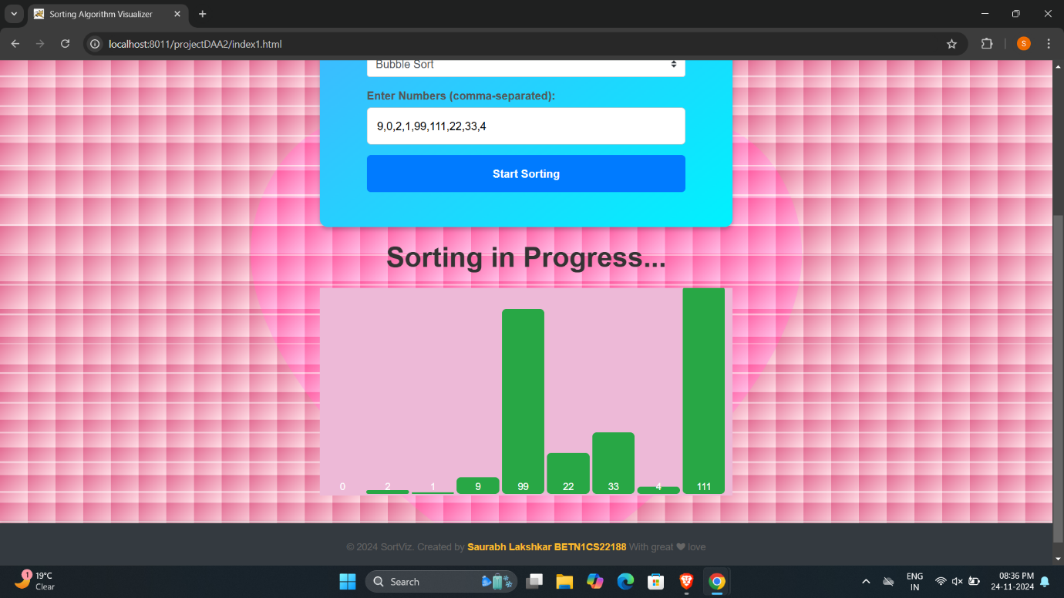

Step 5:- RESULT   
