How to setup environment for Papyrus SAR on Linux

▬▬▼▼▼▬▬

PREREQUISITES

- Checking version of Linux with command following:

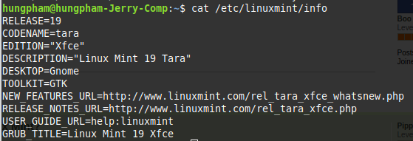
- Installation from source requires the following additional packages:
  - Java JDK
  - Eclipse Photon for Java Developer/ Visual Studio Code/ Atom /etc. used for modifying code.
  - Maven

sudo apt-get update
sudo apt-get install maven

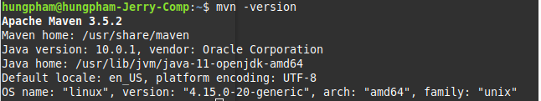

SETUP

This is the link which you referenced to set up the camera and the PapARt library http://forum.rea.lity.tech/t/quick-start-with-a-webcam/18, or you can follow steps below

Step 1: Install processing first https://processing.org/download/ .Once it is installed you need to run it once so that it creates all the folders. Some libraries are

Step 2: Download and install PapARt examples
Download from the link https://github.com/poqudrof/Papart-examples and then extract to your ketchbook/) which was created by Processing when running it first.

Step 3: Download and install all other libraries. PapARt requires additional libraries here is the collection https://www.dropbox.com/s/i8locsl4kmpabtk/libraries.tar.gz?dl=0 . It is used for math, network, 3D, and GUI. It includes well known Processing libraries: PeasyCam, OSCP5, Video, Toxiclibs. And custom ones: SVGExtended, ProcessingTUIO, Skatolo, GuiModes, and Reflections, etc.

Copy all libraries to /home/{yourname}/sketchbook/libraries/. After that please check again all libraries as below must be installed in your sketchbook libraries folder.

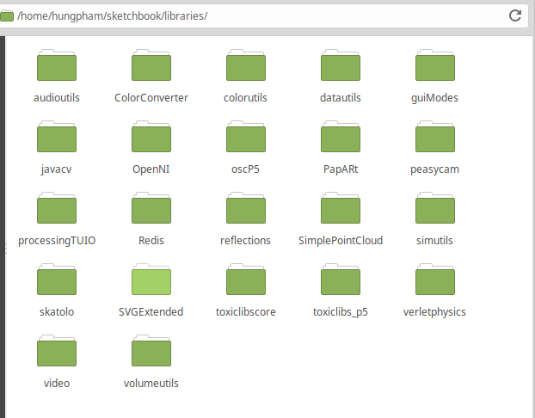
Note: In this guide, we’re using PapARt library version 1.4rc from here
https://forge.pole-aquinetic.net/RealityTech/Papart-exemples/blob/1.4-rc/java or you can use another version from https://github.com/poqudrof/PapARt

Step 4: Install OpenNI from https://www.dropbox.com/s/n5099xtsm71dvof/2-Linux.zip?dl=0
unzip 2-Linux.zip and then unzip 2-Linux/OpenNI-Linux-x64-2.3. After that run command as following:

cd OpenNI-Linux-x64-2.3

sudo cp Include/*.h /usr/include/
sudo cp -R Include/Linux-x86 /usr/include/Linux-x86
sudo cp -R Include/Driver /usr/include/Driver

sudo cp orbbec-usb.rules /etc/udev/rules.d/558-orbbec-usb.rules

sudo cp -r Redist/*.so /usr/lib/
sudo cp -r Redist/*.ini /usr/lib
sudo cp -r Redist/OpenNI2 /usr/lib

Step 5: Camera test and run calibration
Print the marker board: You can find it in libraries \PapARt\data\markers\A4-default.pdf or online on github on: https://github.com/poqudrof/PapARt/blob/master/papart/data/markers/A4-default.svg

Launch the example Sketchbook -> PapARt-examples -> first-examples -> SAR -> TouchAR. Run the example, and show the printed sheet in front of the camera.

Launch the calibration Sketchbook -> PapARt-examples -> calibration -> mainCalib. Run the calib, and show the sheet https://github.com/poqudrof/PapARt/blob/master/papart/data/markers/print-only/calib1-print.svg in front of the camera as this guide https://github.com/poqudrof/PapARt/blob/master/papart/data/markers/print-only/calibration%20instructions.pdf

RUN JAVA APP
Setup to run a java maven application with Processing and PapARt library.

Step 1: Add SSL working out of the box.

sudo apt-get install -y ca-certificates-java && update-ca-certificates -f

Step 2: Add PapARt library jar to Local Repositories

mvn install:install-file -Dfile=/home/{yourname}/sketchbook/libraries/PapARt/library/PapARt.jar -DgroupId=fr.inria -DartifactId=papart -Dversion=1.4-SNAPSHOT -Dpackaging=jar

Step 3: Get the source code and install maven plugins
Get source code from the repository https://forge.pole-aquinetic.net/RealityTechPublic/FragmentsAR

Cd /FragmentsAR/PapyrusSAR
mvn -U clean install

Step 4: Compile the code

mvn compile

Step 5: Run the code

mvn exec:java -Dexec.mainClass="Papyrus"

REFERENCES

https://github.com/poqudrof/PapARt

https://github.com/poqudrof/Papart-examples

http://forum.rea.lity.tech/

