# AI Assignment 2 : Face Recognition

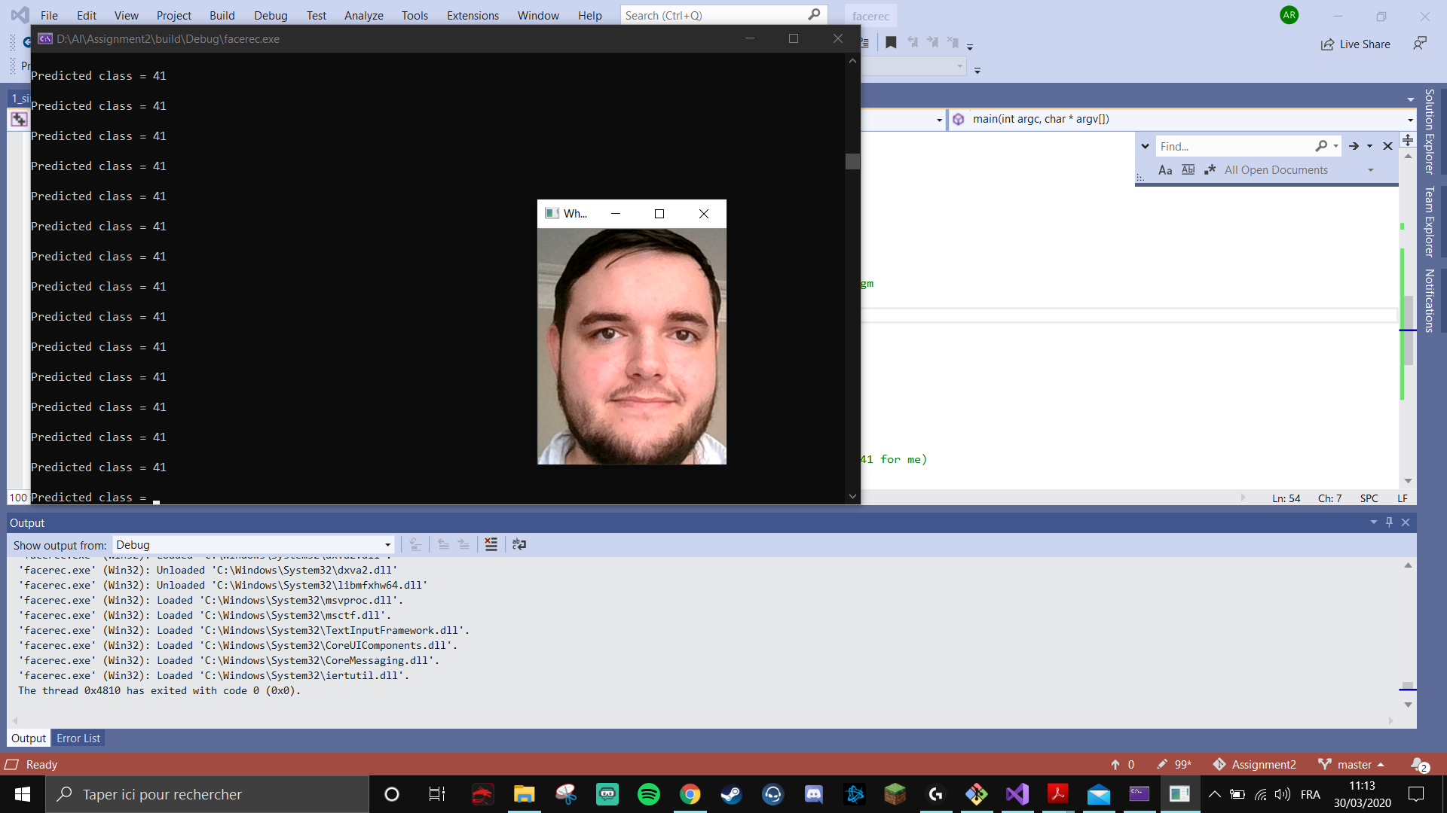

Please note: Only my pictures have been pushed to the repository, please add the att_faces

Question: The FaceRecognizer::predict method returns a label indicating a match has been found. Is it possible to obtain a measure of the system's confidence in that match?

Answer: