React js notes

React is a javascript library used for interfaces

Components

a piece of the UI, you can reuse components to build a webpage

every react has at least 1 root component called App it represents the internal Application and contains other child components

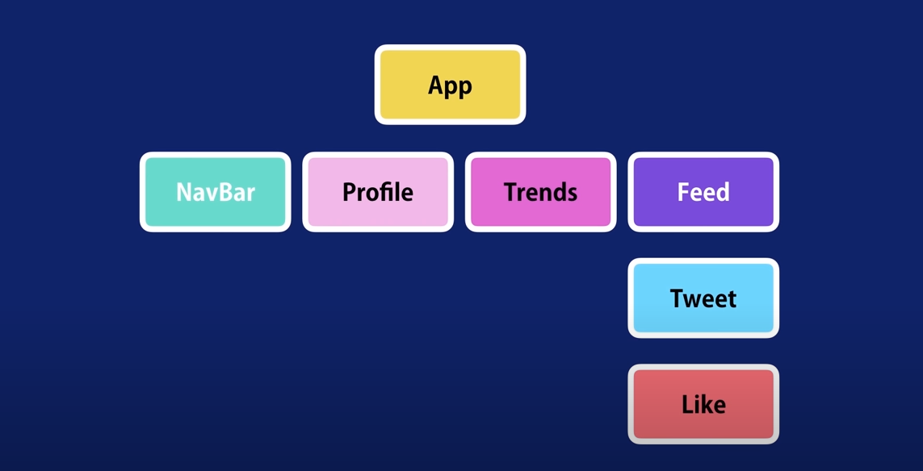The web page will be populated with these different components, in the example twitter is used.

A twitter web page will have these different components and some might have child components like the feed which contains other components like tweet and like.

A components is implemented as a javascript class and it has a state and a render method.

The state is the data that the component will display when its rendered

The render method is tasked with describing what the UI should look like. The output of the render method is a React Element which is a javascript object which maps to a DOM element