How to use git-hub
www.github.com

source- https://guides.github.com/activities/hello-world/

CREATING REPOSITORY

1.go to the website

2. click on the + sign top right

3. create repository

CREATING BRANCH

a branch is used to experiment on the repository without altering it. When u create a branch github takes a snapshot of the code so your coding on a copy of the master

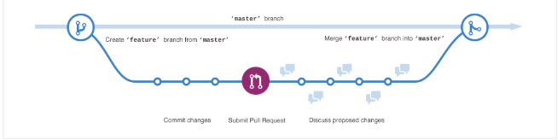
to create a branch go to the repository

Click on branch: Master

Enter the name in the text box and click create branch

EDITING TEXT DOCUMENTS

you can edit text document on github by clicking on the text document and clicking the pencil

Write a Message below to describe the nature of the commit

PULL REQUEST

pull request is when you request to merge your changes to another branch, someone may review the request before it merges.

U can @mention someone with your pull request if u want feedback from a certain person

1. when u have the repository open click on the Pull request tab
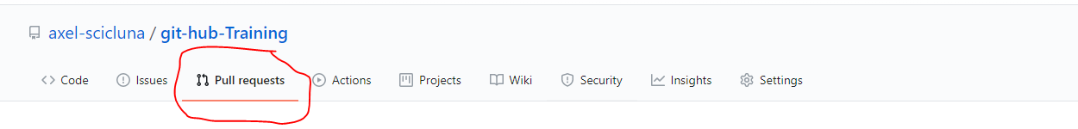

2.On the screen Comparing changes click the boxes to the appropriate branch

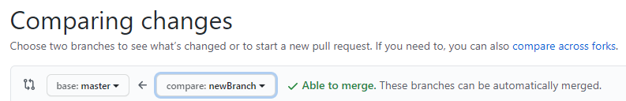
3. The green text is the added changes while the red text is the removed changes

4. Click the Create pull Request

MERGING OF PULLS TO MASTER

1.go back to the pull request tab
2. you will see the request with the name u gave it and click on it
3. Click Merge pull request to finalize it

