How to guide for smart air monitor:

**Hardware:**

The hardware consists of 5 main components:

* ESP32
* CCS811 (gas sensor)
* DHT22 (temp/humidity sensor)
* GP2Y1014AU (particle sensor)
* Buzzer
* Button

 The pins that connect these components to the ESP32 can be changed at the top of the main.ino file.

By using their default values the sensors and components can be connected to the ESP32 in the follwing way:

* CCS811
  + GND -> Ground
  + VCC -> 3.3V
  + SDA -> GPIO21
  + SCL -> GPIO22
  + WAKE-> Ground
* DHT22
  + GND -> Ground
  + VCC -> 3.3V
  + Data -> 10k pull up resistor from VCC; GPIO33
* GP2Y1014AU
  + GND -> Ground
  + VCC -> 5.0V
  + LED -> GPIO19
  + Data -> GPIO34
* Buzzer
  + GPIO18
  + Ground
* Button
  + 5V
  + Ground
  + GPIO17

**Software:**

The Arduino IDE is used for writing and uploading code to the ESP32. For this project some library’s need to be installed.

First the ESP32 board needs to be added to the Arduino IDE, this is done by going to File->Preferences and then adding this link <https://dl.espressif.com/dl/package_esp32_index.json> to the “Additional Board Manager URLs:” and pressing OK.

Next go Tools->Board->Board Manager then search ESP32 and installing the option and comes up.

Once installed go Tools->Board->ESP32 Arduino->ESP32 Dev Module.

Now the ESP32 board is setup in the Arduino IDE, next some libraries need to be installed for this device.

These libraries can be installed though the Library Manager at Tools->Manage Libraries…

* Adafruit CCS811 Library
* DHT sensor library
* Arduino_JSON

Once these are installed the IDE is now setup.

The Server links will now need to be setup:

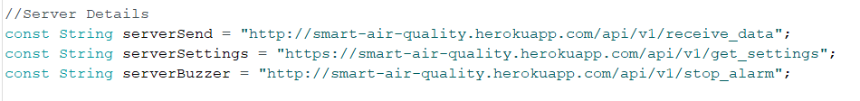

* serverSend is where data from the device will be sent.
* serverSettings is where the device will get its settings from
* serverBuzzer is where data saying the button has been pressed will be sent

Finally the WiFi SSID and password need to be set so the device can connect to the internet

Once this is all done the code can be uploaded to the Device.

**Project Working:**

Assuming hardware and software were setup properly nothing needs to be done while the device is running.