scp_pcap_4128_8192_no.pcap

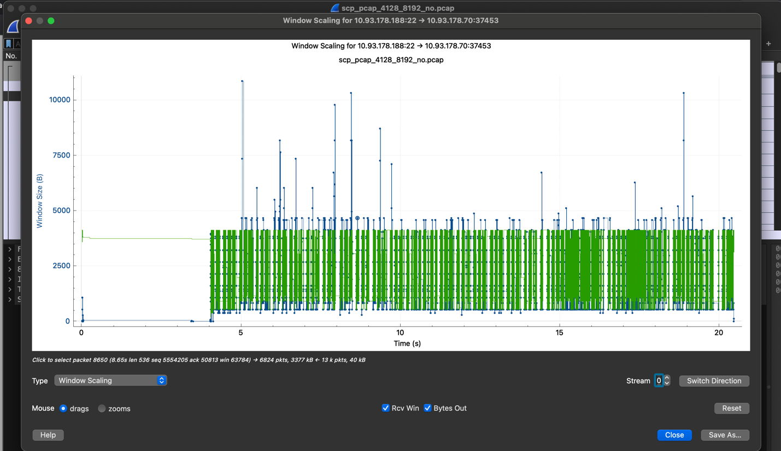

scp_pcap_8192_8192_no.pcap

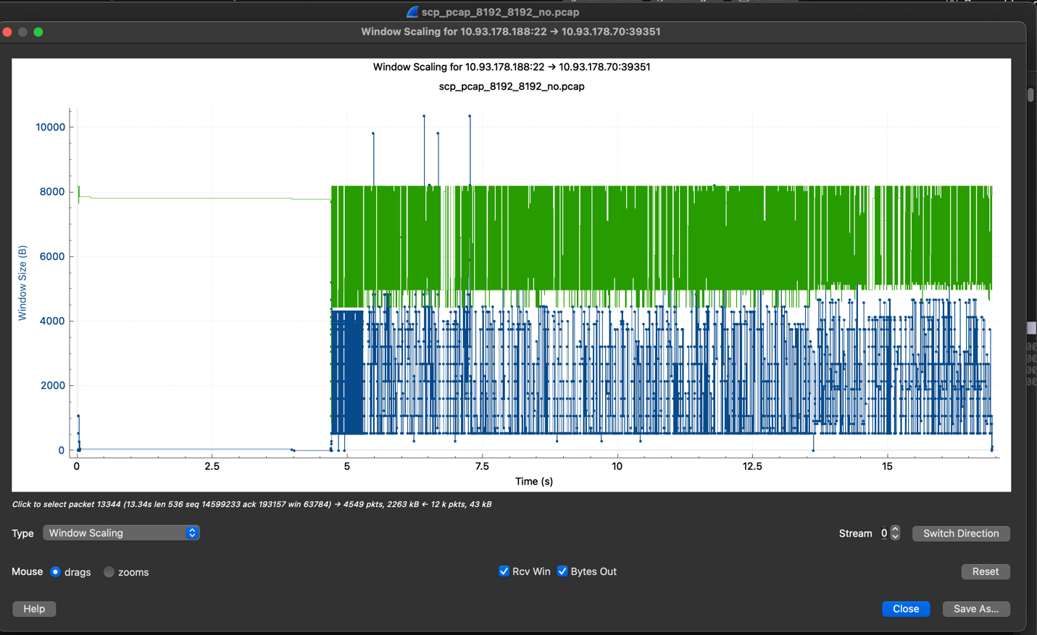

scp_pcap_33024_8192_no.pcap

scp_pcap_131072_8192_no.pcap

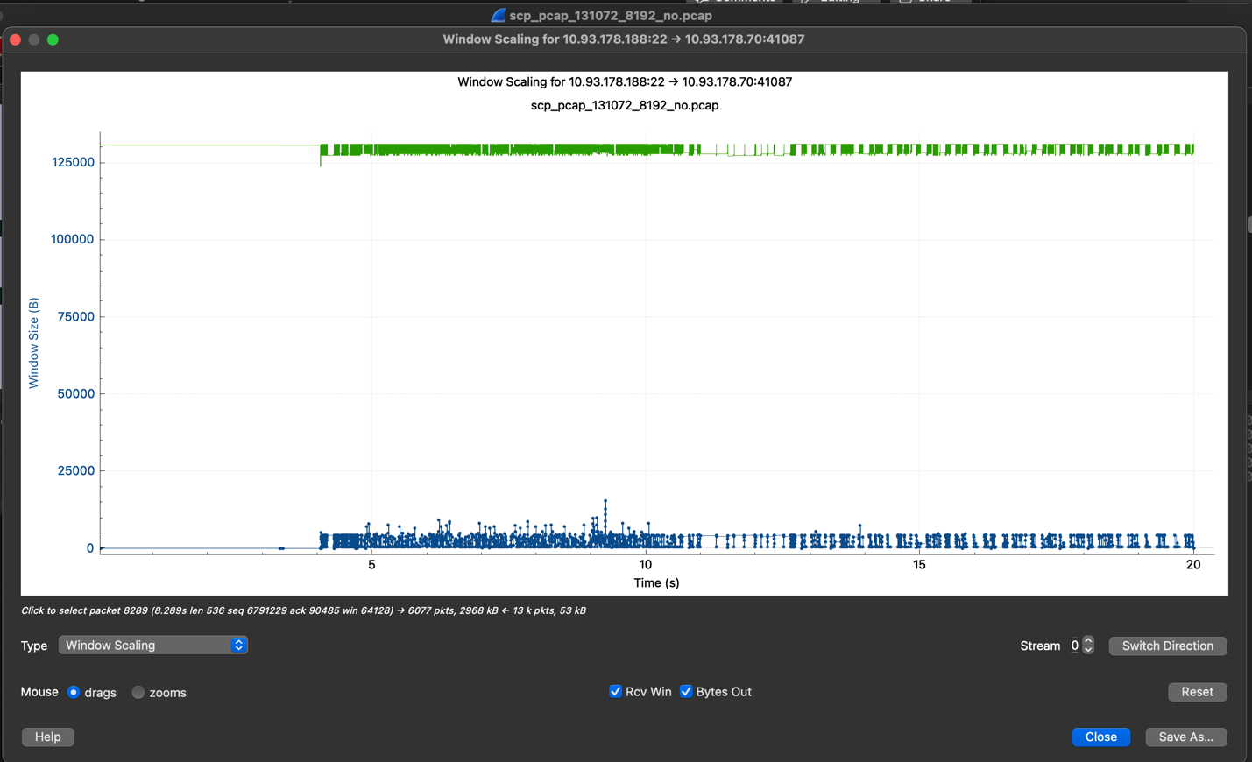

scp_pcap_131072_131072_no.pcap

scp_pcap_4128_8192_yes.pcap

scp_pcap_4128_8192_yes_131072.pcap

scp_pcap_4128_8192_yes_1073741824.pcap

