**6.100L Recitation 9**

**Reminders**

* MQ 9 on Monday 11/21

**Review from the last 2 weeks…**

**Object Orientation Programming (OOP)**

* Objects allow you to store data in python
* Everything in python is an object
* Class defines a type of object
  + so far in class we have seen the following built-in classes: int, float, string, list, tuples, dictionaries
* An object is an instance of its class
  + for example: 3, “hello”, [1,2,3] are all instances of a class
* Advantages of OOP:
  + Allows you to bundle data into packages
  + Reduces complexity of your code, making it easy to reuse code
  + Allows you to implement & test behaviour of each class separately

**Classes**

* a way to create your own data type using the built-in data types as building blocks
  + Real life examples: Elevator, employee, queue at store, stack of pancakes...
* attributes are data & procedures that belong to the class
  + Data attributes: objects that make up the class
  + Methods/procedural attributes: functions that only work with this class
* self:
  + Refers to the instance the method is called on
  + Always the 1st argument when defining a method
  + Not used outside the class definition
* Creating a class:

1. Define class name

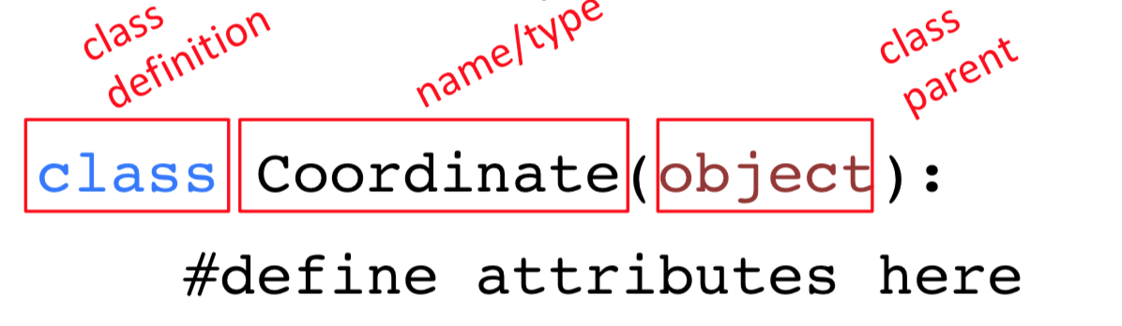

1. Define class attributes
   1. Define how to create an instance of a class using the __init__ method

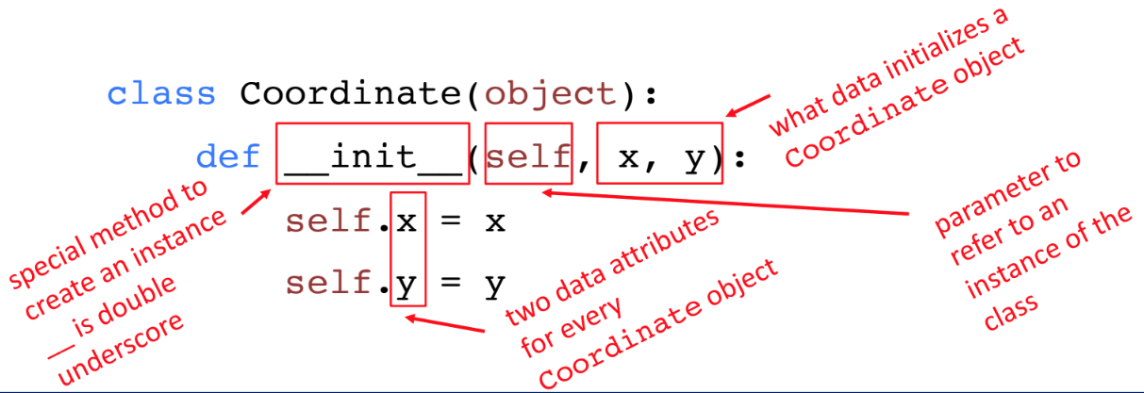

* 1. Define other methods, these do not need to start with __

These methods only work for this class.

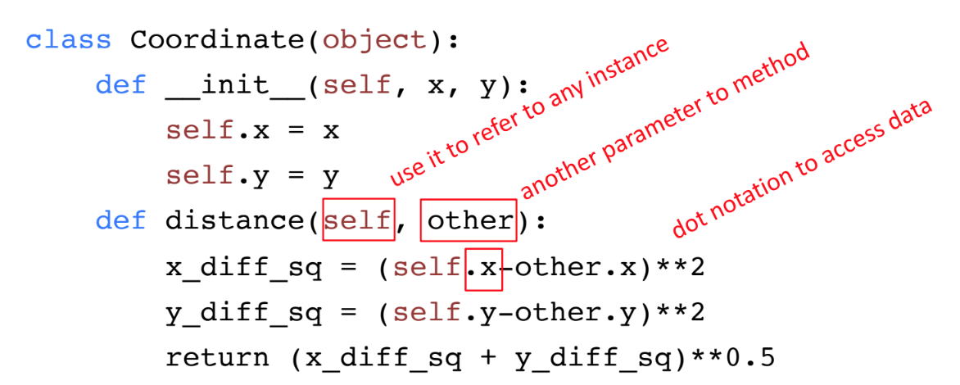

* Using a class:
* First create a new instance of the class

# Using the example Coordinate class above

* + c1 = Coordinate(1,1)
  + c2 = Coordinate(2,1)
* Carry out operations on the instances, using class methods
  + c1.distance(c2)
* In order to be able to call print on an instance of your class you need to define the __str__ function.
  + there are a few more special operators ( __len__, __eq__ etc… → look at lecture slides for details on these)
* You can use isinstance() to check if an instance is an object of a class.
* In general the class defines the representation and methods common across all instances of the class; whereas an object is a SPECIFIC instance of the class
* In general you want to keep your internal representation of your class hidden, to prevent adversarial attacks and bugs.
  + the internal representation refers to what is in your __init__ method
* class variables: shared across all members of a class
  + defined outside of the __init__ method

**Getter and Setter Methods:**

● Getter and setters should be used outside of classes to access data attributes.

● It’s better style to access attributes this way, makes code easier to maintain and

helps prevent bugs

**Inheritance & Hierarchies:**

Why use inheritance?

● Allows you to extend a class with new/different capabilities.

● Reuse code

● Commonalities are explicit in the parent class, differences explicit in the subclass

Structure & how it works:

● You create an inheritance relationship between two classes by defining what

goes into the parameter in the class definition.

The child class inherits all the methods from the parent class.

● We can define new methods in the child class to extend behaviour

● We can redefine methods defined in the parent class to modify behaviour

● When you call a method on an instance of a class: the interpreter tries to find the

method at the level of a class and then checks the parent.

○ This means that if two methods with the same name are defined, the

method in the child class takes precedence.

MIT OpenCourseWare

https://ocw.mit.edu

6.100L Introduction to CS and Programming Using Python

Fall 2022

For information about citing these materials or our Terms of Use, visit: https://ocw.mit.edu/terms