Analyse des Rewards

Vente

|  |  |
| --- | --- |
| Connecté | Non connecté |
|  | None |

Achat

|  |  |
| --- | --- |
| Connecté | Non connecté |
|  | None |

Flux h2

|  |
| --- |
| Non connecté et connecté |
|  |

Flux lithium

|  |  |
| --- | --- |
| Connecté | Non connecté |
|  | None |

Dod n’aprend rien

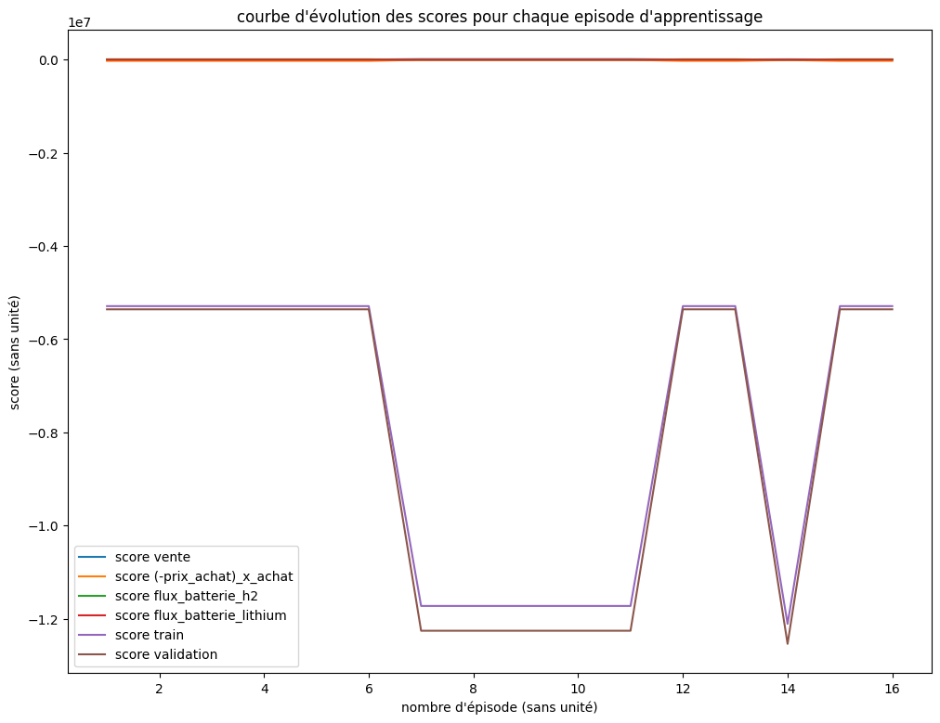

Coupure non connecter

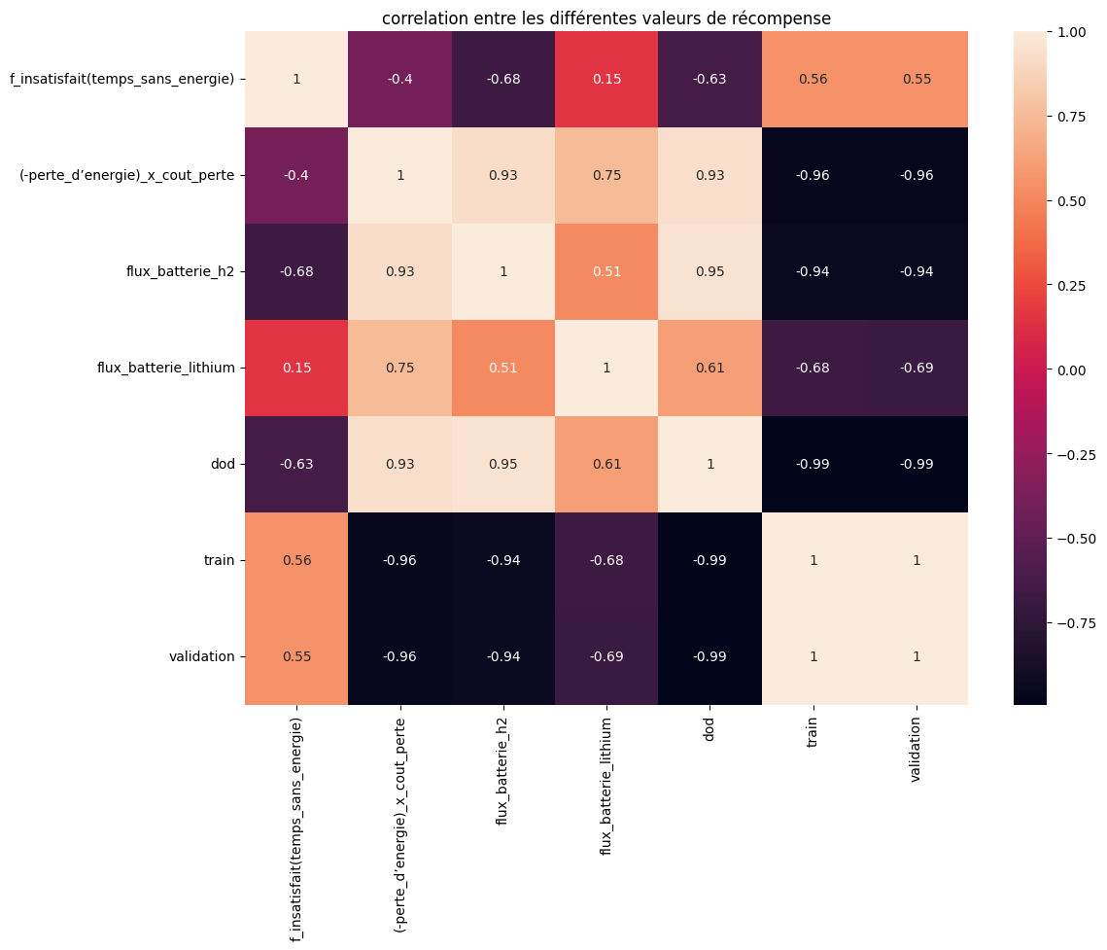

Insatisfaction client non connecté

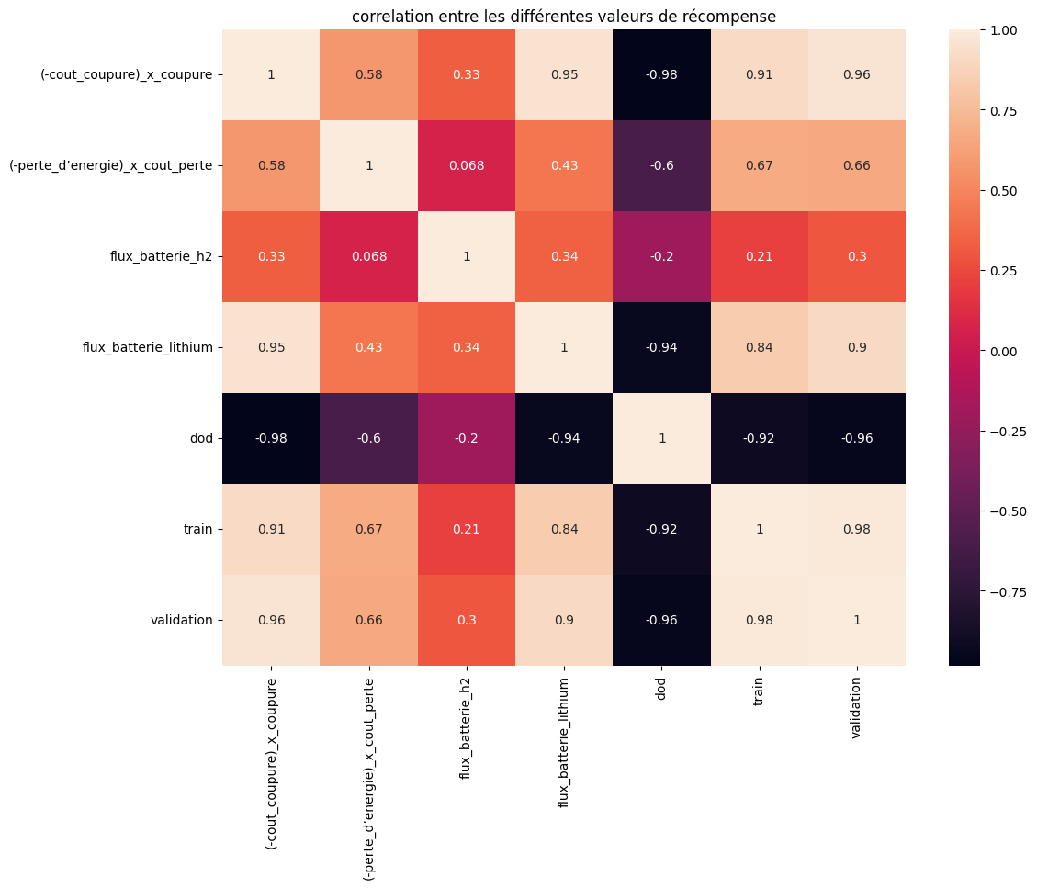

Perte d’energie non connecté

