Axelis Certificate

Certificate of completion
Student name
has completed, and been assessed against the published criteria of
German A1 to B2 (CEFR) Certification Programme
480 contact hours over 48 weeks
Certificate IDAXC-2026-0147
Date of issue21 September 2026
Verify atoverseeducation.com/verify
Rishabh AgrawalFounder & Director
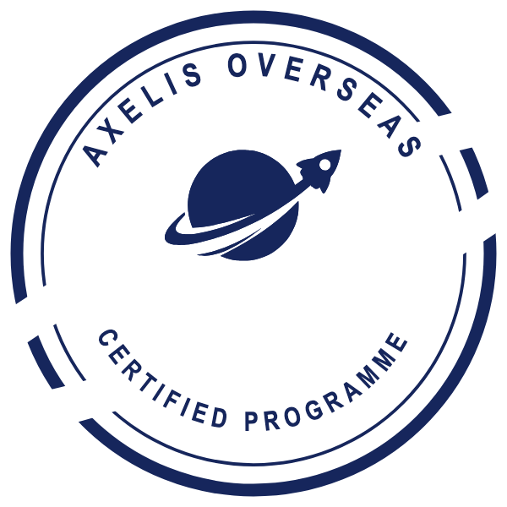
Programme LeadName and signature
This certificate is issued by Axelis Overseas Education Pvt Ltd. It records completion and assessment of an Axelis programme. It is not a degree, not a qualification under any national framework, and not accredited by DPIIT, the British Council or AIRC, each of which recognises the company rather than this credential.

