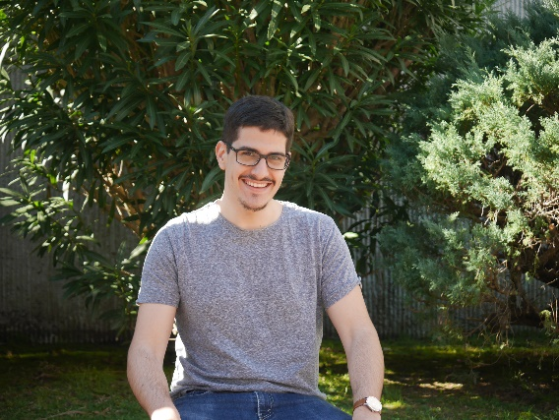

|  |
| --- |
| **Axel Lancieri**  Age: 28 years  Address: Gral Manuel Freire 1626  Phone: (+598)98158899  E-M e-Mail: axel.lavignasse@gmail.com |

**EXPERIENCE**  .

**2016-2022** **Customer service agent** (3 years)

Alorica

**Area:** English / Spanish - Retail / Product Support

**Description:** Offered customer service all abroad the world on a massive retail company that’s a client of Alorica. Started as a retail employee offering services related to bank authorizations, logistics, promotions and services offered based on yearly themes.  
Later on I moved to another sector where I offered product support on items bought by customers of any type of sort, my job was to help the customer figure out why the item is not working, preferably fix the issue on the spot and/or otherwise make sure the customer has a good resolution.

**2014-2015** **Attendant** (7 months)

Puerta del Sur

**Area:** Check in / Parking

**Descripción:** Based on the availabily and the traffic at the airport I would work helping customers get through the check in process, I was posted on the first security line where I would double check their passports and the flight ticket to make sure everything checks out and they can move forward on the check in procedure, otherwise I would be on the parking lot taking offering various services such as a cashier on the parking tickets or private flights taxes, valet-parking and different parking lot promotions.

**STUDIES**  .

2022 **Front End Developer** (Current)

Treehouse

Finished (2015) **Highschool** - Medicine oriented

Liceo n10

**PERSONAL REFERENCES** .

Nacho Picun (Principal programmer, Software engineer) - Phone: +598 91 426 926