## A Comparison of the Statistics of Vestibular Input during Natural Activities and while Piloting an Aircraft

## ABSTRACT

In this study, we measured the statistics and spectral content of vestibular stimulations generated by head movements during an interaction with a complex human-machine interface: a helicopter simulator. Said head motions were then compared with those measured during two routine activities: walking in an office space and during a seated visual exploration. In agreement with prior studies, we found that the frequency content of natural vestibular stimuli experienced during active head movements could be modeled by two power laws in self-navigation tasks. In contrast, in the seated position, the frequency content of natural vestibular stimuli during active head movements was better described by an inverted U-shape in all planes of motion, both during visual exploration and during interaction with the machine. Our results suggest that some sort of anatomical filter shapes the frequency content of natural vestibular stimuli. We further show that, although head movements are very flexible to accommodate to the task at hand, operators tend to pilot their machines in a way that mimics the characteristics of head movements experienced in ecological conditions. We propose that this *anthropomorphization* of the machine aims to reduce its many degrees of freedom into a constrained range such that the operator can integrate its dynamic properties within their own internal model. This behavior possibly reveals a new control scheme for complex human-machine interfaces, for which we propose the term *enmachinement*.

## INTRODUCTION

Externally imposed motion frequencies challenge both perception and motor control. In particular, an adequate processing of vestibular stimuli is instrumental in selecting the appropriate strategy for movement control. For instance, stimulations around 0.2-0.3 Hz constitute the possible origin of 'tilt-translation' ambiguity and externally imposed motion around these frequencies could induce motion sickness [1]. In that context, a number of recent studies have characterized the properties of active and passive head movements experienced during daily activities [2]–[4]. Contrary to self-generated active head movements, passive head movements occur during external postural perturbations. Carriot *et al.* found that active head movements reached magnitudes of 450 °/s, with long-tailed non-Gaussian probability density functions when projected on the three planes of the semi-circular canals - the left anterior, right posterior (LARP) plane, the right anterior, left posterior (RALP) plane, and yaw plane (YAW) [2]. The power spectrum of both active and passive head movements, during natural activities in a standing position, could be fitted with two power laws. The first power law models the slow decrease observed for lower frequencies (< 5Hz in [2] or < 2Hz in [3]), the second models the steeper decrease for higher frequencies, with significant differences in the values of these slopes between active and passive head movements. This result contrasts with the other sensory modalities where a single power law is often observed [5], presumably because both biomechanical pre-neuronal filtering and voluntary control shape the spectral content of natural vestibular inputs [2].

These studies focused on a large set of natural activities (see [2] for a complete list). In contrast, the properties of head movements experienced during the control of complex man-machine interface remains largely unknown. In order to investigate that question, we asked whether the vestibular inputs experienced by the operators of a human-machine interface would present the same statistics as during more ecological activities. The answer to this question appears valuable on two grounds. First, a substantial part of human activities increasingly involves complex man-machines interfaces. Second, individuals should be considered as *embodied*, *i.e.,* as part of a system that involves their immediate environment [6], [7]. That is, when interacting with a machine, one is submitted to sensory afferences that may be sensibly different from the ones experienced during ecological tasks. In turn, this could deeply alter the perceptual and behavioral responses of the operators, which may have detrimental consequences (increased mental load, motion sickness, false maneuvers, *etc*.).

We chose to explore the head movements’ repertoire of helicopter pilots during flights in a simulator. The rationale behind this choice is double. Helicopter pilots interact with an extremely complex man-machine interface. Moreover, the sensory systems of pilots are solicited in two ways: *i)* during self-generated motions of the head, *e.g.,* during the visual exploration of the outside world and of the cockpit; *ii)* during the unusual stimuli caused by the movements of the aircraft, whether initiated voluntarily or provoked by turbulences. In both cases, the sensory afferences experienced by the pilots are – at least partly – shaped by the peculiar dynamics of the aircraft and the flying environment. Therefore, they may be very different from those generated during day-to day activities and more complex to match the expected sensorial re-afferences required for an efficient motor control [8].

In order to compare the properties of vestibular stimuli experienced during an interaction with a human-machine interface with those experienced during natural tasks, the head movements were measured in three experiments: a helicopter flight simulation (which we will refer to as the manual navigation task), a walk in an office space (self-navigation task) and a seated head-free visual exploration task. Our findings extend previous work on the statistics of vestibular inputs during natural tasks. Notably, we demonstrate that the statistics and frequency content of natural vestibular stimuli is task dependent. Our results suggest that new challenges face the operators of complex human-machine interfaces regarding their sensorimotor transformations.

## MATERIALS AND METHODS

### Subjects

The Institutional Review Board Paris Descartes (CERES N°2017-35 dated 23-5-2017) approved the experimental flight protocols following the 1964 Helsinki Declaration.

**Manual navigation task**

Seven operational professional helicopter pilots aged between 31 and 48 (39 +- 5.7) years old participated in this study. They had no known history of balance impairment or dizziness. These pilots had between 300 and 5000 hours of helicopter flights to their record (Table 1). Before testing, all participants gave their informed consent.

Table 1: Summary of pilots’ information

|  |  |  |  |
| --- | --- | --- | --- |
| **Pilot** | **Real flight experience (hours)** | **Simulator experience (hours)** | |
| 1 | 2100 | 26 |
| 2 | 2450 | 25 |
| 3 | 1840 | 28 |
| 4 | 300 | 30 |
| 5 | 1200 | 7 |
| 6 | 965 | 90 |
| 7 | 5000 | 450 |

**Self-navigation task**

Two subjects (aged 23 +- 1 years old), distinct from the pilots, participated in this study. They had no known history of balance impairment or dizziness. Before testing, all participants gave their informed consent.

**Seated visual exploration task**

Five subjects (aged 36 +- 16 years old), distinct from the pilots, participated in this study. They had no known history of balance impairment or dizziness. Before testing, all participants gave their informed consent.

### Sensors

**Manual navigation task**

Pilots were equipped with an inertial-optical hybrid head tracker (Hybrid Optical based Inertial Tracker (HObIT), InterSense). In short, a head-mounted 180 Hz inertial measurement unit (IMU) coupled with a camera measured the position of the head in the reference frame of the simulator. The camera complements the IMU position measurement by correcting the inertial drift, by tracking the position in space of small fiducial markers located on top of the cockpit. The resulting measurements of head position were sampled at 100Hz. Four additional cameras strategically placed in the cockpit recorded the pilot's behavior during the missions and allowed for verification of the recorded motions. It is important to note that the HObIT system only provides position information; velocity had to be derived numerically. Notwithstanding the approximation on head velocity, a head tracker was better suited than an IMU because 1) the HObIT more easily integrates with the heavy equipment of helicopter pilots and 2) the HObIT provides more robust measures when subjected to non-negligible external electromagnetic interference. Regardless, supplementary experiments (see the Supplementary Materials for more details, in particular the impact of sample quality on the power spectra) were conducted to evaluate the accuracy of the velocity measurements using the HObIT system. We found similar velocity estimates and quasi-identical power spectra in the relevant frequency range using the head tracker *vs.* an IMU. These validation experiments suggest that we can be confident in the reliability of our head velocity computation.

An eye tracking device (SMI Eye Tracking Glasses, 60 Hz sampling frequency oversampled at 100 Hz for sensor fusion purposes) was used to record the eye movements of pilots. A custom calibration step (6-points calibration) was conducted at the beginning and at the end of each experiment to ensure precise eye tracking during the whole experience. The direction of the eye movements during a simultaneous head rotation was used to distinguish between active and passive head movements (see section Results).

**Self-navigation & seated visual exploration tasks**

Participants were equipped with an inertial measurement unit (IMU, XSensDot) firmly fixed on their head using a head band. Head velocity was measured at 120Hz and retrieved using the XSensDot proprietary mobile application.

### Experimental protocol

**Manual navigation task**

All flight experiments were performed on a full flight level-D helicopter simulator illustrated in Figure 1. This simulator includes visual surround and stands on a six degrees of freedom platform motion system driven by state-of-the-art algorithms [9], [10]. It obtained the highest certification in terms of immersion and truthfully reflects the vestibular stimuli experienced by pilots during real flights. The simulator is equipped with an EC135 (Eurocopter) helicopter cabin. Prior to the experiment, all pilots went through a realistic flight simulation to get used to this specific simulator. The experiment consisted in two scenarios: the first was a typical reconnaissance mission (approximately 1 hour), and the second scenario was a rescue mission (approximately 1 hour and 30 minutes).

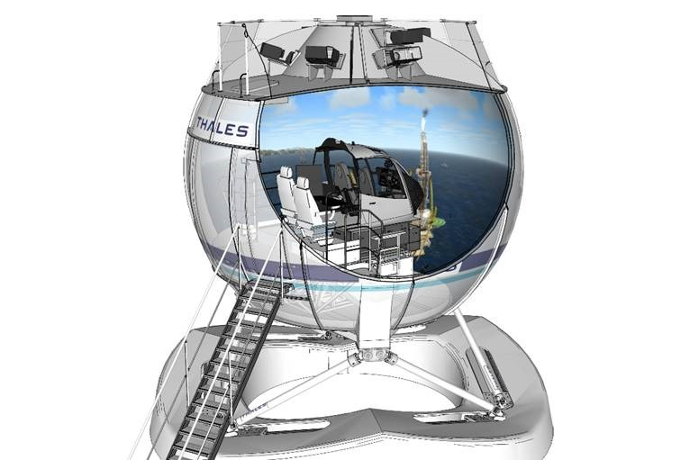

Figure : Full Manual navigation (FFS). The helicopter cabin (EC135) is located in the display dome. The dome is controlled using a six-degrees-of-freedom motion platform.

**Self-navigation task**

Participants walked for several minutes around an office space and came back to their starting position. The experiment was conducted once for every participant.

**Seated visual exploration task**

Participants naturally moved their head to explore their environment while being seated in an office chair. Each participant conducted 4 repetitions of 3 minutes of visual exploration.

### Data analysis

All data analysis was performed in the Python programming language: we used the scipy package for all statistical analysis and frequency analysis.

**Data preprocessing**

Data stemming from the HObIT was associated with a quality value. This quality value is computed directly from the head tracking system and depends on the number of fiducial markers in its field of view. The quality was good (value close to 1) when the head of the pilot remained in the optimal optical tracking zone and decreased to zero when moving away from it. To make sure that only reliable samples were analyzed, samples associated with a quality value below 0.5 were discarded (see supplementary materials for more details and to see the impact of sample quality on the power spectra). This resulted in a variable yet often noticeable loss of data depending on the pilot and the scenario (between 2.9 to 36.3% of data loss). Consequently, the resulting data from pilots were unevenly sampled. In theory, any classical Fourier computation on irregularly sampled data is not mathematically rigorous. One can counteract that problem by juxtaposing valid samples next to the other, effectively removing the ‘gaps’ in the data. In that case, the resulting time series consists of evenly sampled values. Although simple, this technique may lead to sudden ‘jumps’ at the positions where successive valid samples were concatenated. These discontinuities could disrupt the frequency analysis down the road, especially for the higher frequencies. Another way to circumvent this issue is to ‘fill in the gaps’ where the low-quality samples were discarded. We employed such a method, namely an Autoregressive (AR) model, and compared the two approaches. For brevity’s sake, our findings will not be detailed here – the interested reader may find more information in the supplementary materials. In this paragraph, we merely report that both techniques achieved nearly equal results in terms of frequency content, and thereby the simple ‘juxtaposition’ method was used. In particular, the high-frequency artifacts that could have been generated as a result of the juxtaposition did not lead to any apparent aliases over the frequency range of interest (see Supplementary Figure 4).

**Velocity computation**

The angular velocity of the head was obtained by numerical derivation from head orientation data in the cockpit's frame of reference or accessed directly from the IMU’s gyroscopes. The velocity signals were projected onto the semi-circular canal planes – left anterior-right posterior (LARP), right anterior-left posterior (RALP) and yaw (YAW) - according to [2] using the following rotation matrix, with and :

**Probability density functions**

Probability density functions were computed using a Gaussian-kernel density estimation evaluated between -400°/s and +400°/s with a step of 8°/s. Deviation from normality was quantified by the excess kurtosis and computed as follows:

Where X represents the LARP, RALP or YAW angular velocity, μ and σ its mean and standard deviation respectively and <> the average.

**Power spectral densities**

Power spectral densities were computed as described in [4]. Briefly, Welch's average periodogram was used with parameters *nfft=2048* and a Bartlett window of *2048 points*. These parameters led to a frequency resolution of *0.0488* Hzwith our sampling frequency of 100 Hz.

In the self-navigation task and according to previous work in the literature, the power spectrum curves were fitted with a power law over the low- and high-frequencies. We defined the low frequency range from 0.1 to 1 Hz and high-frequency range span 4 to 20 Hz. These ranges were chosen so that they remain appropriate considering the ranges used in neurophysiological studies [11], [12] while truly reflecting the behavior observed with our data. Compared to Carriot *et al.* [2], this translates into a decrease in the higher bound of the low frequency range – from 2 Hz to 1 Hz - and of the lower bound of the high-frequency range – 4 Hz instead of 10 Hz. This shift in bounds accounts for the lower transition frequency found in our results. The upper bound for the high-frequency range was also decreased – 20 Hz rather than 30 Hz – to avoid fitting on power values below the signal’s noise level, as defined by the IMU’s resting noise signal (around 0,01 deg²/s). We defined the transition frequency as the frequency where the power law fits intersect.

For the manual navigation task, a distinction was made between active and passive head movements. Using a classification algorithm (see below), we decomposed the head velocity signals into a succession of short sequences of active and passive motions. Due to the small length of these segments, the power of their spectral content could not be computed using the traditional Welch’s method. Instead, we aggregated the active and passive head movement together to form two time series of respectively active and passive head movements, composed of unevenly spaced samples. The power spectra were then computed using the Lomb-Scargle periodogram, a particular kind of least-squares spectral analysis that estimates a frequency spectrum when data samples are not equally spaced in time [13].

**Discriminating passive from active head movements**

To assess the contribution of active and passive movements to the shape of the spectra in the manual-navigation task, we classified the head movements into active and passive motions. Head movements that occurred with a simultaneous eye movement in the same direction were considered as active head movements. Those that occurred with an eye movement in the opposite direction were considered as passive. Indeed, in ecological settings, humans use a coordinated eye and head movement to shift their gaze to a new target of interest [14]–[22]. On the contrary, when the head is in motion and the gaze is fixated on a target of interest, the vestibulo-ocular, the cervico-ocular and the optokinetic reflex intervene to stabilize the image of the environment on the retina [23]–[25] by counter-rotating the eyes in the direction opposite of the head movement. Thus, identifying the instances when the eyes and the head are moving in the same (resp. opposite) direction ensures that we isolate – part of - the active (resp. passive) movements of the head.

**Statistical analysis**

The Mann–Whitney–Wilcoxon test was used to measure statistical similarity, or lack thereof, of the distribution of angular velocity or spectral content of head movements in the different planes of the semi-circular canals between the different experiments.

The Wilcoxon signed-rank test was used to measure statistical similarity, or lack thereof, of the distribution of angular velocity or spectral content of head movements in each experiment between the different planes of motion.

## RESULTS

**Amplitude of head angular velocity signals**

The vestibular stimulation experienced by the participants during a manual navigation task, a self-navigation task or a seated visual exploration task was recorded. The angular velocity of the head was projected onto the three planes of the semicircular canals to assess the vestibular inputs in each canal independently (Figure 2, left).

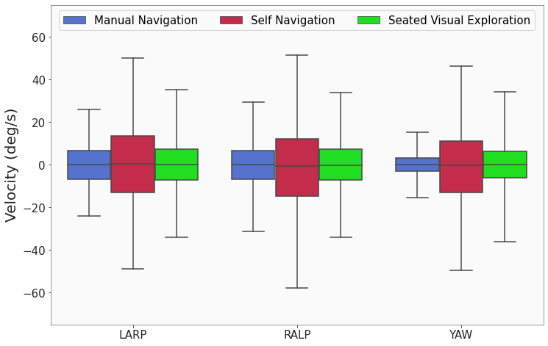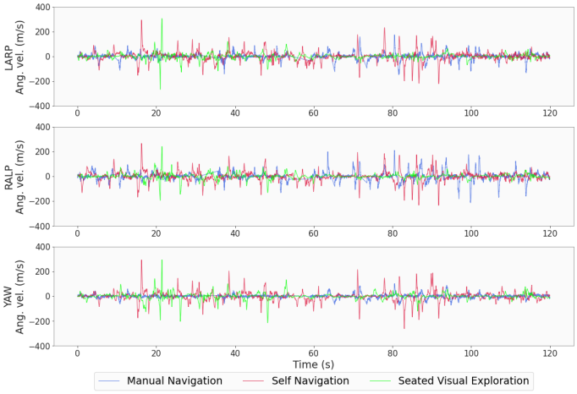

Figure : Left: Two minutes excerpts of the angular velocity signals in the three planes of the semicircular canals from the three experiments. Each signal corresponds to a single participant. Blue: manual navigation task; red: self-navigation task; green: seated visual exploration task. Right: Boxplot of the population-averaged angular velocity signals projected in the three planes of the semicircular canals in the three experiments. Boxes and whiskers correspond to respectively 75% and 95% of the data. Outliers are not represented.

The right-hand side of Figure 2 displays the distribution of the angular velocity with respect to the plane of motion during the tasks investigated. In the RALP, LARP and YAW planes, the spread of the data was systematically smaller during manual navigation and in the seated visual exploration task than during self-navigation. That is, the pilots showed significantly different (p < 0.01, except for the LARP plane between self-navigation and the seated visual exploration where p > 0.05), and overall smaller-velocity head movements when seated. On the other hand, they punctually reached larger velocities, sometimes exceeding 400 °/s, 100 °/s more than during walking (see Figure 3). Additionally, while the head velocities recorded were relatively similar between the three planes of motion for the self-navigation and visual exploration tasks, the velocity dropped significantly in the YAW plane relatively to the LARP and RALP planes during the manual navigation task (compare whiskers and boxes in Figure 2 - LARP *vs.* RALP: p > 0.05, LARP *vs.* YAW: p < 0.01 and RALP *vs.* YAW: p < 0.01).

**Statistics of head angular velocity signals**

We computed the probability density functions of the head angular velocity signals. As illustrated in Figure 3, during manual navigation, self-navigation and the seated visual exploration tasks, the distributions were characterized by a sharp peak centered on zero and large tails. This is reminiscent of the results shown in Figure 2 where the majority of head movements have a velocity < 15 °/s (*cf.* interquartile range) but a fewer yet non-negligible amount of head movements had a velocity in the range 20-400 °/s. The specific shape of the probability density functions for each experiment also reflects our observations above. Notably, the distributions for the manual navigation task present a sharper peak around the null velocity. In the YAW plane of motion, the distribution of the operators of man-machine interfaces stands out with an even sharper peak and a noticeably smaller spread.

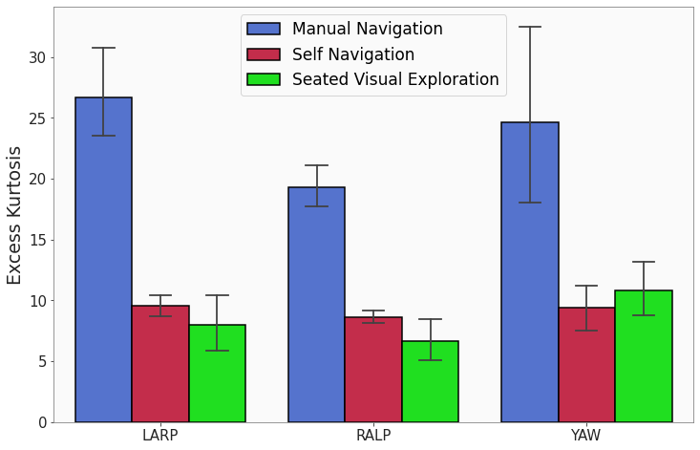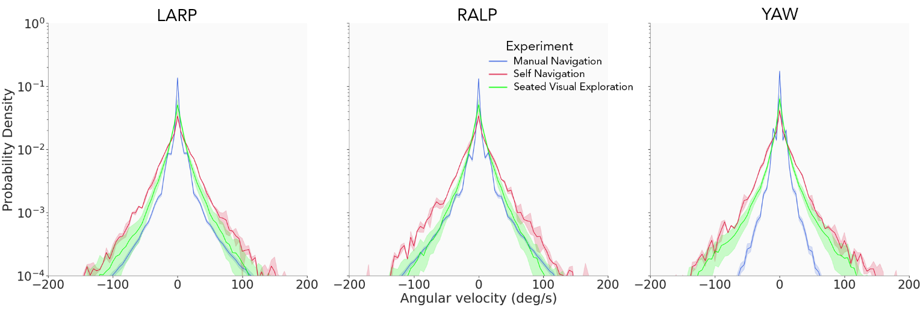

Figure 4: Population-averaged excess kurtosis values for the LARP, RALP and YAW head-velocity signals in the manual navigation task (blue), self-navigation task (red) and during seated visual exploration (green). The error bars represent the 95% confidence interval.

Figure 3: Population-averaged probability density functions for the LARP, RALP and YAW head-velocity signals in the manual navigation task (blue), self-navigation task (red) and during seated visual exploration (green) with corresponding SD (shaded areas).

Deviation from normality was quantified using the excess kurtosis (Figure 4). All distributions presented excess kurtosis values that differed significantly from zero (p < 0.01). The excess kurtosis values for the manual navigation task differed significantly from the others (p < 0.05), as we could intuit from Figure 3.

**Frequency content of head angular velocity signals**

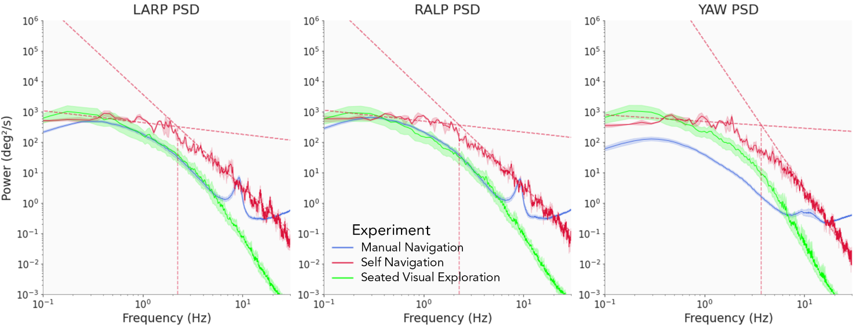We measured the frequency content of the vestibular stimuli experienced by the participants by computing their power spectra (Figure 5). In the self-navigation experiment (Figure 5, red), the power spectra followed a double power law in the three planes of the semicircular canals. This result echoes previous findings on the shape of the power spectra for movements of the head [2]–[4]. Quantitatively, we note that our values for the slope of the fits (*cf.* Figure 5, legend) slightly differ from those reported by Carriot *et al.* [2]but remain consistent. We observe a pronounced drop in the value of the transition frequency in our self-navigation task compared to those in Carriot *et al.* [2]*.* We attribute this divergence to the minute differences in the slope of the fits as well as the decreased intensity in the activities performed by our participants compared to [2].

Figure 5: Population-averaged power spectra of the head-velocity in the LARP, RALP and YAW planes with corresponding 95% confidence interval (shaded areas). Blue: manual navigation task, red: self-navigation task, green: seated visual exploration. The dotted red lines correspond to power law fits of red curves.

The characteristics of the fits are: slope of the LARP low frequency fit = -0.39 +- 0.21, slope of the LARP high frequency fit =-3.04 +- 0.16, transition frequency = 2.24 +- 1.11 Hz; slope of the RALP low frequency fit = -0.36 +- 0.20, slope of the RALP high frequency fit = -3.14 +- 0.15, transition frequency = 2.27 +- 1.08 Hz; slope of the YAW low frequency fit = -0.22 +- 0.22, slope of the YAW high frequency fit = -4.86 +- 0.20, transition frequency = 3.72 +- 1.50.

In both the seated visual exploration (Figure 5, green) and the manual navigation task (Figure 5, blue), the power spectra can no longer be described by two power laws. In the three planes of motion, the power spectra followed an inverted ‘U’ shape: the power increased up to a maximum at around 0.3 Hz before decreasing slowly up to 6 Hz. For frequencies above 6 Hz, we observe a clear dichotomy in the shape of the spectra between the visual exploration and the manual navigation tasks. While the power continues to decrease following the inverted ‘U’ shape in the visual exploration experiment, in the manual navigation task, some sort of peak in the power spectra appear in the LARP and RALP planes, rapidly boosting the power up again - see supplementary materials and discussion sections for more information on this matter. We would also like to draw attention to the unique shape of the spectra in the YAW plane for the manual navigation task, which lacks a resonance peak and shows a lower total average power compared to the other signals. Overall, the unusual frequency content measured in the visual exploration and the manual navigation tasks proved to be quite different from the traditional double power law model experienced during self-navigation.

**Different activities led to different frequency contents**

We wondered how the particular shapes of the power spectra experienced during seated visual exploration or when interacting with a machine would impact the frequency content of natural vestibular stimuli. To quantify their effect, we considered the frequency range 0-10 Hz and divided it into three frequency bands. For each signal, we then computed the average power in that frequency band and divided it by the total signal power (Figure 6). In sum, we gauged the relative contribution of each band to the total signal power. The first band spans 0-2.75 Hz and corresponds to the lower frequencies. The second spans 2.75-6 Hz and corresponds to the lower portion of the high frequencies. The third and final band ranges between 6-10 Hz and corresponds to the higher portion of the high frequencies. The 2.75 Hz threshold separating the first two bands was chosen as the mean of the transition frequencies over the three planes of motion. This value is also in line with low-frequency head movements according to standard clinical values [11], [12]. The 6 Hz separating the last two bands marks the beginning of the resonance peak in the manual navigation task spectra.

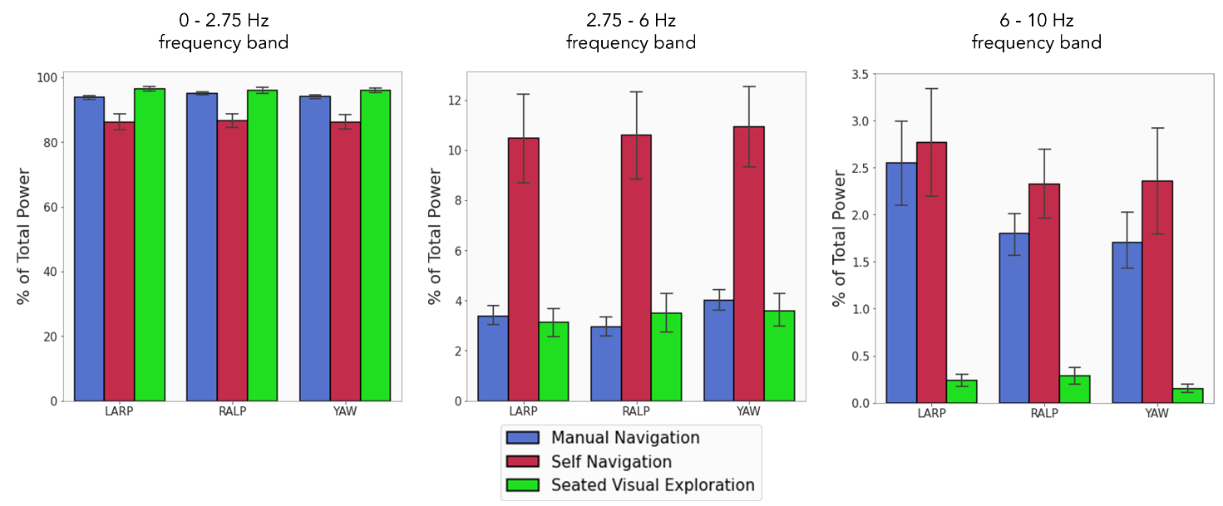

Figure 6: Contribution of several frequency bands to their respective total spectral power, expressed as a percentage of the total power, in the three planes of the semicircular canals during the manual navigation task (blue), the self-navigation task (red) and the seated visual exploration task (green). Error bars represent the 95% confidence interval. Please be mindful of the varying range of the y-axis.

We found that the contribution of each frequency band to the frequency content of natural vestibular stimuli differs considerably with the task, but not so much with the plane of motion. The 0-2.75 Hz band constitutes the predominant contribution to the overall power of the velocity signals. Still, because of their inverted ‘U’ shape that causes the power to decrease more rapidly in the high frequencies, the power spectra obtained during the manual navigation task and the seated visual exploration tasks contain a greater contribution of the 0 to 2.75 Hz frequency band than during the self-navigation task (p < 0.05). For the same reason, we observed a significantly diminished contribution of the frequency band 2.75-6 Hz to their total power compared to the self-navigation task (p < 0.01), with similar contribution (no significant difference in the contribution of that band to the total power, with p > 0.1). In the 6-10 Hz band, the presence of a peak in spectral power for the manual navigation task entails an appreciable contribution of that band compared to the seated visual navigation experiment, reaching levels similar to the self-paced navigation task (no significant difference in all planes of motion between the manual navigation and self-navigation tasks, p > 0.1).

**Active *vs.* passive head movements during manual navigation**

We computed the power spectra of both active (Figure 7, red) and passive head movements (Figure 7, blue). The shape of the spectra for the passive motions qualitatively resembled the results presented in Figure 5 (blue curve), with an inverted ‘U’ shape and a resonant frequency band in the LARP and RALP planes from 6 to 10 Hz. Active movements also presented the characteristic ‘U’ shape, but with a slower fall-off in the high frequencies compared to the passive movements, akin to the shape of the power spectra observed in the self-navigation task. We note that active movements did not present any frequency peak relatively to the power measured in the high-frequency band.

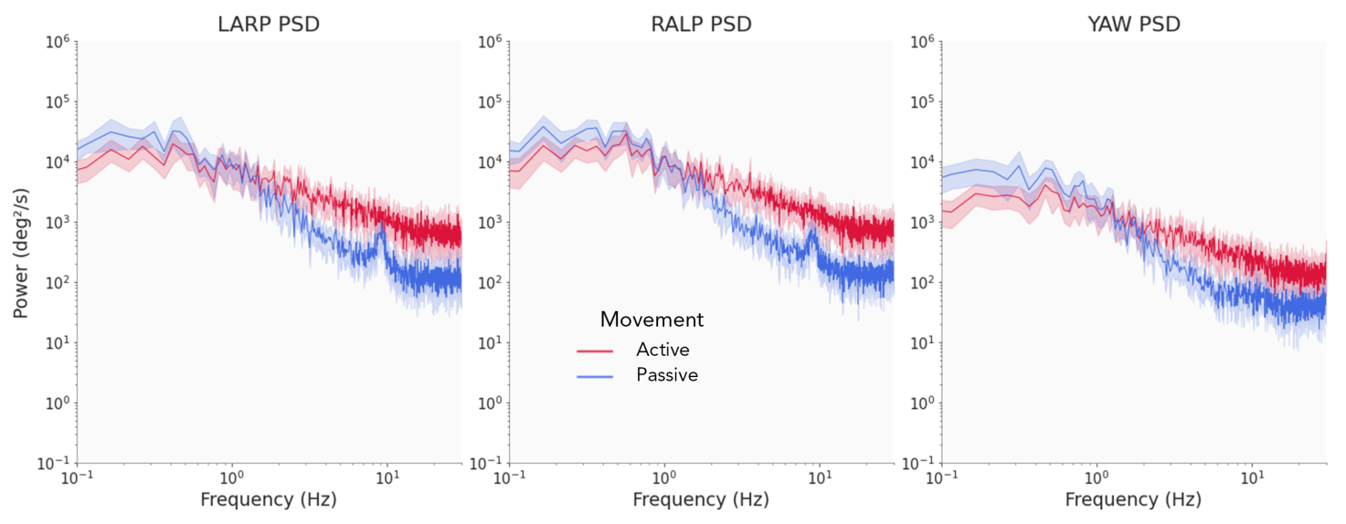

Figure 7: Population-averaged power spectra of the head-velocity signals in the LARP, RALP and YAW planes for active (red) and passive (blue) movements of the pilots with corresponding 95% confidence interval (shaded areas). These curves were computed using the Lomb-Scargle periodogram method.

## DISCUSSION

In this study, we measured and characterized the vestibular stimuli experienced by healthy participants in a variety of real-world activities. We were able to reproduce previous results during a self-navigation task and broadened the scope of research with a seated visual exploration task and an interaction with a complex man-machine interface: a helicopter simulator. Our analysis focused on head movement velocity signals projected in the three planes of the semi-circular canals. We derived statistical metrics from these signals and investigated their frequency content through their power spectra, according to prior works [2], [4].

We found that the range containing 95% of the velocity distributions in the manual navigation task was significantly smaller than for the other tasks, but with a greater total range. This effect was further quantified by the associated probability density functions of the velocity signals. Their distributions differed significantly from normality, with a sharp peak centered on zero and relatively long tails. This shape was more pronounced in the manual navigation task compared to the others, as highlighted by significantly higher excess kurtosis values.

We showed that the frequency content of the vestibular stimuli varied across experiments. For the self-navigation experiment, we were able to fit the power spectra using the same two power laws model used in the literature [2], [4]. For the other two experiments however, the shape of the power spectra showed a surprising inverted ‘U’ shape, which caused the power to fall-off more rapidly in the higher frequencies (>2.75 Hz) than during walking. This unusual shape led to a higher contribution of the low-frequency band (0-2.75 Hz) and a smaller contribution of the high-frequency band (2.75-6 Hz) to the total signal power compared to the self-navigation task.

Taken together, our findings suggest that 1) natural activities such as walking provoke stereotyped vestibular inputs that can be modeled by two power laws on the power spectra of head angular velocity –in accordance with what has been previously reported – and whose intersection, the transition frequency, appears to depend on the intensity of the activity investigated; 2) body posture induces changes in the frequency content affecting the vestibular organs; 3) pilots tend to operate their machines in a way that does not generate highly non-ecological vestibular stimuli; 4) nevertheless, man-machine interfaces used as a means for manual navigation impose unnatural context-based constraints on their operators.

Head movement velocity distributions differed significantly between experiments in all planes of motion. When seated – whether in the manual navigation or the seated visual exploration tasks – head velocity distribution spread was smaller than when walking. This apparent restriction in the spectrum of possible head motion velocity does not originate from a physiological limitation imposed by the seated condition, but rather a task-dependent adaptation. Indeed, in daily activities, humans reorient their visual axis using a combination of eye, head, trunk and foot movements [26], [27]. This inter-segmental coordination can lead to greater head velocity, as it is the sum of head-on-neck velocity, trunk-on-pelvis velocity, and foot-on-ground velocity. On the contrary, when seated, only the neck – and eventually the trunk - contributes to the total head rotation. Yet, in our experiments, the limited freedom of body movement did not seem to impair the possible range of head velocity as they routinely reached values similar to those measured during self-navigation. In sum, the properties of natural head movements are highly flexible in order to adapt to the current task and context.

A closer look at the probability density functions of head velocity reveals that there is a significant difference in their kurtosis value between the manual navigation task and the other two, and no significant difference between the self-navigation and seated visual exploration tasks. Put another way, compared to the other more ‘natural’ activities, the manual navigation task showed probability density functions with sharper peaks and relatively longer tails. This reflects the presence of a majority of low-velocity head movements and a fewer but non-negligible amount of higher velocity head movements when piloting than during ecological activities. Pilots spend a considerable amount of time monitoring their instruments and the low-velocity head movements measured could correspond to small-amplitude gaze shifts between panels on their interface. Because the flight instruments are predominantly stacked vertically in front of the pilot, the coupled eye and head movements tend to have a smaller horizontal component, which is consistent with the smaller velocity range observed in the YAW plane compared to the others (p < 0.01). Thus, the environment of operators of complex man-machine interfaces imposes head movements whose velocity differs from ecological head movements. They are characterized by a predominance of very small-velocity motions and an asymmetry between the YAW plane and the LARP and RALP planes for helicopter pilots, though the same results may presumably hold true for pilots of any mobile machine.

The biomechanical properties of the body act as a filter that alters the spectral content of the mechanical stimuli experienced during natural tasks [28]–[31]. Contrary to what happens in other sensory modalities, biomechanical filtering causes the power spectra of head movements to deviate from a single power law during standing activities, or when subjects are seated on the bus and in the metro while wearing a neck brace [2]–[4]. In this study, the seated visual exploration task only consisted of active head movements with neither self-induced mechanical perturbations (the subjects were sitting still) nor environmental stimuli or vibrations (the chair was stationary). Yet, the shape of the power spectra still deviated from a single power law. Hence, sitting imposed a set of anatomical and physiological constraints that altered the frequency content of natural vestibular stimulation in a different way than during standing activities. In other words, we propose that different skeletal configurations modify the characteristics of natural head motion, acting as some sort of 'anatomical' filter which combines with the more passive biomechanical filter mentioned above. In support of that view, our results during the self-navigation task are in good accordance with those of prior studies [2]–[4], *i.e.* when subjects were in a standing posture. On the other hand, they differ from previous work in seated subjects, most probably because in these studies the subjects wore a neck brace that suppressed head-on-body motion.

While both of the seated tasks investigated showed a similar general shape in their head velocities’ power spectra, the manual navigation task presented an additional peak in the range 6-10 Hz that was not present in the seated visual exploration task. Because of its relatively high frequency, we found it unlikely that this frequency peak was caused by voluntary physiological movements. We considered two plausible sources for this peak: 1) a measurement artifact affecting the sensor, or 2) the presence of vibrational perturbations in the immediate environment of the pilot. Additional tests performed on the head tracking sensor (not shown here) proved its reliability and robustness against potential electromagnetic pollution from neighboring sensors – which would tend to rule out hypothesis 1) – but revealed its sensitivity to mechanical perturbations. To be more specific, the head mounted HObIT was placed at the end of a stiff but flexible metal rod, the extremity of which could vibrate in the 6-12 Hz frequency range when subjected to external disturbances. Comparing the estimations of the power spectra during active (Figure 7, red) and passive head movements (Figure 7, blue) in pilots, we found that only passive movements did present a frequency peak, relatively to the power measured – meaning that the aforementioned vibration might still exist in active motions but is dominated by the frequency content of the head movements. The presence of this 6-10 Hz peak in the spectra of head velocity during passive movements directly suggests that only a partial stabilization of the head is achieved in response to exogeneous perturbations, which are common in a helicopter cabin (see Supplementary Materials). Hence, pilots were possibly subjected to relatively high-frequency vibrations – unfortunately not quantifiable given the experimental apparatus – that they cannot fully compensate for. Hinz *et al.* demonstrated that seat-to-head vibration transmissibility curves presented a peak around 8 Hz when using a backrest [30]. Accordingly, we postulate that the frequency peak was caused during reflexive passive head movements in response to perturbations generated by the movement of the cabin and transmitted to the head *via* the seat. Such vibrations could, in the long run, induce musculoskeletal disorders in the operators [32]: multiple studies have evaluated the effect of whole-body vibrations (WBV) and found that occupations with high exposure to WBV are at risk for the development of pathologies of the neck and shoulder complex [30], [33].

During active behavior, the expected sensory information produced by body movements is compared to the actual sensory information to finely tune motor control [34], [35]. In pilots, vestibular information results from an overlap of two sources: first, their voluntary head movements, and second, the vehicle-induced vestibular inputs caused by their actions on their commands or external perturbations. Roy and Cullen found that, in rhesus monkeys, manually-generated head movements led to neuronal responses that reliably encoded head-in-space movements in the vestibular nuclei [36]. Such absence of vestibular cancellation during manually generated head motions suggested a failure to predict the sensory consequences of such movements. In this study, the pilots managed to finely control their head and their vehicle when piloting. Thus, they were able to elaborate an internal model mixing bodily and helicopter dynamics in order to generate an efferent copy of the expected sensory feedback they experienced during navigation. This mechanism implies some sort of embodiment of the aircraft [37]–[39] – for which we propose the term *enmachinement* – which remains to be investigated.

## LIMITATIONS

Due to difficulties with pilot availability, it was not possible for the pilots to perform the self-navigation and seated visual exploration experiments. The underlying assumption that supported the comparison of head characteristics between different participants in the experiments investigated here is that head movements in healthy individuals were deemed to be sufficiently stereotyped to be comparable. The surge in frequency in the range 6-10 Hz of the power spectra, although indicative of the existence of mechanical disturbances in the immediate environment of the pilots, did not allow to precisely quantify the contribution of high frequency vestibular inputs during piloting. Future experiments should conceive a new head-tracking measurement system suitable for the context of complex man-machine interfaces.

## CONCLUSION

As human-machine interfaces become increasingly central to our everyday lives, it is important to understand how their use may affect our sensory inputs. By measuring the angular velocity of the head during three different tasks, this study established a significant impact of body posture – notably sitting *vs.* standing up – on the statistics and frequency content of vestibular stimuli, revealing that physiological constraints imposed by activity-specific skeletal configurations shape vestibular inputs. Our results also suggest that, although head movements are very flexible in order to adapt to the task at hand, pilots tend to drive their machines in such a way as to reproduce the characteristics of head movements experienced under ecological conditions. We believe that this "anthropomorphism" of the machine allows the operator to constrain its behavior to a range such that as they can supplement their own internal model with the characteristics of the machine. This concept uncovers a new potential control scheme for complex human-machine interfaces: enmachinment.

## SUPPLEMENTARY MATERIALS

**Sample quality**

Each data sample measured with the HObIT had an associated quality value. This value is an indication of how ‘confident’ the sensor is that this measurement is correct. Even though numerous factors can affect the quality of a sample, we believe that the physiological characteristics of the individual whose head is being tracked are the most predominant, notably their height and their posture. The subjective camera that tracks the fiducial has an optimal focus range, hence differences in height and posture may lead to better or worst recordings in terms of quality. Apropos of that, the overall quality of the recordings varies greatly among pilots in the manual navigation task. We found that lower quality samples were in fact artifacts that were detrimental to compute a decent power spectrum. Experimentally, we chose to set a threshold on the minimum quality required for a sampled to be considered correct and discarded the rest. The results presented in this paper included that ‘filtering’ or ‘denoising’ step, with a threshold set to 0.5. Supplementary Figure 1 shows the superposition of the power spectra obtained before and after the filtering. We can see that not filtering the low-quality samples limits the interpretability of our results. While the blue and red curves follow the same shape in the low frequency range (0-3 Hz), many artifacts pollute the higher frequencies when using the raw data.

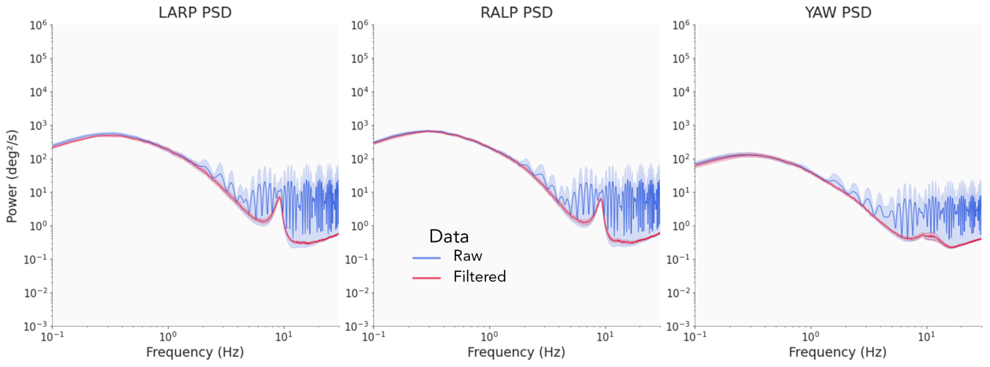

Supplementary Figure 1: Population-averaged power spectra of the head-velocity in the LARP, RALP and YAW planes with corresponding 95% confidence interval (shaded areas). Blue: raw data, red: filtered data, where samples associated with a quality value below 0.5 were discarded.

**Autoregressive model**

An autoregressive (AR) model predicts future values of a time series using its previous values. Such a model is appropriate for our data since the angular velocity of the head is auto correlated: the future velocity of the head depends closely on the immediate previous velocities (see Supplementary Figure 2, left). After removing samples with a low quality, we are left with ‘gaps’ in the time series. We employed an AR model (AutoReg function from the statsmodel python package, which estimates an AR-X model using Conditional Maximum Likelihood) to fill these gaps with data. To avoid generating erroneous data, we restrained the maximum length of a gap to be less than one second. If the number of successive discarded values (samples with a quality value < 0.5) resulted in a gap greater than one second in length, the current ‘data fragment’ was ended and a new fragment was created at the end of the gap. Otherwise, we used the AR model to fill the gap. The model was trained on the ten seconds of data preceding each gap. We chose a number of lags in the model as a linear function of the size of the gap: from 30 lags if the gap’s size is of length 1 (only one sample discarded) up to 300 lags if the gap’s size is of length 100 (100 successive samples discarded). Supplementary Figure 2, right, schematically represents the general idea of the algorithm.

*Supplementary Figure 2: Left: autocorrelation function of the head velocity signal. Correlation decreases steadily until a lag of 50 time steps where it changes sign. From there it rises again in absolute value until a lag of 100 time steps before decreasing again to zero for a lag of 300 time steps. Right: schematic representation of the processing of raw head data.*

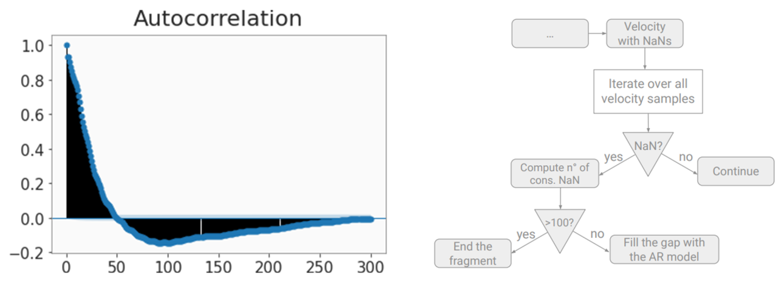Supplementary Figure 3 shows two applications of the AR model on a pilot’s head angular velocity signal. **E**ach gap appears to be completed with appropriate data samples. After application of our AR model, we obtain a collection of relatively clean, evenly sampled measurements of angular velocity signals. These can then be processed traditionally using Welch’s method to obtain the power spectra. We further chose to only consider fragments exceeding 3 minutes for analysis to focus on the more robust parts of the recordings. Supplementary Figure 4 compares the power spectra obtained with the two methods discussed in this article (the simple ‘juxtaposition’ method and the AR model). Clearly, both methods produce comparable results.

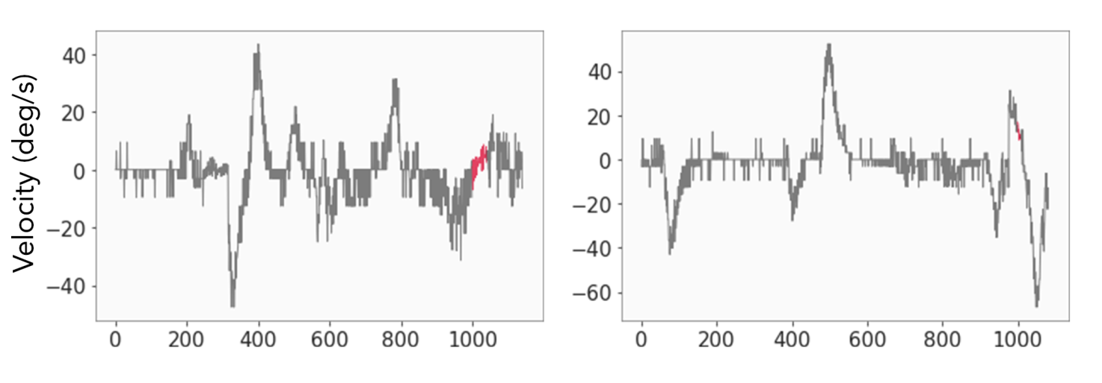

Supplementary Figure 3: Head angular velocity in the LARP plane after applying the AR model. Both curves present the first 10 seconds of training data (in grey) followed by the completion of the gap by the AR model (red) and the next 1 s of true data (grey).

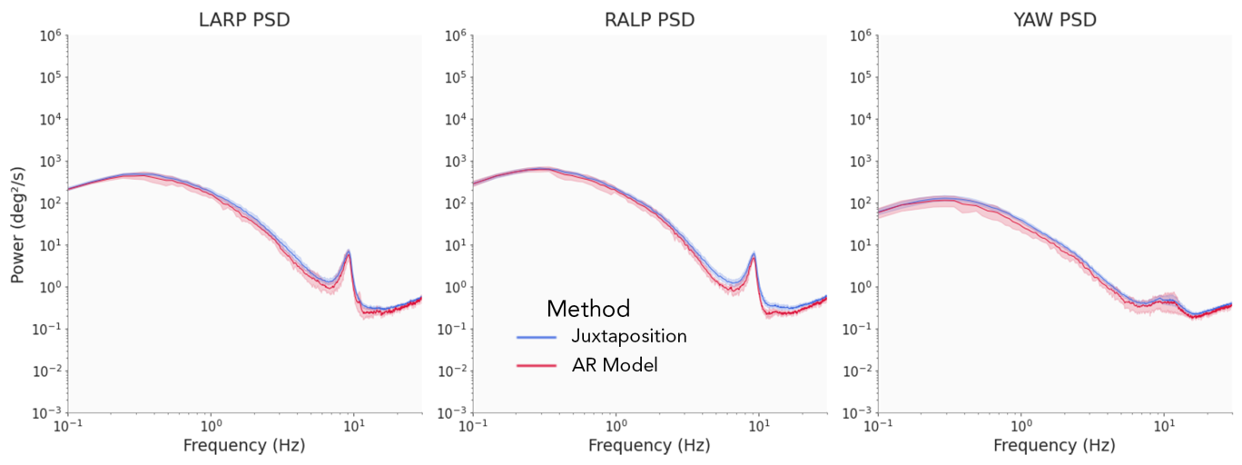

Supplementary Figure 4: Population-averaged power spectra of the head-velocity in the LARP, RALP and YAW planes with corresponding 95% confidence interval (shaded areas). Blue: power spectra obtained with the simple juxtaposition method (detailed in section Materials and Methods, Data preprocessing), red: power spectra obtained after applying our AR Model.

**Environmental stimuli**

We wondered whether the peak present in the power spectra during the manual navigation task could have been caused by some external resonant element in the immediate vicinity of the pilots. To assess the potentially nefarious effects of vibrations stemming from the helicopter simulator, we computed the power spectrum of the velocity signal from an IMU attached to the roof of the cabin (Supplementary Figure 5). The power spectra strongly differed from the ones measured at the participant’s head: they lacked the inverted ‘U’ shape, and the power appeared to be nearly constant over the whole frequency range. Thus, the aforementioned peak does not seem to be generated by mechanical vibrations of the cabin, at the scale of the cabin.

We note that, contrary to [2], the frequency content of the environmental stimuli does not follow a single power law. We attribute this discrepancy in the shape of the power spectra to the atypical nature of our environmental stimuli: movements of the cabin correspond to rotations and translations of a helicopter cabin, in a motorized simulator, driven by actions on the commands translated into a set of angular displacements constrained by the physical limitations of the simulator. Hence, pilots experience environmental stimuli that strongly differ from “white noise”.

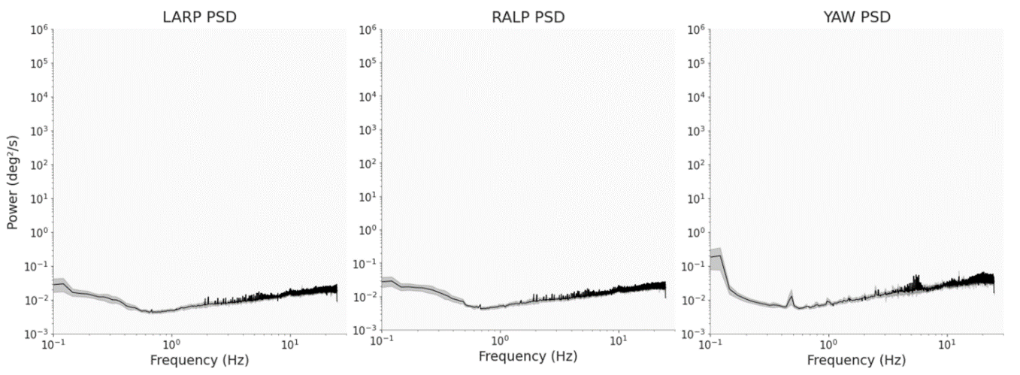

Supplementary Figure 5: Population-averaged power spectra of the environmental motion velocity signal projected in the LARP, RALP and YAW planes, with corresponding 95% confidence interval (shaded areas) during the simulated flight.

## REFERENCES

[1] J. F. Golding and M. A. Gresty, ‘Biodynamic Hypothesis for the Frequency Tuning of Motion Sickness’, *Aerosp. Med. Hum. Perform.*, vol. 87, no. 1, pp. 65–68, Jan. 2016, doi: 10.3357/AMHP.4295.2016.

[2] J. Carriot, M. Jamali, M. J. Chacron, and K. E. Cullen, ‘Statistics of the Vestibular Input Experienced during Natural Self-Motion: Implications for Neural Processing’, *J. Neurosci.*, vol. 34, no. 24, pp. 8347–8357, Jun. 2014, doi: 10.1523/JNEUROSCI.0692-14.2014.

[3] J. Carriot, M. Jamali, K. E. Cullen, and M. J. Chacron, ‘Envelope statistics of self-motion signals experienced by human subjects during everyday activities: Implications for vestibular processing’, *PLOS ONE*, vol. 12, no. 6, p. e0178664, Jun. 2017, doi: 10.1371/journal.pone.0178664.

[4] O. A. Zobeiri, B. Ostrander, J. Roat, Y. Agrawal, and K. E. Cullen, ‘Loss of peripheral vestibular input alters the statistics of head movement experienced during natural self‐motion’, *J. Physiol.*, vol. 599, no. 8, pp. 2239–2254, Apr. 2021, doi: 10.1113/JP281183.

[5] B. Wark, B. N. Lundstrom, and A. Fairhall, ‘Sensory adaptation’, *Curr. Opin. Neurobiol.*, vol. 17, no. 4, pp. 423–429, Aug. 2007, doi: 10.1016/j.conb.2007.07.001.

[6] A. Kingstone, D. Smilek, J. Ristic, C. Kelland Friesen, and J. D. Eastwood, ‘Attention, Researchers! It Is Time to Take a Look at the Real World’, *Curr. Dir. Psychol. Sci.*, vol. 12, no. 5, pp. 176–180, Oct. 2003, doi: 10.1111/1467-8721.01255.

[7] A. Kingstone, D. Smilek, and J. D. Eastwood, ‘Cognitive Ethology: A new approach for studying human cognition’, *Br. J. Psychol.*, vol. 99, no. 3, pp. 317–340, Aug. 2008, doi: 10.1348/000712607X251243.

[8] K. E. Cullen, ‘Vestibular processing during natural self-motion: implications for perception and action’, *Nat. Rev. Neurosci.*, vol. 20, no. 6, pp. 346–363, Jun. 2019, doi: 10.1038/s41583-019-0153-1.

[9] R. Telban, F. Cardullo, and J. Houck, ‘Developments in human centered cueing algorithms for control of flight simulator motion systems’, in *Modeling and Simulation Technologies Conference and Exhibit*, Portland,OR,U.S.A., Aug. 1999. doi: 10.2514/6.1999-4328.

[10] J. Houck, R. Telban, and F. Cardullo, ‘Motion cueing algorithm development: Human-centered linear and nonlinear approaches’. 2005.

[11] D. P. O’Leary and L. L. Davis, ‘High-Frequency Autorotational Testing of the Vestibulo-ocular Reflex’, *Neurol. Clin.*, vol. 8, no. 2, pp. 297–312, May 1990, doi: 10.1016/S0733-8619(18)30357-8.

[12] C. Massot, A. D. Schneider, M. J. Chacron, and K. E. Cullen, ‘The Vestibular System Implements a Linear–Nonlinear Transformation In Order to Encode Self-Motion’, *PLoS Biol.*, vol. 10, no. 7, p. e1001365, Jul. 2012, doi: 10.1371/journal.pbio.1001365.

[13] J. T. VanderPlas, ‘Understanding the Lomb–Scargle Periodogram’, *Astrophys. J. Suppl. Ser.*, vol. 236, no. 1, p. 16, May 2018, doi: 10.3847/1538-4365/aab766.

[14] W. H. Zangemeister and L. Stark, ‘ACTIVE HEAD ROTATIONS AND EYE-HEAD COORDINATION’, *Ann. N. Y. Acad. Sci.*, vol. 374, no. 1 Vestibular an, pp. 540–559, Nov. 1981, doi: 10.1111/j.1749-6632.1981.tb30899.x.

[15] W. H. Zangemeister and L. Stark, ‘Types of gaze movement: Variable interactions of eye and head movements’, *Exp. Neurol.*, vol. 77, no. 3, pp. 563–577, Sep. 1982, doi: 10.1016/0014-4886(82)90228-X.

[16] A. J. Afanador, P. Aitsebaomo, and D. R. Gertsman, ‘Eye and Head Contribution to Gaze at Near through Multifocals: The Usable Field of View’, *Optom. Vis. Sci.*, vol. 63, no. 3, pp. 187–192, Mar. 1986, doi: 10.1097/00006324-198603000-00004.

[17] D. Guitton, ‘Control of eye—head coordination during orienting gaze shifts’, *Trends Neurosci.*, vol. 15, no. 5, pp. 174–179, May 1992, doi: 10.1016/0166-2236(92)90169-9.

[18] JamesH. Fuller, ‘Head movement propensity’, *Exp. Brain Res.*, vol. 92, no. 1, Dec. 1992, doi: 10.1007/BF00230391.

[19] J. S. Stahl, ‘Amplitude of human head movements associated with horizontal saccades’, *Exp. Brain Res.*, vol. 126, no. 1, pp. 41–54, Apr. 1999, doi: 10.1007/s002210050715.

[20] W. Einhäuser *et al.*, ‘Human eye-head co-ordination in natural exploration’, *Netw. Comput. Neural Syst.*, vol. 18, no. 3, pp. 267–297, Jan. 2007, doi: 10.1080/09548980701671094.

[21] J. Pelz, M. Hayhoe, and R. Loeber, ‘The coordination of eye, head, and hand movements in a natural task’, *Exp. Brain Res.*, vol. 139, no. 3, pp. 266–277, Aug. 2001, doi: 10.1007/s002210100745.

[22] Z. C. Thumser, B. S. Oommen, I. S. Kofman, and J. S. Stahl, ‘Idiosyncratic variations in eye–head coupling observed in the laboratory also manifest during spontaneous behavior in a natural setting’, *Exp. Brain Res.*, vol. 191, no. 4, pp. 419–434, Dec. 2008, doi: 10.1007/s00221-008-1534-2.

[23] D. A. Robinson, ‘The oculomotor control system: A review’, *Proc. IEEE*, vol. 56, no. 6, pp. 1032–1049, 1968, doi: 10.1109/PROC.1968.6455.

[24] E. G. Freedman, ‘Coordination of the eyes and head during visual orienting’, *Exp. Brain Res.*, vol. 190, no. 4, pp. 369–387, Oct. 2008, doi: 10.1007/s00221-008-1504-8.

[25] C. Klein and U. Ettinger, Eds., *Eye Movement Research: An Introduction to its Scientific Foundations and Applications*. Cham: Springer International Publishing, 2019. doi: 10.1007/978-3-030-20085-5.

[26] M. F. Land, ‘The coordination of rotations of the eyes, head and trunk in saccadic turns produced in natural situations’, *Exp. Brain Res.*, vol. 159, no. 2, pp. 151–160, Nov. 2004, doi: 10.1007/s00221-004-1951-9.

[27] D. Anastasopoulos, N. Ziavra, M. Hollands, and A. Bronstein, ‘Gaze displacement and inter-segmental coordination during large whole body voluntary rotations’, *Exp. Brain Res.*, vol. 193, no. 3, pp. 323–336, Mar. 2009, doi: 10.1007/s00221-008-1627-y.

[28] B. M. Nigg and W. Liu, ‘The effect of muscle stiffness and damping on simulated impact force peaks during running’, *J. Biomech.*, vol. 32, no. 8, pp. 849–856, Aug. 1999, doi: 10.1016/S0021-9290(99)00048-2.

[29] J. M. Wakeling, A.-M. Liphardt, and B. M. Nigg, ‘Muscle activity reduces soft-tissue resonance at heel-strike during walking’, *J. Biomech.*, vol. 36, no. 12, pp. 1761–1769, Dec. 2003, doi: 10.1016/S0021-9290(03)00216-1.

[30] B. Hinz, G. Menzel, R. Blüthner, and H. Seidel, ‘Seat-to-head Transfer Function of Seated Men ―Determination with Single and Three Axis Excitations at Different Magnitudes’, *Ind. Health*, vol. 48, no. 5, pp. 565–583, 2010, doi: 10.2486/indhealth.MSWBVI-03.

[31] J. M. Wakeling, B. M. Nigg, and A. I. Rozitis, ‘Muscle activity damps the soft tissue resonance that occurs in response to pulsed and continuous vibrations’, *J. Appl. Physiol.*, vol. 93, no. 3, pp. 1093–1103, Sep. 2002, doi: 10.1152/japplphysiol.00142.2002.

[32] P. A. Forbes, A. Kwan, B. G. Rasman, D. E. Mitchell, K. E. Cullen, and J.-S. Blouin, ‘Neural Mechanisms Underlying High-Frequency Vestibulocollic Reflexes In Humans And Monkeys’, *J. Neurosci.*, vol. 40, no. 9, pp. 1874–1887, Feb. 2020, doi: 10.1523/JNEUROSCI.1463-19.2020.

[33] B. Rehn *et al.*, ‘MUSCULOSKELETAL SYMPTOMS AMONG DRIVERS OF ALL-TERRAIN VEHICLES’, *J. Sound Vib.*, vol. 253, no. 1, pp. 21–29, May 2002, doi: 10.1006/jsvi.2001.4247.

[34] K. E. Cullen and J. E. Roy, ‘Signal Processing in the Vestibular System During Active Versus Passive Head Movements’, *J. Neurophysiol.*, vol. 91, no. 5, pp. 1919–1933, May 2004, doi: 10.1152/jn.00988.2003.

[35] K. E. Cullen, ‘The vestibular system: multimodal integration and encoding of self-motion for motor control’, *Trends Neurosci.*, vol. 35, no. 3, pp. 185–196, Mar. 2012, doi: 10.1016/j.tins.2011.12.001.

[36] J. E. Roy and K. E. Cullen, ‘Selective Processing of Vestibular Reafference during Self-Generated Head Motion’, *J. Neurosci.*, vol. 21, no. 6, pp. 2131–2142, Mar. 2001, doi: 10.1523/JNEUROSCI.21-06-02131.2001.

[37] J. Kiverstein, ‘The Meaning of Embodiment’, *Top. Cogn. Sci.*, vol. 4, no. 4, pp. 740–758, Oct. 2012, doi: 10.1111/j.1756-8765.2012.01219.x.

[38] V. Weser and D. R. Proffitt, ‘Tool Embodiment: The Tool’s Output Must Match the User’s Input’, *Front. Hum. Neurosci.*, vol. 12, p. 537, Jan. 2019, doi: 10.3389/fnhum.2018.00537.

[39] F. Osiurak and G. Federico, ‘Four ways of (mis-)conceiving embodiment in tool use’, *Synthese*, vol. 199, no. 1–2, pp. 3853–3879, Dec. 2021, doi: 10.1007/s11229-020-02960-1.

## ADDITIONAL INFORMATION

### Competing interests

No.

### Author contributions

AR, PPV, YJ.

### Funding

This work was funded by Thales under a grant…

IRBA,

### Acknowledgments