Chapter 3: Numerical Modeling of the bond(Martin Chapter 3 and 4)

The types of elements for the concrete and textile could be chosen among 8-point-cube, 20-point-cube and 27-point-cube. About the properties of the bond will discuss in the chapter 3. Although the elements with more points are preciser than the 8-point-cube, but according to the practice, the accuracy can be fulfilled by the 3D element with 8 points.

shear lag theories?

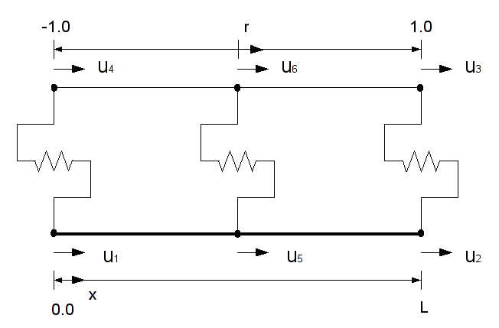
Fiber Interface Model (FIM)

The FIM reflects the interaction between two layers connected via an interface within a single material point. This combination enables the consideration of the interaction of the fiber and the bond during the failure process on material point level.

For the numerical evaluation of the stress transfer between the single fiber and the cementitious matrix a finite element type has been developed that represents the fiber and its interface to the matrix. In the following sections four different elements of this type are derived and their ability to reproduce the crack bridging behavior of a single fiber shall be assessed.

The material points of these elements are associated with a distinct material model that describes both the nonlinear behavior of the interface and the brittle failure of the fiber. The evaluation in a single material model enables the consideration of interactions between failure process of the interface and the damage of the fiber.
- linear element

- linear element with two independent slip fields

- quadratic element

- quadratic element with three independent slip fields

- Assessment of the element performance
The performance comparative examples have demonstrated the superior performance of the quadratic finite elements. It has been demonstrated that the quadratic elements show a better convergence to the analytical solution with increasing number of elements. Furthermore, the elements based on the approach presented by Herrmann [1978] prevent oscillations of the displacements or strains. In order to assess the efficiency of the proposed elements, in this section the computational cost of the solution shall be compared.

For the simulation of larger specimens with a large number of elements the quadratic element would be the right choice in order to achieve the necessary precision.

    - Summary
In this chapter the Fiber Interface Model (FIM) has been introduced which combines the fiber and its interface to the matrix. Four different elements have been introduced and verified. Using quadratic approaches achieve a higher precision with the same number of degrees of freedom.

The FIM using the presented elements can be utilized to reproduce the behavior of a single filament or of a yarn represented as monofilament. Equipped with the corresponding boundary conditions fiber pull-out, single crack bridges and even tensile tests on reinforced composites including the multiple cracking can be reproduced.

The coupling of multiple FIM enable the representation of complex interaction of complex interactions between the filaments of a bundle. The FIM are either coupled parallel to the matrix or serial to each other, depending on the dominating type of interaction. The appropriate choice depends on the dominating form of interaction (fiber-matrix or filament-filament). Furthermore, a combination of serial an parallel coupling can be used to reproduce the gradual transition from the interaction filament-matrix towards filament-filament interaction.

