Chapter 4 Damage

4.1 What is damage?
Continuum damage mechanics is a constitutive theory that describes the progress loss of material integrity due to the propagation and coalescence of micro cracks, micro voids, and similar defects. These changes in the micro structure lead to a degradation of material stiffness observed on the macro scale.

Why should we use damage?
As the damage process changes internal forces and stiffness the computation has to be conducted in the incremental mathematics. Furthermore since the three components can collapse, which of them are the real damage and which of them are destroyed by the collapse of others?

4.2 3D damage models
4.2.1 Isotropic damage
The simple isotropic damage model considered here is described by the basic equations.
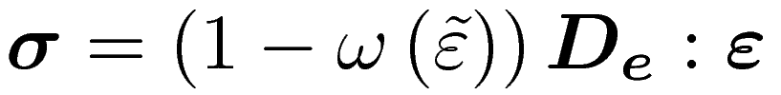
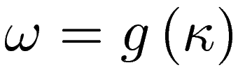
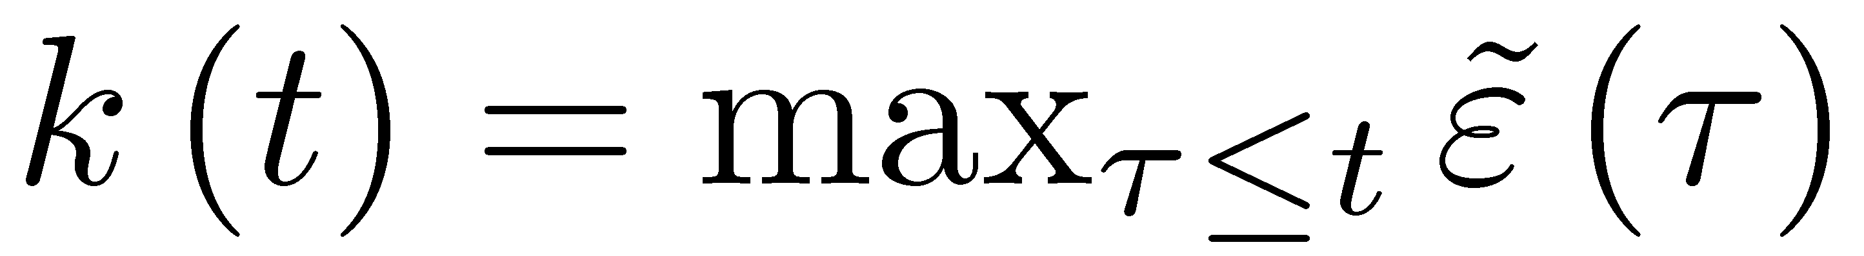
in which 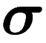 is the stress tensor, 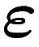 is the strain tensor, 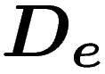 is the elastic stiffness tensor, 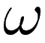 is a scalar damage variable, 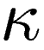 is an internal hardening-softening variable that drives damage. 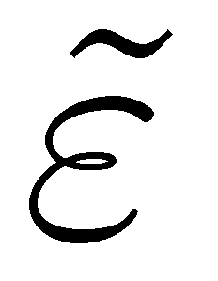is the equivalent strain, which shows the level of the strain in the material. It directly affects the shape of the elastic domain. The choice of a specific expression for the equivalent strain determines the shape of the elastic domain and depends on the type of material.

The damage models with symmetrical damage surfaces are the euclidean norm and the energy norm, while the damage models with unsymmetrical damage surfaces are the Mazars definition, the Rankine criterion of maximal stress and the modified von Mises definition
- Euclidean norm: (picture)
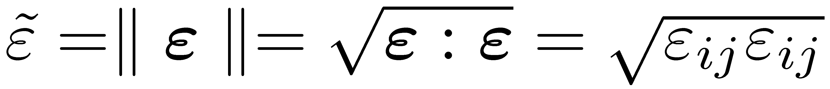
which assigns a strictly positive length or size to all directions.

- Energy norm: (picture for the case 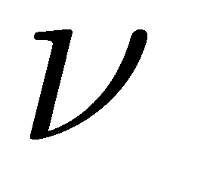= 0.2)
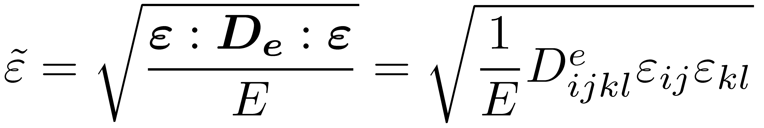
where the normalization by Young's modulus 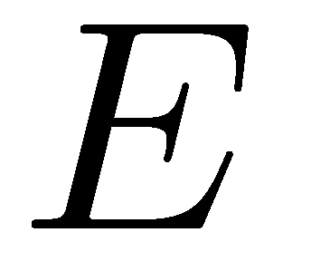is introduced in order to obtain a strain-like quantity. 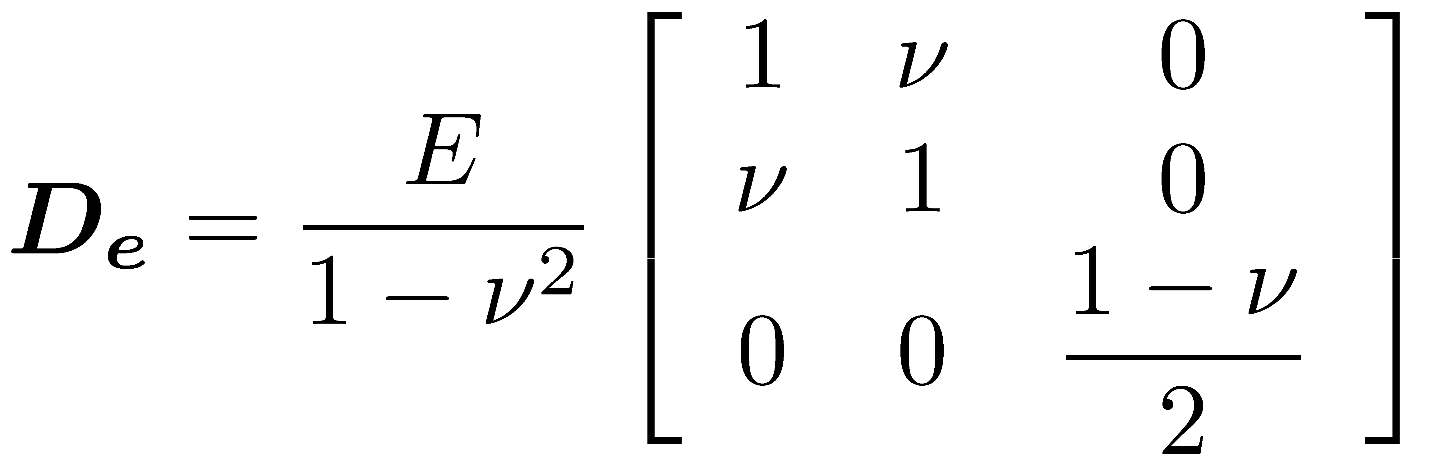 Where is the Poisson's ratio
- Mazars definition: (picture)
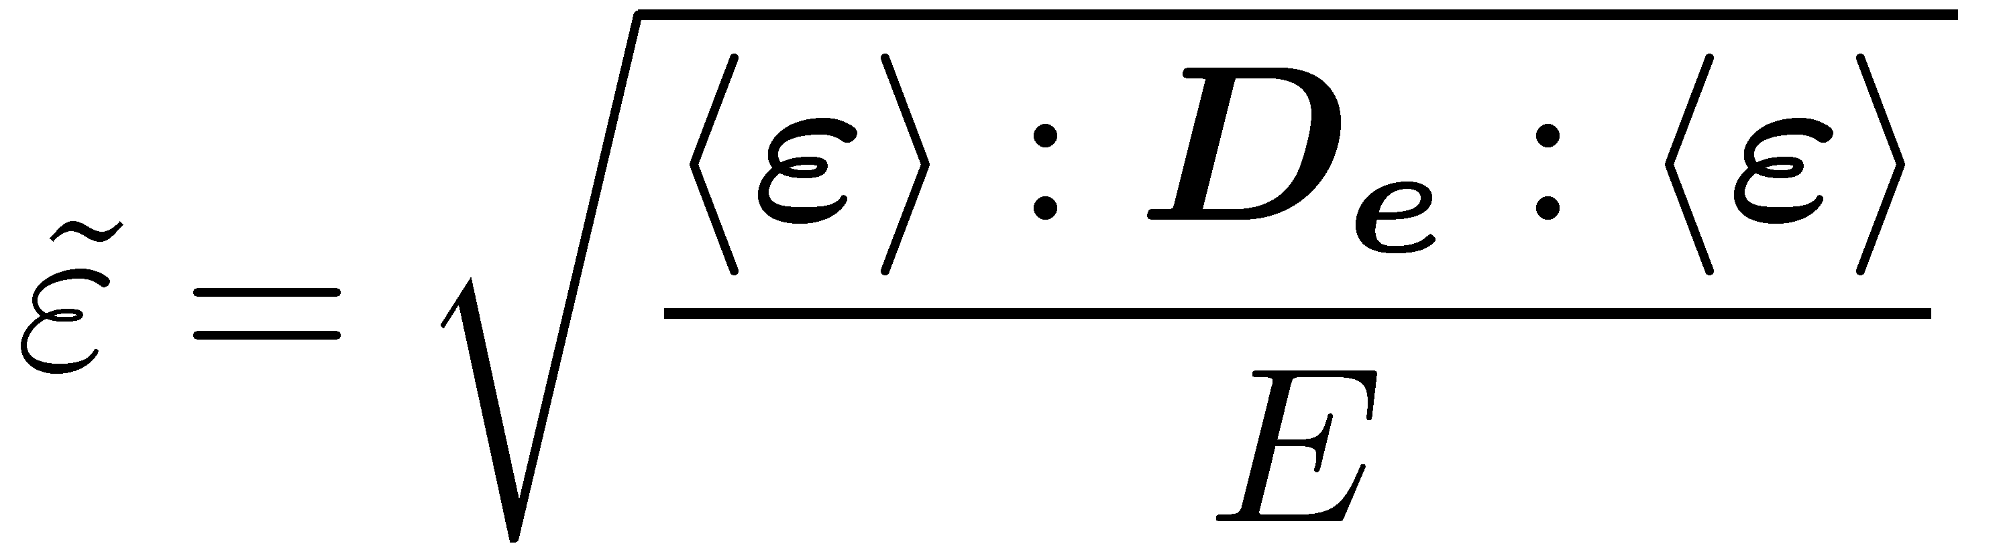
Where McAuley brackets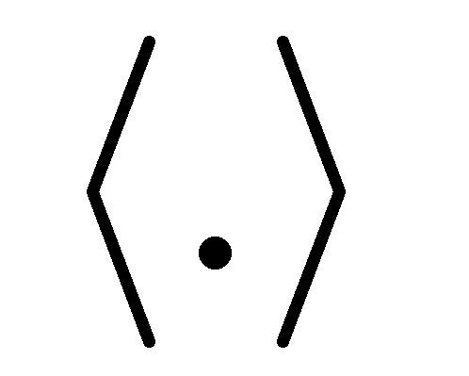denote the “positive part” operator. For symmetric tensors, such as the strain tensor 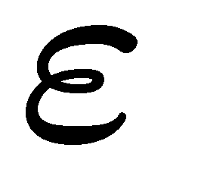, the positive part is a tensor having the same principal directions 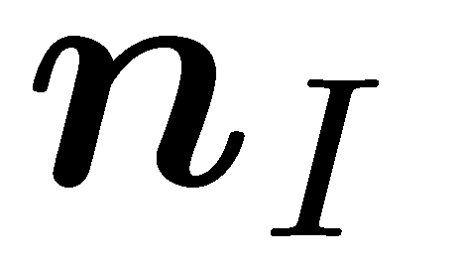 as the original one, with principal values 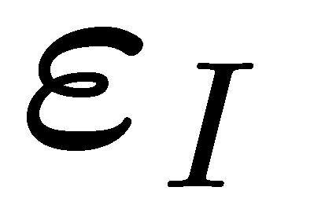 replaced by their positive parts 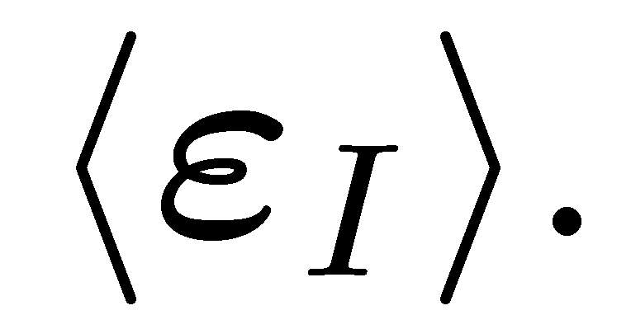 In this way, the symmetrical damage surface changes to a unsymmetrical one, which shows only the positive part of the tensor.
- Definition based on Rankine criterion of maximum principal stress:
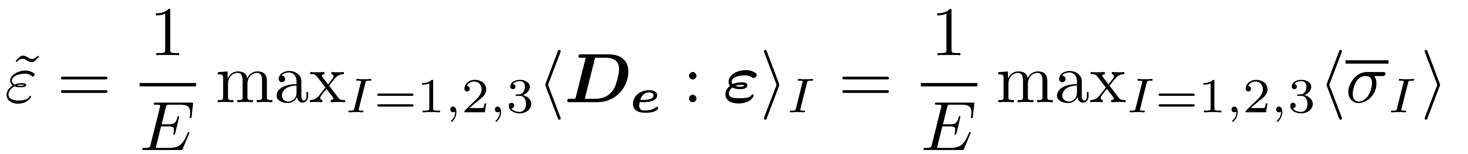
or
can be used, if a model corresponding to the Rankine criterion of maximum principal stress is desired. 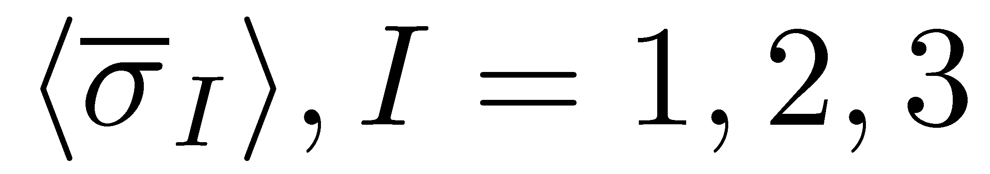, are the positive part of principal values of the effective stress tensor. The former definition exactly corresponds to the Rankine criterion while the latter rounds off the corners in the octants with more than one positive principal stress.
- Modified von Mieses definition: (pictures with k)
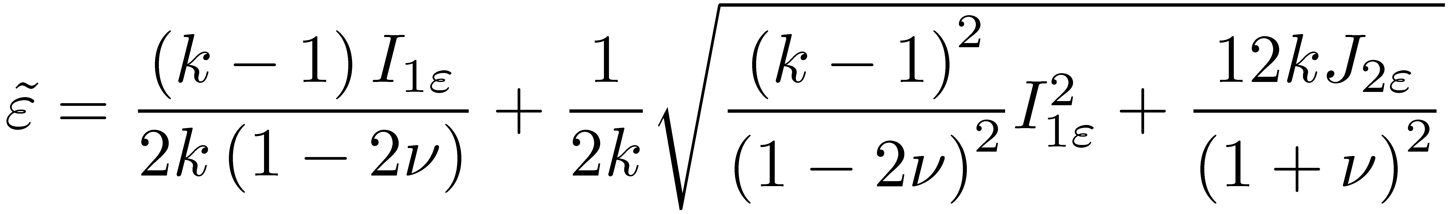
where 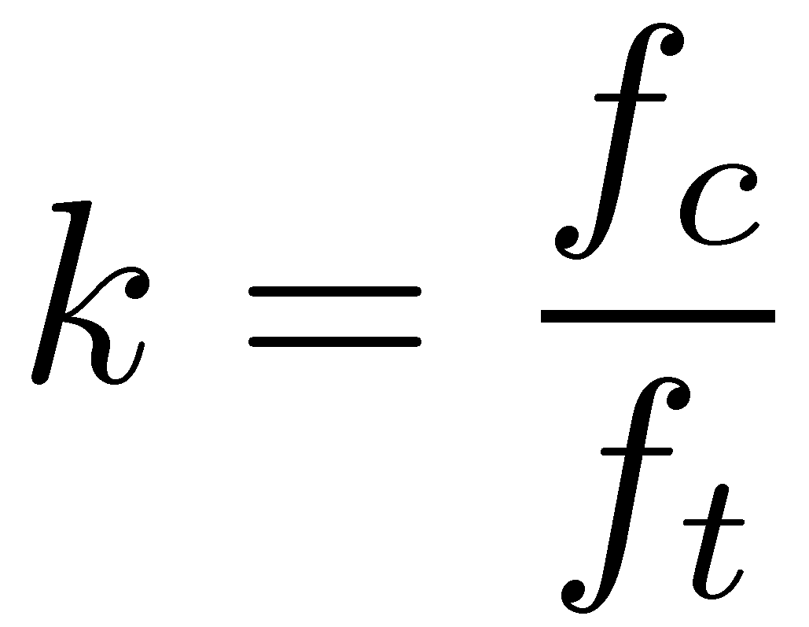presents the ratio between the uniaxial compressive strength and the uniaxial tensile strength. 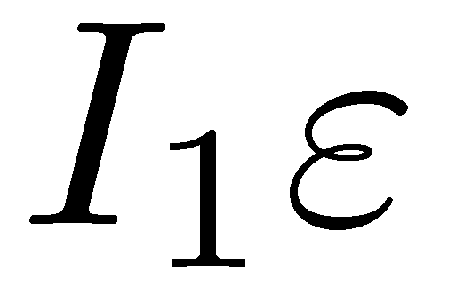Is the first strain invariant i.e. the trace of 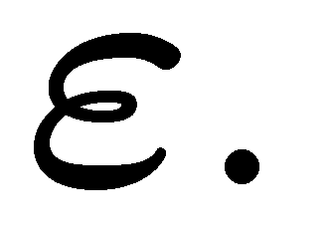
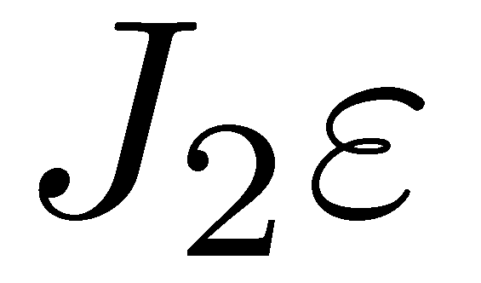is the second deviatoric invariant: 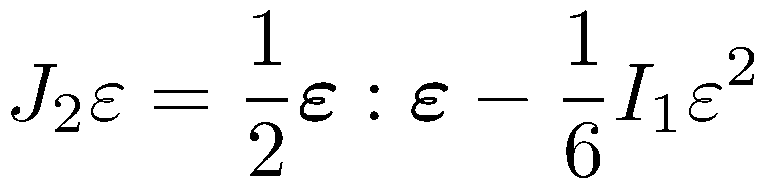
The form of the damage surface depends of 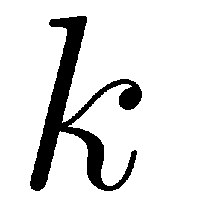, by which is the position of the concavity of the surface determined. Has the meaning of the largest value of equivalent strain that has ever occurred in the previous deformation history of the material up to its current state.
The definition is called “modified von Mises” since the influence of the first invariant is considered in the formulation, in contrast to the standard von Mises formulation, which is based on the second deviatoric invariant only.
The fracture energy 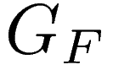, which has the meaning of energy dissipated per unit area of the macroscopic crack, as a primary material characteristic. In failure simulations based on local constitutive models with softening, the correct amount of global energy dissipation can be enforced using the so-called crack band concept.
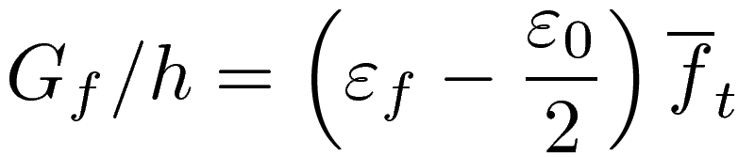
where 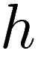 is the thickness of the numerically resolved band of localized inelastic strain. The actual value of depends on the size of the finite elements and also on their shape and orientation with respect to the crack. 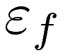 Is a parameter that controls the slope of the softening curve. 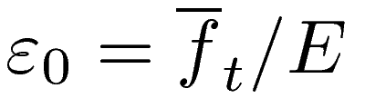 is the strain at peak stress under uniaxial tensor.

4.2.2 Anisotropic damage
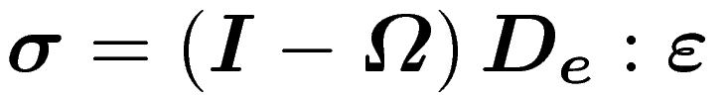
Where the 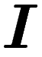 is the identity matrix.
4.2.2.1 Microplane model
The basic concept of the microplane is to project the tensorial quantities onto a set of generic planes, so-called microplanes. Each microplane is defined by its normal direction 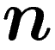. In the case of the kinematic constraint the strain tensor is projected onto the microplanes using the relation 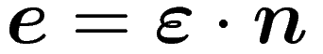. For the static constraint the stress tensor is projected using the relation 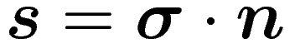. The projection yields a set of either strain or stress vectors which are related by constitutive laws on the microplane-level.

4.2.2.2 Microplane-based damage model (MDM)
The flexibility of the microplane approach shall

4.3 Bond Law

- How to simulate the damage

- Damage occurs → nonlinear calculation
physical nonlinearity, geometric linearity (assumption not extension), bond laws, laws of materials.

- [K] with full integration → locking → reduced Gauss Integration
1). comparing the two integrations (time, steps of integration, accuracy)
2).

- [u] local calculation → not exactly (image, but the force – displacement – curve could be right) → nonlocal calculation (better Kcu=f)

- bond behaves always elastic. 1D / 2D ? (1D)
- Rovings will be checked under elasticity conditions and simple plasticity conditions and more...

- What kinds of damage models are there? (conceptions, short descriptions and comparing pictures )

- What will be the technical problem by using the damage models?
- What is the solution?
- The calculation and the result (appendix and pictures)

