Diplomarbeit

Geliederung:

- Problembeschreibung und Darstellung
- Elementtyp: 27Punkte Cube
- Diskritisierung: Wieviele Elemente / Geometrie

- Damage: 5 Normen (isotropisch) + 1 anisoprotisch (von Alex) und
die Ergebnisse vergleichen und eine davon auswählen
- Verbundelement
- Modelling: Roving
- Fazit: Geometrie
Elementtyp
Elementzahl...

Introductions:

- Bei TRC Dehnkörper-Versuch, passiert es manchmal, dass die Betonblocke abplatzen.

- Garne:
a. Die Querrisse (QR) tauchen zuerst auf.
b. Ein o. mehrere Längsrisse (LR) tauchen auf und verbinden sich die QR.
c. Die LR laufen auf die Garne
d. Die abgeplatzte Dehnkörper können den Mittelwert von Traglast erreichen.
f.

- Textil:
a. Die Abplatzung (Ap) von Textil sind viel komplizierter als die von Garne
b. Die Querbewehrungen von Textil stören die Entwicklung von LR .
c. Ein oder mehrere LR tauchen machmal an der Kante and sie führen zu gravierende Abplatzung.
d. Die Ap von beide Seite sind nicht identisch.
f. Die Ap sind meistens an den Auflager (oben oder/and unten). Wenn die Ap in der Mittel aufgetaucht ist, ist die Tragfähigkeit von

- ein Kapitel von Martin
- Schädigung:

- Modellierung:

- Dehnkörperversuch aus Aif BerichtMaster.pdf
- Geometrie

- Versuchsaufbau und -durchführung

- Versuchsergebnisse und Auswertung

1. Allgemein
Das Versagen der Dehnkörper entstand entweder durch einen Bruch der Bewehrung oder durch ein Abplatzen der Betondeckung infolge Verbundspalten. Da das Verbundspalten eine häufige Versagensursache war, wird Zusammenhang zwischen Verbund- und Sapltzugkräften in Kapitel *** näher beschrieben.
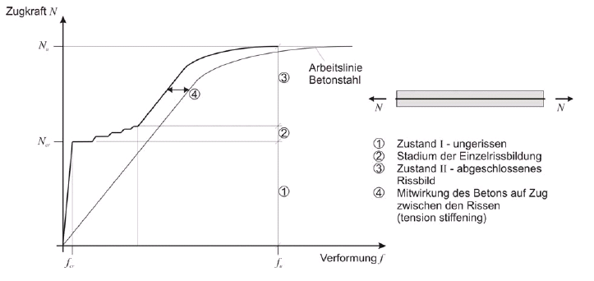

- Simulation

1. Gausspunkt sparen Excel-Tabelle Stephan
Reduced and selective integration and its equivalence to penalized mixed problems [The Finite Eliment Method Volume 1 Basic Formulation and linear Problems O.C.Zienkiewicz, R.L.Taylor McGRAW-HILL International Editions]

- Prblems:
- the lowest order numerical integration rules that still preserve the required convergence order for various elements, but at the same time pointed out the possibility of singularity in the resulting element matrices.
- Reduced integration for those that did not evaluate the stiffness exactly for simple elements and some dangers of its indiscriminate use due to resulting instability

- Result:
- such reduced integration and selective integration has proved its worth in prctice yielding often much more accurate results than the use of more precise integration rules.
- The main reason for success is associated with the fact that it provieds the necessary singularity of the constraint part of the matrix, which avoids locking.
- There is a complete equivalence between reduced (or selective) integration procedures.

2. full integration
3. 1 vs. 2

großer Überblick von Simulation:

- Damage occured → nonlinear calculation
physical nonlinearity, geometric nonlinearity, bondlaws, laws of materials,

- [K] with full integration → locking → reduced Gauss Integration

1). comparing the two integrations (time, steps of integration, accuracy)
2).

- [µ] local calculation → not exactly (image, but the force – displacement – kurve could be right) → nonlocal calculation (better Kcµ=f)

- bond behaves always elastic. 1D / 2D ?
- Rovings will be checked under elasticity conditions and simple plasticity conditions and more...

Introduction:
Concrete as a building material is characterised by good workability, robustness, high compressive strength and low price. One of the disadvantages of concrete is the low tensile strength, while reaches only approximately ten percent of the compressive strength. Therefore an adequate reinforcement needs to be used to carry the forces arising by tensile load. In practice steel works satisfactorily but requires corrosion protection. Alternatively textiles from carbon or alkali-resistant glass fibres can be used as reinforcement. One main advantage is, that they do not require alkaline protecion against corrosion resulting in the possibility of low concrete covers and thin elements.

((Textile reinforced concrete (TRC) is a composite material combining the advantages of fiber reinforced concrete and steel reinforced concrete.

Textile reinforcement is made of glass, carbon or aramid that are alkali resistant and thus not vulnerable to corrosion. As a result, thin-walled elements can be designed with thickness constrained only by the needs to achieve sufficient anchorage of the textile fabrics and to avoid spalling failure.))

Another advantage is the possibility to adjust the fabrics in the TRC elements to correspond with the distribution of forces within the structural element.

The design flexibility can be exploited to increase the effectiveness of the fabrics in terms of the high load carrying and deformation capacity.

The effectivity of the reinforcement can be substantially increased if all fibers are oriented in the direction of the loading. The textile processing of multifilament yarns provided an effective realization of this idea.

The mechanical properties of components made of textile reinforced concrete strongly depend on the interfacial bond strength between the cementitious matrix and the reinforcement.

Motivation:

In order to test the carrying capacity of the textile reinforced concrete, some of experiments were conducted, two of which are Pull-Out and Strain-Stress. Comparing the two experiments, we could see, that the yarn collapse with higher carrying capacity as the Strain-Stress. One of the reason could be the spalling of the concrete. During the Strain-Stress experiment, the concrete spalls mostly and the whole balk collapses. Our interest is, if the spalling could be avoided, would its carrying capacity rise? That means, the concrete could spall, however the yarn could continually carry the load till its collapse.

Under this idea, a simulation model was built, which contains three components: concrete, yarn textile, the bond between the concrete and the yarn textile. The type of concrete is already decided due to the former experiments and the basic idea is, that the concrete should behave weaker and the yarn stronger. The yarn textile is polymer-impregnated and the type of the textile and its epoxy could be also decided. The goal of the work are s to search out the mechanical reasons of the spalling and to improve the yarn textile. Further work is to find out the further carrying capacity of the balk without spalling, or even thought it spalls, the yarn textile could be still under tensile. The meaning of our work are followings,

- How does the spalling come?
- How does it behave?
- Why can the block with spalling carry less as the Pull-out yarn?
- How much is the further carrying capacity of the yarn after spalling, if the spalling could not be avoided.

