Chapter 1: Spalling and tension experiment

- What is spalling

  - Description about the experiments from 3 institutes generally and compare the differences

The tensile experiment was conducted by three institutes, IMB, IBAC and ISF. The primary idea of the experiment is to test the carrying capacity of the specimen. The normal concrete was chosen, in order to test the carrying capacity of the yarns after concrete collapses. However, in the most cases, the concrete collapses in the spalling way. The experiments taking by the IBAC is now as the example listing following. The Geometry of the specimen is 500mm/60mm/10mm, the average distances between cracks is 11.5mm, the number of the yarn is 6 and the number of the cracks is 24, the average width of the cracks is 0.2mm. The sketch of the specimen shows in Fig 1.
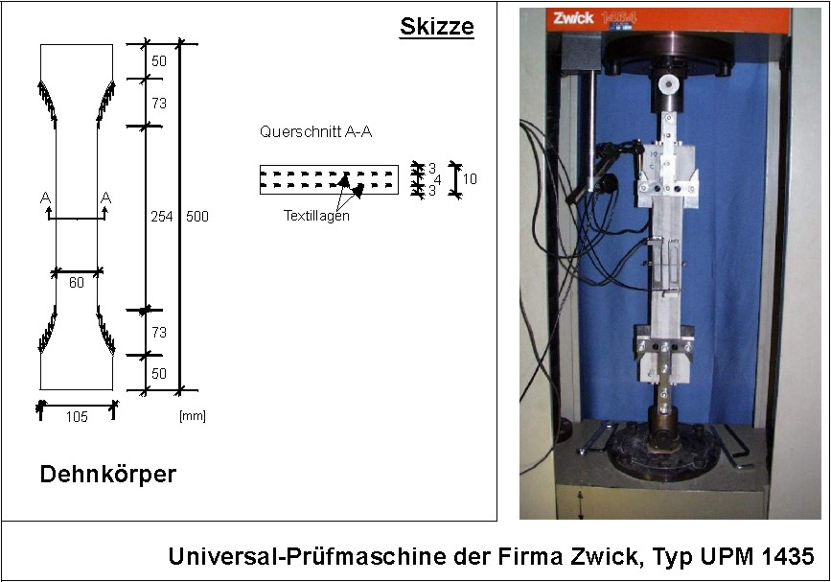

Fig 1.

  - Description about the spalling generally and during the comparison of the 3 experiments, the yarn reinforcement is chose, because...
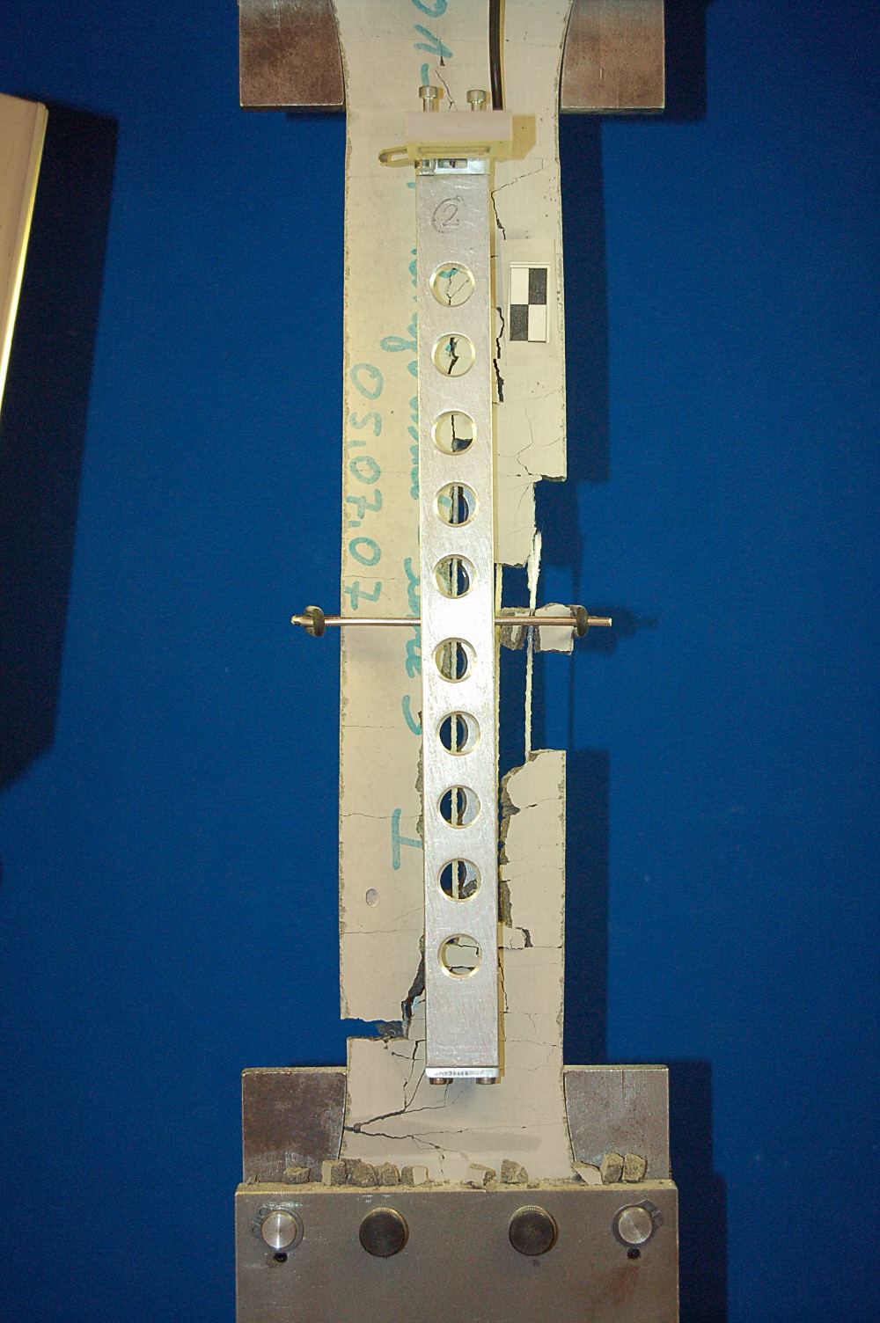
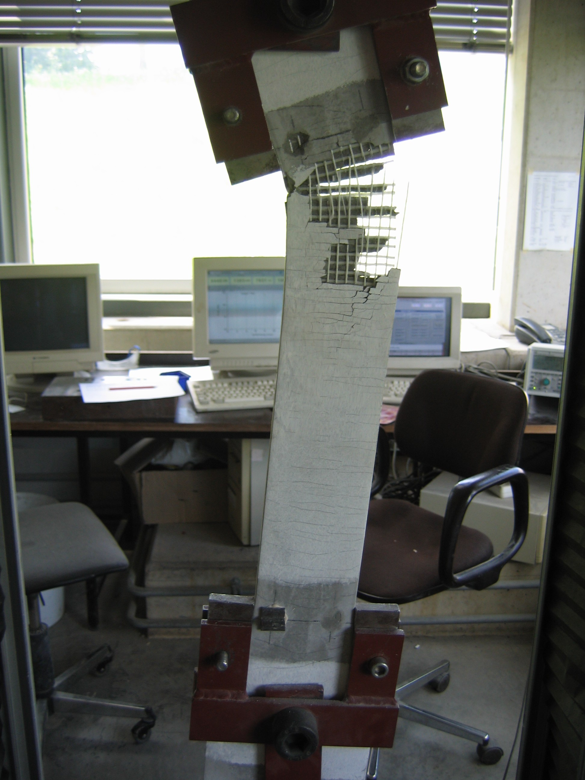
The differences of the spalling behaviors could be seen below.

Roving (from IBAC) Textile (from IMB)

In rovings term, the cross crack (abbreviation as “cc”) comes first and increase regularly by increasing the tensile load. Meanwhile one or more of the longitudinal crack(s) (abbreviation as “lc”) develop and gradually connects the existing ccs. The lcs develop themselves along the reinforcements.

Since the specimen is symmetrical, we could assume, that there are the same number of ccs and lcs on the back surface as on the front surface, which means, the ccs and lcs form themselves as one or more separate island(s). (Pictures)

(Question so far: if the it is really a separate island and a part of concrete falls down, that will mean, that the bond is also defect. Otherwise the bond will hold the island without falling – the bond collapses before the whole system collapses.)

In textile term, the spalling behave itself much more complex as the spalling by rovings. Since the specimen with textile have normally more transverse reinforcements as the roving specimen, and the cross cracks develop themselves along the transverse reinforcements, as a result, there are much more cross cracks one the front and the back surfaces. In some cases, a long and obvious longitudinal crack could not be seen before the collapse of the whole system, but on the left or right narrow surfaces (pictures).

- Garne:
a. Die Querrisse (QR) tauchen zuerst auf.
b. Ein o. mehrere Längsrisse (LR) tauchen auf und verbinden sich die QR.
c. Die LR laufen auf die Garne
d. Die abgeplatzte Dehnkörper können den Mittelwert von Traglast erreichen.
f.

- Textil:
a. Die Abplatzung (Ap) von Textil sind viel komplizierter als die von Garne
b. Die Querbewehrungen von Textil stören die Entwicklung von LR .
c. Ein oder mehrere LR tauchen machmal an der Kante and sie führen zu gravierende Abplatzung.
d. Die Ap von beide Seite sind nicht identisch.
f. Die Ap sind meistens an den Auflager (oben oder/and unten). Wenn die Ap in der Mittel aufgetaucht ist, ist die Tragfähigkeit von

  - pictures
  - assumptions (as a guideline of the simulation)

