Main work:
- introduce the model and the development of the stress in X-direction from the roving to the matrix (with pictures and description).
- Find out the load-displacement-behavior of the bond
- Introduce the ring-stress, which lead to the spalling.

Prepare work:
- introduce the matrix (in introduction)
- the with epoxy-impregnated filaments, roving
- the tension experiments (with pictures and descriptions)
- the spalling (how does it happen, how does it behave, ...)

post work:
- introduce the damage models, which could be used to explain the spalling,
- explain the reasons, why spalling happens.
- Possibly (optional): bias mesh, anisotropic nonlocal

Chapter1: Introduction and motivation
introduce spalling the tension experiments and

Chapter 2: introduce the matrix and roving
- rovings
- Impregnated rovings and its effect
- concrete parameters and properties

Chapter 3: numeric calculation (the main work)
- element type
- element number
- introduce the model
- stress in x-direction and the ring stress

Chapter 4: damage models
- general information about the damage models
- isotropic
- anisotropic (Microplane model, Microplane-based Model MDM )
- bond law

4.1 One should describe the bond function, which is set (used) in the calculation. The point is, the bond law is quite different from the plastic models and the damage models, because the model is only loaded not unloaded. (note: only from the unload process could the damage / plastic models be configured).

4.2 find out the model from Martin, and compare the stiffnesses and graphs of two models.

Chapter 5: mechanical explanation about spalling and prevention
chapter3+chapter4

5.1 introduce the general / main model

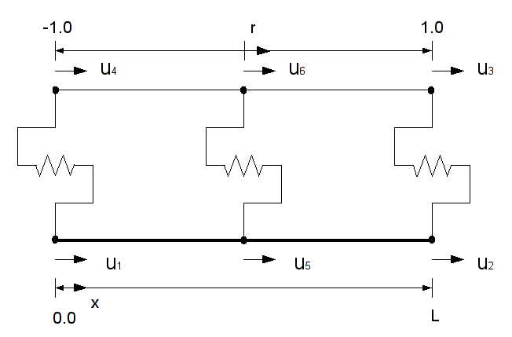
5.2 matrix is elastic

the bond function is given in Chapter 4 (the approximately run of the curve is known and discussed). The values of / on the curve should be specified now.

5.2.1 model: half-tear-off combination between the bond and the matrix
for the angle (No.1) (stiffness of the bond):
the scope of the stiffnesses (min, max)

5.2.2 model: intact combination between the bond and the matrix

for the peak (No.2) (the end of the elasticity):
we assume a peak value and test the stress of the matrix in the model. So far the stress lands on the matrix, or the matrix helps the bond carry the load before the first spring breaks (the end of the elasticity), the peak value is found.

for the curve after the peak (No 3 and No.4): test the two cases

Goal: to find out the behavior after the peak.
Slip = displacement of filament – displacement of matrix
Stress t
Slip s
Stress t
Slip s

5.2.3 obtain the bond function under the assumption, that the matrix is elastic

5.3 matrix is plastic / damaged
analog to 1. Obtain the corresponding bond function
Possibly the development of the stress on the matrix is quite different as above!!!

5.4 the load-displacements-behavior of the WHOLE system, while the matrix is damaged with the corresponding bond function.

Stress t
Slip s
1
2
3
4

Chapter 6: Conclusion

