Introduction:
- steel vs. textile reinforcement (corrosion protection can be omitted)

Concrete as a building material is characterized by good workability, robustness, high compressive strength and low price. One of the disadvantages of concrete is the low tensile strength, while reaches only approximately ten percent of the compressive strength. Therefore an adequate reinforcement needs to be used to carry the forces arising by tensile load. In practice steel works satisfactorily but requires corrosion protection. Alternatively textiles from carbon or alkali-resistant glass fibers can be used as reinforcement. One main advantage is, that they do not require alkaline protection against corrosion resulting in the possibility of low concrete covers and thin elements. The request for thin walled structural elements demands for the application of non-metallic reinforcement materials.

- TRC further advantages...(high load-carrying capacity, small diameter, effectiveness):

Textile reinforced concrete (TRC) represents an interesting new construction material, offering several advantages compared to steel reinforced concrete. These advantages dominate in those fields of applications where thin-walled, structural elements with a high load-carrying capacity are required. To obtain substantial strain hardening behavior and crack width control, one should use many, stiff, strong, and aligned fibers of small diameter. Textiles made of ,for instance AR-glass rovings (roving: bundle of endless fibers, so-called filament) meet these requirements.

Textile reinforcement features a higher effectiveness, because the fiber bundles are arranged in the direction of the main tensile stresses, which means, that fiber material is placed only where necessary in the direction of the tensile forces. This leads to a higher utilization of the reinforcement material and better load-bearing properties of the component. The thickness of TRC-members primarily depends on the required value to ensure a proper anchorage of the reinforcement and to avoid a splitting failure.

- What can we do with the textile reinforced concrete? (see above)
Using high performance fibers as concrete reinforcement allows the production of thin and lightweight elements with high durability and the potential of economic savings.

- What are the experiments developed?

The structural performance of a composite is strongly affected by the properties of the fiber/matrix interface. In order to gain more insight into the basic mechanisms dominating the properties of the fiber/matrix interface, the Pull-out test was developed, in which a single fiber or bar is pulled out off the surrounding matrix and the corresponding load versus displacement relation is recorded.

Another important source of data is the tensile test, which is particular importance to study the load-bearing behavior of TRC-elements and to obtain information about the bond performance of the fabrics. (The tensile specimen in tensile test bears a constant deformation rate of 1 mm/min (0.04 in./min). )

Motivation:

- Spalling is a big problem in front of us, therefore, our goal is to avoid spalling.

According to the basic idea, that the concrete collapses earlier than textile, the further carrying capacity of textile are assumed. During the tensile test, however, most of the tensile specimen collapses and the concrete spalls. Hence, the main task now is to avoid spalling of the concrete.

- What kinds of elements are involved? (with pix)
The textile reinforced concrete is a composite material and obviously three components are into consider, which are the concrete, the textile and the bond of the two. All of they could collapse as shown in Fig 1.

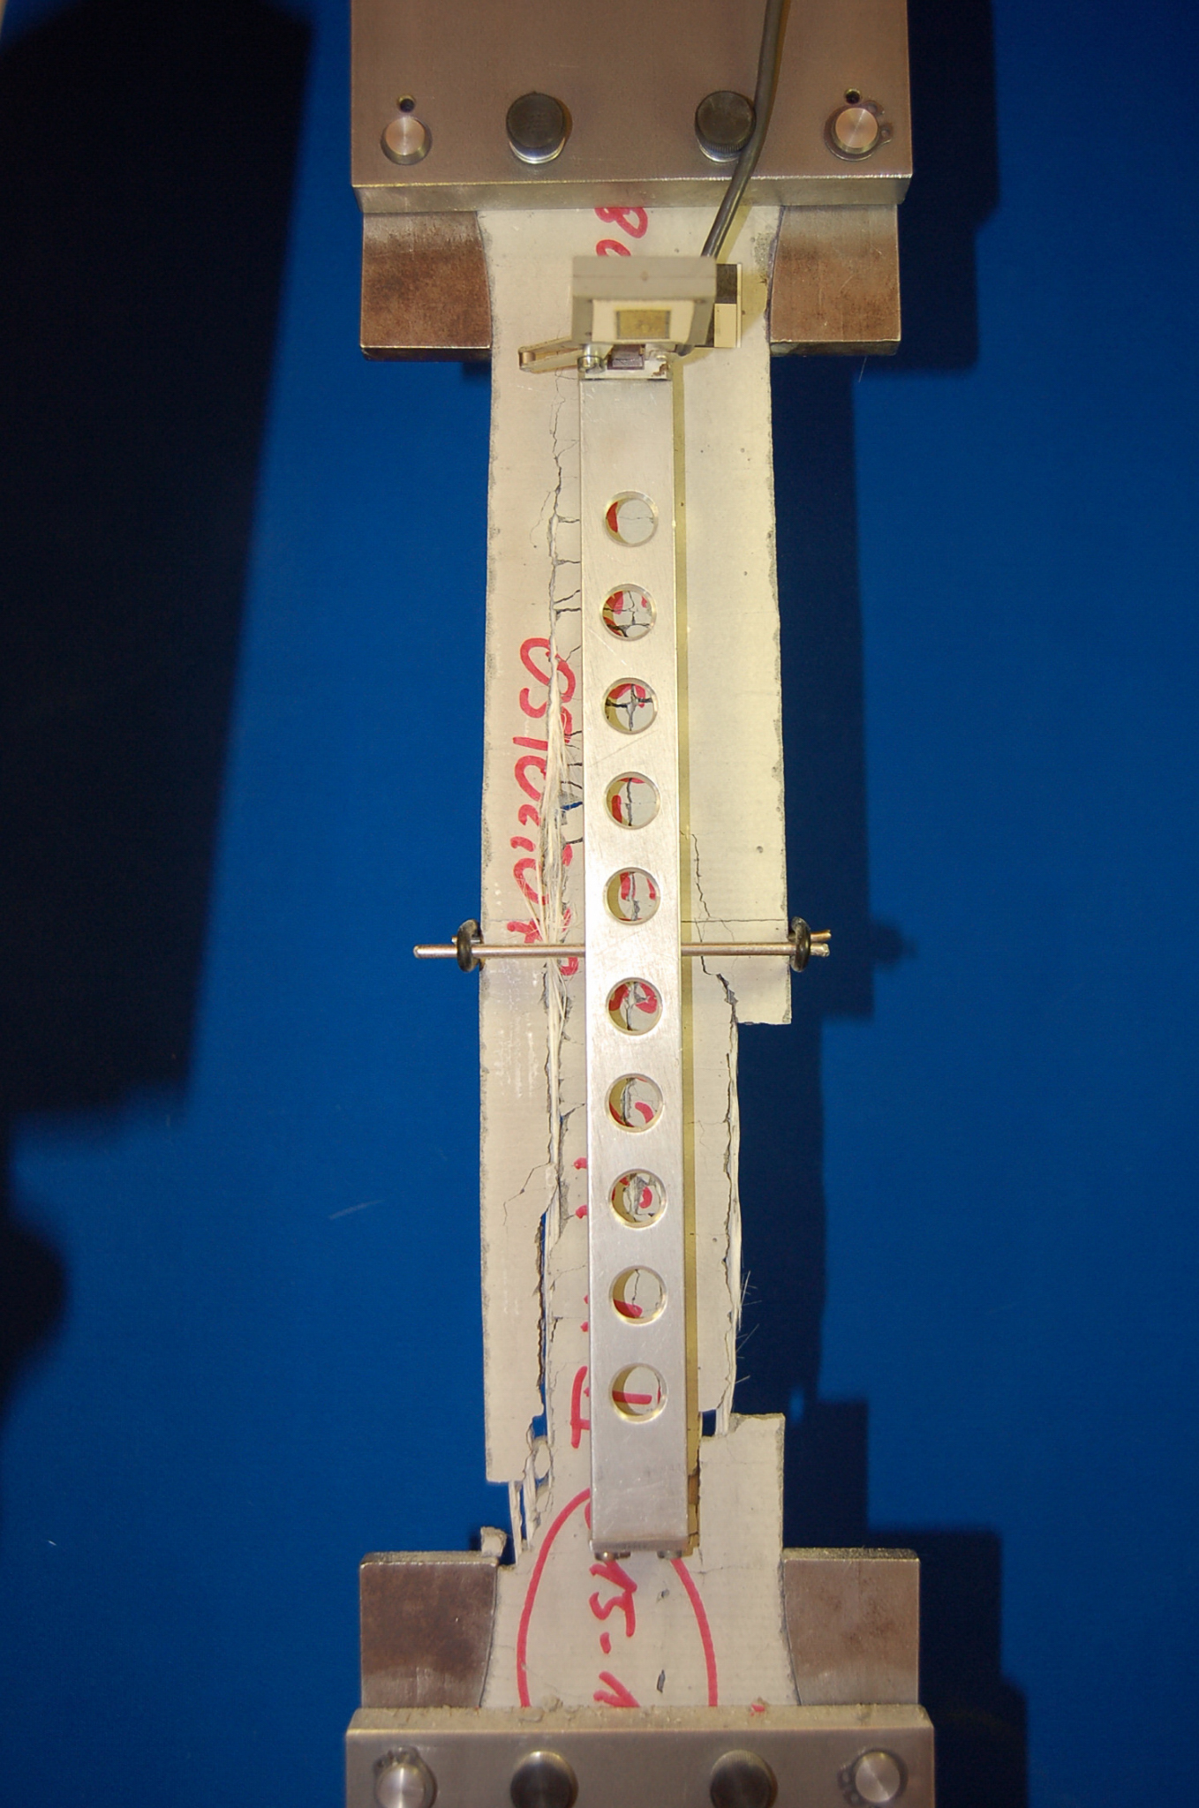
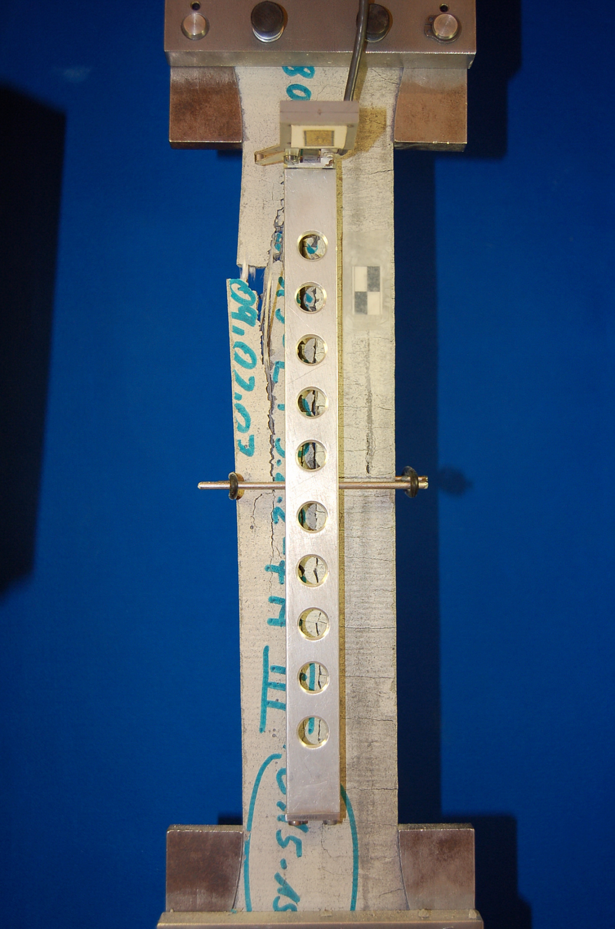
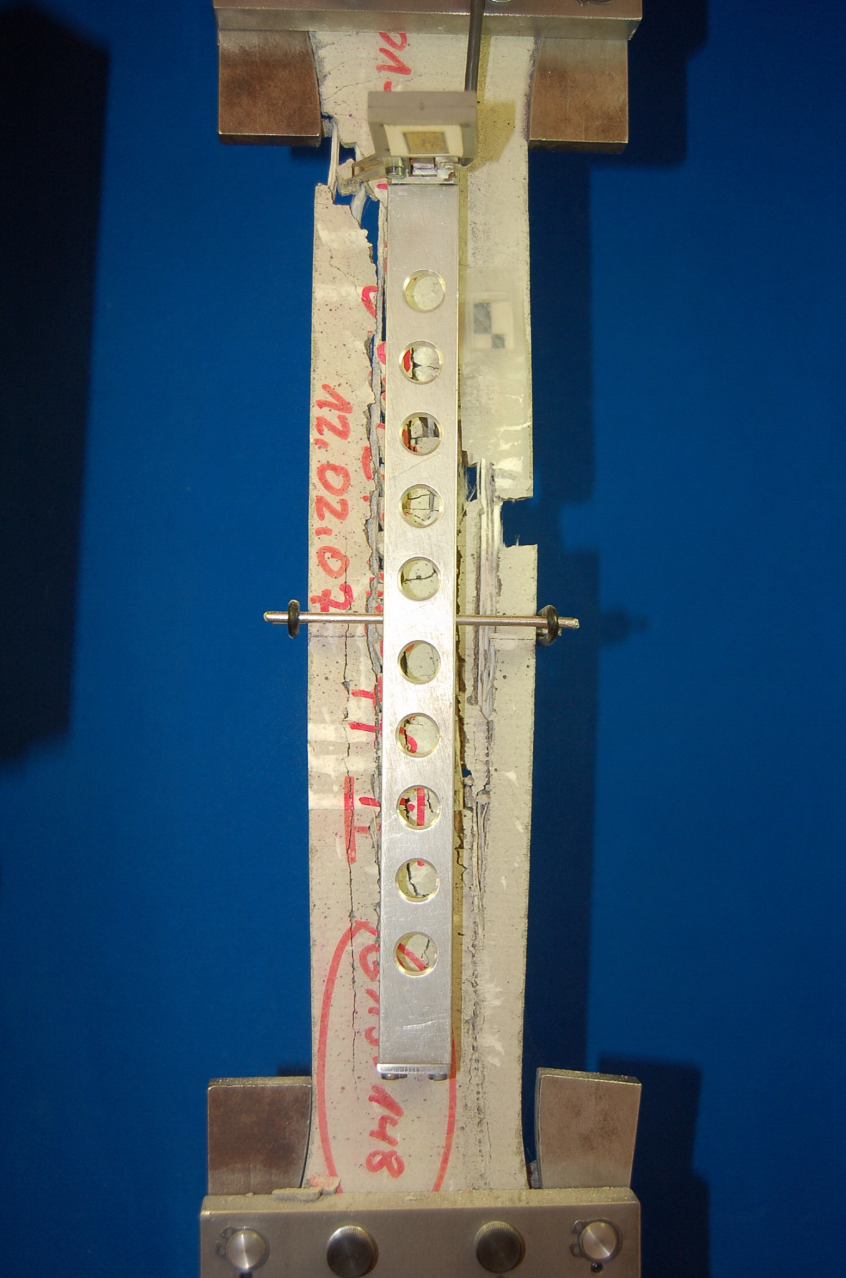

a b c
Fig.1: a: the collapse of concrete
b: the collapse of textile
c: the collapse of the bond

- What would we like to know:
  - How does the spalling mechanism come?
  - How does it behave?
  - What are the involved parameters we should think about?
  - What should we do to avoid spalling?

In order to avoid spalling, the process of which should be firstly understood, in considering the involved parameters and the geometry of the specimen, with the help of finite element modeling. The work secondly is to control the spalling and search out the further carrying capacity of the textile without spalling.

Material parameters:

Matrix:
The continuous matrix that was used to cast the TRC specimens is based on ordinary Portland cement. Ti is a fine grained concrete (also called: micro-concrete) with a small maximum aggregate grain size of 0.6 mm that allows for the complete penetration of the textile meshes.

Bond:

The high utilization of the reinforcement causes a rather quick failure under constant load which is presumed to be the influence of local flaws in the impregnated textiles caused by the load. A possibility in order to increase the durability under constant load is the improvement of the bond between the impregnated textile and the concrete. So the crack width and the corroding surface can be minimized.[7]

Filament (roving):

The roving was processed into two-dimensional textile with a lattice spacing of 8 mm in the 0° direction.

In the present study alkali resistant (AR-) glass rovings with a size produced by the OCV Company are used (VET-RO-ARG-2400-1-05). These rovings consist of approximately 1560 filaments with an average diameter of 27mm, corresponding to a linear density of 2400 tex (1tex = 1g/km).

The load bearing capacity of textile reinforced concrete is determined by the interaction of the filaments themselves (inner bond) and the interaction between filaments and concrete matrix (outer bond). Through the polymeric impregnation the inner bond between the filaments is increased significantly. The good cohesive and adhesive properties of the epoxy resin result in an improved load transmission between the filaments

Short overview:

- Chapter 1: Description about spalling.

- Bei TRC Dehnkörper-Versuch, passiert es manchmal, dass die Betonblocke abplatzen.

- Garne:
a. Die Querrisse (QR) tauchen zuerst auf.
b. Ein o. mehrere Längsrisse (LR) tauchen auf und verbinden sich die QR.
c. Die LR laufen auf die Garne
d. Die abgeplatzte Dehnkörper können den Mittelwert von Traglast erreichen.
f.

- Textil:
a. Die Abplatzung (Ap) von Textil sind viel komplizierter als die von Garne
b. Die Querbewehrungen von Textil stören die Entwicklung von LR .
c. Ein oder mehrere LR tauchen machmal an der Kante and sie führen zu gravierende Abplatzung.
d. Die Ap von beide Seite sind nicht identisch.
f. Die Ap sind meistens an den Auflager (oben oder/and unten). Wenn die Ap in der Mittel aufgetaucht ist, ist die Tragfähigkeit von

- Chapter 2: Types of the elements and discretization

The three involved components have corresponding types of the elements and different discretization.
The types of elements for the concrete and textile could be chosen among 8-point-cube, 20-point-cube and 27-point-cube. About the properties of the bond will discuss in the chapter 3.

- Chapter 3: Damage

Spalling is a damage process, which is normally not included in the library of FE program, Ansys for instance. That is one reason, why we use the simvisage, but not the program on the market.
- Damage occured → nonlinear calculation
physical nonlinearity, geometric nonlinearity, bond laws, laws of materials.

- [K] with full integration → locking → reduced Gauss Integration
1). comparing the two integrations (time, steps of integration, accuracy)
2).

- [u] local calculation → not exactly (image, but the force – displacement – kurve could be right) → nonlocal calculation (better Kcu=f)

- bond behaves always elastic. 1D / 2D ?
- Rovings will be checked under elasticity conditions and simple plasticity conditions and more...

- Chapter 4: The elements (types and numbers)of the bond (Martin)

- Chapter 5: Model and simulation with rovings

Three components could collapse, which of them are the least possible to collapse? Could we reduce three components to two?

With all the information above, a model is built and the spalling process is simulated.

Our goal is to see, how does spalling come and behave.

- Chapter 6: Summery and outlook (points of discussions)
  - If the spalling could not be avoided, how to protect the rovings from the spalling of the concrete

- Concrete Matrix
– Diskritisierung (Genauigkeit)
– Elementtyp
– Damage models

- Bond
– LRH und Ansatz auf unseren Verbundsmodel
– 1D lineare Verlaufen (Kraft-Verschiebungs Verlaufen)
– Die Spielraum von Steifigkeit stimmen (von Versuchen)
- Yarn

