Windows Live Mail  
Email solution for Singapore Polytechnic students

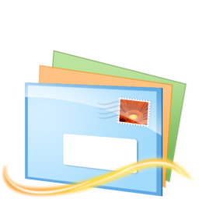

**Purpose**

Most of us students have more than one email account, each for a very different purpose. For example, an average student might have a normal account for use with Windows Live Messenger, an account for newsletters and thread updates from a few selected news / forum-based websites and perhaps one more for official emails. Upon entering Singapore Polytechnic, students are given yet another email account (the SP iChat account) for official school-related emails.

Contrary to what most students think, this iChat email account is really the most important email account for the entire three years of every student’s time here in Singapore Polytechnic. Lecturers communicate with students solely through that channel of communication, yet students mostly neglect their student email accounts. That is to say, if a student receives an email notifying him that he is eligible to sign up for a scholarship, and he misses that email and misses the deadline for follow-up replies, then he has just missed a golden opportunity.

Microsoft student partners aspire to resolve this problem and help you keep track of all your email accounts conveniently as well as offer you much more than just an email service with your iChat student account.

**Steps to set up your email accounts on Windows Live Mail**

**- Downloading and installing Windows Live Mail**

1. Download Windows Live Mail from <http://get.live.com>.
2. Click on “Download”.

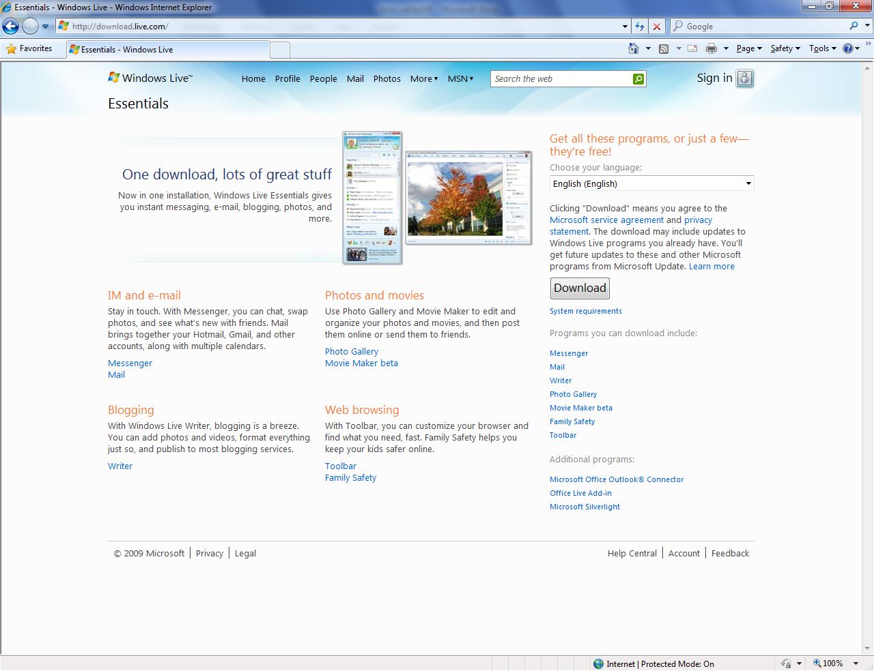

1. Save the installer to a location that you can remember.
2. After the download is complete, double click on the downloaded installer. You might be prompted for permission to install Windows Live Essentials:  
     
   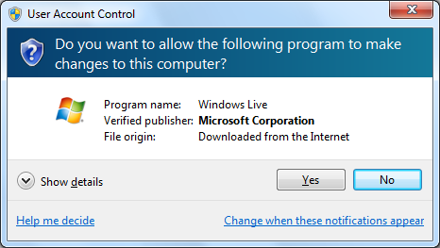
3. Select “Yes” and you should be brought to the installation start point in a few moments:  
     
   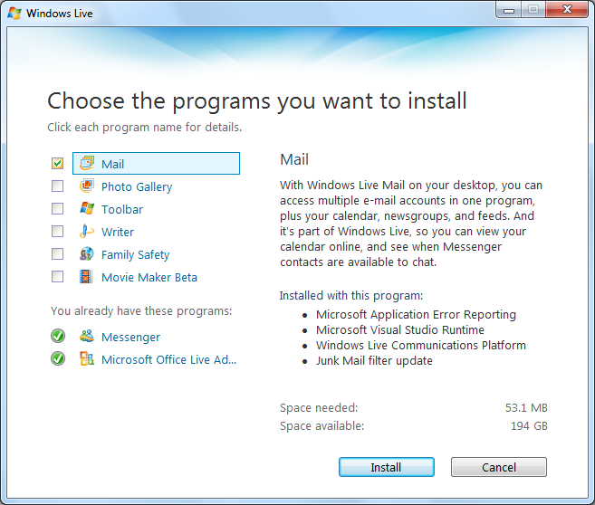
4. Make sure “Mail” is checked. Feel free to install any of the other Windows Live service software bundled in the entire Windows Live Essentials suite.   
     
   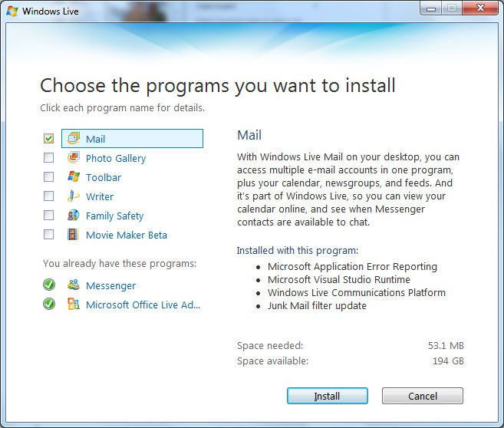
5. Click Install.  
     
   
6. Sit back and relax while Windows Live Essentials installer downloads and installs Windows Live Mail.  
     
   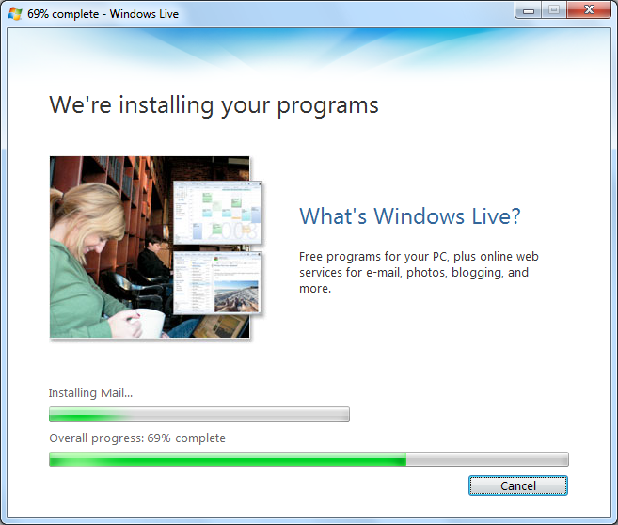
7. After the installation is complete, click “Continue”:  
     
   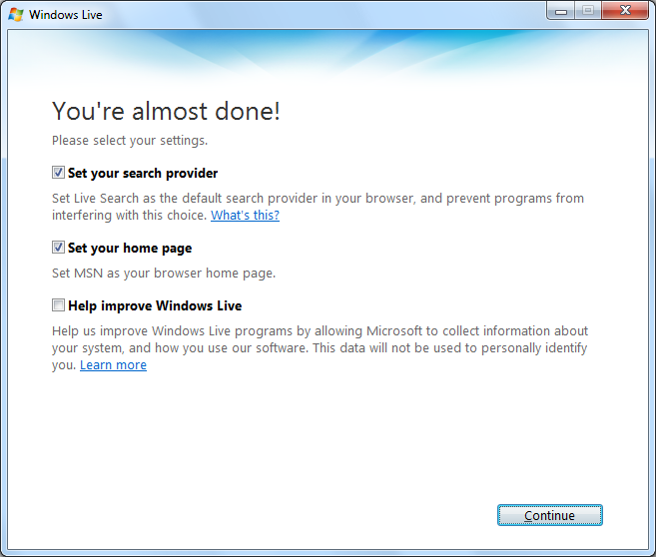
8. After which, click “Close”:  
     
   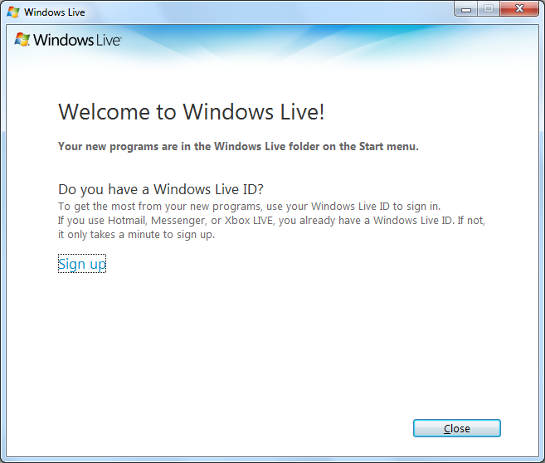

**Setting Up of iChat Student Email Account**

1. Launch “Windows Live Mail” from the Start Menu and you should be prompted to Add an Email Account.  
     
   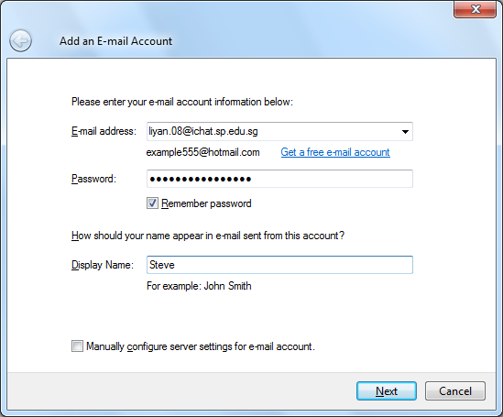
2. Fill in your iChat email address into the “E-mail address” field.
3. Fill in your iChat email password into the “Password” field
4. Fill in the “Display Name” by which you would like to use to identify your student email account.
5. Hit the “Next” button, and you should be brought to a configuration page:  
     
   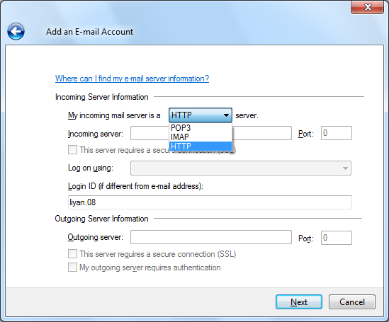
6. Click on “POP3” in the dropdown box as shown in the above screenshot and select HTTP.
7. Hit “Next”.
8. Select “Finish”.
9. Please wait while Windows Live Mail downloads your emails and configures your account.
10. Congratulations! You should have received all your emails from your iChat Student email account.  
      
    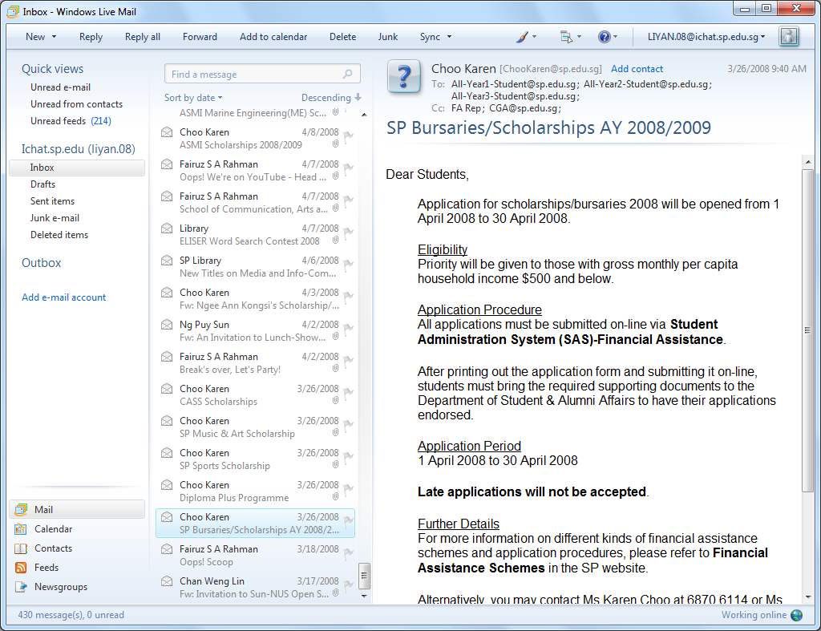

**Setting up of an ordinary Live / MSN / Hotmail account**

1. Launch “Windows Live Mail” from the Start Menu.
2. After Windows Live Mail fires up, click on “Add e-mail account” located on the left pane.  
     
   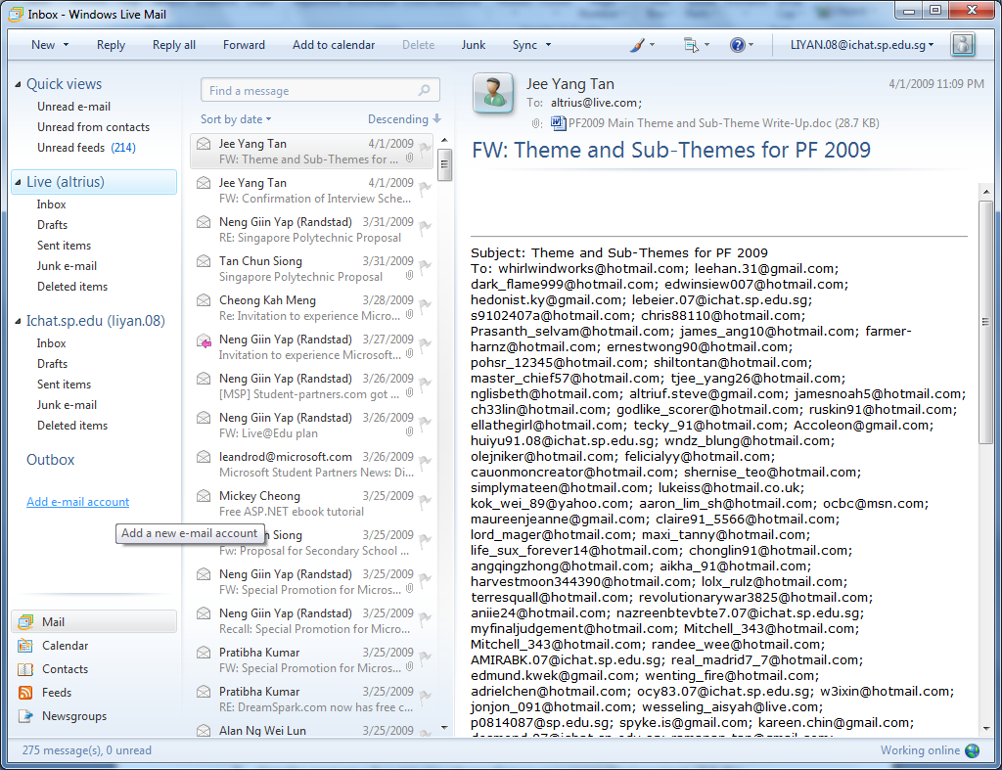
3. Fill in your personal email address into the “E-mail address” field.
4. Fill in your personal email password into the “Password” field.
5. Fill in the “Display Name” by which you would like to use to identify your personal Windows Live based email account.
6. Hit “Next”.
7. You should be told that “You have successfully entered the information required to set up your account.”  
     
   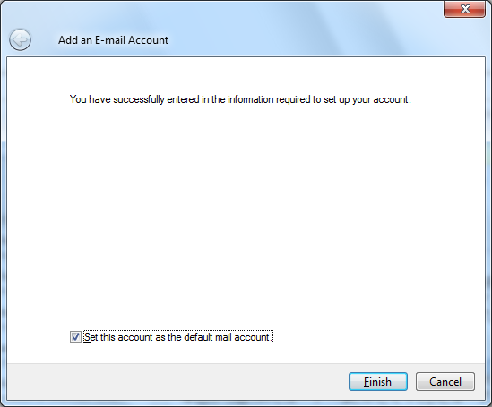
8. You can choose to set that account as your primary account by selecting “Set this account as the default Mail account”.
9. Hit “Finish”.
10. Give the program a few minutes (depending on your connection) or simply click the “Download” button for Windows Live Mail to download your emails from your Windows Live based email account.  
      
    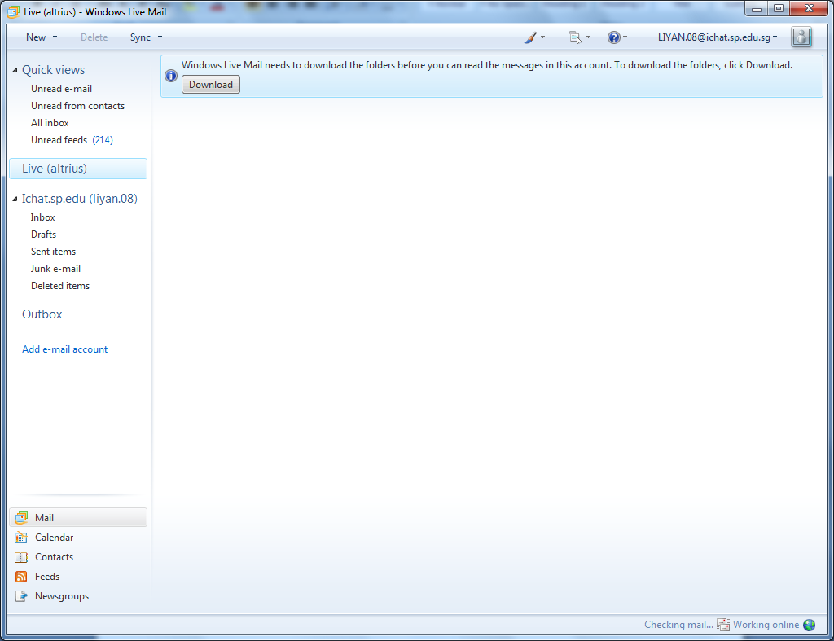
11. Congratulations! You’ve set up your personal email account on Windows Live Mail.

**Setting up of a Gmail account**

1. Navigate to <http://gmail.com>.
2. Login to your Gmail account.
3. Click “Settings” which is located on the top right hand corner of the page.  
     
   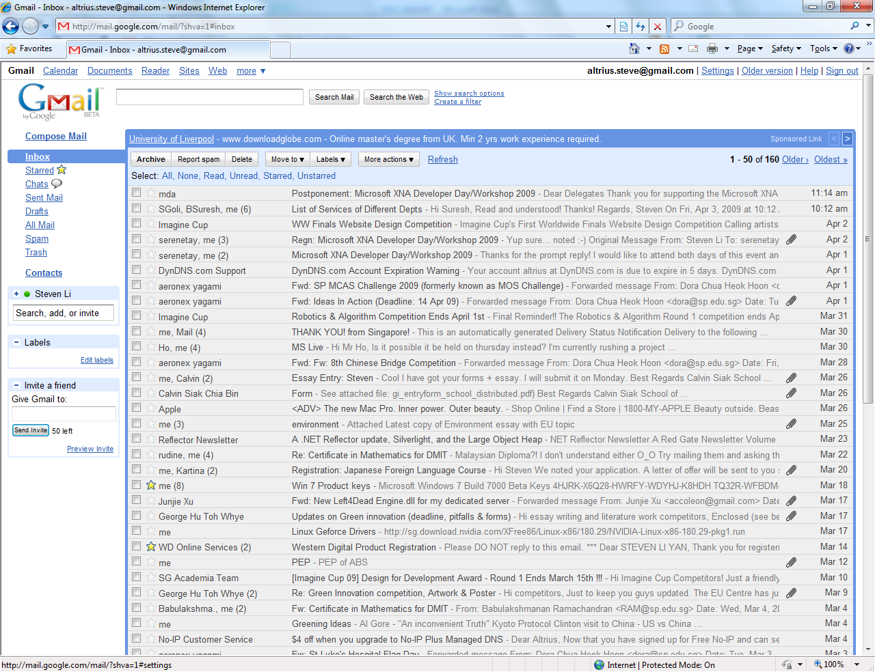
4. Click on the “Forwarding and POP/IMAP” tab.  
     
   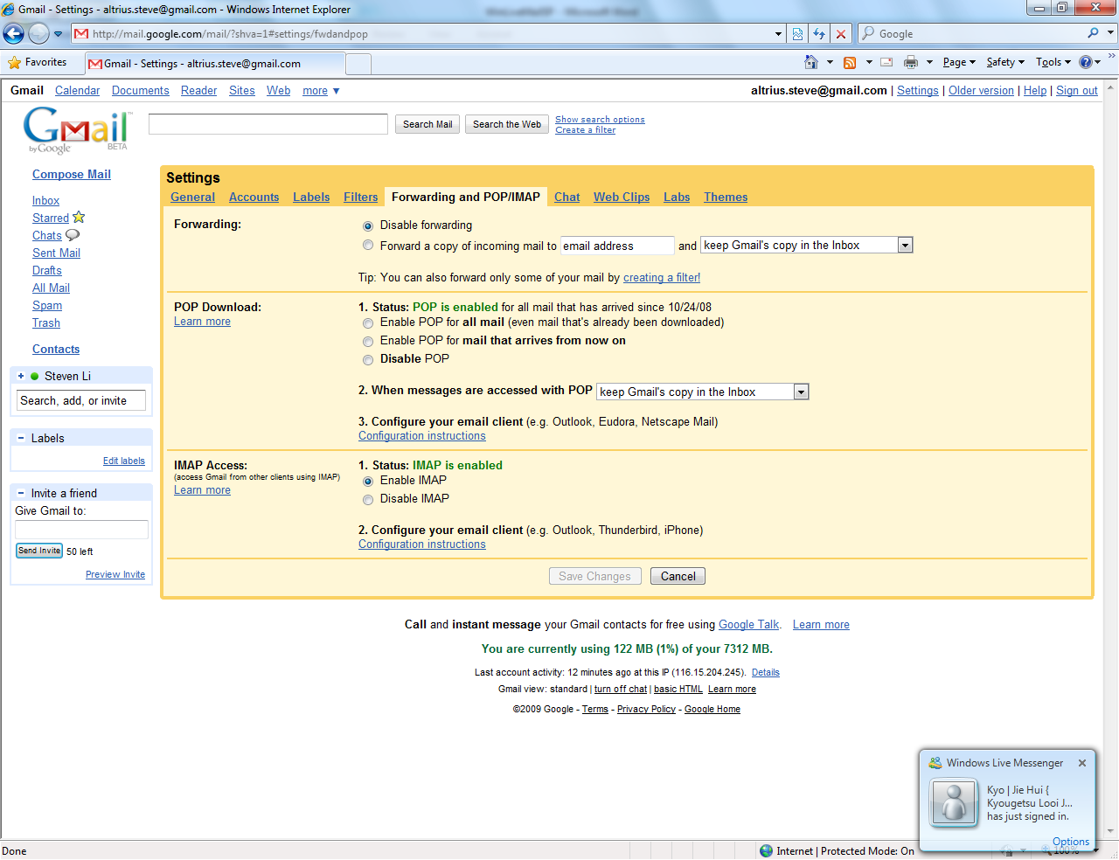
5. Check the radio button that says “Enable POP for all mail (even mail that's already been downloaded)”.  
     
   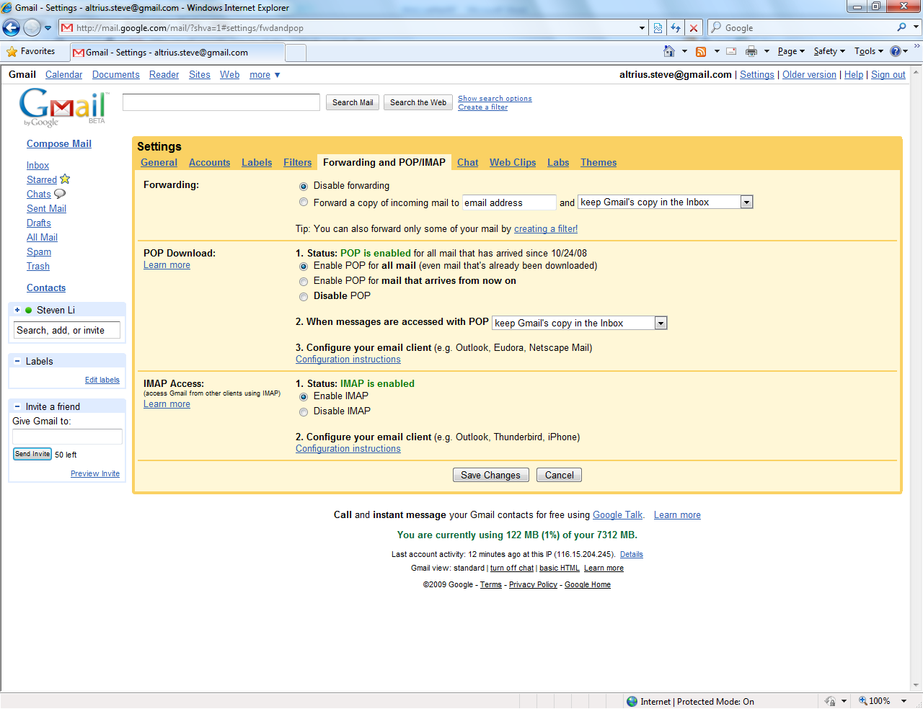
6. Check the radio button that says “Enable IMAP”.
7. Click on “Save Changes”.
8. Launch “Windows Live Mail” from the Start Menu.
9. After Windows Live Mail fires up, click on “Add e-mail account” located on the left pane.  
     
   
10. The “Add an E-mail Account” window pops up.  
      
    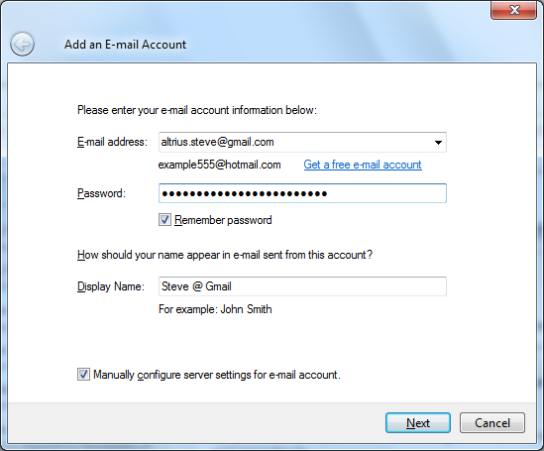
11. Fill in your Gmail email address into the “E-mail address” field.
12. Fill in your Gmail email password into the “Password” field.
13. Fill in the “Display Name” by which you would like to use to identify your Gmail account.
14. Check the option to “Manually configure server settings for e-mail account”.
15. Hit “Next”.
16. You will then be presented with the configuration window.  
      
    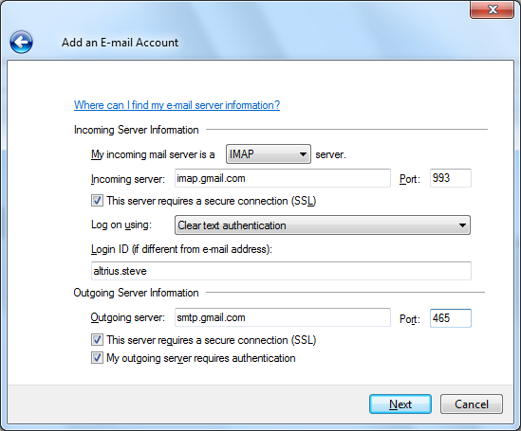
17. Select “IMAP” from the drop down box under “My incoming mail server is a ______ server.”
18. Fill in “imap.gmail.com” for “Incoming server” without the quotation marks.
19. Fill in “993” for “Port” under “Incoming Server” without the quotation marks.
20. Check the selection “This server requires a secure connection (SSL).
21. Leave “Clear text authentication” under “Log on using” as it is.
22. Check to confirm that your “Login ID” is correct.
23. Fill in “smtp.gmail.com” for “Outgoing Server” without the quotation marks.
24. Fill in “465” for “Port” under “Outgoing Server” without the quotation marks.
25. Check the selection that says “This server requires a secure connection (SSL).
26. Check the selection that says “My outgoing server requires authentication”.
27. Hit “Next”.
28. You should be told that “You have successfully entered the information required to set up your account.”  
      
    
29. You can choose to set that account as your primary account by selecting “Set this account as the default Mail account”.
30. Hit “Finish”.
31. Give the program a few minutes (depending on your connection) for Windows Live Mail to download your emails from your Gmail account.  
      
    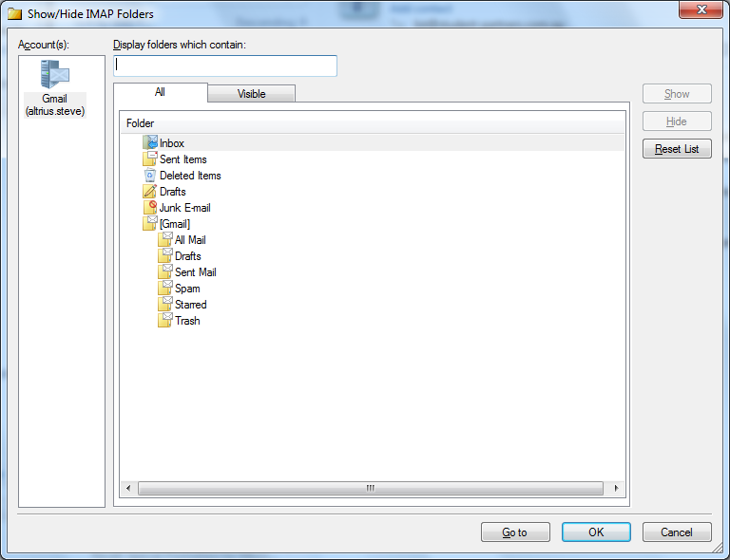
32. Hit “OK”.
33. Give Windows Live Mail a minute as it retrieves all your emails from the Gmail server.
34. Congratulations! You have successfully set up your Gmail account on Windows Live Mail.

**Notes**

In the event that you need technical help, feel free to email [steve@student-partners.com](mailto:steve@student-partners.com).