A Nearly Painless Guide to Computing Theil’s T Statistic

Theil’s T statistic is a flexible, mathematically elegant, and underutilized tool for measuring inequality. The example below shows how anyone with a spreadsheet, some data, and a little intellectual curiosity can develop their own inequality estimates.

Indulge us a leading question: Is income inequality increasing or decreasing in the United States?

To answer this question, it is essential to define some terms. First, what is inequality? There are dozens of statistics that can be thought of as measures of inequality, including variation, inter-quartile range, the Gini Coefficient, and many others. Theil’s T statistic is a particularly flexible and useful measure, so it will be used in the present analysis. Another question is: inequality among whom? This may seem to be a simple question, but it is actually rather nuanced. Are we interested in comparing all American citizens, cities, counties, states or regions? Or are we interested in comparing women to men, various ethnic groups to one another, or small families to large ones? Are we interested in comparing job or industrial categories? It is quite possible that inequality could be increasing between ethnic groups but decreasing according to gender or decreasing within industries but increasing between industries. Arbitrarily, let us decide to limit ourselves to inequality between the 50 States. Another question is what time scale to use. For argument’s sake, say we are interested in the period 1970 – 2000 and start with data in ten-year intervals. Once again, these are somewhat arbitrary choices. In practice, all of the above questions will be asked and answered with a research question in mind and foreknowledge of data quality and availability.

Thus, from a general question, “Is income inequality increasing or decreasing in the United States,” we have moved to a much more specific question, “How has Theil’s T statistic relating to average income across states in the United States changed in the ten year intervals between 1970 and 2000?”

The data needs for the more specific question are rather humble. We need to know the population of the states and either their average or total incomes in 1970, 1980, 1990, and 2000. This data is widely available, one source being the Bureau of Labor Statistics.

Table 1 shows the data requirements for 1970
Table 1. Input data for Theil’s T statistic of Inequality between US states in 1970

 | Total Personal income (thousands of dollars) | Population | Average Income
Alabama | $ 10,276,100 | 3,449,846 | $ 2,979
Alaska | $ 1,595,494 | 304,328 | $ 5,243
Arizona | $ 6,897,021 | 1,794,912 | $ 3,843
… | … | … | …
West Virginia | $ 5,444,159 | 1,746,629 | $ 3,117
Wisconsin | $ 17,628,518 | 4,425,944 | $ 3,983
Wyoming | $ 1,308,284 | 333,795 | $ 3,919
United States | $ 834,455,000 | 203,798,722 | $ 4,095

To compute Theil’s T statistic, we simply multiply a state’s population share (the state’s population / the total United States population), the quotient of a state’s average income and the national average income (average income in the state / average income in the United States), and the natural logarithm of the quotient of a state’s average income and the national average income; and then add these products for each year.

The run-on sentence above makes this task seem harder than it is. Take Alabama in 1970:

- The population share is Alabama’s population (3,449,846) divided by the total US population (203,798,722) = .0169. In other words, Alabama contained about 1.7% of the nationwide population in 1970.
- The quotient of a state’s average income and the national average income is the average income in Alabama ($2,979) divided by the nationwide average ($4,095) = 0.72749. Note that any figure greater than one means that a state was above average and any figure less that one means that a state was below average. In other words, Alabama’s average income was 72.7% or a little less than three quarters of the nationwide average income in 1970.
- The natural logarithm of the quotient of a state’s average income and the national average income is just the natural logarithm of the quotient above; ln (.72749) = log_{e} (.72749) = -0.318154749.
- The contribution of Alabama to the between state inequality measure of Theil’s T statistic in 1970 is simply .0169 * 0.72749 * -0.318154749 = -0.003917994

Using a spreadsheet or other computer software makes the calculations above rather painless, even for thousands of data points.
Table 2. Sample Calculations for Alabama’s Theil Element

Alabama 1970
Population Share | State Average Income / National Average Income | ln (State Average Income / National Average Income) | Theil Element
= 3,449,846 / 203,798,722 | = $2,979 / $4,095 | = ln ($2,979 / $4,095) | =3,449,846 / 203,798,722 *  $2,979 / $4,095 *  ln ($2,979 / $4,095)
0.01692771 | 0.727472527 | -0.318179044 | -0.003918198

Once we repeat this process for each state, we add the contributions to get a total. For 1970, the total Theil Statistic for the United States is 0.01127622. What does this figure tell us about inequality? By itself, not much. However, when we compare the Theil statistics over a series of years, we can get a clear idea of how inequality is changing. Considering 1970 as our base case, Theil’s T dropped to 0.007792409 in 1980, rose to 0.009836321 in 1990, and ended 2000 at 0.009266989. Filling in all the data for the years 1970 to 2000 allows us to graph inequality changes over this period.

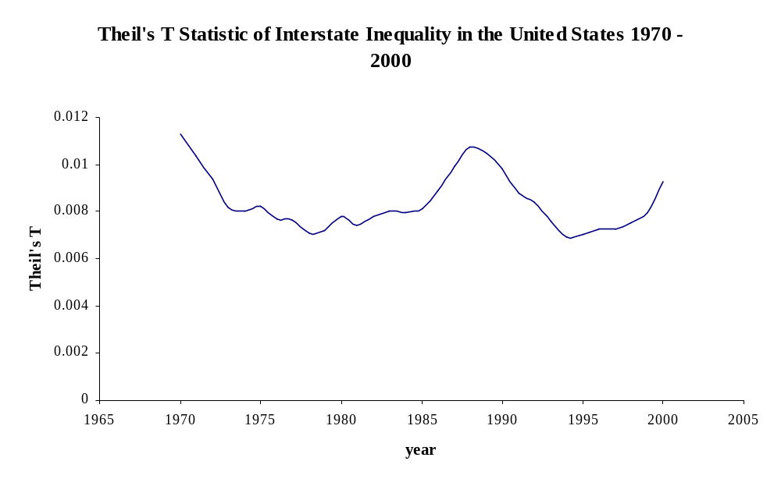Now we can make some limited claims about underlying inequality between states in this time period. Through the early 1970’s between state income inequality declined before stabilizing from 1975 to 1985. The late 1980’s saw a sharp rise in inequality followed by a sharp decline in the early 1990’s. By the late 1990’s inequality was on the rise again. A narrative explanation of the graph above is that the early ‘70’s saw equality gains from the War on Poverty programs and the oil boom in low-income states such as Texas, Oklahoma, and Louisiana. When the oil bubble burst in the mid 1980’s inequality rose sharply before subsiding with the First Gulf War economy. By the 1990’s, the high technology sector was growing in rich states such as California and New York, furthering between state inequality.

The limit of these claims is that we are only considering between-state inequality. Similar or even opposite trends may be occurring at the county, city, or person level, but we cannot speak to this with the current example. Nonetheless, we have some interesting data that serves as a starting point for a more comprehensive study of income inequality.

A note about Theil elements: All things held equal, a larger state (or whatever the unit of analysis is) will have a larger Theil element because larger states have larger population shares. A state with income (or whatever the phenomenon of interest) less than the national (or cross-unit) average will have a quotient less than one. Because the natural logarithm of any value greater than 0 and less than 1 is 0, any state with income that is smaller than the nationwide average will have a negative Theil element, as we see in the case of Alabama. Conversely, a state with income greater than the national average will have a positive Theil element. States with very small population and/or average incomes that are close to the national average will have small Theil element.

Some reminders on computational procedures: To compute Theil’s T statistic you need data on population shares and a measure of interest. If individual data is available, the population share for each individual is 1/N where N = population size. If group data is available, the group data must be sorted in exhaustive, mutually exclusive groups (population members must be in 1 and only 1 group). A single Theil statistic is usually difficult to interpret, so whenever possible it is advisable to have data over a number of time periods. When you have completed your calculations, check to make sure that some contributions are positive and some are negative, and that the total is positive (or zero in the case of perfect equality). Theil’s T statistic is very sensitive to the number of groups, so it is very difficult to compare measures across cross-sectional units. In other words, do not try to directly compare inequality as measured by Theil’s T statistic across the 50 United States to inequality across the 10 Provinces of Canada. Do not limit yourself in your inquiries. You can measure the inequality of many social and economic variables. Examples include the square footage of housing units, numbers of doctors visits, years of education, and crop yields; be creative.

This short document barely scratches the surface of the use of Theil’s T statistic for computing inequality measures. If the example above has piqued your interest in the underlying computations, you may wish return to The Theoretical Basics of Popular Inequality Measures. If you wish to see a step-by-step For more technical details and examples of Theil statistics in practice, please see the work of The University of Texas Inequality Project at http://utip.gov.utexas.edu.

Given the population and the average income, we could compute the total income by multiplication. Given the population and the total income, we could compute average income by division.

