IST 302 G5 Database Project

Eman Alzahrani, Daniel Perez, Shengyu Zhang, Aote Xin

Executive Summary

The IST 302 Database Project aims to develop a sales transaction application with a focus on database design and enhancement procedures. The project is organized into several sections, each addressing specific aspects of the database development process.

All the scripts are shared on a github repository (<https://github.com/axin-geo/IST302DBG5FINAL)>

# 

# **Table of Contents**

Table of Contents 2

Section 1: Business Understanding 3

Overview of sales transaction applications 3

List of users for the sales transaction system 3

Users and their business queries, including its description, the required database table access, and access condition 3

Section 2: Data Understanding 5

Description of all data understanding tasks performed and their outputs 5

Section 3: Conceptual Design (Shengyu) 12

Present the conceptual model (ERD) of the database system, including the justifications 12

Section 4: Security Requirements (Shengyu) 13

Present initial access permission interaction matrix (select, update, insert, delete) 13

List the business views that will be implemented as stored procedures 13

Section 5: Logical Design 15

Present the logic mode (database diagram) of the database system. 15

Specify constraints of the database system 15

Section 6: Physical Design (Daniel) 18

Present the physical data model, including DDL script to create tables with constraints 18

Scripts to create, set constraints and fix data from the tables: 18

Section 7: Database Implementation (AX) 21

DML scripts to populate tables 21

Test integrity constraints 23

Design and implement data access structure for the database system, including indexes, views, and stored procedures 24

Section 8: Conclusion 29

# 

# 

# Section 1: Business Understanding

## Overview of sales transaction applications

A sale is an exchange of a product (or service) between two or more parties in exchange of money or some other compensation. It takes place almost every day in human-life. Whenever there is a sale, there are at least two parties involved; a seller who is typically an owner of the product or who has legal possession and a buyer who is seeking the product.

A transaction is defined as a piece of business, such as the act of buying or selling something. An application for sale transactions is the system that allows a customer to process sales transactions, usually in exchange of cash or an account receivable.

Some examples for such applications could be the software used in the supermarkets where the sales transactions get registered in the company’s database to be processed and accessed by diverse users. Another example we can think of is the software company that sells products online and they have a platform where they process all the sales transactions for their software, this software is used by multiple teams in the company.

## List of users for the sales transaction system

There are many users we identified that could be using the sales transaction system, among those we will find the developers, managers, accountants, etc. For purposes of this project we are going to focus on 2 groups of users, the sales department and the marketing department.

Sales users need a transactional database system to maintain sales history, keep track of customer information, shipping, budgets and product information among others.

Marketing users apply the transaction database system to create marketing and promotion strategies, keep track of product sales and customer behaviors, or to check certain sales channels for example.

## Users and their business queries, including its description, the required database table access, and access condition

**Business Query 1:** Select any channel from the G5_CHANNELS that was NOT used by any sale transaction made.) This query provides information on channels not being used, opening possibilities to explore potential issues with sales channels or sales strategies. It could be useful information for the sales and marketing departments.

This query relies on access to the sales table and provides reading only privileges since it is not necessary to update or delete transactions.

**Business Query 2:** Search sales transactions history for a given date. This query can be made by sales and marketing departments using the business view 2 (transactions for 2012) in which we join products and sales tables conditioned to transactions happening over 2012.

**Business Query 3:** This query provides information about Internet sales promotion history. Providing the transactions made over the internet channel over a certain period of time. This query accesses the Business view 3, where we query sales, channels and promotions tables and filter out sales made over the internet within a determined period of time in 2012.

This particular query will be used for the marketing department, and will be a read only query because for analysis we don’t need to modify any data in the tables.

**Business Query 4:** 2012 Internet Sales Promotion History in Asia: This query is for promotions on sales that happened during 2012 via the internet channel in the continent of Asia. It will be used by the marketing department to analyze how the sales went in the Asian market during 2012. They should have read only permissions because it is not needed to modify the data in the tables using the Business view 4.

**Business Query 5:** Customer demography. This query provides information on the gender and their total price over internet purchases during 2021.

This query is made by the marketing department and read only access is necessary over the business view 5.

**Business Query 6:** calculate the total sales made in a continent in 2012 via the internet. This query is used by the marketing and sales department to verify the total sales categorized by continents. The sales and marketing department should have read only access to the table channels, customers, sales and country to do this query.

**Business Query 7:** Select the product that has the highest sale in 2012 in a continent via a certain channel. This query is used by the marketing and sales department to verify the product with highest sales categorized by continents. The sales and marketing department should have read only access to the table channels, customers, sales and country to do this query.

While in general the queries mentioned don't need modify or delete privileges the sales department and marketing should have those privileges on the products table. Marketing should have those on the promotions and customers table as well, and the sales should have those on the channels and countries table.

# Section 2: Data Understanding

## Description of all data understanding tasks performed and their outputs

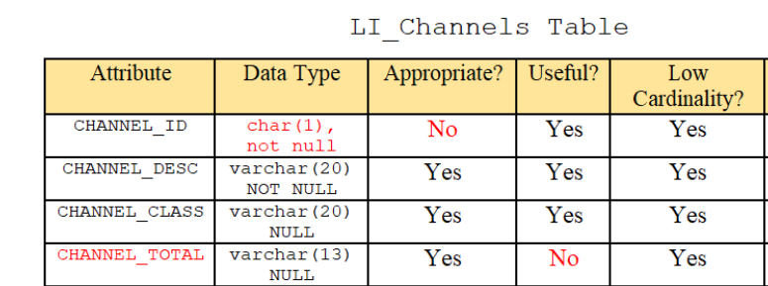

⦁ We deemed the data type for CHANNEL_ID as inappropriate due the fact that the char(n) data type stores character data. With CHANNEL_ID being a primary key, the INT data type is the most appropriate.

⦁ CHANNEL_TOTAL is a useless column, as its values repeat and do not hold significant information for the users.

⦁ Each attribute has low cardinality, due to the limited number of values populated in it.

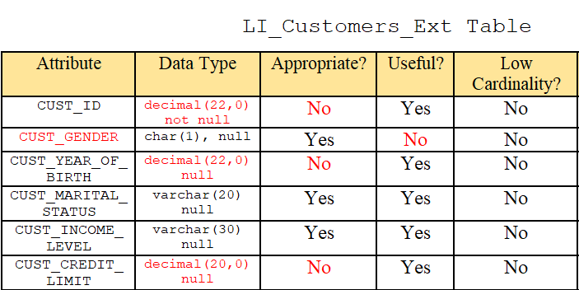

⦁ We deemed the data type for CUST_ID as inappropriate due to the fact that the decimal(p,s) data type is more suited towards values with decimals rather than integers. We replaced this with INT, as most primary keys have this data type, as well.

⦁ We found CUST_GENDER to be a useless column, as there is already a column that indicates customer gender on the LI_CUSTOMERS_INTX table.

⦁ The decimal(p,s) data types for both CUST_YEAR_OF_BIRTH and CUST_CREDIT_LIMIT are deemed inappropriate since both attributes contain values that are integers and not real numbers.

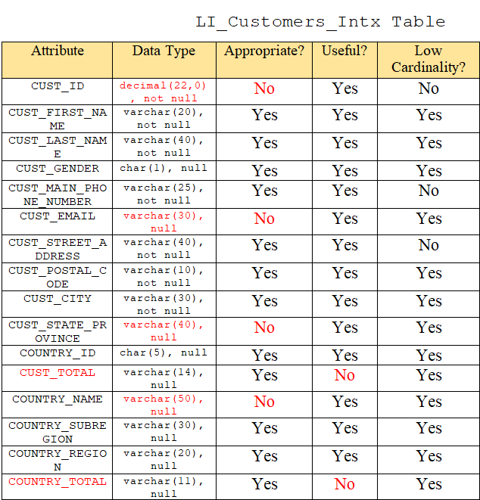

⦁ The data type for CUST_ID is deemed inappropriate since the values of the attribute contain integers instead of real numbers.

⦁ For CUST_EMAIL’s data type, although varchar(n) was the appropriate data type, we decided to decrease the n value to 50 rather than 30.

⦁ Regarding CUST_STATE_PROVINCE’s data type, we did deem varchar(40) as appropriate; however, instead of NULL, we replaced it with NOT NULL. Because the customer’s state is necessary in order for the post office to mail the products to the customer successfully.

⦁ We deemed the CUST_TOTAL attribute as useless due to the fact that the data repeats and holds no significant value to the users.

⦁ With COUNTRY_NAME’s data type, we did find that varchar(50) was appropriate; however, having the country data is necessary in order to properly mail products to the customers. Therefore, rather than NULL, we changed it to NOT NULL.

⦁ We deemed COUNTRY_TOTAL as an useless column since all the values repeat and hold no significant value to the user.

LI_Products Table

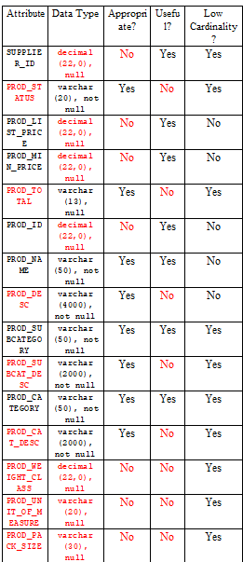

⦁ Regarding the decimal(p,s) datatype of the SUPPLIER_ID and PROD_ID attributes, such is deemed as inappropriate since the values of both attributes are integers and not real numbers. PROD_ID serves as the primary key of this table.

⦁ The attributes PROD_STATUS, PROD_TOTAL, PROD_WEIGHT_CLASS, PROD_UNIT_OF_MEASURE, and PROD_PACK_SIZE are deemed as useless since all the columns repeat and hold no value to the user in terms of decision-making.

⦁ The varchar(n) data type for PROD_UNIT_OF_MEASURE and PROD_PACK_SIZE are deemed inappropriate since all the values contain one character only, so CHAR(1) would have been more appropriate.

⦁ We deemed PROD_DESC, PROD_SUBCAT_DESC and PROD_CAT_DESC as useless because there are other attributes that hold the exact values as all these particular columns, which causes a sense of redundancy.

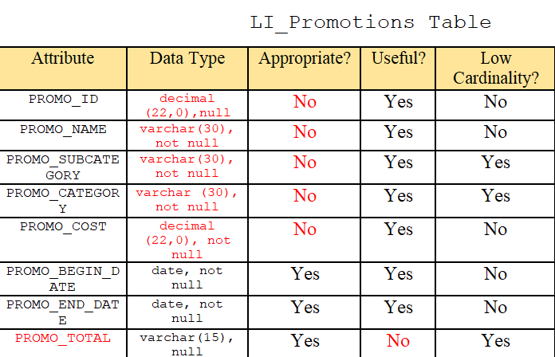

⦁ The PROMO_ID data type is inappropriate since this attribute serves as a primary key, and INTs are more suitable data types for primary keys. In addition, the data in PROMO_ID contains integers and not real numbers.

⦁ We deemed the decimal(22,0) data type for PROMO_COST to be inappropriate.

⦁ The PROMO_TOTAL attribute is considered useless, as the data does not hold valuable insight to the users and has repeating values per each column.

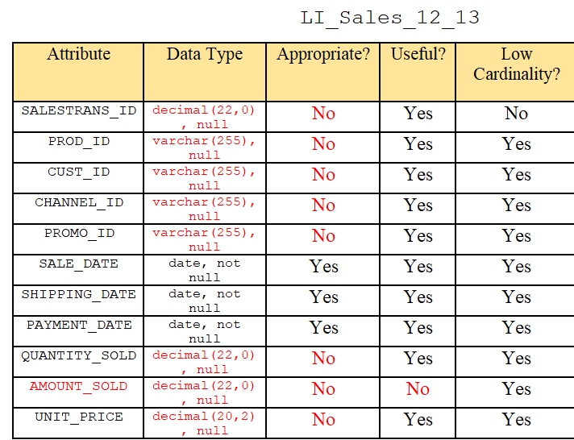

⦁ The SALESTRANS_ID data type is inappropriate since this attribute serves as a primary key, and INTs are more suitable data types for primary keys. In addition, the data in SALESTRANS_ID contain integers and not real numbers.

⦁ The varchar(255) data type is inappropriate for PROD_ID, CUST_ID, CHANNEL_ID, and PROMO_ID since all of these columns serve as primary keys for other tables and have numeric values of integers. The appropriate data type would be INT.

⦁ The decimal(p,s) data type for QUANTITY_SOLD and AMOUNT_SOLD is inappropriate since the values of both attributes are integers and not real numbers.

⦁ The AMOUNT_SOLD attribute is useless, since these values are identical to the values in the UNIT_PRICE column.

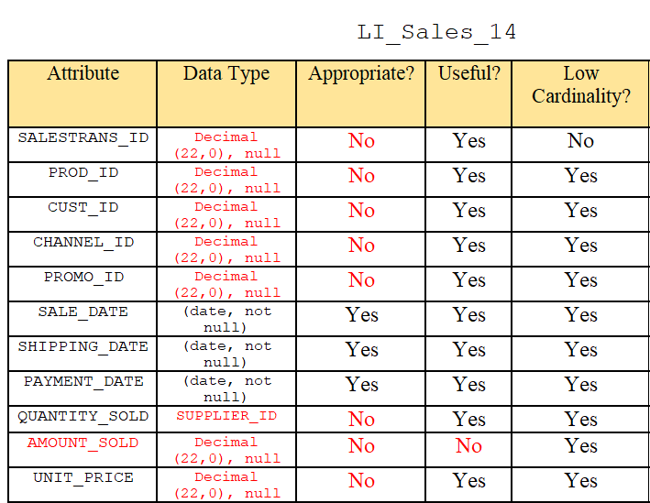

⦁ The SALESTRANS_ID data type is inappropriate since this attribute serves as a primary key, and INTs are more suitable data types for primary keys. In addition, the data in SALESTRANS_ID contain integers and not real numbers.

⦁ The varchar(255) data type is inappropriate for PROD_ID, CUST_ID, CHANNEL_ID, and PROMO_ID since all of these columns serve as primary keys for other tables and have numeric values of integers. The appropriate data type would be INT.

⦁ The decimal(p,s) data type for QUANTITY_SOLD and AMOUNT_SOLD is inappropriate since the values of both attributes are integers and not real numbers.

⦁ The AMOUNT_SOLD attribute is useless, since these values are identical to the values in the UNIT_PRICE column.

# Section 3: Conceptual Design

## Present the conceptual model (ERD) of the database system, including the justifications

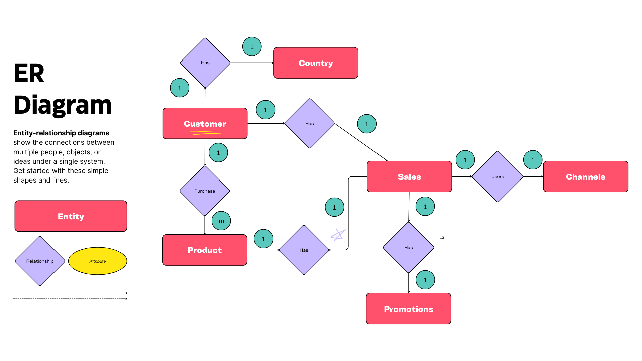

This is an Entity-Relationship (ER) diagram that illustrates the relationships between different entities in a database system.

Here's a description of the components and their connections:

Entities: There are five rectangular entities labeled 'Customer', 'Country', 'Sales', 'Channels', and 'Promotions'.

Relationships: The entities are connected by diamonds indicating relationships. These are labeled 'Has' for the connections between 'Country' and 'Customer', 'Customer' and 'Sales', 'Sales' and 'Channels', and 'Sales' and 'Promotions'.

Attributes: The oval shapes represent the attributes of entities or relationships. In this diagram, the 'Customer' entity has an attribute labeled 'Purchase'.

Cardinality: The connections have cardinality indicators such as '1' or 'm', signifying one-to-one or one-to-many relationships. For example, a '1' near 'Country' and a 'm' near 'Customer' implies that one country can have many customers, but each customer is associated with only one country.

Legend: At the bottom left, there is a legend explaining that rectangles represent entities, diamonds represent relationships, ovals represent attributes, and the lines connecting these shapes illustrate the links between them.

# Section 4: Security Requirements

## Present initial access permission interaction matrix *(select, update, insert, delete)*

|  |  |  |  |  |
| --- | --- | --- | --- | --- |
| ***BUSINESS VIEWs*** | | | | |
| ***USERs*** | BV02 | BV03 | BV04 | BV05 |
| Sales (sale) | S |  | ISUD | ISUD |
| Marketing (mark) |  | ISUD | IS | ISUD |

I: Insert

S: Select

U: Update

D: Delete

## List the business views that will be implemented as stored procedures

The business views that will be implemented as stored procedures are:

**BV02:** Sales Transaction History (Join Products table and Sales table). This table focuses on querying for the sales transactions that happened during a particular date/dates. Sales Product Performance evaluation.

**BV03:** Sales Promotion History: (Join Sales table and Promotions table). This table focus on query for sales promotions that happened during a particular date/dates.

**BV04:** Sales Channel (Join Channel and Sales Table). To know via which channel we have the highest sale for each product.

**BV05**: Customer Demography (Join external and internal customers table together). Answer questions including 1. from which age group of our customers have the highest sale 2. from which gender group of our customers have the highest sale.

# Section 5: Logical Design

## Present the logic mode (database diagram) of the database system.

These are the step we design this logical model:

1. Database Analysis: We initiate the process by conducting a comprehensive analysis of the existing database. This involves scrutinizing each piece of data to differentiate between critical and superfluous information.
2. Determining Key Features: Once we understand the data landscape, we identify the key features and information that the database must retain. These are the pieces of data that are essential for the operations and functionality the database supports.
3. Data Cleaning: With the key features earmarked, we proceed to purge the database of any redundant or irrelevant data. This step ensures that the database is not cluttered with unnecessary information that could hamper efficiency or clarity.
4. Redesign and Consolidation: The next phase is the redesign of the database structure. This involves merging related data to reduce repetition and fragmentation. The consolidation process is aimed at achieving a more streamlined and logical data organization.
5. Structural Integrity: In parallel with consolidation, we meticulously define and verify the primary and foreign keys. Ensuring that primary keys are unique and that foreign keys correctly establish the relationships between tables is crucial for maintaining the integrity and consistency of the database.
6. Normalization: We apply normalization rules to organize the data in the database. Specifically, we notice that a few country and region related columns do not have dependency on the main part of the customers table. Therefore we created a new table named G5_COUNTY. This step minimizes redundancy and dependency by dividing the database into tables and establishing relationships between them.

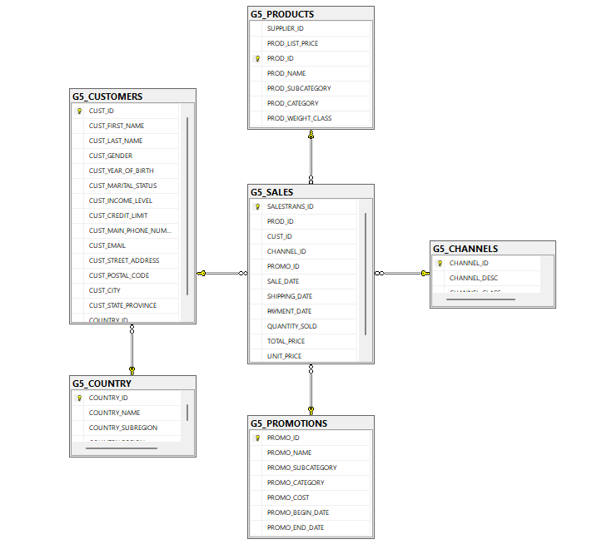

## Specify constraints of the database system

|  |  |  |  |  |
| --- | --- | --- | --- | --- |
| **Database Tables Table Name** | **Primary Key Constraint** | **Referential integrity constraints** | **Relevant inter-columns constraints** | **Domain Constraints** |
| G5_CHANNELS | CHANNEL_ID |  | **CHANNEL_ID**, : int, notNULL, Unique  CHANNEL_DESC: Varchar, notNULL  CHANNEL_CLASS: Varchar, notNull |  |
| G5_CUSTOMERS | CUST_ID |  | **CUST_ID** : int notNull  CUST_FIRST_NAME Varchar(40) CUST_LAST_NAME Varchar(40)  CUST_GENDER char(1) CUST_MAIN_PHONE_NUMBER varchar(25)  CUST_EMAIL varchar(30) CUST_STREET_ADDRESS varchar(30)  CUST_POSTAL_CODE varchar(10)  CUST_CITY varchar(30)  CUST_STATE_PROVINCE CUST_YEAR_OF_BIRTH int(4)  CUST_MARITAL_STATUS varchar(20) CUST_INCOME_LEVEL varchar(30) CUST_CREDIT_LIMIT decimal(20, 0) | 1. *[CUST_GENDER] (M,F),* 2. *[CUST_MARITAL_STATUS] (Single, married, divorced, null, widowed, separate)* |
| G5_PRODUCTS | PROD_ID |  | **PROD_ID**: int, notNULL  PROD_NAME: Varchar, notNULL  PROD_SUBCATEGORY: Varchar notNULL  PROD_CATEGORY:Varchar, notNULL  PROD_WEIGHT_CLASS: int notNULL PROD_LIST_PRICE: decimal, notNULL |  |
| G5_PROMOTIONS | PROMO_ID |  | **PROMO_ID** (integer, not null),  PROMO_NAME (varchar(30), not null),  PROMO_SUBCATEGORY (varchar(30), not null),  PROMO_CATEGORY (varchar(30), not null),  PROMO_COST (integer, not null),  PROMO_BEGIN_DATE (date, null), PROMO_END_DATE (date, null) |  |
| G5_SALES | SALESTRANS_ID | CUST_ID  PROD_ID  PROMO_ID  CHANNEL_ID | **SALESTRANS_ID (integer, not null, unique),**  PROD_ID (integer, not null),  CUST_ID (integer, not null),  CHANNEL_ID (integer, not null),  PROMO_ID (integer, not null),  SALE_DATE (date, null),  SHIPPING_DATE (date, null),  PAYMENT_DATE(date, null),  QUANTITY_SOLD (integer, not null),  AMOUNT_SOLD(decimal, not null),  UNIT_PRICE(decimal, not null) |  |
| G5_COUNTRY | COUNTRY_ID |  | COUNTRY_ID char(5)  COUNTRY_NAME varchar(50)  COUNTRY_SUBREGION varchar(30)  COUNTRY_REGION varchar(20) | *[COUNTRY_REGION] (Oceania, Europe, Americas, Africa, Asia)* |

# Section 6: Physical Design

## Present the physical data model, including DDL script to create tables with constraints

## 

## Scripts to create, set constraints and fix data from the tables:

|  |
| --- |
| -- 1. G5_CHANNELS Table  --- 1.1 create table  CREATE TABLE G5_CHANNELS (  CHANNEL_ID int not NULL unique,  CHANNEL_DESC varchar(50) not NULL,  CHANNEL_CLASS Varchar(50) not Null  CONSTRAINT PK_CHANNEL_ID PRIMARY KEY clustered (CHANNEL_ID)  )  -- 2. Create G5_Customer Table with the data field definition we want  --- 2.1 Create G5_CusEx table  select * into G5_CusEx  from [dbo].[LI_CUSTOMERS_EXT]  --- 2.2 Create G5_CusIn table  select * into G5_CusIn  from [dbo].[LI_CUSTOMERS_INTX]  --- 2.3 Join tables together  select cx.[CUST_ID], [CUST_FIRST_NAME],[CUST_LAST_NAME],  cx.[CUST_GENDER],[CUST_YEAR_OF_BIRTH],[CUST_MARITAL_STATUS],  [CUST_INCOME_LEVEL],[CUST_CREDIT_LIMIT],  [CUST_MAIN_PHONE_NUMBER],[CUST_EMAIL],  [CUST_STREET_ADDRESS],[CUST_POSTAL_CODE],  [CUST_CITY],[CUST_STATE_PROVINCE],  [COUNTRY_ID],[CUST_TOTAL],  [COUNTRY_NAME],[COUNTRY_SUBREGION],  [COUNTRY_REGION],[COUNTRY_TOTAL]  into G5_CUSTOMERS  from G5_CusEx cx  join G5_CusIn ci on cx.CUST_ID = ci.CUST_ID  --- 2.5 alter table G5_Customer table  alter table G5_CUSTOMERS alter column CUST_ID int not Null;  alter table G5_CUSTOMERS alter column CUST_FIRST_NAME Varchar(50);  alter table G5_CUSTOMERS alter column CUST_LAST_NAME Varchar(40);  alter table G5_CUSTOMERS alter column CUST_GENDER char(1);  alter table G5_CUSTOMERS alter column CUST_MAIN_PHONE_NUMBER varchar(25);  alter table G5_CUSTOMERS alter column CUST_EMAIL varchar(30);  alter table G5_CUSTOMERS alter column CUST_STREET_ADDRESS varchar(40);  alter table G5_CUSTOMERS alter column CUST_POSTAL_CODE varchar(10);  alter table G5_CUSTOMERS alter column CUST_CITY varchar(30);  alter table G5_CUSTOMERS alter column CUST_STATE_PROVINCE varchar(40);  alter table G5_CUSTOMERS alter column COUNTRY_ID char(5);  alter table G5_CUSTOMERS alter column COUNTRY_NAME varchar(50);  alter table G5_CUSTOMERS alter column COUNTRY_SUBREGION varchar(30);  alter table G5_CUSTOMERS alter column COUNTRY_REGION varchar(20);  alter table G5_CUSTOMERS alter column CUST_YEAR_OF_BIRTH int;  alter table G5_CUSTOMERS alter column CUST_MARITAL_STATUS varchar(20) null;  alter table G5_CUSTOMERS alter column CUST_INCOME_LEVEL varchar(30);  alter table G5_CUSTOMERS alter column CUST_CREDIT_LIMIT decimal(20, 0);  alter table G5_CUSTOMERS drop column COUNTRY_TOTAL;  alter table G5_CUSTOMERS drop column CUST_TOTAL;  alter table G5_CUSTOMERS ADD CONSTRAINT PK_CUST_ID PRIMARY KEY clustered (CUST_ID);  alter table G5_CUSTOMERS ADD CONSTRAINT CONSTRAINT_GENDER CHECK (CUST_GENDER='f' OR CUST_GENDER='m' OR CUST_GENDER='F' OR CUST_GENDER='M');  alter table G5_CUSTOMERS ADD CONSTRAINT CONSTRAINT_MARITAL_STATUS CHECK (CUST_MARITAL_STATUS='single' OR CUST_MARITAL_STATUS='married' OR CUST_MARITAL_STATUS='divorced'OR CUST_MARITAL_STATUS='separated' OR CUST_MARITAL_STATUS='widowed' OR CUST_MARITAL_STATUS is null);  -- 3. Create Country table from G5_CUSTOMERS  go  select DISTINCT [COUNTRY_ID], COUNTRY_NAME, COUNTRY_SUBREGION, COUNTRY_REGION  into G5_COUNTRY  from G5_CUSTOMERS  Go  – 3.1 Alter table constraints and column settings  alter table G5_COUNTRY alter column COUNTRY_ID int not null  go  alter table G5_COUNTRY ADD CONSTRAINT CONSTRAINT_COUNTRY_REGION CHECK ([COUNTRY_REGION]='Oceania' OR [COUNTRY_REGION]='Europe' OR [COUNTRY_REGION]='Americas' OR [COUNTRY_REGION]='Africa' OR [COUNTRY_REGION]='Asia');  alter table G5_COUNTRY ADD CONSTRAINT PK_COUNTRY_ID PRIMARY KEY clustered (COUNTRY_ID);  -- 4. Create Products table  select * into  G5_PRODUCTS from  [dbo].[LI_PRODUCTS]  -- 4.2 alter data definitions  go  sp_rename 'G5_PRODUCTS.PROD_CAT_DESC','PROD_CATEGORY','COLUMN'  go  alter table G5_PRODUCTS alter column PROD_ID int not NULL;  alter table G5_PRODUCTS alter column PROD_NAME Varchar(50) not NULL;  alter table G5_PRODUCTS alter column PROD_SUBCATEGORY Varchar(50) not NULL;  alter table G5_PRODUCTS alter column PROD_CATEGORY Varchar(50) not NULL;  alter table G5_PRODUCTS alter column PROD_WEIGHT_CLASS int not NULL;  alter table G5_PRODUCTS alter column PROD_LIST_PRICE decimal(20, 2) not NULL;  alter table G5_PRODUCTS ADD CONSTRAINT PK_PROD_ID PRIMARY KEY clustered (PROD_ID);  -- 5. Create Promotions Table  --- 5.1 create and populate Promotions table  select * into  G5_PROMOTIONS from  [dbo].[LI_PROMOTIONS]  --- 5.2 APPLY CONSTRAINT AND NEW DATA FILED DEFINITION  alter table G5_PROMOTIONS alter column PROMO_ID integer not null;  alter table G5_PROMOTIONS alter column PROMO_NAME varchar(30) not null;  alter table G5_PROMOTIONS alter column PROMO_SUBCATEGORY varchar(30) not null;  alter table G5_PROMOTIONS alter column PROMO_CATEGORY varchar(30) not null;  alter table G5_PROMOTIONS alter column PROMO_COST integer not null;  alter table G5_PROMOTIONS alter column PROMO_BEGIN_DATE date null;  alter table G5_PROMOTIONS alter column PROMO_END_DATE date not null;  alter table G5_PROMOTIONS DROP column PROMO_TOTAL;  alter table G5_PROMOTIONS ADD CONSTRAINT PK_PROMO_ID PRIMARY KEY clustered (PROMO_ID)  -- 6. Create Sales Table  --- 6.1 Create G5_SALES table  select * into  G5_SALES from  (select * from [dbo].[LI_SALES_12_13]  union  select * from [dbo].[LI_SALES_14]) a  order by [SALESTRANS_ID]  go  --- 6.2 Table data definition  alter table G5_SALES alter column SALESTRANS_ID integer not null;  alter table G5_SALES alter column PROD_ID integer not null;  alter table G5_SALES alter column CUST_ID integer not null;  alter table G5_SALES alter column CHANNEL_ID integer not null;  alter table G5_SALES alter column PROMO_ID integer not null;  alter table G5_SALES alter column SALE_DATE date null;  alter table G5_SALES alter column SHIPPING_DATE date null;  alter table G5_SALES alter column PAYMENT_DATE date null;  alter table G5_SALES alter column QUANTITY_SOLD integer not null;  go  sp_rename 'G5_SALES.AMOUNT_SOLD','TOTAL_PRICE','COLUMN';  alter table G5_SALES alter column TOTAL_PRICE decimal(20,2) not null;  alter table G5_SALES alter column UNIT_PRICE decimal(20,2) not null;  alter table G5_SALES ADD CONSTRAINT PK_SALESTRANS_ID PRIMARY KEY (SALESTRANS_ID);  alter table G5_SALES ADD CONSTRAINT FK_PROD_ID FOREIGN KEY (PROD_ID) references G5_PRODUCTS (PROD_ID);  alter table G5_SALES ADD CONSTRAINT FK_CUST_ID FOREIGN KEY (CUST_ID) references G5_CUSTOMERS (CUST_ID);  alter table G5_SALES ADD CONSTRAINT FK_PROMO_ID FOREIGN KEY (PROMO_ID) references G5_PROMOTIONS (PROMO_ID);  alter table G5_SALES ADD CONSTRAINT FK_CHANNEL_ID FOREIGN KEY (CHANNEL_ID) references G5_CHANNELS (CHANNEL_ID) |

# Section 7: Database Implementation

## DML scripts to populate tables

All the scripts are shared on a github repository (https://github.com/axin-geo/IST302DBG5FINAL).

1. Populate G5_CHANNELS

INSERT INTO [dbo].[G5_CHANNELS]

SELECT [CHANNEL_ID], [CHANNEL_DESC], [CHANNEL_DESC] FROM [dbo].[LI_CHANNELS]

2. Populate G5_COUNTRY

select DISTINCT [COUNTRY_ID], COUNTRY_NAME, COUNTRY_SUBREGION, COUNTRY_REGION

into G5_COUNTRY

from G5_CUSTOMERS

3. Populate G5_CUSTOMERS

--- 2.1 Create G5_CusEx table

select * into G5_CusEx

from [dbo].[LI_CUSTOMERS_EXT]

--- 2.2 Create G5_CusIn table

select * into G5_CusIn

from [dbo].[LI_CUSTOMERS_INTX]

--- 2.3 Join tables together

select cx.[CUST_ID], [CUST_FIRST_NAME],[CUST_LAST_NAME],

cx.[CUST_GENDER],[CUST_YEAR_OF_BIRTH],[CUST_MARITAL_STATUS],

[CUST_INCOME_LEVEL],[CUST_CREDIT_LIMIT],

[CUST_MAIN_PHONE_NUMBER],[CUST_EMAIL],

[CUST_STREET_ADDRESS],[CUST_POSTAL_CODE],

[CUST_CITY],[CUST_STATE_PROVINCE],

[COUNTRY_ID],[CUST_TOTAL],

[COUNTRY_NAME],[COUNTRY_SUBREGION],

[COUNTRY_REGION],[COUNTRY_TOTAL]

into G5_CUSTOMERS

from G5_CusEx cx

join G5_CusIn ci on cx.CUST_ID = ci.CUST_ID

4. Populate G5_PRODUCTS

select * into

G5_PRODUCTS from

[dbo].[LI_PRODUCTS]

5. Populate G5_PROMOTIONS

select * into

G5_PROMOTIONS from

[dbo].[LI_PROMOTIONS]

6. Populate G5_SALES

select * into

G5_SALES from

(select * from [dbo].[LI_SALES_12_13]

union

select * from [dbo].[LI_SALES_14]) a

order by [SALESTRANS_ID]

## Test integrity constraints

1. G5_CHANNELS (A negative TEST ON PRIMARY KEY. A PRIMARY KEY HAS UNIQUE VALUES AND NOT NULL)

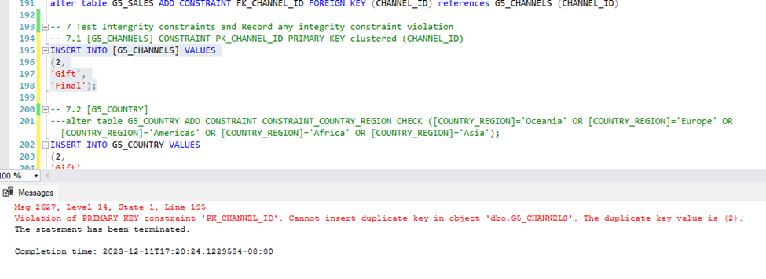

2. G5_COUNTRY (This is a negative test on domain constraint. We added a constraint to 5 domains. If I try to update the COUNTRY_REGION for one row, the domain constraint will be triggered and voided the operation.)

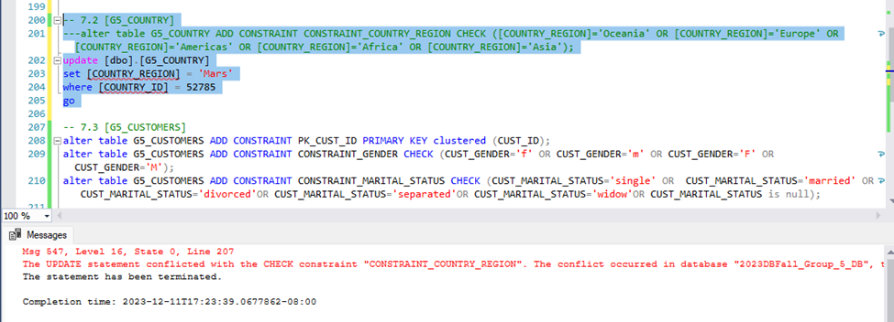

3. G5_CUSTOMERS

a. CONSTRAINT_GENDER (Negative)

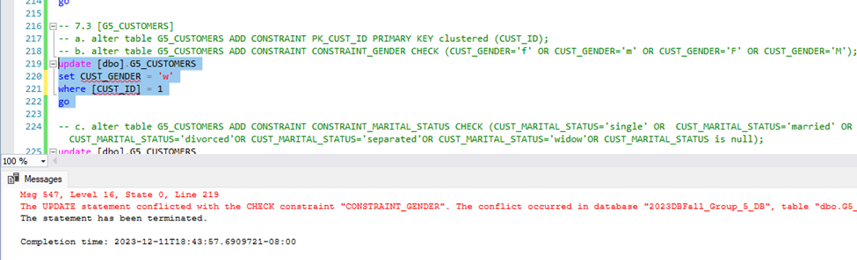

b. CONSTRAINT_MARITAL_STATUS (Negative)

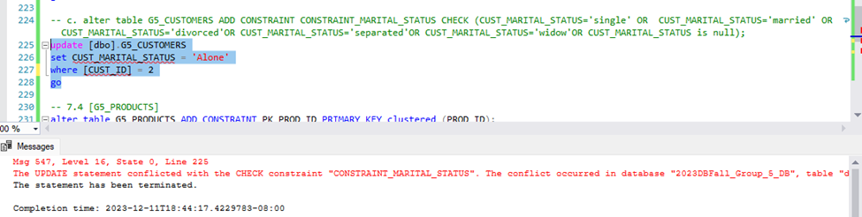

c. CONSTRAINT_MARITAL_STATUS (positive)

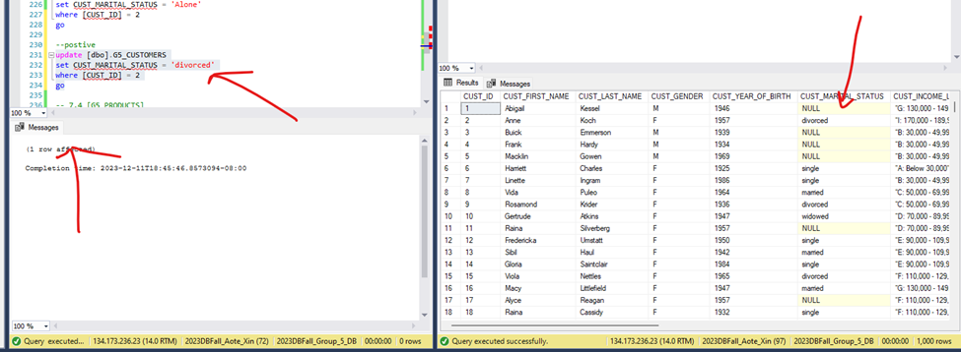

## Design and implement data access structure for the database system, including **,queries, views, indexes, stored procedures,** **security**

1. Business Query 1 (Select any channel from the G5_CHANNELS that was NOT used by any sale transaction made.)

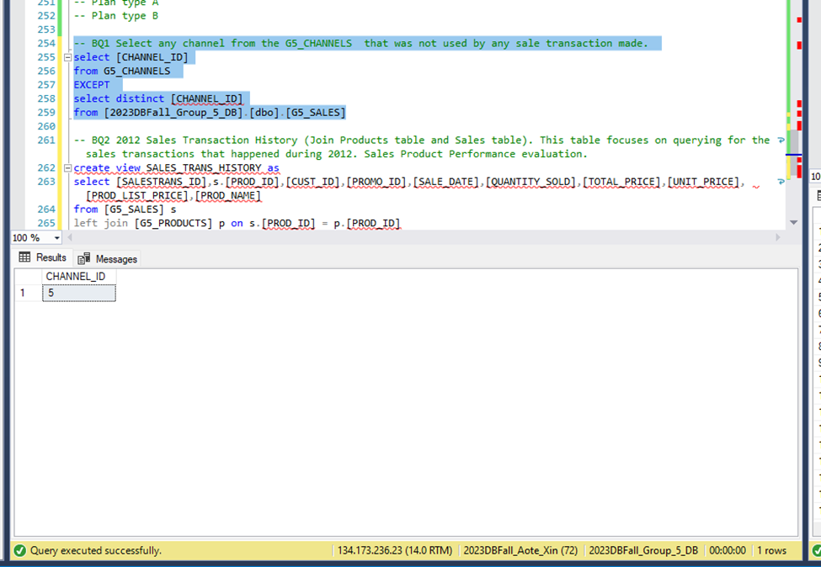

2. Business View 2 (2012 Sales Transaction History (Join Products table and Sales table). This table focuses on querying for the sales transactions that happened during 2012. Sales Product Performance evaluation.) Requirement: Two Tables - JOIN without or with condition, right or left join with complex condition.

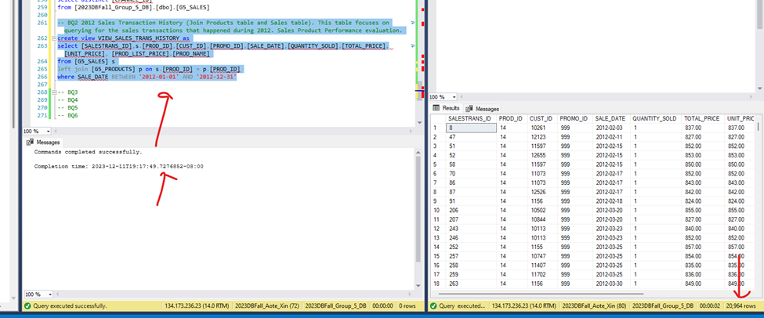

3. Business View 3 (2012 Internet Sales Promotion History: (Join Sales table, channel, Promotions table). This table focus on query for sales promotions that happened during a particular date/dates via the internet channel.) Required: Same as for Two Tables with at least one being either LI_SALES_12_13 or LI_SALES_14.

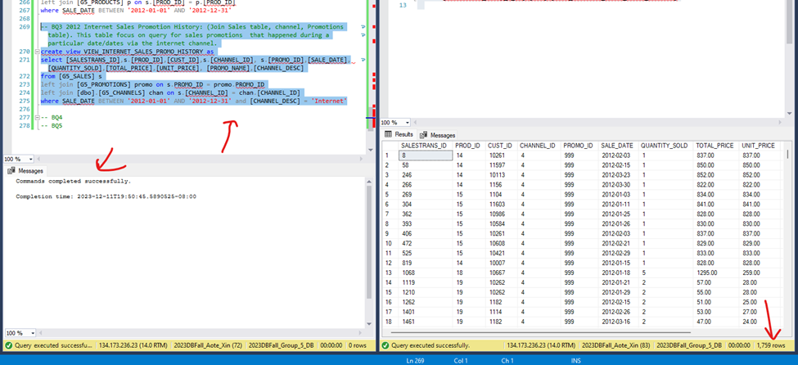

4. Business View 4 (2012 Internet Sales Promotion History in Asia: This table focuses on query for sales promotions that happened during a 2012 via the internet channel in the continent of Asia) Required: 4 tables and need to use COUNTRIES Table.

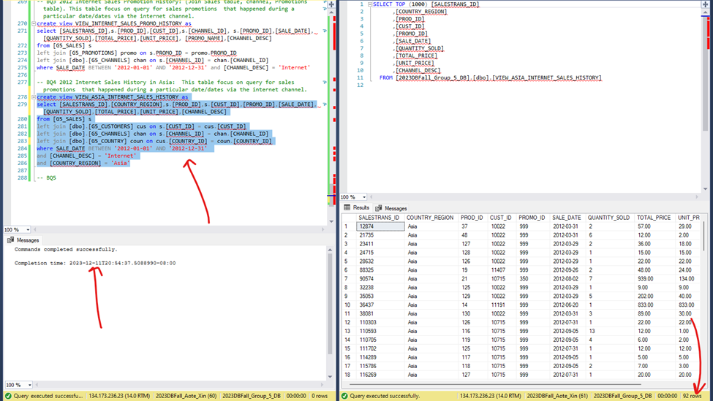

5. Business View 5 (Customer Demography .which gender group of our customers in Asia have the highest sale from purchasing through internet in 2021.) Required: Same as Detail Queries with Four Tables but involving SUM, AVG, COUNT, MAX, MIN operators.

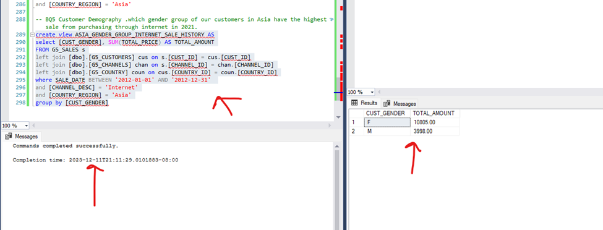

6. Indexes

For the query below, we created 3 indexes and on composite index. Before creating the indexes the execution plan suggested that we creat a composite index on G5_SALES for CUST_ID, CHANNEL_ID AND TOTAL_PRICE. After we created the indexes as suggested, this new plan takes uses of hash join physical operator for inner join and take advantages of the non-clustered index for non-clustered index scan and index seek. Table scan was completed multiple time. And predicates were enforced during the table scan.

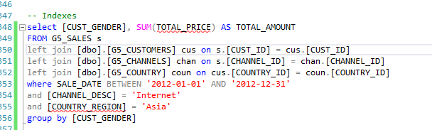

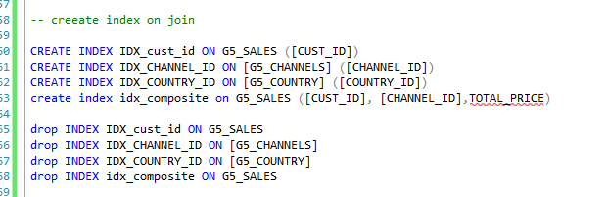

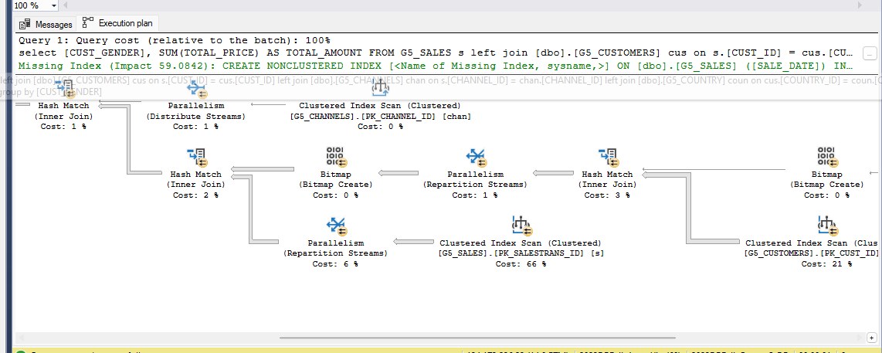

7. Stored Procedure 1 (Procedure1 calculate the total sale made in a continent in 2012 via internet)

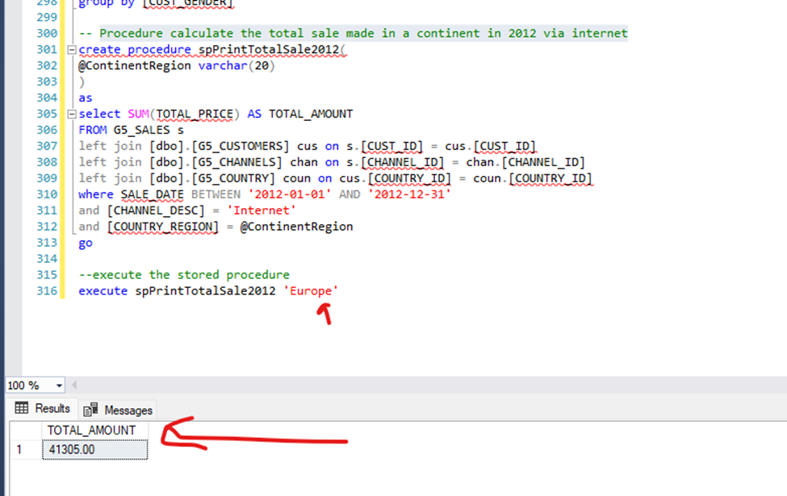

8. Stored Procedure 2 Select the product that has the highest sale in 2012 in a continent via certain channel

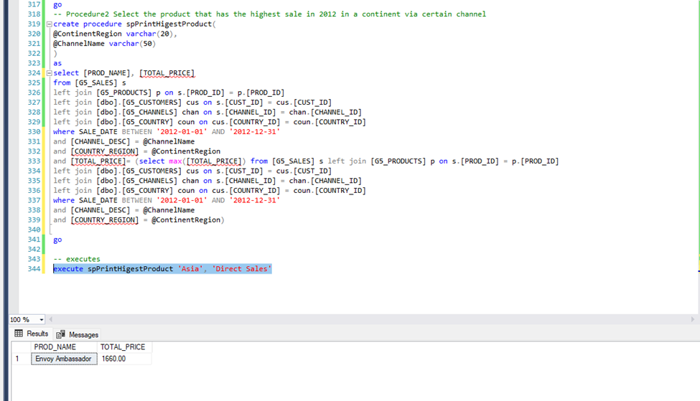

9. Create users (Sale and Mark) to grant security privileges with Views

|  |  |  |  |  |
| --- | --- | --- | --- | --- |
| ***BUSINESS VIEWs*** | | | | |
| ***USERs*** | BV02 (VIEW_SALES_TRANS_HISTORY) | BV03 (VIEW_INTERNET_SALES_PROMO_HISTORY) | BV04 (VIEW_ASIA_INTERNET_SALES_HISTORY) | BV05 (ASIA_GENDER_GROUP_INTERNET_SALE_HISTORY) |
| Sales (sale) | S |  | ISUD | ISUD |
| Marketing (mark) |  | ISUD | IS | ISUD |

9.1 Create the users and grant security privileges to sale and mark according to deign

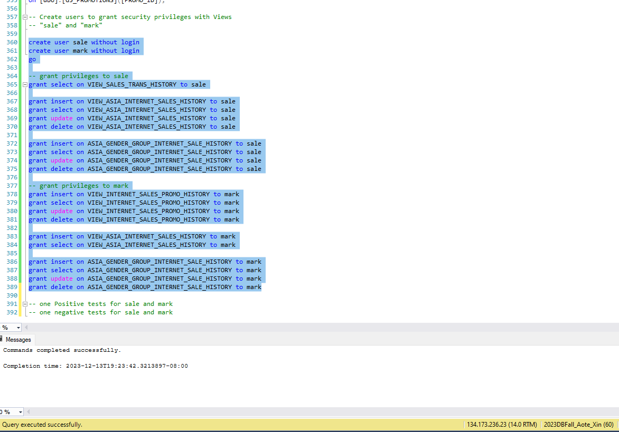

9.2 positive and negative tests for sale

9.2.1 negative update

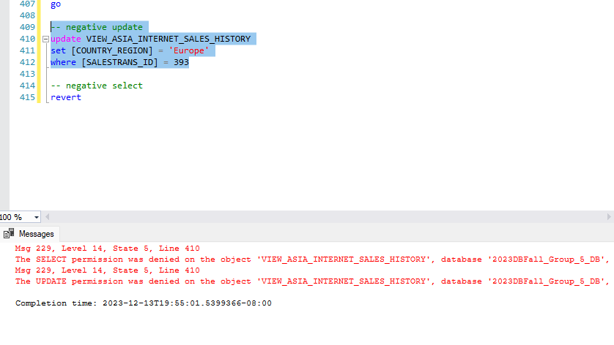

9.2.2 negative select

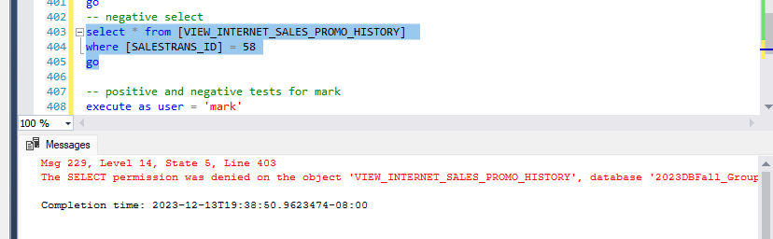

9.3 positive and negative tests for mark

9.3.1 negative update

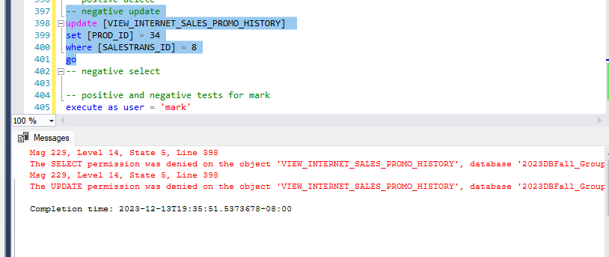

9.3.2 negative select

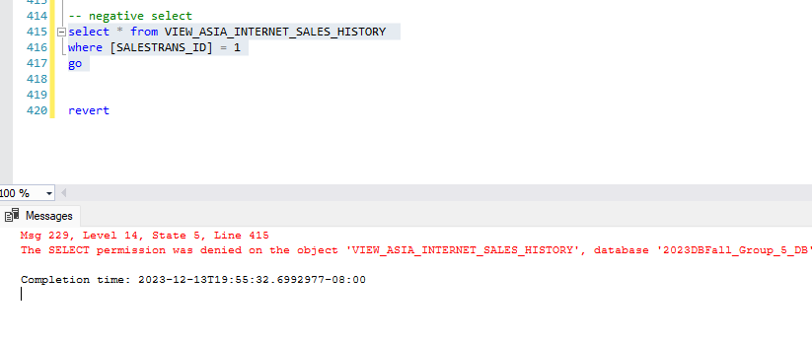

# Section 8: Conclusion

Through this database project, we've deepened our understanding of database design, including selecting the appropriate data types for each attribute and the importance of data cleansing to maintain a robust database. We've gained practical experience in constructing business views, setting up correct access controls, and specifying user permissions, ensuring that only relevant users are included in the database system. By developing integrity constraints, we were able to align our technical knowledge with specific business requirements, enforcing limits where necessary to safeguard the data integrity. The hands-on aspects of the project, including creating and consolidating tables, loading data, implementing stored procedures, testing constraints, and executing queries, allowed us to apply our theoretical planning to a practical environment. We learned not only to create ER diagrams and discern redundant data but also to consolidate tables with overlapping functions, thereby optimizing database size and utility. By employing more suitable data types, we could save space and reduce errors. Establishing meaningful relationships between tables was instrumental in making the database functional and in ensuring it provides relevant and actionable insights.

References:

* <https://www.ibm.com/docs/en/cics-ts/5.4?topic=samples-sale-example-application>
* <https://smallbusiness.chron.com/account-cash-receipts-76317.html>