# **Ian Sanchez Nov 13, 2019 IT FDN 100 A Assignment06**

<https://github.com/isanchez-school/IntroToProg-Python-Mod06>

Managing a To-Do List – Class/Function Edition

Introduction

For this week’s assignment, we were instructed to modify a “starter” script to complete the required task. This is almost the same as last weeks assignment except we have to add functions so that the script can perform the tasks using class/function calls. For each section in this document, I will explain what I did to convert certain parts of code into a function.

Adding code to a function

In the starter script, we are provided with a few classes with various functions. The first task was to add code to a function (Figure 1.1). For this part I grab the code that is under Step 3.4.b Line 168 (Figure 1.2) and move into the defined WriteListDataToFile (changed to SaveDataToFile) function. We also add comments to explain what the function does. (Figure 1.3).

**Figure 1.1 TODO**

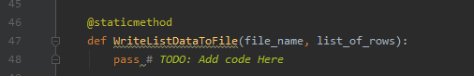

**Figure 1.2 Code from main body**

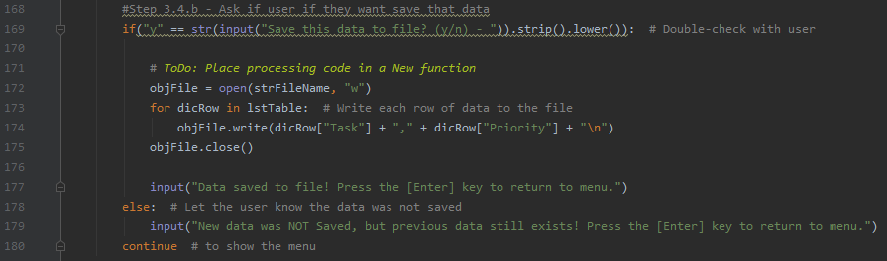

**Figure 1.3 Code moved to function**

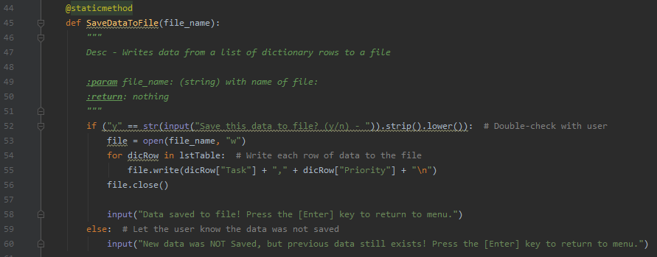

Creating more functions

In the starter script we were asked to add more functions to complete the task. For each option I created a function to perform the task and moved the code from the main body into either File Processor class or IO class. Under the IO class I added AddANewItem and under FileProcessor, I added RemoveAnExistingItem, ReloadDataFromFile. (Fig. 2.1, 2.2 and 2.3)

**Figure. 2.1 AddANewItem function**

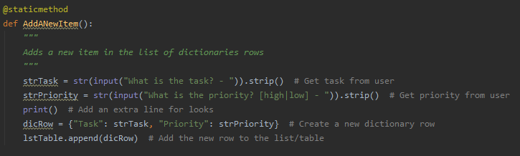

**Figure. 2.2 RemoveAnExistingItem function**

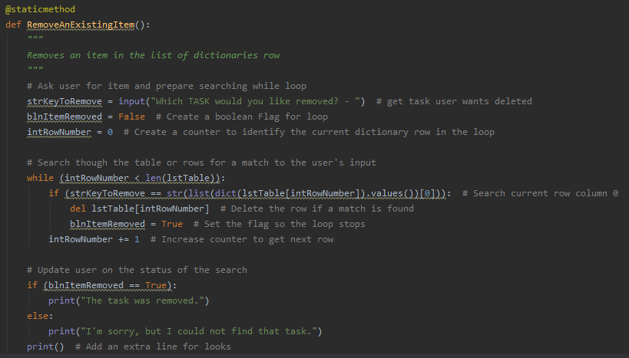

**Figure 2.3 ReloadDataFromFile function**

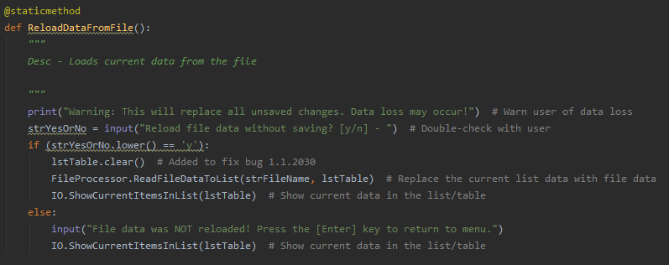

Main body after creating functions

After creating functions and moving those parts of the script to #Processing and #Presentation, this is what the main body looks like (Fig. 3.1 and 3.2)

**Fig. 3.1 Main body before**

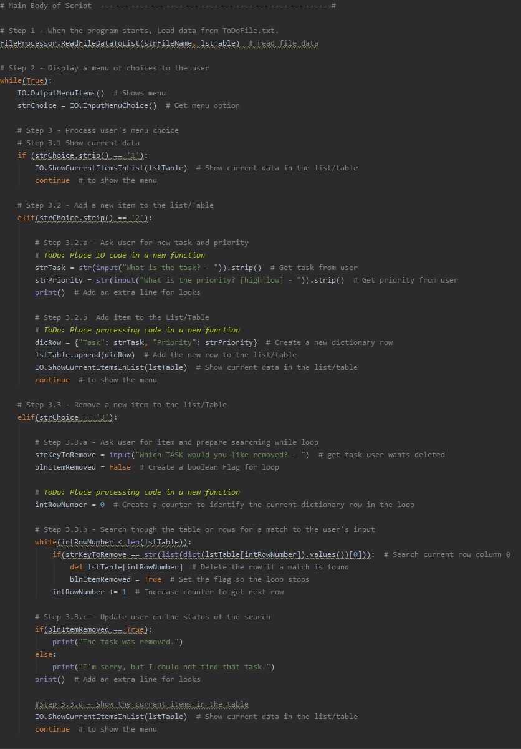

**Fig 3.2 Main body after**

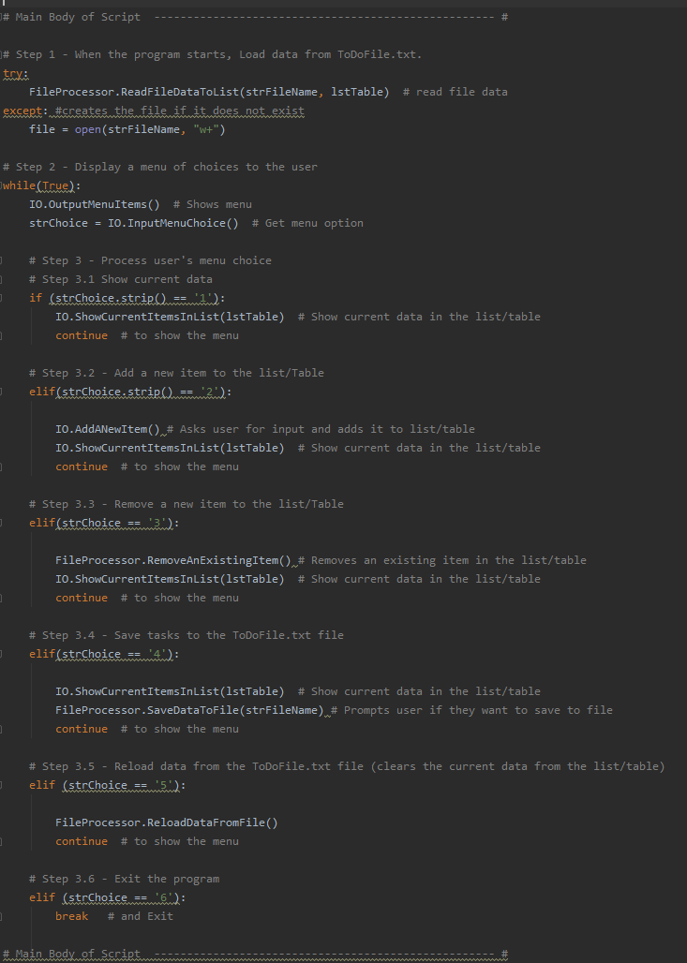

Summary

In this assignment we learned how to work with someone else’s code and add to it to complete a given task. It was a bit simpler this time around as we just needed to move parts of the code into a function. We applied Separation of Concerns and I understand the importance of it in the code (Data, Processing, Presentation, Main Body). In the module we learned about classes/functions and how to properly use and apply it into your code.