**A**

**PROJECT REPORT**

**ON**

**ELECTRONIC**

**LIBRARY**

**SYSTEM**

For

Borrowing,Returning and Read Books

**Submitted**

**By**

Team Name :Giants

Individual Name:Chenxin Li

Tianmin Xiao

Pinhao Xie

Guojin Chen

Roll No.

Date:2019/5/10-2019/5/22

**Internal Guide: External Guide: Mr.Ashu Decai Liu**

**Teacher of NIIT class Teacher of NIIT class**

  PROJECT INDEX

TEAM DESCRIPTION & OVERVIEW

Our group is composed of four students:Chenxin Li, Tianmin Xiao, Pinhao Xie and Guojin Chen. The reason our group is called ‘Giants’ is that we are both eager be more skillful and stronger in both the web world and the real world. So we best four friends decided to be bond together to work.

Our project consists of four parts. In general, it is aimed to borrow, return and even read books which would make reading life much convenient.

**CERTIFICATE**

This is to certify that this report, titled Electronic Library , embodies the original work done by Chenxin Li,Tianmin Xiao,Pinhao Xie and Guojin Chen in partial fulfillment of their course requirement at NIIT

**CERTIFICATE**

**ACKNOWLEDGEMENT**

In the present world of competition there is a race. Project is like a bridge between theory and practical working. With this willing we joined this particular project. First and foremost,I would like to thank our team member who contribute their much time to the project. I am highly obliged in taking the opportunity to sincerely thanks to all the staff members of computer department for their generous attitude and friendly behaviors. At last but not the least I am thankful to all my teachers who have been always helping and encouraging me though out the year.

**PROJECT REPORT**

**HUMAN**

**RESOURCE MANAGEMENT**

**SYSTEM**

Nowadays, our society is developing in a very mad speed. We can not only just improve country’s economy, but also boot our culture and spirits. So it is a great demand to provide people with a available and useful way to read books. Our team made a program to meat this kind of require which we called ‘Electronic Library’. You can borrow, return and even read books with using it.

**Software Requirements**

* J2sdk1.6
* Web Logic Server
* Oracle 10g Database Server/MySql
* Any IDE like Eclipse3.2 or NetBeans 5.1

Original library xinhua bookstore is the main business, with the development of information technology and network, merchants began to enter the library field from material base, equipment, technology and other traditional information service as the service object, the key is not the same, the effect on the library is not very big, but now is not the same as the modern information service, can be said to be the full access to the library field, merchants began to (client) resource library for the readers, the library become a businessman in the middle of the bridge, they hope to information technology as the guide, based on the traditional library business to expand their business space, attract more customers. They not only carry out the processing and sorting of document information in the traditional library business, but also carry out the digital transformation of traditional library collections, the introduction of large digital resources, the mining and organization of network information resources, and the integration of information resources. They use advanced information technology and advanced management mode to improve the utilization rate of information, shorten the response time of users, and save users' time with convenient and quick information utilization. They put forward the slogan is the construction of knowledge network, knowledge center, knowledge positioning, information-oriented management.

**SDLC of the Project**

This project is a web application and going to be developed using J2EE technology like servlets, JSP and JDBC similar to all other software projects, this project too has its own software development like cycle. The SDLC of this project will be discussed under the following heads.

**Requirement Analysis**

Before starting the project, the first thing which should be considered are the requirements. The requirements to be fill filled by the new system can be uncovered through a proper analysis of the existing system for its problems this is known as requirement analysis. Requirement analysis is the most important part to be considered before developing any project as be must be aware of the objective s that be wish to achieve by making this project. This analysis finds out the problems faced by the user or the client and the possible solution to whose problems. We can use some questionnaires to find are the problems are faced by the clients. This system will be helping administrator for doing all the related jobs so the analysis part includes problems faced by the HR administrator and other facilities aspected by him from the new system. The manual handling of all hr functions may produce numerous types of problems such as:

* **Entering, storing and searching of employing information manually are time consuming and error prone process:** the information may include the personal detail of an employee, past history, skills and experience. HRMS records the information’s starting with the applications summated by a candidate and will continue adding new information like selection, training, appraisals, project handle and the other activities involved. This information is to be maintained through out an employees trainer and there after also-for official records. The manual handling of all these functions will required more time and persons for the proper functioning of the HR process. The older book keeping methods generate several other problems when entering a new record of deleting and updating and existing one.
* **The second task which is very important is the time management:** this is about the working days calculation according the attendance records available. This is also about analyzing the time to work ratio for all employees. Similarly, wok load distribution is concerned whit HR management and manually it is very difficult to handle. An automatic system is always required here.
* **Calculating salary and making salary slips of large number employee is quite cumbersome:** the automation of this process becomes most important as it is a periodic process. The calculation of salary is not easy process as it takes care of all the accounting information of an employee the package being received, working days, leaves, benefits program being participate by the employee, pension plan, insurance policy, medical facility etc. handling of all this information and calculating salary periodically every one needs an automated system which can helps the HR professional to perform their task in an efficient manner.

To solve all these problems we can develop a HRMS which will help to automate all the above discussed task associated with HR department. The requirement analysis can be discussed with a much broader view but this given analysis is enough to put a basic platform to build our new system.

**Software Design**

Software design is a solution- “how to approach the creation of a new system”. This important phase is composed of several steps. It provides the understanding and procedural details necessary for implementing the system recommended in the feasibility study.

In software design, there are three distinct types of activities:

* External design
* Architectural design
* Detailed design

**External Design**

External design of software involves conceiving, planning out and specifying the externally observable characteristics of a software product. These characteristics include user displays, report formats, external data sources, functional requirements , performance requirements and high-level process structure for the product.

External design begins during the analysis phase and continues in the design phase.

**Internal Design**

Internal design involves conceiving, planning out and specifying the internal structure and processing details of the software product. The goals of internal design are to specify internal structure and processing details, to record design decision and indicate why certain alternatives and trade-offs were chosen, to elaborate the test plan, and to provide a blueprint for implementation, testing, and maintenance activities.

**Architectural design**

Architectural design concerned with refining the conceptual view of the system, identifying internal processing functions, decomposing high-level functions into sub-functions, and defining internal data streams and data stores, and establishing relationships and interconnections among functions, data streams, and data stores.

The software will be designed according to the various modules required to full fill all the requirements uncovered in our requirements analysis. The whole system can be divided into a number of modules. The following modules can be recognized in our project:

* Login module
* Profile management module
* Recruitment module
* Time management module
* Leave management module
* Payroll management module

**Login module**

This module makes sure that all access to the system is proper and authenticated. All the links and navigation paths are available for manipulating any kink of information only after an authorized person enters a valid set of user ID and PASSWORD. So this module serve as an entry point for the system and only the authorized person can access it.

**Profile management module**

This module provides the interface to enter the information for the new employee. T5he information added once can also be edited. All the information regarding the profile of an employee is stored. This profile information includes fields like name, date of birth, address, date of joining, designation, department and so on.

**Recruitment module**

This module deals with the recruitment procedure of the organization. Right from the starting with the applicants’ registration, calling for written test, technical round, HR round and setting the tests for the called candidates, all functions are handled by this module. This module also manage all the test and uploading the results for all rounds. Finally functioning of this module end with the listing of selected candidate who can be issued offer later.

**Time management module**

All the attendance related details can be entered and reviewed through this module. The interface provides fields to enter the in time and out time on the current date. Administrator can see the daily attendance report for all employees

**Leave management module**

This module deals with the management of leave request. An employee can apply for a leave and can see for the approval of leave requested. a leave application form consists of the fields. Like employee id, employee name, duration (dates), reason etc. the list of all approved leave requests is also shown in the form.

**Payroll module**

This module helps the administrator to add the salary details of an employee every month. The salary details consist of the amount under various heads like basic, HRA, etc. for a particular employee and also show the total sum to be transmitted to the corresponding salary account or payment cheques to be generated.

All these modules together make the full project to work and fulfill all the requirements specified in the requirement analysis.

**Database Design**

The whole project is in fact an information management system, which interacts with the database having a number of tables. The tables with their column names and data type are as follows.

The so-called top-down design is that the designer first plans the function and performance of the whole system, then divides the system into small and simple local modules, and establishes the relationship between them. Its main advantages are:

You can master the performance of the implemented system from the beginning.

As the design goes down, the systematic parameters are further refined and confirmed.

Shorten the design cycle and ensure the accuracy of the design results.

The larger the design scale, the more obvious the advantages of this design method.

The main disadvantage of its design method is that it needs advanced EDA design tools and accurate process library support.

This project uses top-down design, such as login interface design. First, the main login interface is done in general, and then the main login interface is decomposed.

For the local modules with small scale and simple function, they are inextricably related to the main login interface.

[计] acceptation test

Acceptance testing is the last test operation before deploying software. The purpose of acceptance testing is to ensure that the software is prepared

Ready and allows end users to use them to perform established functions and tasks of the software.

Another important part of acceptance testing is configuration review. The purpose of the review is to ensure that the software is fully configured and divided into

Classes are orderly and include the details necessary for software maintenance.

The project is mainly through the further examination of the students, the teacher's instruction to test the project.

Implementation and maintenance

This is the final phase of the project. a large number of software company project implementation cases prove that the software project is successful,

Whether the use of the user's software is smooth or not, whether or not the user's work efficiency and management level have been improved, not only

Depending on the quality of the software product itself, the quality effect of the implementation of the software project also starts with the application of the later user.

To a very important influence. Users of this project can log on to the book management system and learn about the relevant information, or they can also log on to the book management system.

Perform a simple book borrowing operation.

Mvc architecture

MVC architecture system architecture:

The user sends the request at the interface, the system receives the request, processes it, and then presents the result through the interface

With users.

This process includes user actions, data transfer, interface display (page echo), familiar

The MVC pattern is to separate the three, and reduce the coupling of the three.

This project is developed using a model-view-controller architecture. The developers focus on the logical structure of the Java language

Build up. And the related functions are realized through the contact between the Java and the database.

Develop login module

Registration, login is a website portal, its design posture is to treat guests attitude. Although users may only

Spend very little time in registration, login page interaction, but this "moment" is important, between users and registration, login

The interaction is a node that connects the above and the following. Registration, login to all the details affect the completion of the product strategic positioning office

Set the most basic task to absorb the mission of the users they want. So the login module is very important.

The development of this module includes writing code for the following files:

banner5.jpg

中心形式

Center.java

解释形式

Explanation.java

LoginIn.java

LoginIn.form

主表

Main.java

ew1.java

New1.form

Research.java

To129d7...8b37.jpg

云读

Yunreading.java

朱奇

juuce.java

Develop profile management module

In this project, we can log in to the book management system to find relevant information, and the book also has the borrowing information. User-registered database

There will be information such as user name, ID number, gender, etc. The next login is to be entered, the ID number, the secret number,

Code. the user information and the user information are stored in the MySQL database, and the connection between the Java and the database is realized,

**Debugging**

Debugging is the process of isolating and correcting the causes of known errors. Commonly used debugging methods include:

* Debugging by induction or deduction
* Debugging by backtracking

Debugging by induction or deduction proceeds as follows:

* Listing the possible causes for the observed failure
* Using the available information to eliminate various hypotheses
* Elaborating the remaining hypotheses
* Proving or disproving each hypotheses
* Determining the appropriate corrections
* Verifying the corrections

Debugging by backtracking involves working backward in the source code from the point where the error was observed in an attempt to identify the exact point where the error occurred.

Traditional debugging techniques include:

Snapshot dumps-which are machine –level representations of the partial or total program state at a particular point in the execution sequence. For example, core dump during execution of a C program. The image of the program along with all registers are dumped to a file(core) at the point of execution error.

Trace Facilities—which list changes in selected state components. In its simplest form, a trace will print all changes in data values for all variables and changes control flow. For example, in Visual Basic 4.0 usage of watch pane is a trace facility.

Traditional breakpoint facility—interrupts program execution and transfers control to the programmer’s terminal when execution reaches a specified break instruction in the source code, for example, inserting breakpoints in a Visual Basic program by using stop keyword.

**Unit Testing**

A program unit is usually small enough that the programmer who developed it can test it in great detail and certainly in greater detail than will be possible when the unit is integrated into an evolving software product. As mentioned in previous sessions, there are four categories of tests that a programmer will typically perform on a program unit:

* Functional tests-specify operating condition, input values and expected results. For example, for a function written for string copy, the source or destination string can be passed as null argument. The function should be able to take care of that situation.
* Performance tests—should be designed to verify response time, execution time, throughput, primary and secondary memory utilization and traffic rates on data channels and communication links. For example, a query executed takes 5 seconds to display results, is a test for response time. Execution time is the time taken by CPU to execute a program. Throughput is the rate at which data gets transferred from one data source to destination. Primary and secondary memory utilization needs to be optimized. Traffic rates on data channels and communication link testing is applicable for networks.
* Stress tests—are designed to overload a system in various ways. The purpose of a stress test is to determine the limitation of the system. For example, during a sort operation, the available memory can be reduced to see whether the program is able to handle the situation.
* Structural tests—are concerned with examining the internal processing logic of a software system. For example, if a function is responsible for tax calculation, the verification of the logic is a structural test.

**System Testing**

A system is tested for online responses, volume of transactions, stress, recovery from failure, and usability.

System testing involves two kind of activities—Integration testing and acceptance testing.

**Integration Testing**

Bottom-up integration is the traditional strategy used to integrate the components of a software system into a functioning whole. Bottom-up integration consists of unit testing, followed by subsystem testing, followed by testing of the entire system. Unit testing has the goal of discovering errors in the individual modules of the system. The primary purpose of subsystem testing is to verify operation of the interfaces between modules in the subsystem. System testing is concerned with the decision logic, control flow, recovery procedures, and throughput, capacity and timing characteristics of the entire system.

Disadvantages of bottom-up testing include:

* Necessity to write and debug test harnesses for modules and subsystems
* Level of complexity that result from combining modules and subsystems into larger units.

Top-down integration starts with the main routine and one or two immediate subordinated routines in the system structure. Top-down integration offers several advantages:

* System integration is distributed throughout the implementation phase. Modules are integrated as they are developed
* Top-level interfaces are tested first
* The top-level routines provide a natural test harness for lower-level routines
* Errors are localized to the new modules and interfaces that are being added

Automated tools in integration testing include:

* Module drivers
* Test data generators
* Environment simulators
* Library management facility to allow easy configuration and reconfiguration of system elements

**Acceptance Testing**

Acceptance testing involves planning and execution of functional tests, performance tests and stress tests in order to demonstrate that the implemented system satisfies its requirements.

Tools of special importance during acceptance testing include:

* Test Coverage Analyzer—records the control paths followed for each test case.
* Timing Analyzer—also called a profiler, reports the time spent in various regions of the source code under different test cases. These regions of the code are areas to concentrate on to improve system performance.
* Coding Standards—static analyzer and standard checkers are used to inspect code for deviations from standards and guidelines.

**Implementation and Maintenance**

This is the last stage in SDLC. The project is implemented for the client in real environment where it can be used. The project then runs in real environment with all the real process executed by the user. The implementation includes the proper deployment of the project onto the server. After the real execution of the project under the real circumstances by the user, some loop holes many be uncovered. It is also possible that after sometime the user may request some changes of report some problems in the working system. The maintenance of a project means updating the project for the required changes in the implemented system.

**MVC Architecture**

This project will be developed using model-view-controller architecture. This architecture, when implemented makes life of the developer easy. The developer can concentrate on logic building in the controller servlet and other helper classes for it while a designer can design good JSP pages without much java code implementing some logic in the pages. In MCV architecture, a central controller servlet handles all the business logic with the help of some helper classes. Model part defines by a pure java classes or JavaBeans which are nothing but data transfer objects used to carry data. They may be initialized automatically or manually using ResultSet. Finally, view part is implemented through JSP pages which are used to create the real views of the system to the user. Separating development of a project into these three aspects is somewhat complex but it increases reusability of components and extensibility of the system.

Let us see how this architecture is used in the development of this project. In this project. In our project, every module has given its own controller servlet which handles request for a single module. The controller servlet has its own helper class which defines all the required methods that will be used by the servlet to complete some function. Pure java classes will be used as data transfer objects and they will be populated manually using methods of helper classes by the controller servlet and finally a next view [JSP] will be selected for the user

**DEVELOPING A LOGIN MODULE**

The proposed HR management system is to be used for the manipulation of some data which is of greater importance for any organization and should always be protected from the unauthorized access. The designed login module is being developed to allow only authorized person to access the available interface and links to add, update and search the important data. Every access to the system goes through this module and is forwarded to the authorized section only after the some mission of a valid login name and password

The development of this module includes writing code for the following files

* **UserLoginDBobj.java**
* **USerLoginDBMethods.java**
* **Hrms_User_Login.java**
* **Hrms__User_Login.jsp**
* **Hrms_User_Login_Pswd_Change.jsp**
* **Hrms_Default.jsp**
* **Hrms_Footer.jsp**
* **Hrms_Header.jsp**
* **Hrms_Main_Menu.jsp**

**DEVELOPING PROFILE MANAGEMENT MODULE**

The profile of all employees is to be maintained using this application and development of this module includes designing user interface to enter new profile of an employee and editing the existing profile an employee. We can search an employee profile. The profile related information includes personal details, department name, designation, date of joining etc. The search form can help to see profile of an employee by just giving the search key, like an employee ID and employee NAME.

A profile record for an employee is stored in the table HRMS_EMPLOYEE. To complete the development of this module we need following files

* **Hrms_Employee.java**
* **EmployeeDbobj.java**
* **EmployeeDBMethods.java**
* **Employee_Insert.jsp**
* **Employee_Search.jsp**
* **Employee_Edit.jsp**

**DEVELOPING RECUITMENT MODULE**

Recruitment of new employee is a process which includes number of rounds handled by HRDEPARTMENT. The process starts with the registration of the applicants and calling of sort listed candidate for written test. The result of on the appearing candidates is updated for the marks obtained. Candidate who clear written test are called for technical round. The process include sort listen and updating various test results for each candidate till it final selection. The recruitment process will require lots of men hours it handled manually. The recruitment module gives all the required interfaces to handled recruitment process of the new candidate. This automat the process, saved time, and makes it less error prone.

Before discussing the logic implemented for recruitment process, we will describe the registration process for a new applicant. The necessary files to be coded here are as follows.

* **Hrms_Applicant.java**
* **applicantDbobj.java**
* **applicantDBMethods.java**

In addition to these java classes we need following jsp pages

* **Applicant_Register.jsp**
* **Applicant_Edit.jsp**
* **Applicant_List.jsp**

**DEVELOPING TIME MANAGEMENT MODULE**

This module is designed for handling daily attendance detail of every employee like time to entering and leaving the office. These details helps HR department in deciding the number of working hours of an employee. Keeping track of in and out time of each employee is of great concern for HR department and it should be taken care of in a well manner with some automation of the process.

This module again has been developed using the same pattern used in designing earlier developed modules

The following code files are to be generated for developing this module

* **Time_Management.java**
* **DateYearMonthDayDBobj.java**
* **EmpDailyAttendanceDBobj.java**
* **TimeManagementDBMethods.java**
* **Employee_Daily_Attendance.jsp**
* **Employee_Daily_Attendance_summary.jsp**

**DEVELOPING LEAVE MANAGEMENT MODULE**

A human resource department manage the entire leave request from employees which one of the many functions handled by it. Every employee has some number of allowed-leaved. Any leave request needs to be approved by the hr department after considering various things like how much work is pending with that employee, how many leaves he is left is, how important the given reason is. This module has been developed with interfaces to fill the leave request form and submitting the form for approval. The approval leave request can be summarized in a single jsp page showing brief details of the leave

Following files are to be coded in this module

* **Leave_Management.java**
* **LeaveRequest.java**
* **LeaveMgmtBeanMethods.java**

In addition to these java classes we need following jsp pages

* **Leave_Request.jsp**
* **Leave_Request_Edit.jsp**
* **Leave_Request_List.jsp**

**DEVELOPING PAYROLL MODULE**

Generating pay slips after calculating the monthly salary of all employee of an organization is among the most complex functions of HR department. This is the area which needs atomization with lots of care. There are number of things which are considered while generating monthly salary of an employee. These things may include total leave, total attendance and salary package of that particular employee for a given moth. All calculation must be correct as it is a financial matter and any error may become a meter dispute. Every employee has its own salary package including basic salary, HRA, DA ,TA, PF etc. all this information together makes a salary agreement which helps in generating pay slip for a month after calculation with due consideration of attendance in a month. So this module will be discussing two jobs-to update the salary agreement and to calculate the salary of employee every month.

Similar to all other previous module, this module also implements MVC architecture with a servlet, few pure java classes and some jsp pages.

The list of code files to be created for this module is as follows.

* **Hrms_Payroll.java**
* **EmpSal.java**
* **EmployeeAggrement.java**
* **PayrollBeanMethods.java**

This module needs a number of JSP pages which will be discussed with their code in this chapter.

Following is the list of JSP pages developed here:

* **Salary_Search.jsp**
* **Employee_Aggrement.jsp**
* **Employee_Aggrement_edit.jsp**
* **Salary_Slip.jsp**

**COST ESTIMATION**

Today, software is the most expensive element of virtually a computer - based systems. So it necessary to estimate cost of project for a developer, because

Large cost estimation error can make the difference between profit and loss. Cost overrun can be disastrous for the developer. **Rob Thomsett** says “In an age of

Outsourcing and increased competition, the ability to estimate more accurate has

Emerged as a critical survival factor for many IT groups”.

Software cost and effort estimation will never be an exact science. Too many variables- human, technical environment,-can affect the ultimate cost of software and effort applied to develop the software.

For cost estimation of this project (RBRS), I carry out the different tasks in

This project according to the time period gives below. First we estimate the

Cost in working hours.

* Analysis carried out 10 days from 01 May 2008 to 10 May 2008.
* Design carried out 05days from 15 May 2008 to 20 May 2008.
* Coding carried out 15 days from 21 May 2008 to 5 Jun 2008.
* Integration & Testing carried out 20 days from 6 June 2008 to 26 June 2008.
* Report Writing(Documentation of the project) carried out 17 days from

27 June 2008 to 13 July 2008

Given Table shows starting and ending date of each work task and total working days. Table also shows concurrency between two or more work tasks. Code generation, Report Working, and Integration & Testing work tasks have been completed in concurrent manner.

|  |  |  |  |  |
| --- | --- | --- | --- | --- |
| **Work Done By** | **Work task** | **Starting Date** | **Ending Date** | **Duration(day)** |
| John | Analysis | 1 May 08 | 10May 08 | 10 |
| Carol | Design | 15May08 | 20May 08 | 05 |
| Natasha + Carol | Code generation | 21May08 | 5June08 | 15 |
| Mike + John | Report Writing | 6June08 | 26 June08 | 20 |
| Mike + John + Carol | Integration & Testing | 27June08 | 13 July08 | 16 |
|  |  |  |  | Total Day = 66 |

This software has been developed in 66 days. I work on this project 5 hours a day.

The total hours = 66*5 = 330

Estimated the working cost of manpower is $.10/Hour.

Then the total cost of the project is = 330*10 = 3300

So the Estimated Total cost of the Project is Three Thousand, Three Hundred, only.

**Login module**

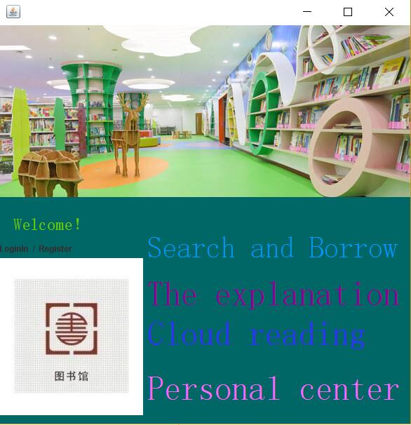

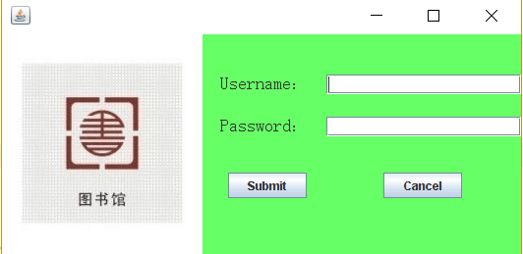

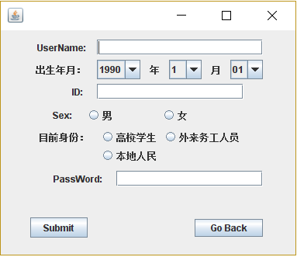

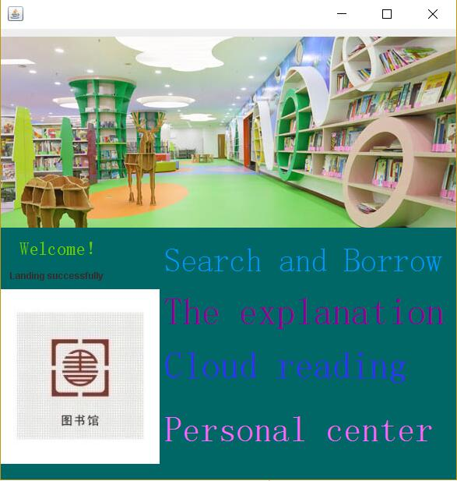

**Search and Borrow management module**

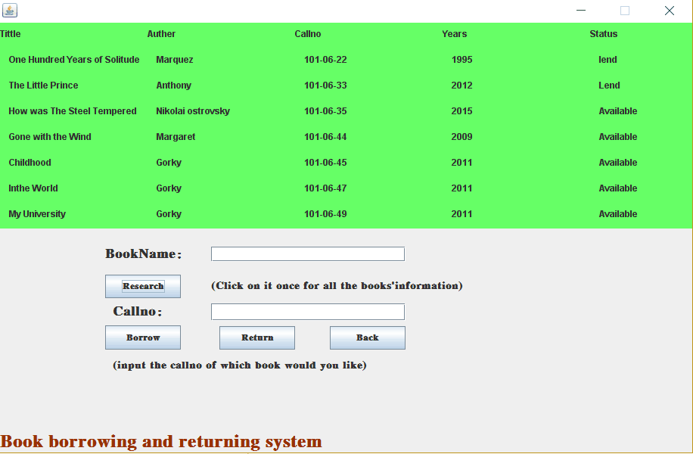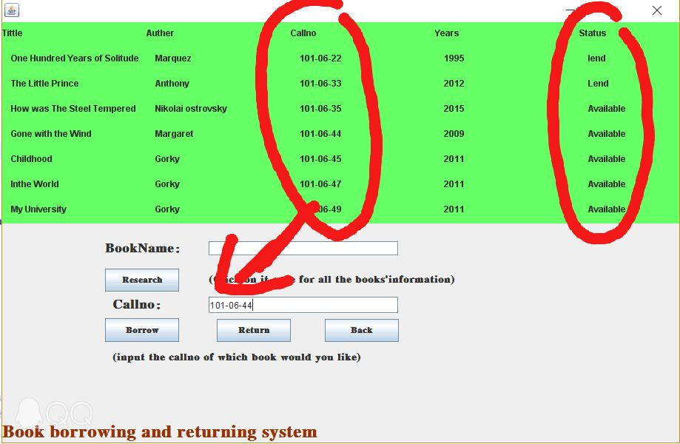

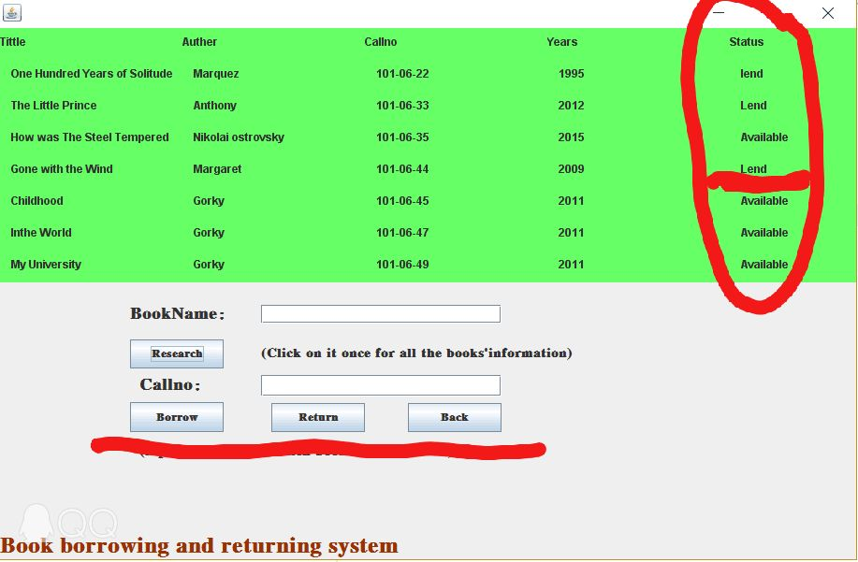

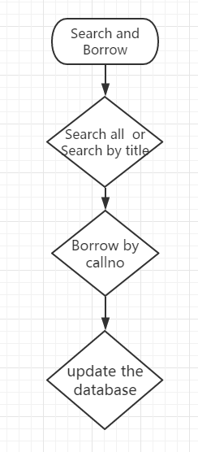

**other module**

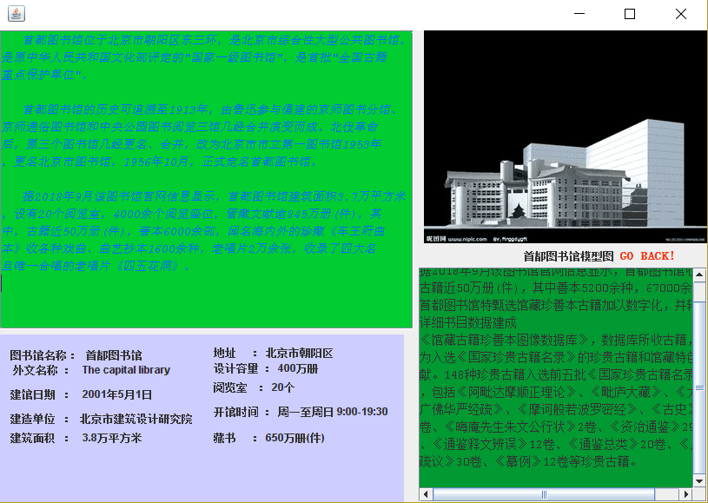

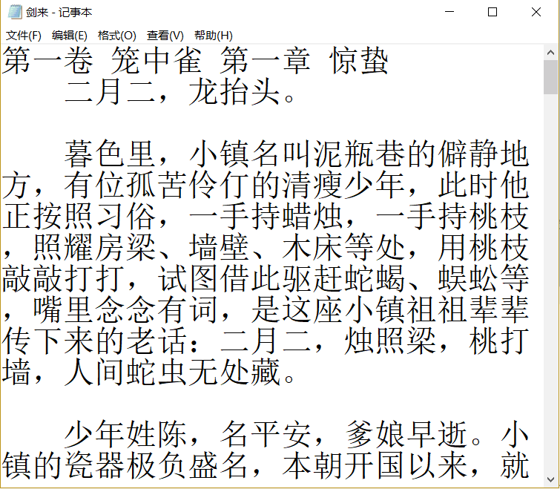

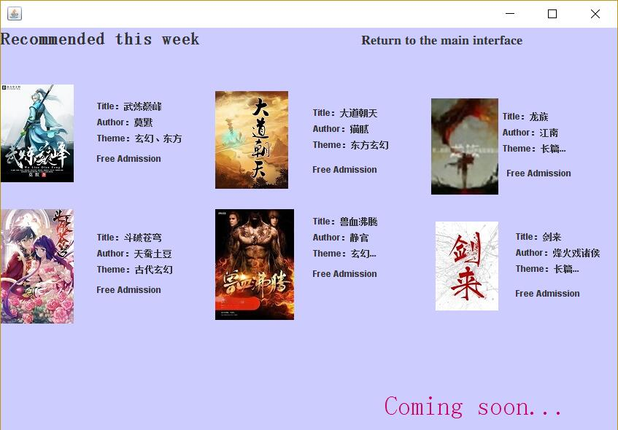

**Personal Center**

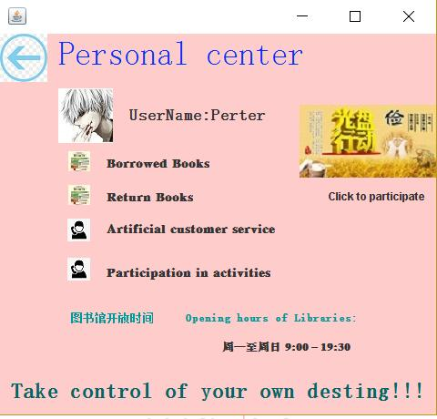

**Project flow chart**

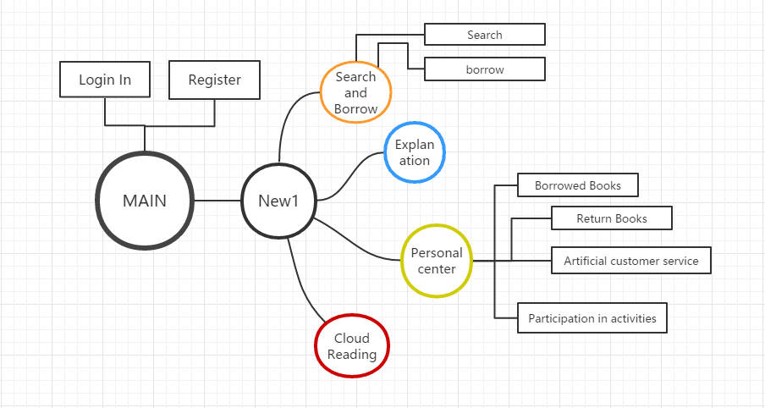

**CODE**

**Code of Main.java**

import javax.swing.JFrame;

import javax.swing.JOptionPane;

public class Main extends javax.swing.JFrame {

public Main() {

initComponents();

}

@SuppressWarnings("unchecked")

// <editor-fold defaultstate="collapsed" desc="Generated Code">

private void initComponents() {

jPanel1 = new javax.swing.JPanel();

jLabel1 = new javax.swing.JLabel();

jLabel2 = new javax.swing.JLabel();

jLabel3 = new javax.swing.JLabel();

jLabel4 = new javax.swing.JLabel();

jLabel5 = new javax.swing.JLabel();

jLabel6 = new javax.swing.JLabel();

jLabel7 = new javax.swing.JLabel();

jLabel8 = new javax.swing.JLabel();

jLabel9 = new javax.swing.JLabel();

jLabel10 = new javax.swing.JLabel();

setDefaultCloseOperation(javax.swing.WindowConstants.EXIT_ON_CLOSE);

jPanel1.setBackground(new java.awt.Color(0, 102, 102));

jLabel1.setIcon(new javax.swing.ImageIcon(getClass().getResource("/project/banner5.jpg"))); // NOI18N

jLabel2.setFont(new java.awt.Font("宋体", 0, 24)); // NOI18N

jLabel2.setForeground(new java.awt.Color(102, 204, 0));

jLabel2.setText("Welcome！");

jLabel3.setText("LoginIn");

jLabel3.addMouseListener(new java.awt.event.MouseAdapter() {

public void mouseClicked(java.awt.event.MouseEvent evt) {

jLabel3MouseClicked(evt);

}

});

jLabel4.setText("Register");

jLabel4.addMouseListener(new java.awt.event.MouseAdapter() {

public void mouseClicked(java.awt.event.MouseEvent evt) {

jLabel4MouseClicked(evt);

}

});

jLabel5.setFont(new java.awt.Font("宋体", 0, 42)); // NOI18N

jLabel5.setForeground(new java.awt.Color(0, 153, 255));

jLabel5.setText("Search and Borrow");

jLabel5.addMouseListener(new java.awt.event.MouseAdapter() {

public void mouseClicked(java.awt.event.MouseEvent evt) {

jLabel5MouseClicked(evt);

}

});

jLabel6.setFont(new java.awt.Font("宋体", 0, 48)); // NOI18N

jLabel6.setForeground(new java.awt.Color(153, 0, 153));

jLabel6.setText("The explanation");

jLabel6.addMouseListener(new java.awt.event.MouseAdapter() {

public void mouseClicked(java.awt.event.MouseEvent evt) {

jLabel6MouseClicked(evt);

}

});

jLabel7.setFont(new java.awt.Font("宋体", 0, 48)); // NOI18N

jLabel7.setForeground(new java.awt.Color(51, 51, 255));

jLabel7.setText("Cloud reading");

jLabel7.addMouseListener(new java.awt.event.MouseAdapter() {

public void mouseClicked(java.awt.event.MouseEvent evt) {

jLabel7MouseClicked(evt);

}

});

jLabel8.setFont(new java.awt.Font("宋体", 0, 48)); // NOI18N

jLabel8.setForeground(new java.awt.Color(255, 102, 255));

jLabel8.setText("Personal center");

jLabel8.addMouseListener(new java.awt.event.MouseAdapter() {

public void mouseClicked(java.awt.event.MouseEvent evt) {

jLabel8MouseClicked(evt);

}

});

jLabel9.setText("/");

jLabel10.setIcon(new javax.swing.ImageIcon(getClass().getResource("/project/t01297d774571018b37.jpg"))); // NOI18N

jLabel10.addMouseListener(new java.awt.event.MouseAdapter() {

public void mouseClicked(java.awt.event.MouseEvent evt) {

jLabel10MouseClicked(evt);

}

});

javax.swing.GroupLayout jPanel1Layout = new javax.swing.GroupLayout(jPanel1);

jPanel1.setLayout(jPanel1Layout);

jPanel1Layout.setHorizontalGroup(

jPanel1Layout.createParallelGroup(javax.swing.GroupLayout.Alignment.LEADING)

.addComponent(jLabel1)

.addGroup(jPanel1Layout.createSequentialGroup()

.addGroup(jPanel1Layout.createParallelGroup(javax.swing.GroupLayout.Alignment.LEADING)

.addGroup(jPanel1Layout.createSequentialGroup()

.addGroup(jPanel1Layout.createParallelGroup(javax.swing.GroupLayout.Alignment.LEADING)

.addGroup(jPanel1Layout.createSequentialGroup()

.addGap(19, 19, 19)

.addComponent(jLabel2))

.addGroup(jPanel1Layout.createSequentialGroup()

.addComponent(jLabel3)

.addPreferredGap(javax.swing.LayoutStyle.ComponentPlacement.RELATED)

.addComponent(jLabel9)

.addPreferredGap(javax.swing.LayoutStyle.ComponentPlacement.RELATED)

.addComponent(jLabel4)))

.addGap(83, 83, 83))

.addGroup(javax.swing.GroupLayout.Alignment.TRAILING, jPanel1Layout.createSequentialGroup()

.addComponent(jLabel10)

.addPreferredGap(javax.swing.LayoutStyle.ComponentPlacement.RELATED)))

.addGroup(jPanel1Layout.createParallelGroup(javax.swing.GroupLayout.Alignment.LEADING)

.addComponent(jLabel5)

.addGroup(jPanel1Layout.createParallelGroup(javax.swing.GroupLayout.Alignment.LEADING, false)

.addComponent(jLabel6, javax.swing.GroupLayout.DEFAULT_SIZE, javax.swing.GroupLayout.DEFAULT_SIZE, Short.MAX_VALUE)

.addComponent(jLabel7, javax.swing.GroupLayout.PREFERRED_SIZE, 360, javax.swing.GroupLayout.PREFERRED_SIZE))

.addComponent(jLabel8)))

);

jPanel1Layout.setVerticalGroup(

jPanel1Layout.createParallelGroup(javax.swing.GroupLayout.Alignment.LEADING)

.addGroup(jPanel1Layout.createSequentialGroup()

.addComponent(jLabel1, javax.swing.GroupLayout.PREFERRED_SIZE, 245, javax.swing.GroupLayout.PREFERRED_SIZE)

.addGap(18, 18, 18)

.addGroup(jPanel1Layout.createParallelGroup(javax.swing.GroupLayout.Alignment.LEADING)

.addGroup(jPanel1Layout.createSequentialGroup()

.addGap(22, 22, 22)

.addComponent(jLabel5, javax.swing.GroupLayout.PREFERRED_SIZE, 63, javax.swing.GroupLayout.PREFERRED_SIZE)

.addPreferredGap(javax.swing.LayoutStyle.ComponentPlacement.RELATED)

.addComponent(jLabel6)

.addPreferredGap(javax.swing.LayoutStyle.ComponentPlacement.RELATED)

.addComponent(jLabel7, javax.swing.GroupLayout.PREFERRED_SIZE, 46, javax.swing.GroupLayout.PREFERRED_SIZE)

.addGap(27, 27, 27)

.addComponent(jLabel8))

.addGroup(jPanel1Layout.createSequentialGroup()

.addComponent(jLabel2, javax.swing.GroupLayout.PREFERRED_SIZE, 41, javax.swing.GroupLayout.PREFERRED_SIZE)

.addPreferredGap(javax.swing.LayoutStyle.ComponentPlacement.RELATED)

.addGroup(jPanel1Layout.createParallelGroup(javax.swing.GroupLayout.Alignment.BASELINE)

.addComponent(jLabel3)

.addComponent(jLabel9)

.addComponent(jLabel4))

.addPreferredGap(javax.swing.LayoutStyle.ComponentPlacement.RELATED)

.addComponent(jLabel10)))

.addContainerGap())

);

javax.swing.GroupLayout layout = new javax.swing.GroupLayout(getContentPane());

getContentPane().setLayout(layout);

layout.setHorizontalGroup(

layout.createParallelGroup(javax.swing.GroupLayout.Alignment.LEADING)

.addComponent(jPanel1, javax.swing.GroupLayout.DEFAULT_SIZE, javax.swing.GroupLayout.DEFAULT_SIZE, Short.MAX_VALUE)

);

layout.setVerticalGroup(

layout.createParallelGroup(javax.swing.GroupLayout.Alignment.LEADING)

.addGroup(javax.swing.GroupLayout.Alignment.TRAILING, layout.createSequentialGroup()

.addGap(0, 0, Short.MAX_VALUE)

.addComponent(jPanel1, javax.swing.GroupLayout.PREFERRED_SIZE, javax.swing.GroupLayout.DEFAULT_SIZE, javax.swing.GroupLayout.PREFERRED_SIZE))

);

pack();

}// </editor-fold>

private void jLabel3MouseClicked(java.awt.event.MouseEvent evt) {

LoginIn as = new LoginIn();

as.show();

dispose();

}

private void jLabel4MouseClicked(java.awt.event.MouseEvent evt) {

Zhuce z = new Zhuce();

z.show();

}

private void jLabel5MouseClicked(java.awt.event.MouseEvent evt) {

JOptionPane.showMessageDialog(this, "YOU HAVE NOT LOGININ YET");

}

private void jLabel6MouseClicked(java.awt.event.MouseEvent evt) {

JOptionPane.showMessageDialog(this, "YOU HAVE NOT LOGININ YET");

}

private void jLabel10MouseClicked(java.awt.event.MouseEvent evt) {

JOptionPane.showMessageDialog(this, "YOU HAVE NOT LOGININ YET");

}

private void jLabel7MouseClicked(java.awt.event.MouseEvent evt) {

JOptionPane.showMessageDialog(this, "YOU HAVE NOT LOGININ YET");

}

private void jLabel8MouseClicked(java.awt.event.MouseEvent evt) {

JOptionPane.showMessageDialog(this, "YOU HAVE NOT LOGININ YET");

}

public static void main(String args[]) {

//<editor-fold defaultstate="collapsed" desc=" Look and feel setting code (optional) ">

/*

* If Nimbus (introduced in Java SE 6) is not available, stay with the

* default look and feel. For details see

* http://download.oracle.com/javase/tutorial/uiswing/lookandfeel/plaf.html

*/

try {

for (javax.swing.UIManager.LookAndFeelInfo info : javax.swing.UIManager.getInstalledLookAndFeels()) {

if ("Nimbus".equals(info.getName())) {

javax.swing.UIManager.setLookAndFeel(info.getClassName());

break;

}

}

} catch (ClassNotFoundException ex) {

java.util.logging.Logger.getLogger(Main.class.getName()).log(java.util.logging.Level.SEVERE, null, ex);

} catch (InstantiationException ex) {

java.util.logging.Logger.getLogger(Main.class.getName()).log(java.util.logging.Level.SEVERE, null, ex);

} catch (IllegalAccessException ex) {

java.util.logging.Logger.getLogger(Main.class.getName()).log(java.util.logging.Level.SEVERE, null, ex);

} catch (javax.swing.UnsupportedLookAndFeelException ex) {

java.util.logging.Logger.getLogger(Main.class.getName()).log(java.util.logging.Level.SEVERE, null, ex);

}

//</editor-fold>

java.awt.EventQueue.invokeLater(new Runnable() {

public void run() {

new Main().setVisible(true);

}

});

}

// Variables declaration - do not modify

private javax.swing.JLabel jLabel1;

private javax.swing.JLabel jLabel10;

private javax.swing.JLabel jLabel2;

private javax.swing.JLabel jLabel3;

private javax.swing.JLabel jLabel4;

private javax.swing.JLabel jLabel5;

private javax.swing.JLabel jLabel6;

private javax.swing.JLabel jLabel7;

private javax.swing.JLabel jLabel8;

private javax.swing.JLabel jLabel9;

private javax.swing.JPanel jPanel1;

// End of variables declaration

}

**Code of LoginIn.java**

public class LoginIn extends javax.swing.JFrame {

public LoginIn() {

initComponents();

}

@SuppressWarnings("unchecked")

// <editor-fold defaultstate="collapsed" desc="Generated Code">

private void initComponents() {

jPanel1 = new javax.swing.JPanel();

jLabel1 = new javax.swing.JLabel();

jPasswordField1 = new javax.swing.JPasswordField();

jLabel2 = new javax.swing.JLabel();

jTextField1 = new javax.swing.JTextField();

jLabel3 = new javax.swing.JLabel();

jToggleButton1 = new javax.swing.JToggleButton();

jToggleButton2 = new javax.swing.JToggleButton();

setDefaultCloseOperation(javax.swing.WindowConstants.EXIT_ON_CLOSE);

addMouseListener(new java.awt.event.MouseAdapter() {

public void mouseClicked(java.awt.event.MouseEvent evt) {

formMouseClicked(evt);

}

});

jPanel1.setBackground(new java.awt.Color(102, 255, 102));

jLabel1.setFont(new java.awt.Font("宋体", 0, 18)); // NOI18N

jLabel1.setText("Password：");

jPasswordField1.addActionListener(new java.awt.event.ActionListener() {

public void actionPerformed(java.awt.event.ActionEvent evt) {

jPasswordField1ActionPerformed(evt);

}

});

jLabel2.setFont(new java.awt.Font("宋体", 0, 18)); // NOI18N

jLabel2.setText("Username：");

jTextField1.addActionListener(new java.awt.event.ActionListener() {

public void actionPerformed(java.awt.event.ActionEvent evt) {

jTextField1ActionPerformed(evt);

}

});

jLabel3.setIcon(new javax.swing.ImageIcon(getClass().getResource("/project/t01297d774571018b37.jpg"))); // NOI18N

jLabel3.addMouseListener(new java.awt.event.MouseAdapter() {

public void mouseClicked(java.awt.event.MouseEvent evt) {

jLabel3MouseClicked(evt);

}

});

jToggleButton1.setText("Submit");

jToggleButton1.addMouseListener(new java.awt.event.MouseAdapter() {

public void mouseClicked(java.awt.event.MouseEvent evt) {

jToggleButton1MouseClicked(evt);

}

});

jToggleButton1.addActionListener(new java.awt.event.ActionListener() {

public void actionPerformed(java.awt.event.ActionEvent evt) {

jToggleButton1ActionPerformed(evt);

}

});

jToggleButton2.setText("Cancel");

jToggleButton2.addMouseListener(new java.awt.event.MouseAdapter() {

public void mouseClicked(java.awt.event.MouseEvent evt) {

jToggleButton2MouseClicked(evt);

}

});

javax.swing.GroupLayout jPanel1Layout = new javax.swing.GroupLayout(jPanel1);

jPanel1.setLayout(jPanel1Layout);

jPanel1Layout.setHorizontalGroup(

jPanel1Layout.createParallelGroup(javax.swing.GroupLayout.Alignment.LEADING)

.addGroup(jPanel1Layout.createSequentialGroup()

.addComponent(jLabel3)

.addGap(18, 18, 18)

.addGroup(jPanel1Layout.createParallelGroup(javax.swing.GroupLayout.Alignment.LEADING)

.addGroup(jPanel1Layout.createParallelGroup(javax.swing.GroupLayout.Alignment.LEADING)

.addGroup(javax.swing.GroupLayout.Alignment.TRAILING, jPanel1Layout.createSequentialGroup()

.addComponent(jToggleButton1, javax.swing.GroupLayout.PREFERRED_SIZE, 80, javax.swing.GroupLayout.PREFERRED_SIZE)

.addGap(14, 14, 14))

.addGroup(jPanel1Layout.createSequentialGroup()

.addComponent(jLabel2, javax.swing.GroupLayout.PREFERRED_SIZE, 99, javax.swing.GroupLayout.PREFERRED_SIZE)

.addPreferredGap(javax.swing.LayoutStyle.ComponentPlacement.RELATED)))

.addGroup(javax.swing.GroupLayout.Alignment.TRAILING, jPanel1Layout.createSequentialGroup()

.addComponent(jLabel1)

.addGap(18, 18, 18)))

.addGroup(jPanel1Layout.createParallelGroup(javax.swing.GroupLayout.Alignment.LEADING)

.addGroup(jPanel1Layout.createSequentialGroup()

.addGroup(jPanel1Layout.createParallelGroup(javax.swing.GroupLayout.Alignment.LEADING, false)

.addComponent(jTextField1, javax.swing.GroupLayout.DEFAULT_SIZE, 198, Short.MAX_VALUE)

.addComponent(jPasswordField1))

.addGap(0, 0, Short.MAX_VALUE))

.addGroup(javax.swing.GroupLayout.Alignment.TRAILING, jPanel1Layout.createSequentialGroup()

.addGap(0, 0, Short.MAX_VALUE)

.addComponent(jToggleButton2, javax.swing.GroupLayout.PREFERRED_SIZE, 80, javax.swing.GroupLayout.PREFERRED_SIZE)

.addGap(60, 60, 60))))

);

jPanel1Layout.setVerticalGroup(

jPanel1Layout.createParallelGroup(javax.swing.GroupLayout.Alignment.LEADING)

.addComponent(jLabel3)

.addGroup(jPanel1Layout.createSequentialGroup()

.addGap(37, 37, 37)

.addGroup(jPanel1Layout.createParallelGroup(javax.swing.GroupLayout.Alignment.BASELINE)

.addComponent(jTextField1, javax.swing.GroupLayout.PREFERRED_SIZE, javax.swing.GroupLayout.DEFAULT_SIZE, javax.swing.GroupLayout.PREFERRED_SIZE)

.addComponent(jLabel2, javax.swing.GroupLayout.PREFERRED_SIZE, 24, javax.swing.GroupLayout.PREFERRED_SIZE))

.addGap(21, 21, 21)

.addGroup(jPanel1Layout.createParallelGroup(javax.swing.GroupLayout.Alignment.BASELINE)

.addComponent(jLabel1)

.addComponent(jPasswordField1, javax.swing.GroupLayout.PREFERRED_SIZE, javax.swing.GroupLayout.DEFAULT_SIZE, javax.swing.GroupLayout.PREFERRED_SIZE))

.addGap(37, 37, 37)

.addGroup(jPanel1Layout.createParallelGroup(javax.swing.GroupLayout.Alignment.BASELINE)

.addComponent(jToggleButton1)

.addComponent(jToggleButton2)))

);

javax.swing.GroupLayout layout = new javax.swing.GroupLayout(getContentPane());

getContentPane().setLayout(layout);

layout.setHorizontalGroup(

layout.createParallelGroup(javax.swing.GroupLayout.Alignment.LEADING)

.addComponent(jPanel1, javax.swing.GroupLayout.Alignment.TRAILING, javax.swing.GroupLayout.DEFAULT_SIZE, javax.swing.GroupLayout.DEFAULT_SIZE, Short.MAX_VALUE)

);

layout.setVerticalGroup(

layout.createParallelGroup(javax.swing.GroupLayout.Alignment.LEADING)

.addComponent(jPanel1, javax.swing.GroupLayout.DEFAULT_SIZE, javax.swing.GroupLayout.DEFAULT_SIZE, Short.MAX_VALUE)

);

pack();

}// </editor-fold>

private void jLabel3MouseClicked(java.awt.event.MouseEvent evt) {

Main ad = new Main();

ad.show();

}

private void jToggleButton1MouseClicked(java.awt.event.MouseEvent evt) {

PreparedStatement pst;

ResultSet rs;

try {

Class.forName("com.mysql.jdbc.Driver");

Connection con = DriverManager.getConnection("jdbc:mysql://localhost:3306/Library", "root", "1234");

String sql = "select * from User where Username=? and Password=?";

pst = con.prepareStatement(sql);

pst.setString(1, jTextField1.getText());

pst.setString(2, jPasswordField1.getText());

rs = pst.executeQuery();

if (jTextField1.getText().length() == 0) {

JOptionPane.showMessageDialog(this, "Empty User Name", "Warning", JOptionPane.WARNING_MESSAGE);

} else if (jPasswordField1.getPassword().length == 0) {

JOptionPane.showMessageDialog(this, "Empty Password", "Warning", JOptionPane.WARNING_MESSAGE);

} else if (rs.next()) {

New1 s = new New1();

s.setVisible(true);

dispose();

} else {

JOptionPane.showMessageDialog(this,"Incorrect User Name or Password","Error",JOptionPane.ERROR_MESSAGE);

}

} catch (Exception e) {

JOptionPane.showMessageDialog(this, e);

}

}

private void jTextField1ActionPerformed(java.awt.event.ActionEvent evt) {

}

private void jPasswordField1ActionPerformed(java.awt.event.ActionEvent evt) {

}

private void formMouseClicked(java.awt.event.MouseEvent evt) {

}

private void jToggleButton2MouseClicked(java.awt.event.MouseEvent evt) {

this.hide();// TODO add your handling code here:

}

private void jToggleButton1ActionPerformed(java.awt.event.ActionEvent evt) {

}

public static void main(String args[]) {

try {

for (javax.swing.UIManager.LookAndFeelInfo info : javax.swing.UIManager.getInstalledLookAndFeels()) {

if ("Nimbus".equals(info.getName())) {

javax.swing.UIManager.setLookAndFeel(info.getClassName());

break;

}

}

} catch (ClassNotFoundException ex) {

java.util.logging.Logger.getLogger(LoginIn.class.getName()).log(java.util.logging.Level.SEVERE, null, ex);

} catch (InstantiationException ex) {

java.util.logging.Logger.getLogger(LoginIn.class.getName()).log(java.util.logging.Level.SEVERE, null, ex);

} catch (IllegalAccessException ex) {

java.util.logging.Logger.getLogger(LoginIn.class.getName()).log(java.util.logging.Level.SEVERE, null, ex);

} catch (javax.swing.UnsupportedLookAndFeelException ex) {

java.util.logging.Logger.getLogger(LoginIn.class.getName()).log(java.util.logging.Level.SEVERE, null, ex);

}

java.awt.EventQueue.invokeLater(new Runnable() {

public void run() {

new LoginIn().setVisible(true);

}

});

}

// Variables declaration - do not modify

private javax.swing.JLabel jLabel1;

private javax.swing.JLabel jLabel2;

private javax.swing.JLabel jLabel3;

private javax.swing.JPanel jPanel1;

private javax.swing.JPasswordField jPasswordField1;

private javax.swing.JTextField jTextField1;

private javax.swing.JToggleButton jToggleButton1;

private javax.swing.JToggleButton jToggleButton2;

// End of variables declaration

}

**Code of Zhuce.java**

public class Zhuce extends javax.swing.JFrame {

public Zhuce() {

initComponents();

}

@SuppressWarnings("unchecked")

// <editor-fold defaultstate="collapsed" desc="Generated Code">

private void initComponents() {

buttonGroup1 = new javax.swing.ButtonGroup();

buttonGroup2 = new javax.swing.ButtonGroup();

buttonGroup3 = new javax.swing.ButtonGroup();

buttonGroup4 = new javax.swing.ButtonGroup();

jTextField1 = new javax.swing.JTextField();

jLabel3 = new javax.swing.JLabel();

jRadioButton4 = new javax.swing.JRadioButton();

jComboBox2 = new javax.swing.JComboBox();

jLabel1 = new javax.swing.JLabel();

jLabel4 = new javax.swing.JLabel();

jRadioButton3 = new javax.swing.JRadioButton();

jComboBox3 = new javax.swing.JComboBox();

jLabel5 = new javax.swing.JLabel();

jTextField2 = new javax.swing.JTextField();

jRadioButton5 = new javax.swing.JRadioButton();

jLabel6 = new javax.swing.JLabel();

jRadioButton1 = new javax.swing.JRadioButton();

jComboBox1 = new javax.swing.JComboBox();

jLabel2 = new javax.swing.JLabel();

jRadioButton2 = new javax.swing.JRadioButton();

jLabel7 = new javax.swing.JLabel();

jLabel8 = new javax.swing.JLabel();

jPasswordField1 = new javax.swing.JPasswordField();

jToggleButton1 = new javax.swing.JToggleButton();

jToggleButton2 = new javax.swing.JToggleButton();

setDefaultCloseOperation(javax.swing.WindowConstants.EXIT_ON_CLOSE);

jTextField1.setInheritsPopupMenu(true);

jTextField1.addActionListener(new java.awt.event.ActionListener() {

public void actionPerformed(java.awt.event.ActionEvent evt) {

jTextField1ActionPerformed(evt);

}

});

jLabel3.setText("年");

jLabel3.setAutoscrolls(true);

buttonGroup1.add(jRadioButton4);

jRadioButton4.setText("外来务工人员");

jRadioButton4.setAutoscrolls(true);

jRadioButton4.setInheritsPopupMenu(true);

jComboBox2.setModel(new javax.swing.DefaultComboBoxModel(new String[] { "1", "2", "3", "4", "5", "6", "7", "8", "9", "10", "11", "12", " " }));

jComboBox2.setAutoscrolls(true);

jComboBox2.setInheritsPopupMenu(true);

jLabel1.setText("UserName:");

jLabel1.setAutoscrolls(true);

jLabel4.setText("月");

jLabel4.setAutoscrolls(true);

buttonGroup1.add(jRadioButton3);

jRadioButton3.setText("高校学生");

jRadioButton3.setAutoscrolls(true);

jRadioButton3.setInheritsPopupMenu(true);

jComboBox3.setModel(new javax.swing.DefaultComboBoxModel(new String[] { "01", "02", "03", "04", "05", "06", "07", "08", "09", "10", "11", "12", "13", "14", "15", "16", "17", "18", "19", "20", "21", "22", "23", "24", "25", "26", "27", "28", "29", "30", " ", " " }));

jComboBox3.setAutoscrolls(true);

jComboBox3.setInheritsPopupMenu(true);

jLabel5.setText("ID:");

jLabel5.setAutoscrolls(true);

jTextField2.setInheritsPopupMenu(true);

jTextField2.addActionListener(new java.awt.event.ActionListener() {

public void actionPerformed(java.awt.event.ActionEvent evt) {

jTextField2ActionPerformed(evt);

}

});

buttonGroup1.add(jRadioButton5);

jRadioButton5.setText("本地人民");

jRadioButton5.setAutoscrolls(true);

jRadioButton5.setInheritsPopupMenu(true);

jLabel6.setText("Sex:");

jLabel6.setAutoscrolls(true);

buttonGroup2.add(jRadioButton1);

jRadioButton1.setText("男");

jRadioButton1.setAutoscrolls(true);

jRadioButton1.setInheritsPopupMenu(true);

jComboBox1.setModel(new javax.swing.DefaultComboBoxModel(new String[] { "1990", "1991", "1992", "1993", "1994", "1995", "1996", "1997", "1998", "1999", "2000", "2001", "2002", "2003", " " }));

jComboBox1.setAutoscrolls(true);

jComboBox1.setInheritsPopupMenu(true);

jComboBox1.addActionListener(new java.awt.event.ActionListener() {

public void actionPerformed(java.awt.event.ActionEvent evt) {

jComboBox1ActionPerformed(evt);

}

});

jLabel2.setText("出生年月：");

jLabel2.setAutoscrolls(true);

buttonGroup2.add(jRadioButton2);

jRadioButton2.setText("女");

jRadioButton2.setAutoscrolls(true);

jRadioButton2.setInheritsPopupMenu(true);

jLabel7.setText("目前身份：");

jLabel7.setAutoscrolls(true);

jLabel8.setText("PassWord:");

jPasswordField1.addActionListener(new java.awt.event.ActionListener() {

public void actionPerformed(java.awt.event.ActionEvent evt) {

jPasswordField1ActionPerformed(evt);

}

});

jToggleButton1.setText("Submit");

jToggleButton1.addMouseListener(new java.awt.event.MouseAdapter() {

public void mouseClicked(java.awt.event.MouseEvent evt) {

jToggleButton1MouseClicked(evt);

}

});

jToggleButton2.setText("Go Back");

jToggleButton2.addMouseListener(new java.awt.event.MouseAdapter() {

public void mouseClicked(java.awt.event.MouseEvent evt) {

jToggleButton2MouseClicked(evt);

}

});

javax.swing.GroupLayout layout = new javax.swing.GroupLayout(getContentPane());

getContentPane().setLayout(layout);

layout.setHorizontalGroup(

layout.createParallelGroup(javax.swing.GroupLayout.Alignment.LEADING)

.addGroup(layout.createSequentialGroup()

.addGroup(layout.createParallelGroup(javax.swing.GroupLayout.Alignment.LEADING)

.addGroup(layout.createSequentialGroup()

.addGap(49, 49, 49)

.addComponent(jLabel7)

.addPreferredGap(javax.swing.LayoutStyle.ComponentPlacement.UNRELATED)

.addGroup(layout.createParallelGroup(javax.swing.GroupLayout.Alignment.LEADING)

.addComponent(jRadioButton5)

.addGroup(layout.createSequentialGroup()

.addComponent(jRadioButton3)

.addPreferredGap(javax.swing.LayoutStyle.ComponentPlacement.UNRELATED)

.addComponent(jRadioButton4))))

.addGroup(layout.createParallelGroup(javax.swing.GroupLayout.Alignment.TRAILING)

.addGroup(layout.createParallelGroup(javax.swing.GroupLayout.Alignment.LEADING, false)

.addGroup(layout.createSequentialGroup()

.addGroup(layout.createParallelGroup(javax.swing.GroupLayout.Alignment.LEADING)

.addGroup(layout.createSequentialGroup()

.addGap(45, 45, 45)

.addGroup(layout.createParallelGroup(javax.swing.GroupLayout.Alignment.TRAILING, false)

.addComponent(jLabel2)

.addComponent(jLabel1))

.addGap(14, 14, 14))

.addGroup(javax.swing.GroupLayout.Alignment.TRAILING, layout.createSequentialGroup()

.addContainerGap()

.addComponent(jLabel5)

.addGap(18, 18, 18)))

.addGroup(layout.createParallelGroup(javax.swing.GroupLayout.Alignment.LEADING, false)

.addComponent(jTextField1)

.addGroup(layout.createSequentialGroup()

.addComponent(jComboBox1, javax.swing.GroupLayout.PREFERRED_SIZE, javax.swing.GroupLayout.DEFAULT_SIZE, javax.swing.GroupLayout.PREFERRED_SIZE)

.addPreferredGap(javax.swing.LayoutStyle.ComponentPlacement.RELATED)

.addComponent(jLabel3)

.addPreferredGap(javax.swing.LayoutStyle.ComponentPlacement.RELATED)

.addComponent(jComboBox2, javax.swing.GroupLayout.PREFERRED_SIZE, javax.swing.GroupLayout.DEFAULT_SIZE, javax.swing.GroupLayout.PREFERRED_SIZE)

.addPreferredGap(javax.swing.LayoutStyle.ComponentPlacement.RELATED)

.addComponent(jLabel4)

.addPreferredGap(javax.swing.LayoutStyle.ComponentPlacement.RELATED)

.addComponent(jComboBox3, javax.swing.GroupLayout.PREFERRED_SIZE, javax.swing.GroupLayout.DEFAULT_SIZE, javax.swing.GroupLayout.PREFERRED_SIZE))

.addComponent(jTextField2, javax.swing.GroupLayout.PREFERRED_SIZE, 189, javax.swing.GroupLayout.PREFERRED_SIZE)))

.addGroup(layout.createSequentialGroup()

.addGap(67, 67, 67)

.addComponent(jLabel6)

.addGap(18, 18, 18)

.addComponent(jRadioButton1)

.addGap(59, 59, 59)

.addComponent(jRadioButton2))

.addGroup(layout.createSequentialGroup()

.addGap(38, 38, 38)

.addComponent(jToggleButton1)

.addPreferredGap(javax.swing.LayoutStyle.ComponentPlacement.RELATED, javax.swing.GroupLayout.DEFAULT_SIZE, Short.MAX_VALUE)

.addComponent(jToggleButton2, javax.swing.GroupLayout.PREFERRED_SIZE, 88, javax.swing.GroupLayout.PREFERRED_SIZE)))

.addGroup(layout.createSequentialGroup()

.addContainerGap()

.addComponent(jLabel8)

.addGap(18, 18, 18)

.addComponent(jPasswordField1, javax.swing.GroupLayout.PREFERRED_SIZE, 189, javax.swing.GroupLayout.PREFERRED_SIZE))))

.addContainerGap(42, Short.MAX_VALUE))

);

layout.setVerticalGroup(

layout.createParallelGroup(javax.swing.GroupLayout.Alignment.LEADING)

.addGroup(layout.createSequentialGroup()

.addContainerGap()

.addGroup(layout.createParallelGroup(javax.swing.GroupLayout.Alignment.BASELINE)

.addComponent(jLabel1)

.addComponent(jTextField1, javax.swing.GroupLayout.PREFERRED_SIZE, javax.swing.GroupLayout.DEFAULT_SIZE, javax.swing.GroupLayout.PREFERRED_SIZE))

.addPreferredGap(javax.swing.LayoutStyle.ComponentPlacement.RELATED)

.addGroup(layout.createParallelGroup(javax.swing.GroupLayout.Alignment.BASELINE)

.addComponent(jLabel2)

.addComponent(jComboBox1, javax.swing.GroupLayout.PREFERRED_SIZE, javax.swing.GroupLayout.DEFAULT_SIZE, javax.swing.GroupLayout.PREFERRED_SIZE)

.addComponent(jLabel3)

.addComponent(jComboBox2, javax.swing.GroupLayout.PREFERRED_SIZE, javax.swing.GroupLayout.DEFAULT_SIZE, javax.swing.GroupLayout.PREFERRED_SIZE)

.addComponent(jLabel4)

.addComponent(jComboBox3, javax.swing.GroupLayout.PREFERRED_SIZE, javax.swing.GroupLayout.DEFAULT_SIZE, javax.swing.GroupLayout.PREFERRED_SIZE))

.addPreferredGap(javax.swing.LayoutStyle.ComponentPlacement.RELATED)

.addGroup(layout.createParallelGroup(javax.swing.GroupLayout.Alignment.BASELINE)

.addComponent(jLabel5)

.addComponent(jTextField2, javax.swing.GroupLayout.PREFERRED_SIZE, javax.swing.GroupLayout.DEFAULT_SIZE, javax.swing.GroupLayout.PREFERRED_SIZE))

.addPreferredGap(javax.swing.LayoutStyle.ComponentPlacement.UNRELATED)

.addGroup(layout.createParallelGroup(javax.swing.GroupLayout.Alignment.BASELINE)

.addComponent(jLabel6)

.addComponent(jRadioButton1)

.addComponent(jRadioButton2))

.addPreferredGap(javax.swing.LayoutStyle.ComponentPlacement.UNRELATED)

.addGroup(layout.createParallelGroup(javax.swing.GroupLayout.Alignment.BASELINE)

.addComponent(jRadioButton3)

.addComponent(jLabel7)

.addComponent(jRadioButton4))

.addPreferredGap(javax.swing.LayoutStyle.ComponentPlacement.RELATED)

.addComponent(jRadioButton5)

.addPreferredGap(javax.swing.LayoutStyle.ComponentPlacement.UNRELATED)

.addGroup(layout.createParallelGroup(javax.swing.GroupLayout.Alignment.BASELINE)

.addComponent(jLabel8)

.addComponent(jPasswordField1, javax.swing.GroupLayout.PREFERRED_SIZE, javax.swing.GroupLayout.DEFAULT_SIZE, javax.swing.GroupLayout.PREFERRED_SIZE))

.addGap(40, 40, 40)

.addGroup(layout.createParallelGroup(javax.swing.GroupLayout.Alignment.BASELINE)

.addComponent(jToggleButton1)

.addComponent(jToggleButton2, javax.swing.GroupLayout.PREFERRED_SIZE, 23, javax.swing.GroupLayout.PREFERRED_SIZE))

.addContainerGap(22, Short.MAX_VALUE))

);

pack();

}// </editor-fold>

private void jComboBox1ActionPerformed(java.awt.event.ActionEvent evt) {

}

private void jToggleButton1MouseClicked(java.awt.event.MouseEvent evt) {

PreparedStatement stmt;

ResultSet rs = null;

try {

Class.forName("com.mysql.jdbc.Driver");

Connection con = DriverManager.getConnection("jdbc:mysql://localhost:3306/library", "root", "1234");

String sql = "insert into User values(?,?,?)";

stmt = (PreparedStatement) con.prepareStatement(sql);

stmt.setString(1, jTextField1.getText());

stmt.setString(2, jPasswordField1.getText());

stmt.setString(3, jTextField2.getText());

JOptionPane.showMessageDialog(this, "Register successfully");

int i;

i = stmt.executeUpdate();

} catch (Exception e) {

JOptionPane.showMessageDialog(this,e);

}

}

private void jTextField1ActionPerformed(java.awt.event.ActionEvent evt) {

// TODO add your handling code here:

}

private void jPasswordField1ActionPerformed(java.awt.event.ActionEvent evt) {

// TODO add your handling code here:

}

private void jTextField2ActionPerformed(java.awt.event.ActionEvent evt) {

// TODO add your handling code here:

}

private void jToggleButton2MouseClicked(java.awt.event.MouseEvent evt) {

this.dispose();

}

public static void main(String args[]) {

try {

for (javax.swing.UIManager.LookAndFeelInfo info : javax.swing.UIManager.getInstalledLookAndFeels()) {

if ("Nimbus".equals(info.getName())) {

javax.swing.UIManager.setLookAndFeel(info.getClassName());

break;

}

}

} catch (ClassNotFoundException ex) {

java.util.logging.Logger.getLogger(Zhuce.class.getName()).log(java.util.logging.Level.SEVERE, null, ex);

} catch (InstantiationException ex) {

java.util.logging.Logger.getLogger(Zhuce.class.getName()).log(java.util.logging.Level.SEVERE, null, ex);

} catch (IllegalAccessException ex) {

java.util.logging.Logger.getLogger(Zhuce.class.getName()).log(java.util.logging.Level.SEVERE, null, ex);

} catch (javax.swing.UnsupportedLookAndFeelException ex) {

java.util.logging.Logger.getLogger(Zhuce.class.getName()).log(java.util.logging.Level.SEVERE, null, ex);

}

java.awt.EventQueue.invokeLater(new Runnable() {

public void run() {

new Zhuce().setVisible(true);

}

});

}

// Variables declaration - do not modify

private javax.swing.ButtonGroup buttonGroup1;

private javax.swing.ButtonGroup buttonGroup2;

private javax.swing.ButtonGroup buttonGroup3;

private javax.swing.ButtonGroup buttonGroup4;

private javax.swing.JComboBox jComboBox1;

private javax.swing.JComboBox jComboBox2;

private javax.swing.JComboBox jComboBox3;

private javax.swing.JLabel jLabel1;

private javax.swing.JLabel jLabel2;

private javax.swing.JLabel jLabel3;

private javax.swing.JLabel jLabel4;

private javax.swing.JLabel jLabel5;

private javax.swing.JLabel jLabel6;

private javax.swing.JLabel jLabel7;

private javax.swing.JLabel jLabel8;

private javax.swing.JPasswordField jPasswordField1;

private javax.swing.JRadioButton jRadioButton1;

private javax.swing.JRadioButton jRadioButton2;

private javax.swing.JRadioButton jRadioButton3;

private javax.swing.JRadioButton jRadioButton4;

private javax.swing.JRadioButton jRadioButton5;

private javax.swing.JTextField jTextField1;

private javax.swing.JTextField jTextField2;

private javax.swing.JToggleButton jToggleButton1;

private javax.swing.JToggleButton jToggleButton2;

// End of variables declaration

}

**Code of Research.jsp**

public class Zhuce extends javax.swing.JFrame {

public Zhuce() {

initComponents();

}

@SuppressWarnings("unchecked")

// <editor-fold defaultstate="collapsed" desc="Generated Code">

private void initComponents() {

buttonGroup1 = new javax.swing.ButtonGroup();

buttonGroup2 = new javax.swing.ButtonGroup();

buttonGroup3 = new javax.swing.ButtonGroup();

buttonGroup4 = new javax.swing.ButtonGroup();

jTextField1 = new javax.swing.JTextField();

jLabel3 = new javax.swing.JLabel();

jRadioButton4 = new javax.swing.JRadioButton();

jComboBox2 = new javax.swing.JComboBox();

jLabel1 = new javax.swing.JLabel();

jLabel4 = new javax.swing.JLabel();

jRadioButton3 = new javax.swing.JRadioButton();

jComboBox3 = new javax.swing.JComboBox();

jLabel5 = new javax.swing.JLabel();

jTextField2 = new javax.swing.JTextField();

jRadioButton5 = new javax.swing.JRadioButton();

jLabel6 = new javax.swing.JLabel();

jRadioButton1 = new javax.swing.JRadioButton();

jComboBox1 = new javax.swing.JComboBox();

jLabel2 = new javax.swing.JLabel();

jRadioButton2 = new javax.swing.JRadioButton();

jLabel7 = new javax.swing.JLabel();

jLabel8 = new javax.swing.JLabel();

jPasswordField1 = new javax.swing.JPasswordField();

jToggleButton1 = new javax.swing.JToggleButton();

jToggleButton2 = new javax.swing.JToggleButton();

setDefaultCloseOperation(javax.swing.WindowConstants.EXIT_ON_CLOSE);

jTextField1.setInheritsPopupMenu(true);

jTextField1.addActionListener(new java.awt.event.ActionListener() {

public void actionPerformed(java.awt.event.ActionEvent evt) {

jTextField1ActionPerformed(evt);

}

});

jLabel3.setText("年");

jLabel3.setAutoscrolls(true);

buttonGroup1.add(jRadioButton4);

jRadioButton4.setText("外来务工人员");

jRadioButton4.setAutoscrolls(true);

jRadioButton4.setInheritsPopupMenu(true);

jComboBox2.setModel(new javax.swing.DefaultComboBoxModel(new String[] { "1", "2", "3", "4", "5", "6", "7", "8", "9", "10", "11", "12", " " }));

jComboBox2.setAutoscrolls(true);

jComboBox2.setInheritsPopupMenu(true);

jLabel1.setText("UserName:");

jLabel1.setAutoscrolls(true);

jLabel4.setText("月");

jLabel4.setAutoscrolls(true);

buttonGroup1.add(jRadioButton3);

jRadioButton3.setText("高校学生");

jRadioButton3.setAutoscrolls(true);

jRadioButton3.setInheritsPopupMenu(true);

jComboBox3.setModel(new javax.swing.DefaultComboBoxModel(new String[] { "01", "02", "03", "04", "05", "06", "07", "08", "09", "10", "11", "12", "13", "14", "15", "16", "17", "18", "19", "20", "21", "22", "23", "24", "25", "26", "27", "28", "29", "30", " ", " " }));

jComboBox3.setAutoscrolls(true);

jComboBox3.setInheritsPopupMenu(true);

jLabel5.setText("ID:");

jLabel5.setAutoscrolls(true);

jTextField2.setInheritsPopupMenu(true);

jTextField2.addActionListener(new java.awt.event.ActionListener() {

public void actionPerformed(java.awt.event.ActionEvent evt) {

jTextField2ActionPerformed(evt);

}

});

buttonGroup1.add(jRadioButton5);

jRadioButton5.setText("本地人民");

jRadioButton5.setAutoscrolls(true);

jRadioButton5.setInheritsPopupMenu(true);

jLabel6.setText("Sex:");

jLabel6.setAutoscrolls(true);

buttonGroup2.add(jRadioButton1);

jRadioButton1.setText("男");

jRadioButton1.setAutoscrolls(true);

jRadioButton1.setInheritsPopupMenu(true);

jComboBox1.setModel(new javax.swing.DefaultComboBoxModel(new String[] { "1990", "1991", "1992", "1993", "1994", "1995", "1996", "1997", "1998", "1999", "2000", "2001", "2002", "2003", " " }));

jComboBox1.setAutoscrolls(true);

jComboBox1.setInheritsPopupMenu(true);

jComboBox1.addActionListener(new java.awt.event.ActionListener() {

public void actionPerformed(java.awt.event.ActionEvent evt) {

jComboBox1ActionPerformed(evt);

}

});

jLabel2.setText("出生年月：");

jLabel2.setAutoscrolls(true);

buttonGroup2.add(jRadioButton2);

jRadioButton2.setText("女");

jRadioButton2.setAutoscrolls(true);

jRadioButton2.setInheritsPopupMenu(true);

jLabel7.setText("目前身份：");

jLabel7.setAutoscrolls(true);

jLabel8.setText("PassWord:");

jPasswordField1.addActionListener(new java.awt.event.ActionListener() {

public void actionPerformed(java.awt.event.ActionEvent evt) {

jPasswordField1ActionPerformed(evt);

}

});

jToggleButton1.setText("Submit");

jToggleButton1.addMouseListener(new java.awt.event.MouseAdapter() {

public void mouseClicked(java.awt.event.MouseEvent evt) {

jToggleButton1MouseClicked(evt);

}

});

jToggleButton2.setText("Go Back");

jToggleButton2.addMouseListener(new java.awt.event.MouseAdapter() {

public void mouseClicked(java.awt.event.MouseEvent evt) {

jToggleButton2MouseClicked(evt);

}

});

javax.swing.GroupLayout layout = new javax.swing.GroupLayout(getContentPane());

getContentPane().setLayout(layout);

layout.setHorizontalGroup(

layout.createParallelGroup(javax.swing.GroupLayout.Alignment.LEADING)

.addGroup(layout.createSequentialGroup()

.addGroup(layout.createParallelGroup(javax.swing.GroupLayout.Alignment.LEADING)

.addGroup(layout.createSequentialGroup()

.addGap(49, 49, 49)

.addComponent(jLabel7)

.addPreferredGap(javax.swing.LayoutStyle.ComponentPlacement.UNRELATED)

.addGroup(layout.createParallelGroup(javax.swing.GroupLayout.Alignment.LEADING)

.addComponent(jRadioButton5)

.addGroup(layout.createSequentialGroup()

.addComponent(jRadioButton3)

.addPreferredGap(javax.swing.LayoutStyle.ComponentPlacement.UNRELATED)

.addComponent(jRadioButton4))))

.addGroup(layout.createParallelGroup(javax.swing.GroupLayout.Alignment.TRAILING)

.addGroup(layout.createParallelGroup(javax.swing.GroupLayout.Alignment.LEADING, false)

.addGroup(layout.createSequentialGroup()

.addGroup(layout.createParallelGroup(javax.swing.GroupLayout.Alignment.LEADING)

.addGroup(layout.createSequentialGroup()

.addGap(45, 45, 45)

.addGroup(layout.createParallelGroup(javax.swing.GroupLayout.Alignment.TRAILING, false)

.addComponent(jLabel2)

.addComponent(jLabel1))

.addGap(14, 14, 14))

.addGroup(javax.swing.GroupLayout.Alignment.TRAILING, layout.createSequentialGroup()

.addContainerGap()

.addComponent(jLabel5)

.addGap(18, 18, 18)))

.addGroup(layout.createParallelGroup(javax.swing.GroupLayout.Alignment.LEADING, false)

.addComponent(jTextField1)

.addGroup(layout.createSequentialGroup()

.addComponent(jComboBox1, javax.swing.GroupLayout.PREFERRED_SIZE, javax.swing.GroupLayout.DEFAULT_SIZE, javax.swing.GroupLayout.PREFERRED_SIZE)

.addPreferredGap(javax.swing.LayoutStyle.ComponentPlacement.RELATED)

.addComponent(jLabel3)

.addPreferredGap(javax.swing.LayoutStyle.ComponentPlacement.RELATED)

.addComponent(jComboBox2, javax.swing.GroupLayout.PREFERRED_SIZE, javax.swing.GroupLayout.DEFAULT_SIZE, javax.swing.GroupLayout.PREFERRED_SIZE)

.addPreferredGap(javax.swing.LayoutStyle.ComponentPlacement.RELATED)

.addComponent(jLabel4)

.addPreferredGap(javax.swing.LayoutStyle.ComponentPlacement.RELATED)

.addComponent(jComboBox3, javax.swing.GroupLayout.PREFERRED_SIZE, javax.swing.GroupLayout.DEFAULT_SIZE, javax.swing.GroupLayout.PREFERRED_SIZE))

.addComponent(jTextField2, javax.swing.GroupLayout.PREFERRED_SIZE, 189, javax.swing.GroupLayout.PREFERRED_SIZE)))

.addGroup(layout.createSequentialGroup()

.addGap(67, 67, 67)

.addComponent(jLabel6)

.addGap(18, 18, 18)

.addComponent(jRadioButton1)

.addGap(59, 59, 59)

.addComponent(jRadioButton2))

.addGroup(layout.createSequentialGroup()

.addGap(38, 38, 38)

.addComponent(jToggleButton1)

.addPreferredGap(javax.swing.LayoutStyle.ComponentPlacement.RELATED, javax.swing.GroupLayout.DEFAULT_SIZE, Short.MAX_VALUE)

.addComponent(jToggleButton2, javax.swing.GroupLayout.PREFERRED_SIZE, 88, javax.swing.GroupLayout.PREFERRED_SIZE)))

.addGroup(layout.createSequentialGroup()

.addContainerGap()

.addComponent(jLabel8)

.addGap(18, 18, 18)

.addComponent(jPasswordField1, javax.swing.GroupLayout.PREFERRED_SIZE, 189, javax.swing.GroupLayout.PREFERRED_SIZE))))

.addContainerGap(42, Short.MAX_VALUE))

);

layout.setVerticalGroup(

layout.createParallelGroup(javax.swing.GroupLayout.Alignment.LEADING)

.addGroup(layout.createSequentialGroup()

.addContainerGap()

.addGroup(layout.createParallelGroup(javax.swing.GroupLayout.Alignment.BASELINE)

.addComponent(jLabel1)

.addComponent(jTextField1, javax.swing.GroupLayout.PREFERRED_SIZE, javax.swing.GroupLayout.DEFAULT_SIZE, javax.swing.GroupLayout.PREFERRED_SIZE))

.addPreferredGap(javax.swing.LayoutStyle.ComponentPlacement.RELATED)

.addGroup(layout.createParallelGroup(javax.swing.GroupLayout.Alignment.BASELINE)

.addComponent(jLabel2)

.addComponent(jComboBox1, javax.swing.GroupLayout.PREFERRED_SIZE, javax.swing.GroupLayout.DEFAULT_SIZE, javax.swing.GroupLayout.PREFERRED_SIZE)

.addComponent(jLabel3)

.addComponent(jComboBox2, javax.swing.GroupLayout.PREFERRED_SIZE, javax.swing.GroupLayout.DEFAULT_SIZE, javax.swing.GroupLayout.PREFERRED_SIZE)

.addComponent(jLabel4)

.addComponent(jComboBox3, javax.swing.GroupLayout.PREFERRED_SIZE, javax.swing.GroupLayout.DEFAULT_SIZE, javax.swing.GroupLayout.PREFERRED_SIZE))

.addPreferredGap(javax.swing.LayoutStyle.ComponentPlacement.RELATED)

.addGroup(layout.createParallelGroup(javax.swing.GroupLayout.Alignment.BASELINE)

.addComponent(jLabel5)

.addComponent(jTextField2, javax.swing.GroupLayout.PREFERRED_SIZE, javax.swing.GroupLayout.DEFAULT_SIZE, javax.swing.GroupLayout.PREFERRED_SIZE))

.addPreferredGap(javax.swing.LayoutStyle.ComponentPlacement.UNRELATED)

.addGroup(layout.createParallelGroup(javax.swing.GroupLayout.Alignment.BASELINE)

.addComponent(jLabel6)

.addComponent(jRadioButton1)

.addComponent(jRadioButton2))

.addPreferredGap(javax.swing.LayoutStyle.ComponentPlacement.UNRELATED)

.addGroup(layout.createParallelGroup(javax.swing.GroupLayout.Alignment.BASELINE)

.addComponent(jRadioButton3)

.addComponent(jLabel7)

.addComponent(jRadioButton4))

.addPreferredGap(javax.swing.LayoutStyle.ComponentPlacement.RELATED)

.addComponent(jRadioButton5)

.addPreferredGap(javax.swing.LayoutStyle.ComponentPlacement.UNRELATED)

.addGroup(layout.createParallelGroup(javax.swing.GroupLayout.Alignment.BASELINE)

.addComponent(jLabel8)

.addComponent(jPasswordField1, javax.swing.GroupLayout.PREFERRED_SIZE, javax.swing.GroupLayout.DEFAULT_SIZE, javax.swing.GroupLayout.PREFERRED_SIZE))

.addGap(40, 40, 40)

.addGroup(layout.createParallelGroup(javax.swing.GroupLayout.Alignment.BASELINE)

.addComponent(jToggleButton1)

.addComponent(jToggleButton2, javax.swing.GroupLayout.PREFERRED_SIZE, 23, javax.swing.GroupLayout.PREFERRED_SIZE))

.addContainerGap(22, Short.MAX_VALUE))

);

pack();

}// </editor-fold>

private void jComboBox1ActionPerformed(java.awt.event.ActionEvent evt) {

}

private void jToggleButton1MouseClicked(java.awt.event.MouseEvent evt) {

PreparedStatement stmt;

ResultSet rs = null;

try {

Class.forName("com.mysql.jdbc.Driver");

Connection con = DriverManager.getConnection("jdbc:mysql://localhost:3306/library", "root", "1234");

String sql = "insert into User values(?,?,?)";

stmt = (PreparedStatement) con.prepareStatement(sql);

stmt.setString(1, jTextField1.getText());

stmt.setString(2, jPasswordField1.getText());

stmt.setString(3, jTextField2.getText());

JOptionPane.showMessageDialog(this, "Register successfully");

int i;

i = stmt.executeUpdate();

} catch (Exception e) {

JOptionPane.showMessageDialog(this,e);

}

}

private void jTextField1ActionPerformed(java.awt.event.ActionEvent evt) {

// TODO add your handling code here:

}

private void jPasswordField1ActionPerformed(java.awt.event.ActionEvent evt) {

// TODO add your handling code here:

}

private void jTextField2ActionPerformed(java.awt.event.ActionEvent evt) {

// TODO add your handling code here:

}

private void jToggleButton2MouseClicked(java.awt.event.MouseEvent evt) {

this.dispose();

}

public static void main(String args[]) {

try {

for (javax.swing.UIManager.LookAndFeelInfo info : javax.swing.UIManager.getInstalledLookAndFeels()) {

if ("Nimbus".equals(info.getName())) {

javax.swing.UIManager.setLookAndFeel(info.getClassName());

break;

}

}

} catch (ClassNotFoundException ex) {

java.util.logging.Logger.getLogger(Zhuce.class.getName()).log(java.util.logging.Level.SEVERE, null, ex);

} catch (InstantiationException ex) {

java.util.logging.Logger.getLogger(Zhuce.class.getName()).log(java.util.logging.Level.SEVERE, null, ex);

} catch (IllegalAccessException ex) {

java.util.logging.Logger.getLogger(Zhuce.class.getName()).log(java.util.logging.Level.SEVERE, null, ex);

} catch (javax.swing.UnsupportedLookAndFeelException ex) {

java.util.logging.Logger.getLogger(Zhuce.class.getName()).log(java.util.logging.Level.SEVERE, null, ex);

}

java.awt.EventQueue.invokeLater(new Runnable() {

public void run() {

new Zhuce().setVisible(true);

}

});

}

**Code of yunreading.jsp**

import java.io.*;

import java.util.logging.Level;

import java.util.logging.Logger;

public class yunreading extends javax.swing.JFrame {

/**

* Creates new form yunreading

*/

public yunreading() {

initComponents();

}

/**

* This method is called from within the constructor to initialize the form.

* WARNING: Do NOT modify this code. The content of this method is always

* regenerated by the Form Editor.

*/

@SuppressWarnings("unchecked")

// <editor-fold defaultstate="collapsed" desc="Generated Code">

private void initComponents() {

jPanel1 = new javax.swing.JPanel();

jLabel23 = new javax.swing.JLabel();

jLabel21 = new javax.swing.JLabel();

jLabel22 = new javax.swing.JLabel();

jLabel20 = new javax.swing.JLabel();

jLabel11 = new javax.swing.JLabel();

jLabel25 = new javax.swing.JLabel();

jLabel24 = new javax.swing.JLabel();

jLabel26 = new javax.swing.JLabel();

jLabel27 = new javax.swing.JLabel();

jLabel13 = new javax.swing.JLabel();

jLabel28 = new javax.swing.JLabel();

jLabel29 = new javax.swing.JLabel();

jLabel30 = new javax.swing.JLabel();

jLabel31 = new javax.swing.JLabel();

jLabel12 = new javax.swing.JLabel();

jLabel1 = new javax.swing.JLabel();

jLabel16 = new javax.swing.JLabel();

jLabel32 = new javax.swing.JLabel();

jLabel33 = new javax.swing.JLabel();

jLabel34 = new javax.swing.JLabel();

jLabel35 = new javax.swing.JLabel();

jLabel39 = new javax.swing.JLabel();

jLabel37 = new javax.swing.JLabel();

jLabel38 = new javax.swing.JLabel();

jLabel14 = new javax.swing.JLabel();

jLabel36 = new javax.swing.JLabel();

jLabel2 = new javax.swing.JLabel();

jLabel40 = new javax.swing.JLabel();

jLabel41 = new javax.swing.JLabel();

jLabel42 = new javax.swing.JLabel();

jLabel43 = new javax.swing.JLabel();

jLabel3 = new javax.swing.JLabel();

jLabel4 = new javax.swing.JLabel();

setDefaultCloseOperation(javax.swing.WindowConstants.EXIT_ON_CLOSE);

jPanel1.setBackground(new java.awt.Color(204, 204, 255));

jLabel23.setText("Title：武炼巅峰");

jLabel21.setText("Theme：玄幻、东方");

jLabel22.setText("Author：莫默");

jLabel20.setText("Free Admission");

jLabel11.setIcon(new javax.swing.ImageIcon(getClass().getResource("/图片/u=1766701603,463295750&fm=26&gp=0.jpg"))); // NOI18N

jLabel11.addMouseListener(new java.awt.event.MouseAdapter() {

public void mouseClicked(java.awt.event.MouseEvent evt) {

jLabel11MouseClicked(evt);

}

});

jLabel25.setText("Author：猫腻");

jLabel24.setText("Title：大道朝天");

jLabel26.setText("Theme：东方玄幻");

jLabel27.setText("Free Admission");

jLabel13.setIcon(new javax.swing.ImageIcon(getClass().getResource("/图片/u=2446009752,2713589581&fm=26&gp=0.jpg"))); // NOI18N

jLabel13.addMouseListener(new java.awt.event.MouseAdapter() {

public void mouseClicked(java.awt.event.MouseEvent evt) {

jLabel13MouseClicked(evt);

}

});

jLabel28.setText("Author：天蚕土豆");

jLabel29.setText("Theme：古代玄幻");

jLabel30.setText("Free Admission");

jLabel31.setText("Title：斗破苍穹");

jLabel12.setIcon(new javax.swing.ImageIcon(getClass().getResource("/图片/u=2282103524,461008304&fm=26&gp=0.jpg"))); // NOI18N

jLabel1.setBackground(new java.awt.Color(255, 51, 51));

jLabel1.setFont(new java.awt.Font("宋体", 0, 36)); // NOI18N

jLabel1.setForeground(new java.awt.Color(204, 0, 102));

jLabel1.setText("Coming soon……");

jLabel16.setIcon(new javax.swing.ImageIcon(getClass().getResource("/图片/u=3140622531,1187879991&fm=26&gp=0.jpg"))); // NOI18N

jLabel32.setText("Title：兽血沸腾");

jLabel33.setText("Free Admission");

jLabel34.setText("Author：静官");

jLabel35.setText("Theme：玄幻、魔幻");

jLabel39.setText("Theme：长篇魔幻");

jLabel37.setText("Free Admission");

jLabel38.setText("Author：江南");

jLabel14.setIcon(new javax.swing.ImageIcon(getClass().getResource("/图片/u=3025906957,3213918140&fm=26&gp=0.jpg"))); // NOI18N

jLabel36.setText("Title：龙族");

jLabel2.setIcon(new javax.swing.ImageIcon(getClass().getResource("/图片/u=2453534831,3693219437&fm=26&gp=0.jpg"))); // NOI18N

jLabel2.addMouseListener(new java.awt.event.MouseAdapter() {

public void mouseClicked(java.awt.event.MouseEvent evt) {

jLabel2MouseClicked(evt);

}

});

jLabel40.setText("Title：剑来");

jLabel41.setText("Theme：长篇魔幻");

jLabel42.setText("Free Admission");

jLabel43.setText("Author：烽火戏诸侯");

jLabel3.setFont(new java.awt.Font("宋体", 1, 24)); // NOI18N

jLabel3.setText("Recommended this week");

jLabel4.setFont(new java.awt.Font("方正小标宋简体", 0, 18)); // NOI18N

jLabel4.setText("Return to the main interface");

jLabel4.addMouseListener(new java.awt.event.MouseAdapter() {

public void mouseClicked(java.awt.event.MouseEvent evt) {

jLabel4MouseClicked(evt);

}

});

javax.swing.GroupLayout jPanel1Layout = new javax.swing.GroupLayout(jPanel1);

jPanel1.setLayout(jPanel1Layout);

jPanel1Layout.setHorizontalGroup(

jPanel1Layout.createParallelGroup(javax.swing.GroupLayout.Alignment.LEADING)

.addGroup(jPanel1Layout.createSequentialGroup()

.addGroup(jPanel1Layout.createParallelGroup(javax.swing.GroupLayout.Alignment.LEADING)

.addGroup(jPanel1Layout.createSequentialGroup()

.addGroup(jPanel1Layout.createParallelGroup(javax.swing.GroupLayout.Alignment.LEADING)

.addGroup(jPanel1Layout.createSequentialGroup()

.addComponent(jLabel12)

.addGap(32, 32, 32)

.addGroup(jPanel1Layout.createParallelGroup(javax.swing.GroupLayout.Alignment.LEADING)

.addComponent(jLabel29, javax.swing.GroupLayout.PREFERRED_SIZE, 156, javax.swing.GroupLayout.PREFERRED_SIZE)

.addComponent(jLabel28)

.addComponent(jLabel31)

.addComponent(jLabel30)))

.addGroup(jPanel1Layout.createSequentialGroup()

.addComponent(jLabel11)

.addGap(32, 32, 32)

.addGroup(jPanel1Layout.createParallelGroup(javax.swing.GroupLayout.Alignment.LEADING)

.addComponent(jLabel21, javax.swing.GroupLayout.PREFERRED_SIZE, 156, javax.swing.GroupLayout.PREFERRED_SIZE)

.addComponent(jLabel22)

.addComponent(jLabel23)

.addComponent(jLabel20))))

.addPreferredGap(javax.swing.LayoutStyle.ComponentPlacement.RELATED)

.addGroup(jPanel1Layout.createParallelGroup(javax.swing.GroupLayout.Alignment.LEADING)

.addComponent(jLabel16)

.addComponent(jLabel13))

.addGap(26, 26, 26)

.addGroup(jPanel1Layout.createParallelGroup(javax.swing.GroupLayout.Alignment.TRAILING, false)

.addGroup(jPanel1Layout.createSequentialGroup()

.addGroup(jPanel1Layout.createParallelGroup(javax.swing.GroupLayout.Alignment.LEADING)

.addComponent(jLabel26, javax.swing.GroupLayout.PREFERRED_SIZE, 156, javax.swing.GroupLayout.PREFERRED_SIZE)

.addComponent(jLabel25)

.addComponent(jLabel24)

.addComponent(jLabel27))

.addPreferredGap(javax.swing.LayoutStyle.ComponentPlacement.RELATED)

.addComponent(jLabel14))

.addGroup(jPanel1Layout.createSequentialGroup()

.addGroup(jPanel1Layout.createParallelGroup(javax.swing.GroupLayout.Alignment.LEADING)

.addComponent(jLabel33)

.addComponent(jLabel35, javax.swing.GroupLayout.PREFERRED_SIZE, 90, javax.swing.GroupLayout.PREFERRED_SIZE)

.addComponent(jLabel34)

.addComponent(jLabel32))

.addPreferredGap(javax.swing.LayoutStyle.ComponentPlacement.RELATED, javax.swing.GroupLayout.DEFAULT_SIZE, Short.MAX_VALUE)

.addComponent(jLabel2)))

.addGroup(jPanel1Layout.createParallelGroup(javax.swing.GroupLayout.Alignment.LEADING)

.addGroup(jPanel1Layout.createSequentialGroup()

.addGap(24, 24, 24)

.addGroup(jPanel1Layout.createParallelGroup(javax.swing.GroupLayout.Alignment.LEADING)

.addComponent(jLabel41, javax.swing.GroupLayout.PREFERRED_SIZE, 96, javax.swing.GroupLayout.PREFERRED_SIZE)

.addComponent(jLabel40)

.addComponent(jLabel43)

.addComponent(jLabel42)))

.addGroup(jPanel1Layout.createSequentialGroup()

.addPreferredGap(javax.swing.LayoutStyle.ComponentPlacement.UNRELATED)

.addComponent(jLabel37))

.addGroup(jPanel1Layout.createSequentialGroup()

.addPreferredGap(javax.swing.LayoutStyle.ComponentPlacement.RELATED)

.addGroup(jPanel1Layout.createParallelGroup(javax.swing.GroupLayout.Alignment.LEADING)

.addComponent(jLabel39, javax.swing.GroupLayout.PREFERRED_SIZE, 96, javax.swing.GroupLayout.PREFERRED_SIZE)

.addComponent(jLabel36)

.addComponent(jLabel38)))))

.addGroup(jPanel1Layout.createSequentialGroup()

.addComponent(jLabel3)

.addGap(221, 221, 221)

.addComponent(jLabel4)))

.addContainerGap(23, Short.MAX_VALUE))

.addGroup(javax.swing.GroupLayout.Alignment.TRAILING, jPanel1Layout.createSequentialGroup()

.addGap(0, 0, Short.MAX_VALUE)

.addComponent(jLabel1, javax.swing.GroupLayout.PREFERRED_SIZE, 253, javax.swing.GroupLayout.PREFERRED_SIZE)

.addGap(66, 66, 66))

);

jPanel1Layout.setVerticalGroup(

jPanel1Layout.createParallelGroup(javax.swing.GroupLayout.Alignment.LEADING)

.addGroup(jPanel1Layout.createSequentialGroup()

.addGroup(jPanel1Layout.createParallelGroup(javax.swing.GroupLayout.Alignment.BASELINE)

.addComponent(jLabel3)

.addComponent(jLabel4))

.addGap(40, 40, 40)

.addGroup(jPanel1Layout.createParallelGroup(javax.swing.GroupLayout.Alignment.LEADING)

.addGroup(javax.swing.GroupLayout.Alignment.TRAILING, jPanel1Layout.createSequentialGroup()

.addGroup(jPanel1Layout.createParallelGroup(javax.swing.GroupLayout.Alignment.TRAILING)

.addComponent(jLabel14)

.addGroup(jPanel1Layout.createSequentialGroup()

.addComponent(jLabel36)

.addPreferredGap(javax.swing.LayoutStyle.ComponentPlacement.RELATED)

.addComponent(jLabel38)

.addPreferredGap(javax.swing.LayoutStyle.ComponentPlacement.RELATED)

.addComponent(jLabel39)

.addGap(18, 18, 18)

.addComponent(jLabel37)

.addGap(22, 22, 22)))

.addGap(20, 20, 20))

.addGroup(javax.swing.GroupLayout.Alignment.TRAILING, jPanel1Layout.createSequentialGroup()

.addComponent(jLabel24)

.addPreferredGap(javax.swing.LayoutStyle.ComponentPlacement.RELATED)

.addComponent(jLabel25)

.addPreferredGap(javax.swing.LayoutStyle.ComponentPlacement.RELATED)

.addComponent(jLabel26)

.addGap(18, 18, 18)

.addComponent(jLabel27)

.addGap(47, 47, 47))

.addGroup(javax.swing.GroupLayout.Alignment.TRAILING, jPanel1Layout.createSequentialGroup()

.addGroup(jPanel1Layout.createParallelGroup(javax.swing.GroupLayout.Alignment.TRAILING)

.addGroup(jPanel1Layout.createParallelGroup(javax.swing.GroupLayout.Alignment.LEADING)

.addComponent(jLabel11, javax.swing.GroupLayout.PREFERRED_SIZE, 152, javax.swing.GroupLayout.PREFERRED_SIZE)

.addGroup(jPanel1Layout.createSequentialGroup()

.addGap(30, 30, 30)

.addComponent(jLabel23)

.addPreferredGap(javax.swing.LayoutStyle.ComponentPlacement.RELATED)

.addComponent(jLabel22)

.addPreferredGap(javax.swing.LayoutStyle.ComponentPlacement.RELATED)

.addComponent(jLabel21)

.addPreferredGap(javax.swing.LayoutStyle.ComponentPlacement.UNRELATED)

.addComponent(jLabel20)))

.addComponent(jLabel13))

.addGap(28, 28, 28)))

.addGroup(jPanel1Layout.createParallelGroup(javax.swing.GroupLayout.Alignment.LEADING)

.addComponent(jLabel16)

.addGroup(jPanel1Layout.createSequentialGroup()

.addGap(8, 8, 8)

.addComponent(jLabel32)

.addPreferredGap(javax.swing.LayoutStyle.ComponentPlacement.RELATED)

.addComponent(jLabel34)

.addPreferredGap(javax.swing.LayoutStyle.ComponentPlacement.RELATED)

.addComponent(jLabel35)

.addPreferredGap(javax.swing.LayoutStyle.ComponentPlacement.UNRELATED)

.addComponent(jLabel33))

.addComponent(jLabel12)

.addGroup(jPanel1Layout.createSequentialGroup()

.addGap(30, 30, 30)

.addComponent(jLabel31)

.addPreferredGap(javax.swing.LayoutStyle.ComponentPlacement.RELATED)

.addComponent(jLabel28)

.addPreferredGap(javax.swing.LayoutStyle.ComponentPlacement.RELATED)

.addComponent(jLabel29)

.addPreferredGap(javax.swing.LayoutStyle.ComponentPlacement.UNRELATED)

.addComponent(jLabel30))

.addGroup(jPanel1Layout.createSequentialGroup()

.addGap(17, 17, 17)

.addGroup(jPanel1Layout.createParallelGroup(javax.swing.GroupLayout.Alignment.LEADING)

.addComponent(jLabel2)

.addGroup(jPanel1Layout.createSequentialGroup()

.addGap(12, 12, 12)

.addComponent(jLabel40)

.addPreferredGap(javax.swing.LayoutStyle.ComponentPlacement.RELATED)

.addComponent(jLabel43)

.addPreferredGap(javax.swing.LayoutStyle.ComponentPlacement.RELATED)

.addComponent(jLabel41)

.addGap(18, 18, 18)

.addComponent(jLabel42)))))

.addPreferredGap(javax.swing.LayoutStyle.ComponentPlacement.RELATED, 91, Short.MAX_VALUE)

.addComponent(jLabel1)

.addGap(125, 125, 125))

);

javax.swing.GroupLayout layout = new javax.swing.GroupLayout(getContentPane());

getContentPane().setLayout(layout);

layout.setHorizontalGroup(

layout.createParallelGroup(javax.swing.GroupLayout.Alignment.LEADING)

.addComponent(jPanel1, javax.swing.GroupLayout.PREFERRED_SIZE, javax.swing.GroupLayout.DEFAULT_SIZE, javax.swing.GroupLayout.PREFERRED_SIZE)

);

layout.setVerticalGroup(

layout.createParallelGroup(javax.swing.GroupLayout.Alignment.LEADING)

.addComponent(jPanel1, javax.swing.GroupLayout.PREFERRED_SIZE, javax.swing.GroupLayout.DEFAULT_SIZE, javax.swing.GroupLayout.PREFERRED_SIZE)

);

pack();

}// </editor-fold>

private void jLabel11MouseClicked(java.awt.event.MouseEvent evt) {

File file = new File("C:\\Users\\Administrator\\Documents\\NetBeansProjects\\Myproject\\src\\文档\\武炼巅峰.txt");

try {

java.awt.Desktop.getDesktop().open(file);

} catch (IOException ex) {

Logger.getLogger(yunreading.class.getName()).log(Level.SEVERE, null, ex);

}

}

private void jLabel13MouseClicked(java.awt.event.MouseEvent evt) {

File file = new File("C:\\Users\\Administrator\\Documents\\NetBeansProjects\\Myproject\\src\\文档\\大道朝天.txt");

try {

java.awt.Desktop.getDesktop().open(file);

} catch (IOException ex) {

Logger.getLogger(yunreading.class.getName()).log(Level.SEVERE, null, ex);

}

}

private void jLabel4MouseClicked(java.awt.event.MouseEvent evt) {

New1 af = new New1();

af.show();

dispose();

}

private void jLabel2MouseClicked(java.awt.event.MouseEvent evt) {

File file = new File("C:\\Users\\Administrator\\Documents\\NetBeansProjects\\Myproject\\src\\文档\\剑来.txt");

try {

java.awt.Desktop.getDesktop().open(file);

} catch (IOException ex) {

Logger.getLogger(yunreading.class.getName()).log(Level.SEVERE, null, ex);

}

}

/**

* @param args the command line arguments

*/

public static void main(String args[]) {

/*

* Set the Nimbus look and feel

*/

//<editor-fold defaultstate="collapsed" desc=" Look and feel setting code (optional) ">

/*

* If Nimbus (introduced in Java SE 6) is not available, stay with the

* default look and feel. For details see

* http://download.oracle.com/javase/tutorial/uiswing/lookandfeel/plaf.html

*/

try {

for (javax.swing.UIManager.LookAndFeelInfo info : javax.swing.UIManager.getInstalledLookAndFeels()) {

if ("Nimbus".equals(info.getName())) {

javax.swing.UIManager.setLookAndFeel(info.getClassName());

break;

}

}

} catch (ClassNotFoundException ex) {

java.util.logging.Logger.getLogger(yunreading.class.getName()).log(java.util.logging.Level.SEVERE, null, ex);

} catch (InstantiationException ex) {

java.util.logging.Logger.getLogger(yunreading.class.getName()).log(java.util.logging.Level.SEVERE, null, ex);

} catch (IllegalAccessException ex) {

java.util.logging.Logger.getLogger(yunreading.class.getName()).log(java.util.logging.Level.SEVERE, null, ex);

} catch (javax.swing.UnsupportedLookAndFeelException ex) {

java.util.logging.Logger.getLogger(yunreading.class.getName()).log(java.util.logging.Level.SEVERE, null, ex);

}

//</editor-fold>

/*

* Create and display the form

*/

java.awt.EventQueue.invokeLater(new Runnable() {

public void run() {

new yunreading().setVisible(true);

}

});

}

**Code of Center.jsp**

public class Center extends javax.swing.JFrame {

public Center() {

initComponents();

}

@SuppressWarnings("unchecked")

// <editor-fold defaultstate="collapsed" desc="Generated Code">

private void initComponents() {

jPanel1 = new javax.swing.JPanel();

jLabel11 = new javax.swing.JLabel();

jLabel6 = new javax.swing.JLabel();

jLabel7 = new javax.swing.JLabel();

jLabel2 = new javax.swing.JLabel();

jLabel3 = new javax.swing.JLabel();

jLabel4 = new javax.swing.JLabel();

jLabel9 = new javax.swing.JLabel();

jLabel5 = new javax.swing.JLabel();

jLabel1 = new javax.swing.JLabel();

jLabel10 = new javax.swing.JLabel();

jLabel12 = new javax.swing.JLabel();

jLabel13 = new javax.swing.JLabel();

jLabel14 = new javax.swing.JLabel();

jLabel15 = new javax.swing.JLabel();

jLabel16 = new javax.swing.JLabel();

jLabel8 = new javax.swing.JLabel();

jLabel17 = new javax.swing.JLabel();

setDefaultCloseOperation(javax.swing.WindowConstants.EXIT_ON_CLOSE);

jPanel1.setBackground(new java.awt.Color(255, 204, 204));

jLabel11.setIcon(new javax.swing.ImageIcon(getClass().getResource("/图片/7b0665614ff0946660a6e1f7ea5fefd2.jpg"))); // NOI18N

jLabel6.setIcon(new javax.swing.ImageIcon(getClass().getResource("/图片/faf1b6a6e0816837d926816eadbbd09d.jpg"))); // NOI18N

jLabel7.setFont(new java.awt.Font("方正小标宋简体", 1, 14)); // NOI18N

jLabel7.setText("Return Books");

jLabel2.setIcon(new javax.swing.ImageIcon(getClass().getResource("/图片/de87eb667f78097beaa5defa685b16d9.jpg"))); // NOI18N

jLabel3.setFont(new java.awt.Font("宋体", 1, 18)); // NOI18N

jLabel3.setText("UserName:Perter");

jLabel4.setFont(new java.awt.Font("方正小标宋简体", 1, 14)); // NOI18N

jLabel4.setText("Borrowed Books");

jLabel9.setFont(new java.awt.Font("方正小标宋简体", 1, 14)); // NOI18N

jLabel9.setText("Artificial customer service");

jLabel5.setIcon(new javax.swing.ImageIcon(getClass().getResource("/图片/faf1b6a6e0816837d926816eadbbd09d.jpg"))); // NOI18N

jLabel1.setFont(new java.awt.Font("宋体", 0, 36)); // NOI18N

jLabel1.setForeground(new java.awt.Color(0, 51, 255));

jLabel1.setText("Personal center");

jLabel10.setIcon(new javax.swing.ImageIcon(getClass().getResource("/图片/168c01939b710375db0b598c1d4ed823.jpg"))); // NOI18N

jLabel10.addMouseListener(new java.awt.event.MouseAdapter() {

public void mouseClicked(java.awt.event.MouseEvent evt) {

jLabel10MouseClicked(evt);

}

});

jLabel12.setFont(new java.awt.Font("方正小标宋简体", 1, 14)); // NOI18N

jLabel12.setText("Participation in activities");

jLabel13.setIcon(new javax.swing.ImageIcon(getClass().getResource("/图片/7b0665614ff0946660a6e1f7ea5fefd2.jpg"))); // NOI18N

jLabel14.setFont(new java.awt.Font("方正小标宋简体", 1, 12)); // NOI18N

jLabel14.setForeground(new java.awt.Color(51, 51, 51));

jLabel14.setText("周一至周日 9:00－19:30");

jLabel15.setFont(new java.awt.Font("宋体", 1, 12)); // NOI18N

jLabel15.setForeground(new java.awt.Color(0, 153, 153));

jLabel15.setText(" 图书馆开放时间 Opening hours of Libraries:");

jLabel16.setIcon(new javax.swing.ImageIcon(getClass().getResource("/图片/timg_1.jpg"))); // NOI18N

jLabel8.setFont(new java.awt.Font("新宋体", 1, 24)); // NOI18N

jLabel8.setForeground(new java.awt.Color(0, 102, 102));

jLabel8.setText("Take control of your own desting!!!");

jLabel17.setText("Click to participate");

javax.swing.GroupLayout jPanel1Layout = new javax.swing.GroupLayout(jPanel1);

jPanel1.setLayout(jPanel1Layout);

jPanel1Layout.setHorizontalGroup(

jPanel1Layout.createParallelGroup(javax.swing.GroupLayout.Alignment.TRAILING)

.addGroup(javax.swing.GroupLayout.Alignment.LEADING, jPanel1Layout.createSequentialGroup()

.addComponent(jLabel10)

.addPreferredGap(javax.swing.LayoutStyle.ComponentPlacement.UNRELATED)

.addGroup(jPanel1Layout.createParallelGroup(javax.swing.GroupLayout.Alignment.LEADING)

.addGroup(jPanel1Layout.createSequentialGroup()

.addGroup(jPanel1Layout.createParallelGroup(javax.swing.GroupLayout.Alignment.LEADING)

.addComponent(jLabel15, javax.swing.GroupLayout.PREFERRED_SIZE, 333, javax.swing.GroupLayout.PREFERRED_SIZE)

.addComponent(jLabel1)

.addGroup(jPanel1Layout.createSequentialGroup()

.addComponent(jLabel2)

.addGap(18, 18, 18)

.addComponent(jLabel3)))

.addGap(0, 0, Short.MAX_VALUE))

.addGroup(jPanel1Layout.createSequentialGroup()

.addGap(10, 10, 10)

.addGroup(jPanel1Layout.createParallelGroup(javax.swing.GroupLayout.Alignment.TRAILING)

.addComponent(jLabel6, javax.swing.GroupLayout.PREFERRED_SIZE, 24, javax.swing.GroupLayout.PREFERRED_SIZE)

.addComponent(jLabel5, javax.swing.GroupLayout.PREFERRED_SIZE, 24, javax.swing.GroupLayout.PREFERRED_SIZE)

.addComponent(jLabel11)

.addComponent(jLabel13))

.addGap(18, 18, 18)

.addGroup(jPanel1Layout.createParallelGroup(javax.swing.GroupLayout.Alignment.LEADING)

.addComponent(jLabel9)

.addComponent(jLabel12)

.addGroup(jPanel1Layout.createSequentialGroup()

.addGroup(jPanel1Layout.createParallelGroup(javax.swing.GroupLayout.Alignment.LEADING)

.addComponent(jLabel4)

.addComponent(jLabel7))

.addPreferredGap(javax.swing.LayoutStyle.ComponentPlacement.RELATED, javax.swing.GroupLayout.DEFAULT_SIZE, Short.MAX_VALUE)

.addGroup(jPanel1Layout.createParallelGroup(javax.swing.GroupLayout.Alignment.LEADING)

.addComponent(jLabel16, javax.swing.GroupLayout.Alignment.TRAILING)

.addGroup(javax.swing.GroupLayout.Alignment.TRAILING, jPanel1Layout.createSequentialGroup()

.addComponent(jLabel17)

.addContainerGap())))))))

.addGroup(jPanel1Layout.createSequentialGroup()

.addContainerGap(javax.swing.GroupLayout.DEFAULT_SIZE, Short.MAX_VALUE)

.addGroup(jPanel1Layout.createParallelGroup(javax.swing.GroupLayout.Alignment.TRAILING)

.addGroup(jPanel1Layout.createSequentialGroup()

.addComponent(jLabel8)

.addContainerGap())

.addGroup(jPanel1Layout.createSequentialGroup()

.addComponent(jLabel14)

.addGap(94, 94, 94))))

);

jPanel1Layout.setVerticalGroup(

jPanel1Layout.createParallelGroup(javax.swing.GroupLayout.Alignment.LEADING)

.addGroup(jPanel1Layout.createSequentialGroup()

.addGroup(jPanel1Layout.createParallelGroup(javax.swing.GroupLayout.Alignment.TRAILING, false)

.addGroup(jPanel1Layout.createSequentialGroup()

.addComponent(jLabel10)

.addPreferredGap(javax.swing.LayoutStyle.ComponentPlacement.RELATED, javax.swing.GroupLayout.DEFAULT_SIZE, Short.MAX_VALUE)

.addGroup(jPanel1Layout.createParallelGroup(javax.swing.GroupLayout.Alignment.LEADING)

.addComponent(jLabel5, javax.swing.GroupLayout.Alignment.TRAILING)

.addComponent(jLabel4, javax.swing.GroupLayout.Alignment.TRAILING))

.addGap(15, 15, 15)

.addGroup(jPanel1Layout.createParallelGroup(javax.swing.GroupLayout.Alignment.TRAILING)

.addComponent(jLabel7)

.addComponent(jLabel6)))

.addGroup(jPanel1Layout.createSequentialGroup()

.addComponent(jLabel1)

.addGap(18, 18, 18)

.addGroup(jPanel1Layout.createParallelGroup(javax.swing.GroupLayout.Alignment.LEADING)

.addComponent(jLabel2)

.addGroup(jPanel1Layout.createSequentialGroup()

.addGap(18, 18, 18)

.addGroup(jPanel1Layout.createParallelGroup(javax.swing.GroupLayout.Alignment.LEADING)

.addComponent(jLabel16)

.addComponent(jLabel3))))

.addPreferredGap(javax.swing.LayoutStyle.ComponentPlacement.UNRELATED)

.addComponent(jLabel17)

.addGap(2, 2, 2)))

.addGroup(jPanel1Layout.createParallelGroup(javax.swing.GroupLayout.Alignment.LEADING)

.addGroup(jPanel1Layout.createSequentialGroup()

.addGap(15, 15, 15)

.addComponent(jLabel11))

.addGroup(jPanel1Layout.createSequentialGroup()

.addGap(18, 18, 18)

.addComponent(jLabel9)))

.addGap(18, 18, 18)

.addGroup(jPanel1Layout.createParallelGroup(javax.swing.GroupLayout.Alignment.TRAILING)

.addComponent(jLabel13)

.addComponent(jLabel12))

.addGap(33, 33, 33)

.addComponent(jLabel15)

.addGap(18, 18, 18)

.addComponent(jLabel14)

.addPreferredGap(javax.swing.LayoutStyle.ComponentPlacement.RELATED, 25, Short.MAX_VALUE)

.addComponent(jLabel8)

.addContainerGap())

);

javax.swing.GroupLayout layout = new javax.swing.GroupLayout(getContentPane());

getContentPane().setLayout(layout);

layout.setHorizontalGroup(

layout.createParallelGroup(javax.swing.GroupLayout.Alignment.LEADING)

.addComponent(jPanel1, javax.swing.GroupLayout.PREFERRED_SIZE, javax.swing.GroupLayout.DEFAULT_SIZE, javax.swing.GroupLayout.PREFERRED_SIZE)

);

layout.setVerticalGroup(

layout.createParallelGroup(javax.swing.GroupLayout.Alignment.LEADING)

.addComponent(jPanel1, javax.swing.GroupLayout.DEFAULT_SIZE, javax.swing.GroupLayout.DEFAULT_SIZE, Short.MAX_VALUE)

);

pack();

}// </editor-fold>

private void jLabel10MouseClicked(java.awt.event.MouseEvent evt) {

New1 o = new New1();

o.show();

dispose();

}

public static void main(String args[]) {

//<editor-fold defaultstate="collapsed" desc=" Look and feel setting code (optional) ">

/*

* If Nimbus (introduced in Java SE 6) is not available, stay with the

* default look and feel. For details see

* http://download.oracle.com/javase/tutorial/uiswing/lookandfeel/plaf.html

*/

try {

for (javax.swing.UIManager.LookAndFeelInfo info : javax.swing.UIManager.getInstalledLookAndFeels()) {

if ("Nimbus".equals(info.getName())) {

javax.swing.UIManager.setLookAndFeel(info.getClassName());

break;

}

}

} catch (ClassNotFoundException ex) {

java.util.logging.Logger.getLogger(Center.class.getName()).log(java.util.logging.Level.SEVERE, null, ex);

} catch (InstantiationException ex) {

java.util.logging.Logger.getLogger(Center.class.getName()).log(java.util.logging.Level.SEVERE, null, ex);

} catch (IllegalAccessException ex) {

java.util.logging.Logger.getLogger(Center.class.getName()).log(java.util.logging.Level.SEVERE, null, ex);

} catch (javax.swing.UnsupportedLookAndFeelException ex) {

java.util.logging.Logger.getLogger(Center.class.getName()).log(java.util.logging.Level.SEVERE, null, ex);

}

//</editor-fold>

java.awt.EventQueue.invokeLater(new Runnable() {

public void run() {

new Center().setVisible(true);

}

});

}

**Code of explanation.jsp**

private void jLabel13MouseClicked(java.awt.event.MouseEvent evt) {

New1 l = new New1();

l.show();

dispose();

}

**Code of New1.jsp**

jPanel1 = new javax.swing.JPanel();

jLabel1 = new javax.swing.JLabel();

jLabel2 = new javax.swing.JLabel();

jLabel3 = new javax.swing.JLabel();

jLabel5 = new javax.swing.JLabel();

jLabel6 = new javax.swing.JLabel();

jLabel7 = new javax.swing.JLabel();

jLabel8 = new javax.swing.JLabel();

jLabel10 = new javax.swing.JLabel();

setDefaultCloseOperation(javax.swing.WindowConstants.EXIT_ON_CLOSE);

jPanel1.setBackground(new java.awt.Color(0, 102, 102));

jLabel1.setIcon(new javax.swing.ImageIcon(getClass().getResource("/project/banner5.jpg"))); // NOI18N

jLabel2.setFont(new java.awt.Font("宋体", 0, 24)); // NOI18N

jLabel2.setForeground(new java.awt.Color(102, 204, 0));

jLabel2.setText("Welcome！");

jLabel3.setText("Landing successfully");

jLabel3.addMouseListener(new java.awt.event.MouseAdapter() {

public void mouseClicked(java.awt.event.MouseEvent evt) {

jLabel3MouseClicked(evt);

}

});

jLabel5.setFont(new java.awt.Font("宋体", 0, 42)); // NOI18N

jLabel5.setForeground(new java.awt.Color(0, 153, 255));

jLabel5.setText("Search and Borrow");

jLabel5.addMouseListener(new java.awt.event.MouseAdapter() {

public void mouseClicked(java.awt.event.MouseEvent evt) {

jLabel5MouseClicked(evt);

}

});

jLabel6.setFont(new java.awt.Font("宋体", 0, 48)); // NOI18N

jLabel6.setForeground(new java.awt.Color(153, 0, 153));

jLabel6.setText("The explanation");

jLabel6.addMouseListener(new java.awt.event.MouseAdapter() {

public void mouseClicked(java.awt.event.MouseEvent evt) {

jLabel6MouseClicked(evt);

}

});

jLabel7.setFont(new java.awt.Font("宋体", 0, 48)); // NOI18N

jLabel7.setForeground(new java.awt.Color(51, 51, 255));

jLabel7.setText("Cloud reading");

jLabel7.addMouseListener(new java.awt.event.MouseAdapter() {

public void mouseClicked(java.awt.event.MouseEvent evt) {

jLabel7MouseClicked(evt);

}

});

jLabel8.setFont(new java.awt.Font("宋体", 0, 45)); // NOI18N

jLabel8.setForeground(new java.awt.Color(255, 102, 255));

jLabel8.setText("Personal center");

jLabel8.addMouseListener(new java.awt.event.MouseAdapter() {

public void mouseClicked(java.awt.event.MouseEvent evt) {

jLabel8MouseClicked(evt);

}

});

jLabel10.setIcon(new javax.swing.ImageIcon(getClass().getResource("/project/t01297d774571018b37.jpg"))); // NOI18N

jLabel10.addMouseListener(new java.awt.event.MouseAdapter() {

public void mouseClicked(java.awt.event.MouseEvent evt) {

jLabel10MouseClicked(evt);

}

});

javax.swing.GroupLayout jPanel1Layout = new javax.swing.GroupLayout(jPanel1);

jPanel1.setLayout(jPanel1Layout);

jPanel1Layout.setHorizontalGroup(

jPanel1Layout.createParallelGroup(javax.swing.GroupLayout.Alignment.LEADING)

.addGroup(jPanel1Layout.createSequentialGroup()

.addGroup(jPanel1Layout.createParallelGroup(javax.swing.GroupLayout.Alignment.LEADING)

.addComponent(jLabel10)

.addGroup(jPanel1Layout.createSequentialGroup()

.addContainerGap()

.addGroup(jPanel1Layout.createParallelGroup(javax.swing.GroupLayout.Alignment.TRAILING)

.addComponent(jLabel3)

.addComponent(jLabel2))))

.addGap(6, 6, 6)

.addGroup(jPanel1Layout.createParallelGroup(javax.swing.GroupLayout.Alignment.LEADING)

.addComponent(jLabel6)

.addComponent(jLabel5)

.addComponent(jLabel7)

.addComponent(jLabel8))

.addContainerGap())

.addComponent(jLabel1, javax.swing.GroupLayout.DEFAULT_SIZE, javax.swing.GroupLayout.DEFAULT_SIZE, Short.MAX_VALUE)

);

jPanel1Layout.setVerticalGroup(

jPanel1Layout.createParallelGroup(javax.swing.GroupLayout.Alignment.LEADING)

.addGroup(jPanel1Layout.createSequentialGroup()

.addComponent(jLabel1)

.addPreferredGap(javax.swing.LayoutStyle.ComponentPlacement.RELATED)

.addGroup(jPanel1Layout.createParallelGroup(javax.swing.GroupLayout.Alignment.LEADING)

.addGroup(jPanel1Layout.createSequentialGroup()

.addComponent(jLabel2, javax.swing.GroupLayout.PREFERRED_SIZE, 41, javax.swing.GroupLayout.PREFERRED_SIZE)

.addPreferredGap(javax.swing.LayoutStyle.ComponentPlacement.RELATED)

.addComponent(jLabel3))

.addGroup(jPanel1Layout.createSequentialGroup()

.addGap(4, 4, 4)

.addComponent(jLabel5, javax.swing.GroupLayout.PREFERRED_SIZE, 63, javax.swing.GroupLayout.PREFERRED_SIZE)))

.addPreferredGap(javax.swing.LayoutStyle.ComponentPlacement.RELATED)

.addGroup(jPanel1Layout.createParallelGroup(javax.swing.GroupLayout.Alignment.LEADING)

.addGroup(jPanel1Layout.createSequentialGroup()

.addComponent(jLabel6)

.addGap(18, 18, 18)

.addComponent(jLabel7, javax.swing.GroupLayout.PREFERRED_SIZE, 46, javax.swing.GroupLayout.PREFERRED_SIZE)

.addGap(33, 33, 33)

.addComponent(jLabel8))

.addComponent(jLabel10))

.addContainerGap(20, Short.MAX_VALUE))

);

javax.swing.GroupLayout layout = new javax.swing.GroupLayout(getContentPane());

getContentPane().setLayout(layout);

layout.setHorizontalGroup(

layout.createParallelGroup(javax.swing.GroupLayout.Alignment.LEADING)

.addComponent(jPanel1, javax.swing.GroupLayout.DEFAULT_SIZE, javax.swing.GroupLayout.DEFAULT_SIZE, Short.MAX_VALUE)

);

layout.setVerticalGroup(

layout.createParallelGroup(javax.swing.GroupLayout.Alignment.LEADING)

.addGroup(javax.swing.GroupLayout.Alignment.TRAILING, layout.createSequentialGroup()

.addGap(0, 10, Short.MAX_VALUE)

.addComponent(jPanel1, javax.swing.GroupLayout.PREFERRED_SIZE, javax.swing.GroupLayout.DEFAULT_SIZE, javax.swing.GroupLayout.PREFERRED_SIZE))

);

pack();

}// </editor-fold>