

User Guide

Axiom® Software Inc.

Introduction

Axiom® Blog, from Axiom Software Inc., is a database-driven web application that allows users to publish and administer web log entries through a web browser. The Axiom Blog is full of features to allow you to easily post and administer your own blog website. This software is being distributed free of charge as a reference application for the Axiom Stack.

Overview
Axiom Blog has two main sections, the public facing section allows the end user the ability to search and view blog posts and add comments of their own regarding those posts. The private section is the Management System, available by secure login, which gives users access to several common blog publishing tools, such as the ability to write, review and publish posts, manage comments, manage users, organize posts within user defined categories, and customize the overall look and feel of the application.

This application is bundled with and designed to run on the Axiom Stack. The information on the Initial Setup in this document will walk you through the application setup.

Features
This is a quick overview of some of the key features of Axiom Blog. For more detailed information, refer to the Blog Management System section.

Posts
Users can create Posts using a WYSIWYG Editor. The posts can contain images, with customized alignment and sizes. Drafts can also be created, which can be published for public viewing at a later time.

Authors
The Axiom Blog allows users to invite additional Authors to post on their Blog. The Author role is limited to writing blog posts within the management system interface. All Author posts need to be reviewed and approved by the administrator prior to publishing.

Layout / Appearance
Administrators can choose from two different layouts for the public facing application. One layout is optimized for the 800x600 resolution, the other for 1024x768 resolution. There are three built in styles users can use to customize the look and feel of the blog. The application styles are also fully customizable by dropping a file to into the CSS field.

Comments with OpenID Support
Visitors of the Blog now have the ability to post comments using OpenID accounts. These accounts can then be Whitelisted to enable automatic approval.

What is OpenID?
OpenID is a shared identity service, which allows internet users to log on to many different web sites using a single digital identity, eliminating the need for a different user name and password for each site. OpenID eliminates the need for multiple usernames across different websites, simplifying your online experience.

Initial Setup
The Axiom Blog application comes packaged with the Axiom Stack server itself, so all that needs to be done is a little configuration prior to starting up. In the blog directory, edit the app.properties file and add the line:

smtp = <your smtp server address>

This is needed so that email notifications can be sent. You’re now ready to start up your Axiom Stack Server. Upon startup, in your browser, navigate to:

http://<your server hostname>/blog/home/manage

You will be prompted to log into the Blog Management System. The initial username and password for the Axiom Blog is as follows:

Username: admin
Password: password

Upon successful login, you will be prompted to verify the identity of the main Administrator and to set up your initial password. After successfully verifying the account, you will be taken to the Blog Management System.

Blog Management System
The Blog Management System is divided into four main sections, which can be navigated to by using the tabs at the top of the screen. The four sections are the 1 Overview, 2. Postings,
3. Authors and 4. Blog Settings. It is important to note, that the Authors and Blog Settings areas cannot be accessed by users that do not have an Administrator role. Users and Roles are discussed further in the Authors section.

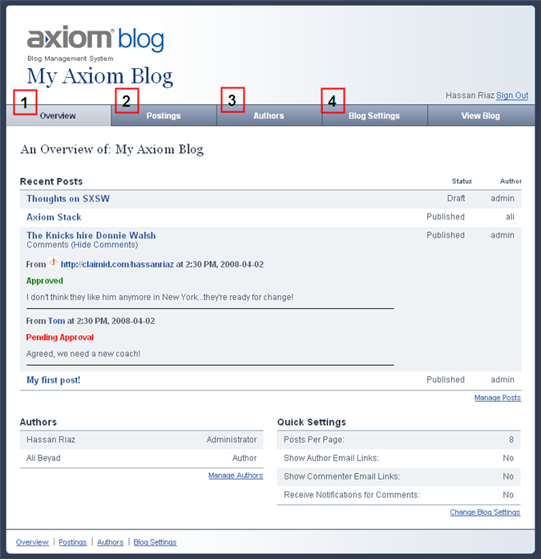

1. Overview
The first tab in the Blog Management System is the Overview tab. This tab is divided into 3 simple sections, A. Recent Posts, B. Authors and C. Quick Settings.

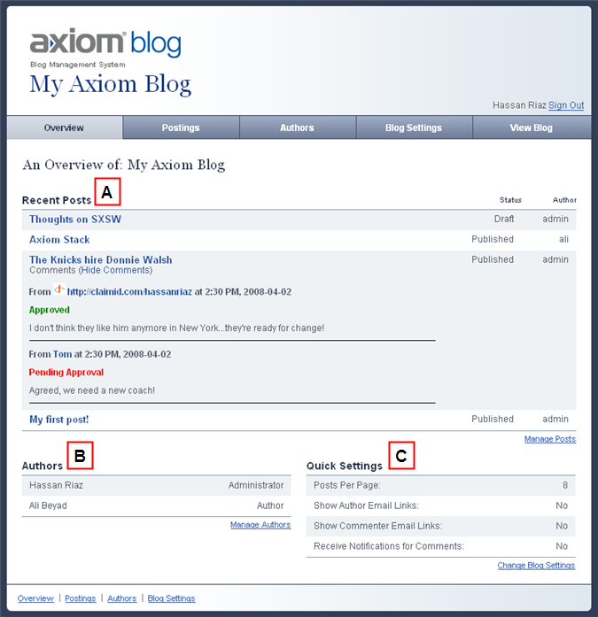

A. Recent Posts – This simply shows the 5 most recently made posts on the Blog, along with their Comments.
B. Authors – This shows 5 Authors and their roles.
C. Quick Settings – Displays 4 of the main settings that are currently set.
Each of these sections is followed by links for management of items related to them.

2. Postings
The Postings section is divided into four sub-sections. Everything that can be done to Administer Blog Posts can be done from here by navigating through the Postings sub-sections. You can Create blog posts, manage the blog posts, manage user comments and manage the categories used for each posting. Below is a detailed view of each sub-section.

A. Postings – Create
The Create sub-section is used to create new blog postings.

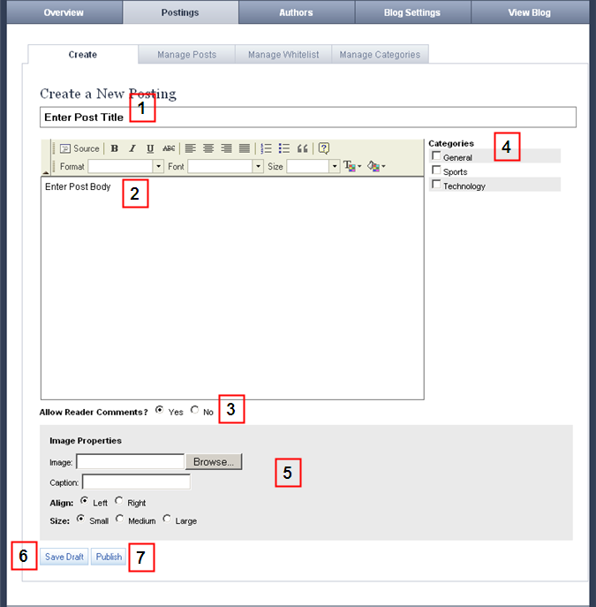

1. Post Title – This is where users enter the Title of their Posts. This is a required field.
2. Post Body – A WYSIWYG Editor is used to enter the Body of a Post. This field is also required. Include html markup. Editor toolbar includes source button (to view the html source), text formatting buttons, bulleted and numbered lists and adding links.
3. Allow Reader Comments – If “yes” is selected, readers of the post in the public viewing site will have the option of submitting Comments.
4. Categories – A list of all the available Categories appears on the right side. Decide which categories are most relevant and choose.
5. Image Properties – Images can be placed into the posts. Simply browse and select the image you want to place into your post. Axiom Blog can handle over 100 image file formats. Select placement, left or right, and size, small (100x75), medium (240x180) or large (500x375). Add an optional caption if you’d like. If you select an image to upload, it will be uploaded on saving the page and the options will then be associated to the Image. If no image is specified, these options will be ignored.
6. Save Draft – If this button is clicked, the Post will be saved as a Draft and not be viewable by readers.
7. Publish – Click this to save and publish the Post. It will be viewable by readers.

B. Postings – Manage Posts
This sub-section allows users to Search for, Edit, or Delete Blog Posts and Comments. The listing of Posts can be filtered to show All Posts, only Drafts, or only Published Posts by clicking on the specified Links.

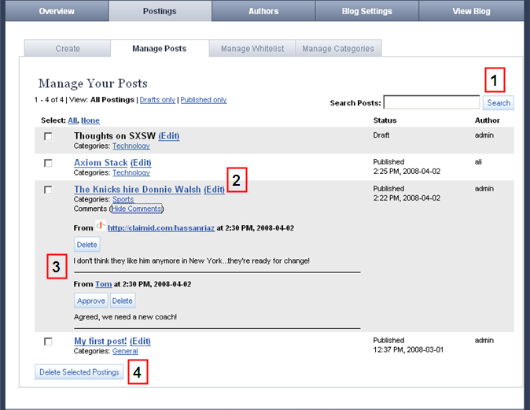

1. Search – To search for a particular post, simply type your search term in the specified text field, and click the Search button. This action searches both blog entry title and blog copy.
2. Edit – Edit posts by clicking on the Edit link next to the post’s title. This will take you to a screen similar to the Create sub-section. You will be able to edit the post using a WYSIWYG editor. To navigate back to the Manage Posts sub-section from the edit screen, click on the Manage All Postings link next to the Edit header.
3. Manage Comments – Comments can be Approved and Deleted by clicking on the View Comments link.
4. Delete - Delete posts by selecting the checkbox next to the desired post (or posts), and clicking the Delete Selected Postings button. All posts can be selected at once by clicking the “Select All” link.

C. Postings – Manage Whitelist
The Manage Whitelist sub-section is where OpenID accounts can be managed. Whitelisting an OpenID account automatically approves all past and future comments made by that account. Similar to the Manage Posts sub-section, OpenID accounts can be filtered to show All Accounts, only Whitelisted Accounts or only Pending Accounts (those with which comments have been made but have not yet been Whitelisted).

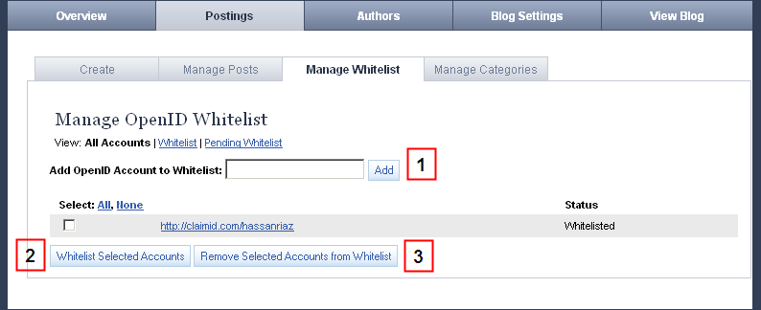

1. Add Account – Add an OpenID Account to the Whitelist. Any past and future comments made by this account will automatically be approved.
2. Whitelist Selected Accounts – Whitelisting an OpenID account will automatically approve all past and future comments made by the account.
3. Remove Selected Accounts from Whitelist – This will remove the selected OpenID account from the Whitelist and automatically remove approval of Comments made by the account.

D. Postings – Manage Categories
Users can create or delete categories in this sub-section. Once created, the categories will be available to choose on the Create Posting sub-section.

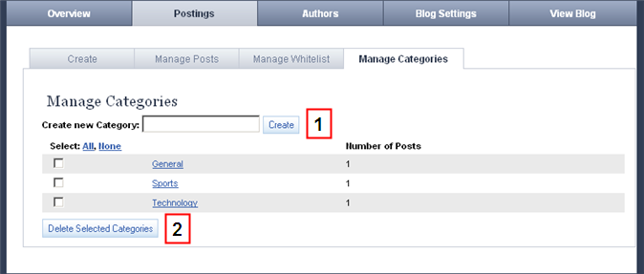

1. Create – Simply type the name of the Category you wish to create in the Create new Category text field, and click Create to create the specified category. Once created, the new category will be available to choose in the Create Posting screen.
2. Delete - To delete categories, select the checkbox next to the desired category (or categories), and click the Delete Selected Categories button. All posts can be selected at once by selecting the “Select All Categories” checkbox.

3. Authors
Administrator’s role
The authors tab is the tab Administrators use to manage authors of the Blog Management System. Authors can be created, edited, and deleted here. There are two different roles that can be associated with a user, administrator or author (see #6 below for a description of the roles). This tab can only be accessed by users with an Administrator role.

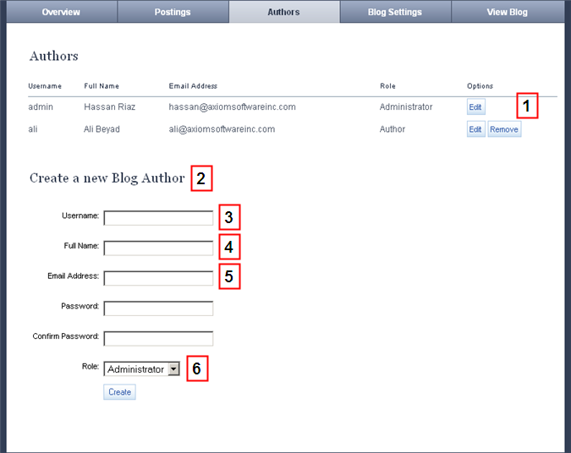

Current Users
1. Edit / Delete – To edit or delete a current user, click the corresponding button in the Options column for that user. Note that the initial admin cannot be deleted.
2. Create – Simply fill out the form and click the Create button to create a new user. All fields are required to create a new user. Upon creation of an author, an email will be sent with a link that will allow them to verify their new account. Once verified, they can begin posting.

New User Form Fields
3. Username – This is the username the Author will use to log into the Blog Management System.
4. Full name – The Author’s name as it will appear to readers on the website.
5. Email Address – This is needed for password reminders and notifications, including the initial invitation. This must be a valid email address.
6. Role – There are two roles – Administrator and Author.
1. Administrators have access to all of the management features of the blog.
2. Authors can only create / edit posts, manage comments and manage categories. Authors cannot add more blog authors or change the settings of the blog.

4. Blog Settings
The Blog Settings tab contains two sub-sections, Basic Settings and Template Settings. This section and its sub-sections can only be accessed by users with an Administrator role.

Blog Settings – Basic Settings
The Basic Settings sub-section allows administrators to manage certain areas of the Axiom Blog.

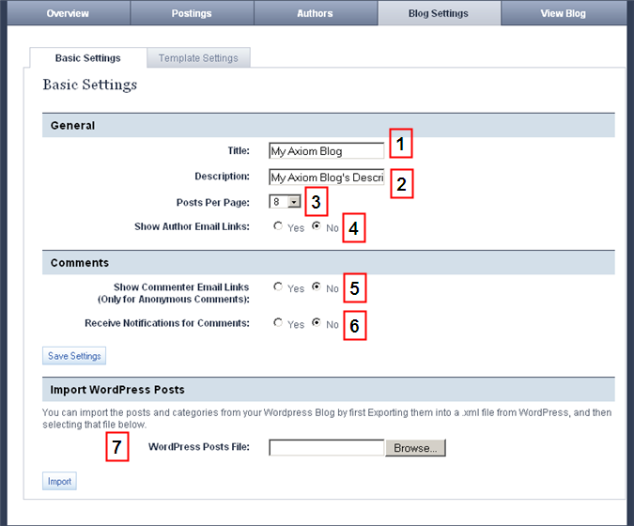

1. Title – This is the title of the blog as it will appear to the readers in the main heading at the top of the page.
2. Description – The blog description will appear in the description meta tag.
3. Posts Per Page – This is the number of posts that will appear on the Home Page, Search Results, and Category pages. The user can choose from 5 to 15 posts per page by using the dropdown list.
4. Show Author Email Links – If selected, the blog author’s name and email address will appear under their posts. This only applies to Anonymous Comments.
5. Show Commenter Email Links – If selected, the blog commenter’s email address will be added as a hyperlink to their names.
6. Receive Notifications for Comments – Choosing this option will send an email notification to a post author when a user leaves a comment for one of their posts.
7. WordPress Blog Import – Axiom Blog is configured to easily import a WordPress blog export file. If you are a current WordPress blogger, you can export your blog from your application. Using the import form, you can upload your WordPress file and all of your posts and categories will be entered in the Axiom Blog application. This feature works with export files that are exported from WordPress version 2.1 or higher.

Blog Settings – Template Settings
The Template Settings sub-section is to specify the appearance of the front end blog website. The layout can be set here using two built in formats, one optimized for 800 x 600 resolutions, and one for 1024 x 768 resolutions. Three distinct styles can be chosen for the look and feel of the front-end application. The standard styles can be overridden using the Use Your Own Style Sheet form. Simply add-in your own styles and change the look to something unique.

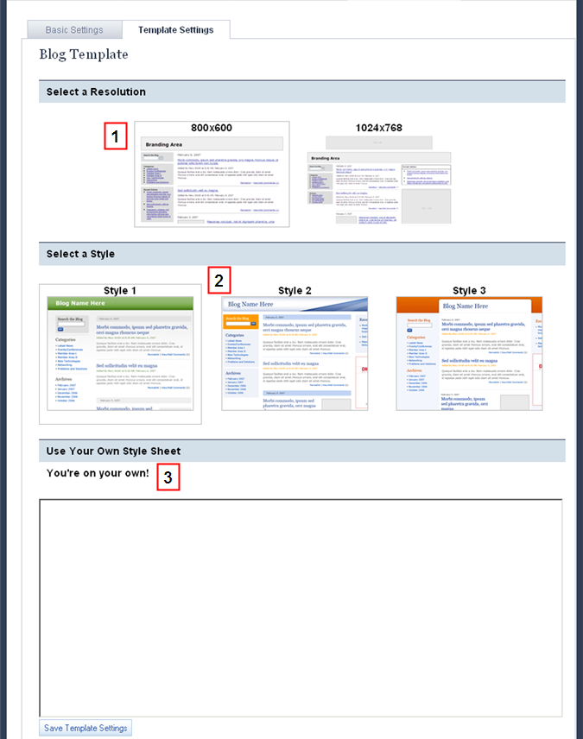

1. Select a resolution – Resolution choices are 800x600 and 1024x768, with slightly different layouts for each. Just choose the resolution you want and click Save Template Settings below.

2. Select a style – There are three style choices built in to the Axiom Blog. The colors and styles are changed by simply choosing image of the style you want, then click the Save Template Settings button below to make you change.

3. Use your own stylesheet – With Axiom Blog, it’s possible to change the look and feel of the application to a custom design of your own by pasting a stylesheet into the Use Your Own Stylesheet field. Just add in your own styles and you have complete control of the look of the application.

Viewing the Blog
In order to view the blog, navigate to:

http://<your server address>/blog/home

This will take you to the Home Page view of the blog. The home page is where the most recent posts are listed in order of their publish date and time.

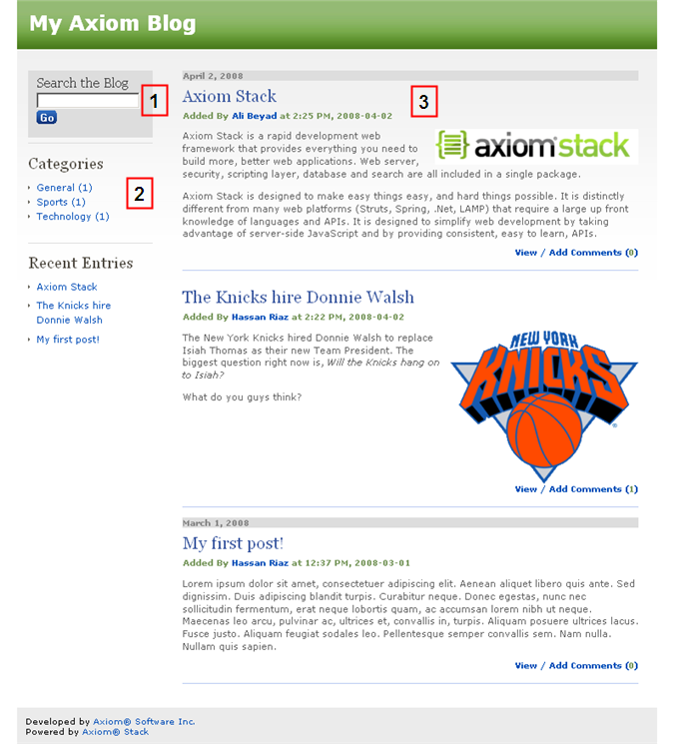

1. Searching – simply enter your search term and click the Go button to perform a search through all the posts in the blog.
2. Categories – the left rail contains a list of all the Categories that have been added. Clicking on a Category will bring up a listing of all the Posts associated to the category, sorted by their publish date and time.
3. Posts – Clicking on the title of a post (or its View/Comment link) will take you to the post’s page. This is where readers can submit comments if they are enabled for that post.

Viewing and Commenting on Posts
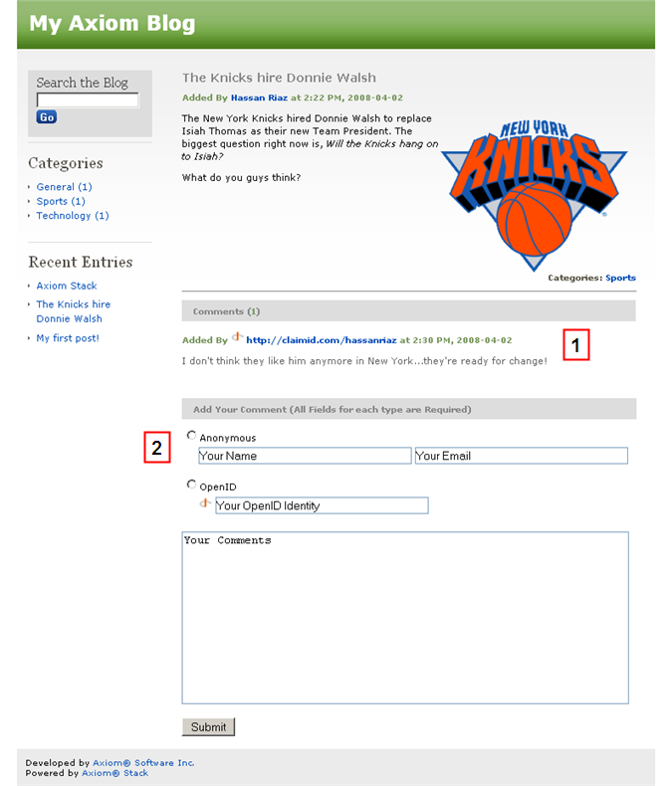

1. Comments – Approved comments are displayed beneath the body of the Post.
2. Making Comments – Visitors can comment anonymously or choose to use their OpenID account to make Comments. Frequent visitors may have their OpenID accounts Whitelisted, which will allow automatic approval of comments.

