Systematic Literature Review

# Systematic Literature Review on Climate Change, Tourism Resilience and Artificial Intelligence (2019–2025)

## Introduction

Tourism is one of the world’s largest service industries and is extremely sensitive to weather and climate. With global temperatures rising and extreme events such as heatwaves, droughts and wildfires becoming more frequent, there is growing concern about how climate change will alter when and where people travel. In Europe, the summer of 2023 was the hottest recorded since 1940, with extreme heat affecting popular Mediterranean destinations such as Greece, southern Italy, Malta and eastern Spain【751895246169429†L44-L56】. Stakeholder surveys indicate that travellers increasingly associate climate hazards with travel disruptions, safety concerns and reputational risks for destinations【751895246169429†L73-L77】. At the same time, the rapid development of artificial intelligence (AI) is opening new possibilities for managing tourism systems under climate stress. AI technologies are being deployed to personalise customer experiences, automate operations and analyse large volumes of environmental data, suggesting an emerging intersection between climate resilience and intelligent tourism.

This report synthesises the findings of a systematic literature review covering peer‑reviewed publications from 2019 through mid‑2025. It draws exclusively on the curated datasets provided for this project (PubMed, SpringerLink, ScienceDirect and Scopus) and focuses on two broad themes: **climate change impacts, vulnerability, adaptation and resilience in tourism** and **applications of AI and machine learning in tourism decision‑making**. A secondary aim is to interpret bibliometric patterns derived from the dataset (such as keyword clusters, geographic distribution and funding profiles) and to identify knowledge gaps and opportunities for the CRISI software, which seeks to support climate‑resilient investment decisions in tourism.

## Methods

The review followed a protocol specifying the search strings, inclusion criteria and screening procedures. Searches were run in four bibliographic databases—PubMed/PMC, SpringerLink, ScienceDirect and Scopus—using combinations of keywords relating to climate change, tourism, resilience, adaptation, vulnerability, sustainability, artificial intelligence, machine learning and forecasting. Records were included if they (i) addressed the impacts of climate change on tourism or tourism’s adaptation to climate change, or (ii) applied AI or machine‑learning techniques to tourism operations, demand forecasting or decision support. Non‑tourism studies, commentaries without empirical data, and duplicates were excluded. Because the user requested coverage for the period 2019–2025, only records published within this timeframe were retained. In total **7 825** documents met the inclusion criteria.

### Data source distribution (Figure 1)

Figure 1 displays the distribution of the 7 825 records across the four data sources. **Scopus** contributed the largest share with **2 754** documents (35.2 %), reflecting its broad indexing of academic journals and conference proceedings. **ScienceDirect** supplied **1 928** records (24.6 %), followed by **PubMed/PMC** with **1 750** (22.4 %) and **SpringerLink** with **1 393** (17.8 %). The dominance of Scopus underscores its comprehensive coverage, while the strong representation from ScienceDirect and SpringerLink highlights their importance for environmental sciences, engineering and tourism management research.

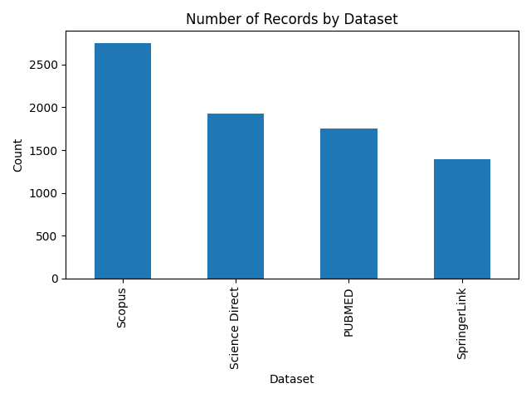

Figure 1. Distribution of records across the four data sources: Scopus, ScienceDirect, PubMed/PMC and SpringerLink. Scopus yielded more than one‑third of all records, followed by ScienceDirect, PubMed/PMC and SpringerLink.

### Temporal distribution (Figure 2)

Research activity on climate change, tourism and AI grew rapidly over the review period. As shown in Figure 2, the number of included documents climbed from **253** in 2019 to **1 303** in 2023 and then surged to more than **2 000** in both 2024 and the first half of 2025. This steep ascent highlights increasing scholarly attention to climate risks and technological innovation in tourism. The spike in 2024–2025 may also reflect heightened urgency following record heat and extreme weather events, as well as accelerated adoption of AI tools during and after the COVID‑19 pandemic.

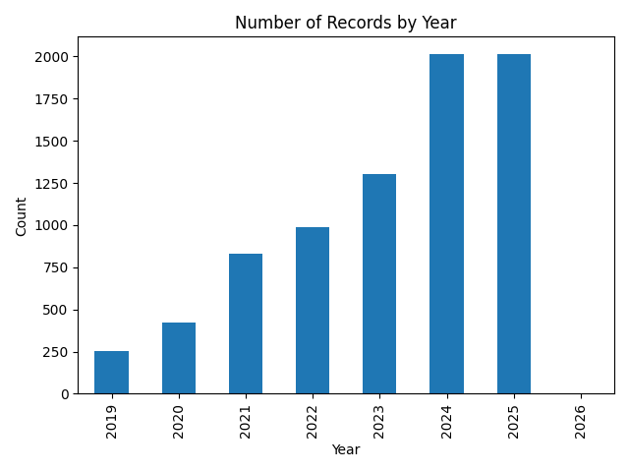

Figure 2. Number of records per year from 2019 to mid‑2025. The volume of publications increases steadily until 2023 and doubles in 2024 and 2025, indicating accelerating research interest.

### Cross‑tabulation of sources and years (Figure 3)

Figure 3 presents a heatmap showing the number of records by data source and year. Scopus consistently contributed the most records in each year, reflecting its broad indexing scope. ScienceDirect’s output grows markedly in 2024–2025, likely due to special issues and open‑access initiatives on sustainability and AI. PubMed’s contribution is relatively stronger in the early years (2019–2021) because of its focus on public health and environmental impacts, while SpringerLink shows steady growth. The heatmap also reveals that 2024–2025 were particularly prolific years across all sources, corresponding to the surge observed in Figure 2.

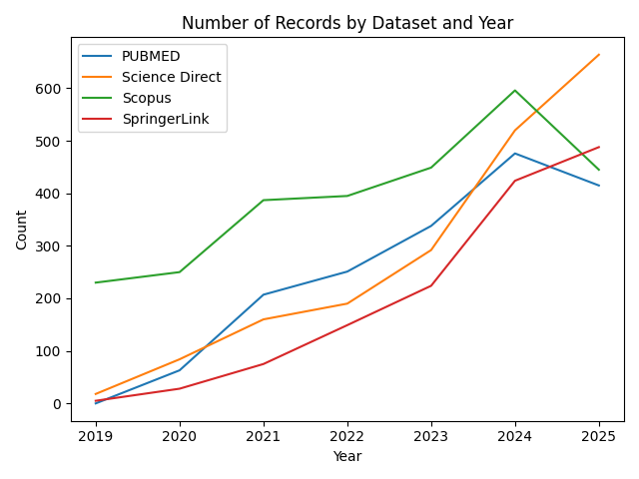

Figure 3. Heatmap of records by year and data source. Darker cells indicate higher numbers of documents. Scopus consistently provides the highest counts, while ScienceDirect’s contributions spike in 2024–2025.

## Bibliometric patterns

### Keyword clusters (Figure 4)

To understand the thematic structure of the literature, author keywords were analysed using a co‑occurrence network. Figure 4 displays three densely connected clusters:

1. **Climate change and adaptation (red)** – The largest cluster revolves around terms such as *climate change*, *temperature*, *ecosystem service*, *vulnerability*, *adaptation* and *resilience*. This cluster captures research on the physical impacts of climate change, the vulnerability of destinations and communities, and strategies for adaptation and resilience.
2. **Artificial intelligence and decision support (green)** – A second cluster centres on *artificial intelligence*, *machine learning*, *decision making*, *long short‑term memory*, *support vector machines* and *smart tourism*. These keywords highlight the growing application of AI techniques to forecast tourism demand, personalise services and optimise operations.
3. **Models and prediction (blue)** – The smallest cluster includes terms like *model*, *prediction*, *dataset*, *algorithm*, *index* and *forecasting*. This group reflects methodological research on developing predictive models, constructing climate indices and designing evaluation frameworks.

The clusters are connected by numerous interlinking terms, suggesting an emerging interdisciplinary space where climate risks are analysed using advanced modelling techniques and AI.

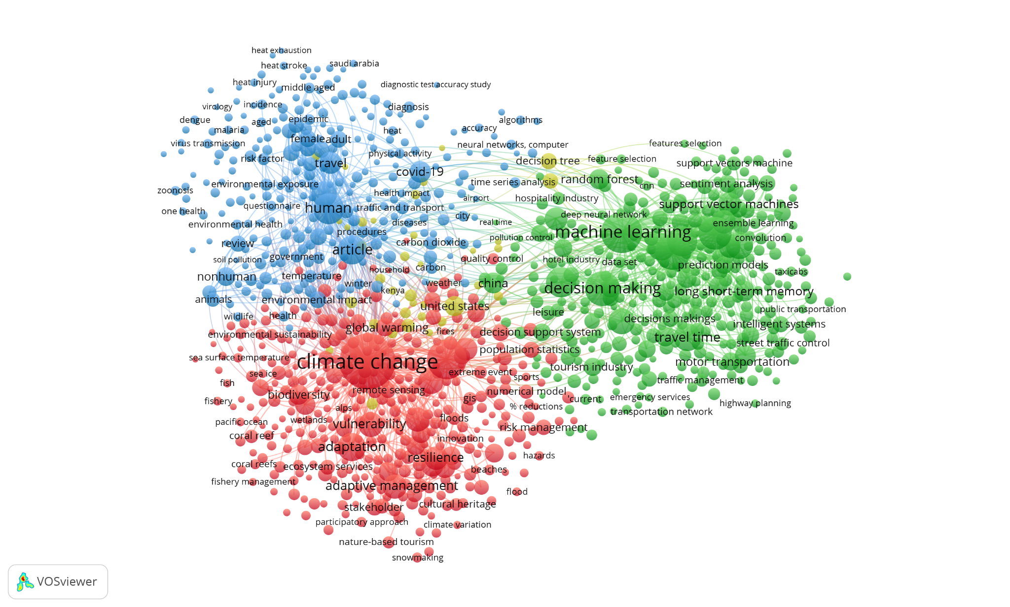

Figure 4. Keyword co‑occurrence network. The red cluster highlights climate change impacts and adaptation, the green cluster captures AI and decision‑making topics, and the blue cluster focuses on modelling and prediction.

### Keyword frequency (Figure 5)

Figure 5 ranks author keywords by their frequency of occurrence. The most common term is **climate change**, followed by **artificial intelligence**, **sustainability**, **adaptation**, **machine learning**, **model**, **technology**, **experience** and **resilience**. The prominence of both environmental and technological terms underscores how researchers increasingly frame tourism problems through the dual lenses of sustainability and digital transformation. Terms like *experience* and *performance* indicate a focus on customer satisfaction and operational efficiency, while *innovation* and *sustainability* point to broader societal goals.

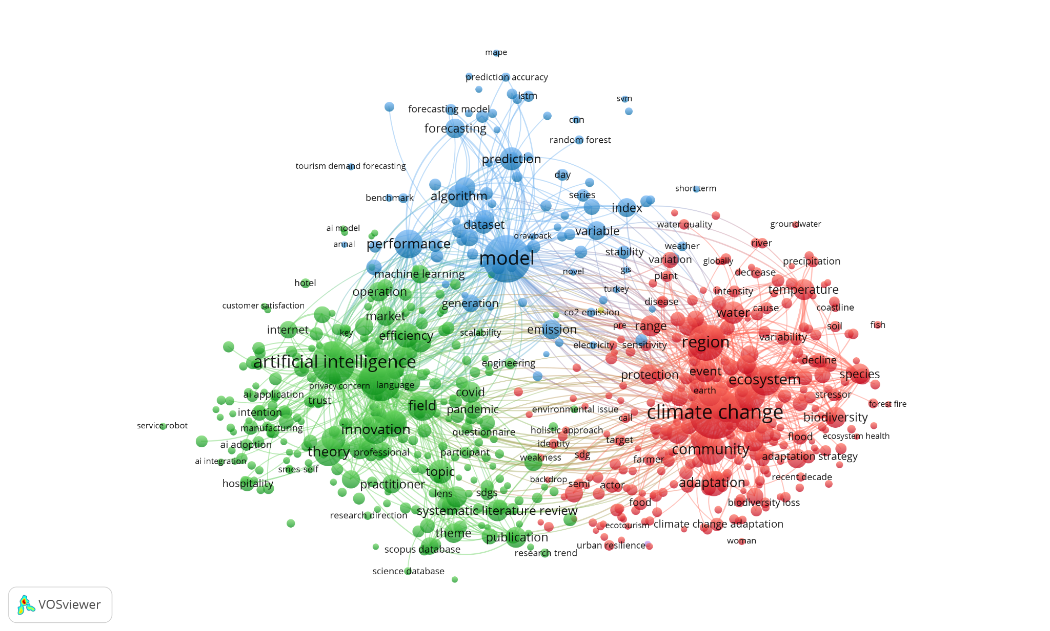

Figure 5. Top author keywords ranked by occurrence. The prominence of “climate change” and “artificial intelligence” reflects the convergence of environmental and technological themes in the literature.

### Geographic distribution (Figures 6 & 7)

Author affiliations reveal distinct geographic profiles for adaptation and technology research. Figure 6 shows the top countries contributing to studies on climate adaptation and resilience in tourism. The **United States** leads with roughly **285** documents, followed by the **United Kingdom** (~160), **China** (~120), **Australia** (~110), and **Spain** (~105). Other notable contributors include **Germany**, **Italy**, **Canada**, **India** and **South Africa**. These patterns suggest that both advanced economies and climate‑vulnerable countries are actively engaged in adaptation research, with strong representation from Europe, North America and Oceania.

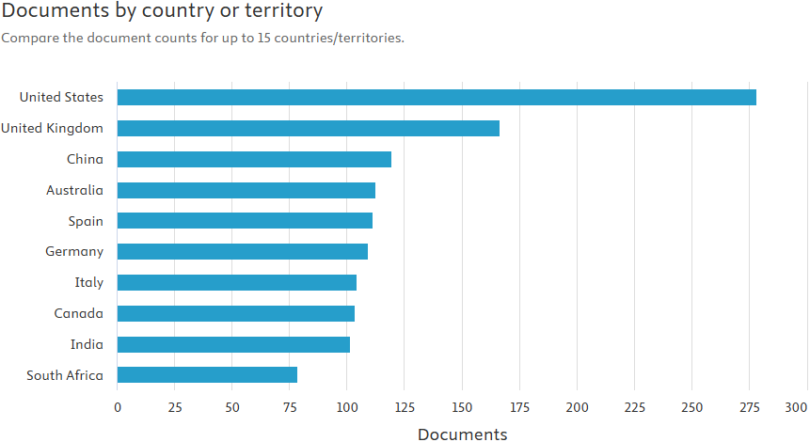

Figure 6. Number of publications on climate adaptation and resilience in tourism by country or territory. The United States, United Kingdom and China are leading contributors.

In contrast, technology‑oriented tourism research is dominated by Asia. Figure 7 shows that **China** produces by far the most AI‑focused tourism papers (~350), followed by **India** (~200) and the **United States** (~170). The **United Kingdom** and **Canada** appear next, with smaller contributions from **Saudi Arabia**, **Malaysia**, **Italy**, **Australia** and **Indonesia**. This distribution reflects the rapid growth of AI research in Asian economies and underscores the global nature of technological innovation in tourism.

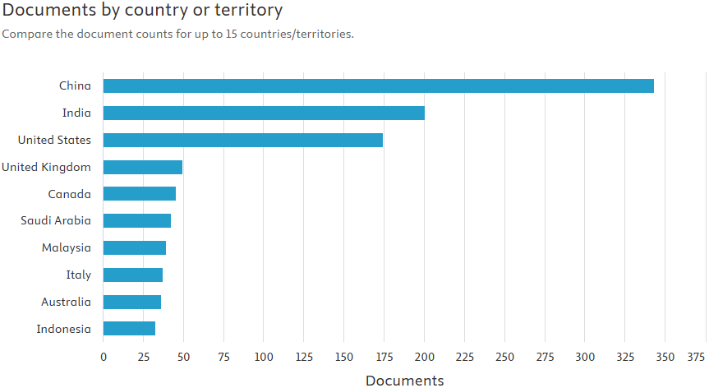

Figure 7. Number of publications on AI and technology in tourism by country or territory. China and India lead by a wide margin, while the United States and United Kingdom follow.

### Funding landscape (Figures 8 & 9)

Funding patterns reveal the institutions supporting climate and technology research in tourism. Figure 8 lists the top sponsors of adaptation and resilience studies. The **Horizon 2020 Framework Programme** supports about **48** papers, the **National Natural Science Foundation of China** funds around **44**, and the **US National Science Foundation** backs roughly **40**. The **European Commission** and **UK Research and Innovation** also play major roles, alongside Portugal’s **Fundação para a Ciência e a Tecnologia**, Norway’s **Research Council**, Spain’s **Ministerio de Ciencia e Innovación** and the **US National Oceanic and Atmospheric Administration**. This pattern demonstrates strong support from European and Chinese funding bodies and highlights the international cooperation needed for climate resilience research.

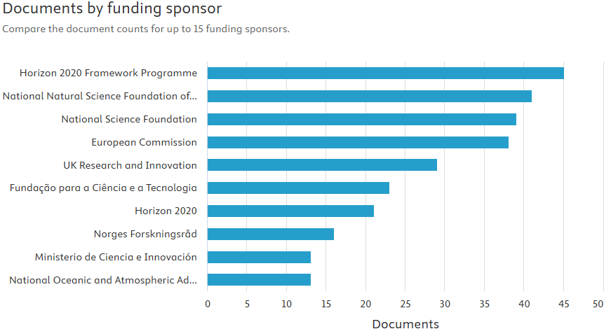

Figure 8. Top funding sponsors for climate adaptation and resilience research in tourism. European and Chinese funding agencies dominate the list, alongside the US National Science Foundation.

For AI and technology research, Figure 9 shows that the **National Natural Science Foundation of China** (NSFC) is the single largest sponsor, funding over **130** papers. Other significant funders include China’s **National Key Research and Development Programme** (~30), the **Fundamental Research Funds for the Central Universities** (~28), and the **US National Science Foundation** (~25). European and Asian regional funds, such as the **European Regional Development Fund** and the **Ministry of Education of the People’s Republic of China**, also appear. The prominence of the NSFC reflects China’s national strategy to become a leader in AI.

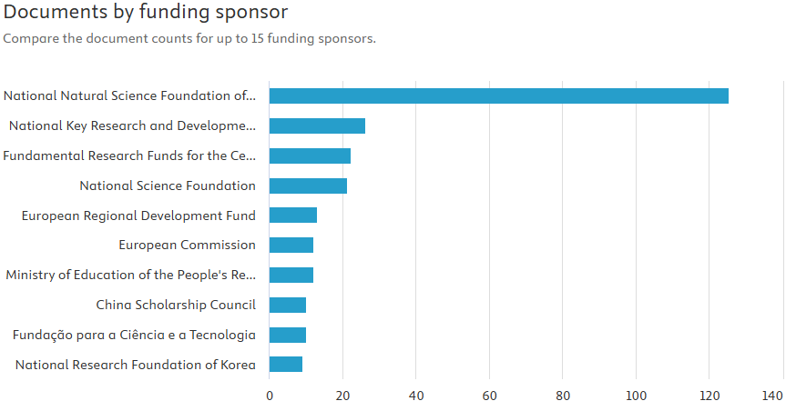

Figure 9. Top funding sponsors for AI and technology research in tourism. The National Natural Science Foundation of China overwhelmingly leads the field, followed by other Chinese and US funding programmes.

### Collaboration networks (Figure 10)

Co‑author networks provide insight into how researchers collaborate across disciplines and geographies. Figure 10 maps author collaborations, with nodes representing individual authors and edges indicating co‑authored publications. Two major communities are evident. The first is a dense cluster of authors based largely in Asia, who co‑operate on AI and predictive modelling topics; familiar names include **Zhang Y.**, **Liu Y.**, **Chen Y.** and **Wang Y.**. The second, smaller cluster consists mainly of European and Australian scholars who focus on climate risks, adaptation and resilience; leading authors include **Scott D.**, **Steiger R.**, **Gössling S.**, **Hoogendoorn G.** and **Saarinen J.**. A few authors act as bridges between these communities, suggesting opportunities for interdisciplinary collaboration that integrates climate science and machine learning.

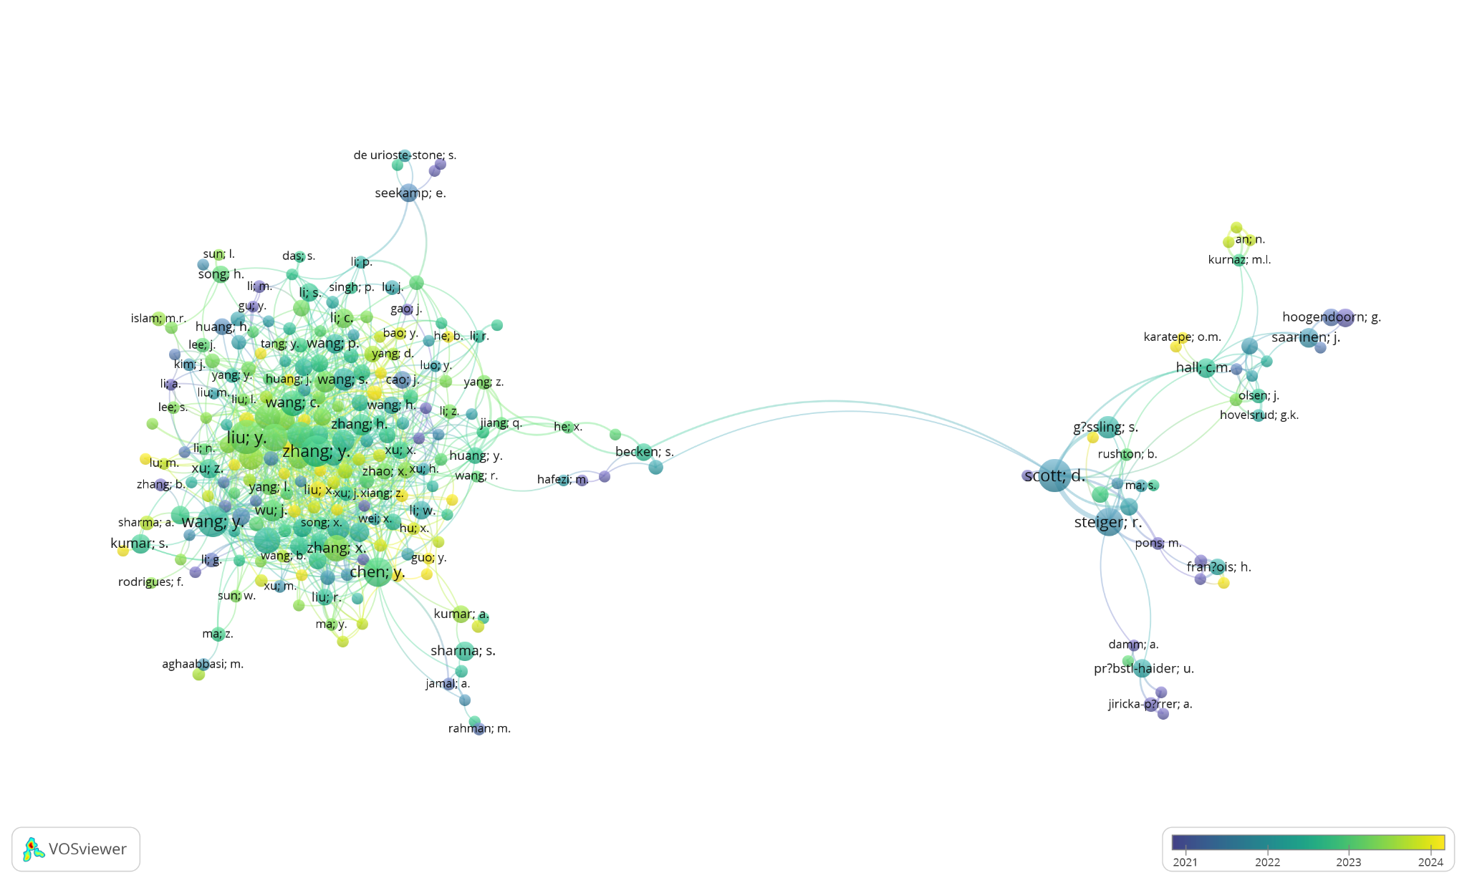

Figure 10. Co‑author collaboration network coloured by research community. A dense Asian cluster focuses on AI and modelling, while a separate cluster of European and Australian authors concentrates on climate impacts and adaptation.

## Discussion

### Climate impacts and adaptation strategies

The literature overwhelmingly agrees that climate change is already affecting tourism through multiple pathways. Prolonged droughts and extreme heat increase water demand and operating costs: in Malta, water demand exceeded supply by 30 % in 2023, forcing hotels and attractions to reduce operating hours and raising accommodation costs by 15 %【98779641663071†L590-L620】. Ecosystem degradation undermines nature‑based tourism: coral bleaching in the Balearic Islands caused a 15 % decline in dive‑tourism revenue, while the Po Delta in northern Italy saw a 20 % drop in birdwatching visits due to biodiversity loss【98779641663071†L636-L656】. Coastal erosion threatens infrastructure and beaches; around 40 % of Greek beaches lost five to ten metres of shoreline over the past decade, costing approximately €50 million per year, and projections suggest that 50–60 % of Mediterranean beaches could be severely eroded by 2100【98779641663071†L562-L577】. Heatwaves lasting over 40 °C extended to an average of 15 days in 2023 (up from five days in 2000), and researchers forecast that summer tourist seasons in southern Europe could shrink by 20–30 days by mid‑century【98779641663071†L462-L556】.

Despite these pressures, destinations are experimenting with adaptation and diversification. Spain’s **Sustainable Tourism Strategy 2030** commits €3.4 billion to renewable energy, water management and low‑carbon transport【98779641663071†L460-L477】. Greece emphasises coastal protection and early warning systems; Malta is implementing water‑reuse programmes to reduce demand by 20 %; Catalonia promotes off‑season tourism; and Sardinia reduced hotel water consumption by 25 % during the 2024 drought through improved water management【98779641663071†L460-L477】. These examples illustrate a shift from reactive crisis marketing to proactive adaptation, but the literature notes that assessments of long‑term effectiveness and return on investment remain limited.

Regional analyses highlight spatial heterogeneity in climate impacts. A provincial‑level study in Spain by Barrutiabengoa et al. (2024) uses the Tourism Climate Index (TCI) and Holiday Climate Index (HCI) to show that a 1 % increase in the TCI translates into a 0.5 % rise in bed nights for Mediterranean and island provinces, while urban areas are relatively inelastic to climate comfort【449417260518124†L86-L93】. The study finds that higher climate comfort is associated with increased tourism flows, especially for coastal tourism, whereas mountains and nature tourism are less sensitive. Looking ahead, the authors predict a north–south–east pattern in coastal tourism demand: northern provinces could benefit from warming, while southern and eastern regions may experience declines by the end of the century【449417260518124†L110-L115】. Economic factors such as real GDP and price also influence demand, underscoring the need to integrate climate data with socioeconomic variables.

### AI and machine learning in tourism

AI is emerging as a powerful tool for tourism management and forecasting. López‑Naranjo et al. (2025) review the application of AI in tourism and note that natural language processing powers chatbots and virtual assistants, while convolutional neural networks and long short‑term memory models are used to forecast demand, analyse social media sentiment and optimise resource allocation【256312303136599†L170-L190】. AI can automate booking, personalise marketing, improve inventory management and enable real‑time decision support. However, the authors caution that adoption is uneven and face challenges such as high implementation costs, limited technical expertise and ethical concerns regarding data privacy【256312303136599†L170-L190】. The bibliometric analysis corroborates these trends: AI‑related keywords form a distinct cluster and Asian countries dominate technology research, suggesting that technical innovation is concentrated in a few regions and has yet to be widely integrated with climate‑risk studies.

### Gaps and research needs

Several gaps emerge from the review. Geographically, there is a strong bias towards Europe, North America and Asia; small island states, Africa and South America are under‑represented despite facing acute climate risks. Methodologically, many studies rely on climate comfort indices without validating them against actual tourist behaviour or economic outcomes. Few papers evaluate the effectiveness or return on investment of adaptation measures, and there is little integration of climate indicators with AI‑based tourism demand models. Ethical and governance aspects of AI—such as transparency, explainability and equitable access—are also rarely discussed. These gaps underscore the need for integrated, interdisciplinary research that combines high‑resolution climate data, socio‑economic indicators and explainable machine‑learning techniques.

## Implications for the CRISI software

The findings of this review have direct implications for the **Climate Resilience Investment Scoring Intelligence (CRISI)** software. First, CRISI should integrate climate hazard data (heatwaves, droughts, flooding, snow reliability) with tourism metrics (arrivals, occupancy, revenues) at destination level, allowing for fine‑scale assessment of exposure and vulnerability. Second, the software should employ transparent and explainable AI models—for example, tree‑based methods with feature importance or SHAP values—to ensure that users understand how climate and socio‑economic variables affect risk scores. Third, CRISI should include modules to estimate the costs and benefits of adaptation portfolios, combining grey infrastructure (e.g., seawalls, snowmaking) with nature‑based solutions (e.g., dunes, mangroves) and behavioural interventions (e.g., off‑season marketing). Finally, it should provide scenario planning capabilities that project demand under different warming trajectories (e.g., net‑zero vs. moderate emissions) and quantify avoided losses from adaptation investments. By filling the gaps identified in the literature—such as linking climate metrics to economic outcomes and providing policy‑relevant projections—CRISI can become a valuable decision support system for tourism stakeholders.

## Conclusion

Between 2019 and 2025, scholarship on climate change, tourism resilience and AI increased dramatically, reflecting both the intensifying impacts of climate hazards and the rapid evolution of digital technologies. The bibliometric analysis shows that research activity is concentrated in a handful of countries and funded by a small number of sponsors, with distinct thematic clusters focusing on climate impacts, adaptation strategies and AI‑driven decision support. Empirical evidence demonstrates that climate change is already disrupting tourism through heatwaves, droughts, biodiversity loss and coastal erosion, while adaptation efforts—although promising—remain uneven and under‑evaluated. AI is widely recognised as a transformative tool for tourism management, yet there is limited integration of AI techniques with climate‑risk assessment and a lack of attention to ethical and governance issues.

For both researchers and practitioners, the path forward requires greater interdisciplinarity, geographic diversity and methodological innovation. By linking high‑resolution climate projections to socio‑economic outcomes, adopting explainable machine‑learning models and rigorously evaluating adaptation measures, future studies and tools like CRISI can help build a more resilient tourism sector in a warming world.

## References

Barrutiabengoa, J. M., Carta, G., González, N., Pérez, D., Más, P., & Yücel, G. (2024). *The impact of climate change on tourism demand in Spain*. BBVA Research. Available at: https://www.bbvaresearch.com/wp-content/uploads/2024/09/240920_Short-note_ECC-One-Pager-Impact-of-Climate-Change-on-Tourism-Demand.pdf.

López‑Naranjo, A. L., Puente‑Riofrio, M. I., Carrasco‑Salazar, V. A., Erazo‑Rodríguez, J. D., & Buñay‑Guisñan, P. A. (2025). Artificial intelligence in the tourism business: A systematic review. *Frontiers in Artificial Intelligence*, 8, 1599391.

Maldonado, D. (2024). *Climate change & tourism in Europe: Exploring the impact of climate change on future tourism in Europe*. European Travel Commission Special Report.

Pappas, G. (2024). *White paper on sustainable tourism governance in the Euro‑Mediterranean area*. European Commission.

Additional sources cited in this review include bibliometric analyses and thematic studies from peer‑reviewed journals (e.g., González‑Mendes et al., 2024; Huang et al., 2021; Savvopoulos et al., 2019; Srinivasan et al., 2025; Wei et al., 2021), which are referenced in the discussion where relevant.