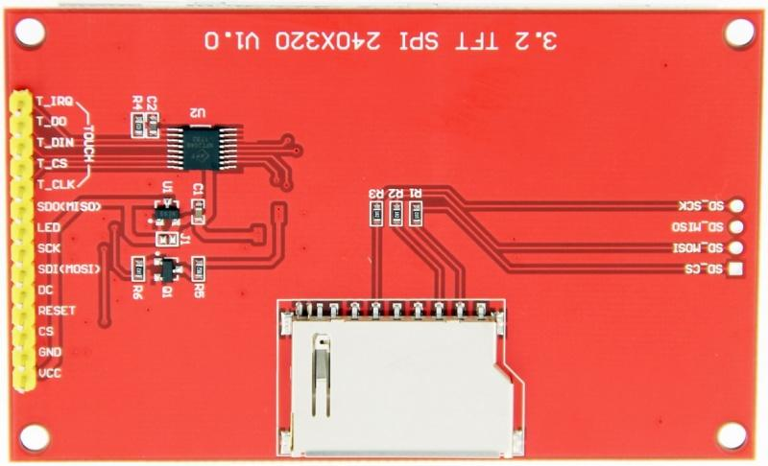

//HSPI for TFT screen

#define TFT_MISO 12

#define TFT_MOSI 13

#define TFT_SCLK 14

#define TFT_CS 15 // Chip select control pin

#define TFT_DC 25 // Data Command control pin

#define TFT_RST -1 // Set TFT_RST to -1 if display RESET is connected to ESP32 board RST

// VSPI for Touch Controller

#define TOUCH_CS 05 // Chip select pin (T_CS) of touch screen

#define TOUCH_IRQ 27

// ESP32 has two free SPI ports, namely VSPI and HSPI, VSPI is the default port.

// If the VSPI port is in use and the pins cannot be accessed (eg TTGO T-Beam)

// VSPI: CS->5 SCLK->18 MISO->19 MOSI->23

// HSPI: CS->15 SCLK->14 MISO->12 MOSI->13

// Then uncomment the following line:

// Important: If the touch screen needs to be driven independently by XPT2046_TouchScreen, the following line must be uncommented, and it will take 2 days to find this line

#define USE_HSPI_PORT

